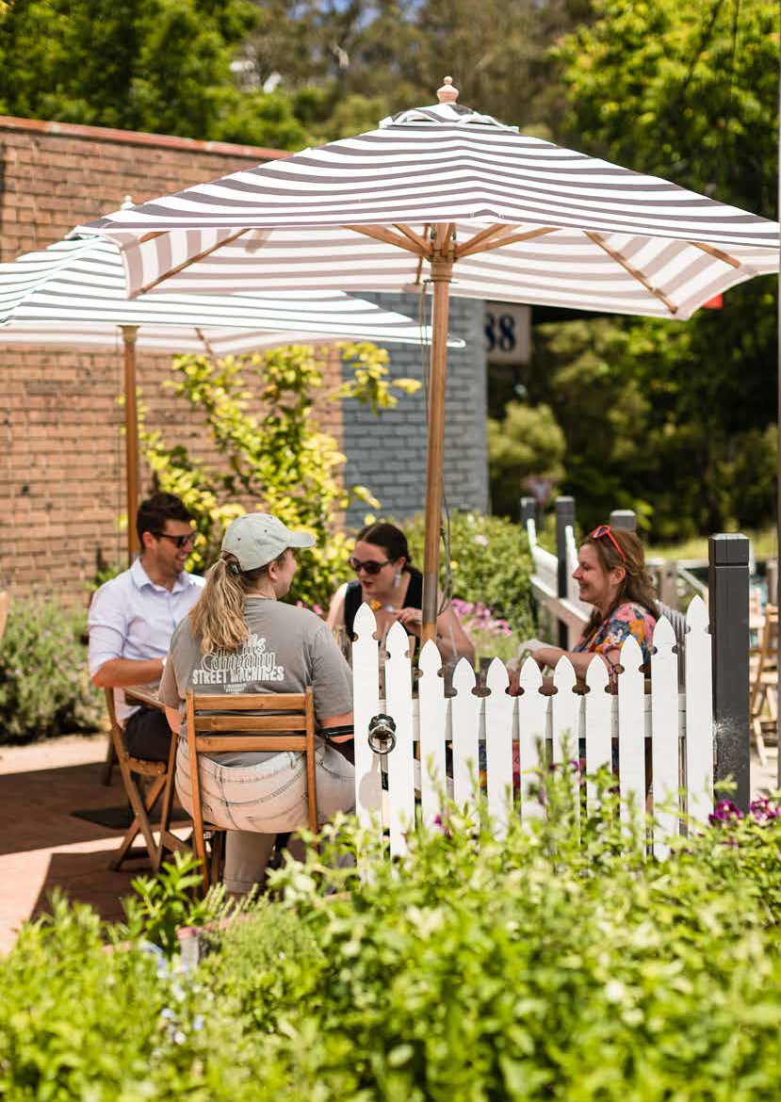

Municipal Recovery Plan

Pandemic and Storm Recovery November 2022

**Table of Contents**

|  |  |  |  |
| --- | --- | --- | --- |
|  | 1 | Executive summary | 4 |
| 2 | Background | 6 |
|  | 2.1 Key facts about the Yarra Ranges and its natural environment | 6 |
|  | 2.2 Access to essential services | 7 |
| 3 | Key social, health & wellbeing statistics | 8 |
| 4 | 2021 census key statistics - Yarra Ranges compared with Victoria | 9 |
| 5 | Pandemic impact overview | 10 |
| 6 | June 2021 storm | 12 |
| 7 | Emergency storm response | 14 |
| 8 | Transition to recovery | 14 |
|  | 8.1 Initial recovery activities | 14 |
|  | 8.2 Secondary impact assessment | 15 |
| 9 | RECOVERY | 16 |
|  | 9.1 Principles of recovery | 17 |
|  | 9.2 Recovery objectives | 17 |
|  | 9.3 Commitment to community led recovery | 18 |
|  | 9.4 Cultural Recovery | 18 |
|  | 9.5 Regional Community Recovery Committees | 19 |
|  | 9.6 Recovery priorities by region – Regional Community Recovery Committees | 20 |
|  | 9.7 Common themes and differences among the four regions | 24 |
|  | 9.8 Advisory Committees | 24 |
|  | 9.9 Recovery governance | 25 |
|  | 9.10 Establishment of the Recovery Directorate | 25 |
| 10 | Recovery Activities 2021-22 | 26 |
| 11 | Recovery Issues that are hampering recovery | 28 |
|  |  | 11.1 Climate change impacts by 2030 | 29 |
| 2 |  |  |  |

1. Impact assessment at the end of 2021-22 30
   1. Schools survey results 30
   2. Expenditure assessment for the Yarra Ranges 31
2. Recovery over the medium to long term 32
   1. Experience from the 2009 bushfires 32
   2. Recovery Timeline – the next five years 32
   3. Advocacy by Yarra Ranges Council 34
   4. Funding Recovery 34
   5. Strategic Links & Risk Mitigation 35
   6. Recovery risk mitigation 35
3. RECOVERY ACTION PLAN 37
   1. Advocacy Action Plan 38
   2. People, Culture and Wellbeing Action Plan 41
   3. Business, Tourism and Economy Action Plan 47
   4. Public Infrastructure Action Plan 50
   5. Environment and Biodiversity Action Plan 50
   6. Planning and Rebuilding Action Plan 52

###### Version control

Version:

Date Description Author

###### Related Documents/Plans

YRC Municipal Emergency Management Plan YRC Relief and Recovery Plan

###### Document Approval

Name Title Date

3.0

November 2022

YRC Municipal Recovery Plan - Version 3

D. Booth

Jane Sinnamon Director Recovery

3

1. **Executive summary**

Yarra Ranges Council is the largest physical metropolitan municipality in Greater Melbourne with a population density of only 64 persons per square kilometre

compared with 453 persons per square kilometre for Greater Melbourne.1

The area, renowned for its environment and resulting bounty is literally the bedrock for its residents and those who have cared for it for thousands of years.

This land and its people located on Wurundjeri Country, have weathered many natural disasters. However, the combination of the COVID-19 pandemic and the June 2021 storm event placed untold levels of stress on the community.

COVID-19 restrictions have had severe implications across the Yarra Ranges consisting of:

* Wellbeing issues with a significant proportion of the community reporting a major impact on their mental health (21 per cent in September 2021, 15 per cent in June 2022) 2
* The community not feeling socially connected during the pandemic (22 per cent in September 2021 and 13% in June 2022) 3
* Support agencies reporting an increase in domestic violence incidents with rates double the State average prior to the pandemic. 4 Anecdotal reports over 2022 suggest that rates have increased recently in the Yarra Ranges, particularly in the Hills region
* The ongoing unreliability of telecommunication and power networks which undermined the ability of businesses to operate, magnified social isolation for

communities with no services, and severely impacted the education of our young people It should be noted that Council’s telecommunications advocacy through the ‘Connecting Victoria program’ has been highly effective, with the Victorian Government announcing funding for dozens of new mobile towers across 26 suburbs in the Yarra Ranges, including 15 in Mount Evelyn, 8 in Mooroolbark and 4 in Lilydale

* Tourism, hospitality, and creative industries brought to the brink of collapse

On the eve of restrictions lifting from Victoria’s fourth lockdown, as businesses were restocking and readying to welcome the public back, the Yarra Ranges was the epicentre of the most violent storm in Victoria’s recorded history resulting in:

* 79 properties non-habitable
* 183 properties registered for storm impacts
* more than 1,000 homes and business extensively impacted by storm debris

4 1 ID Community Profile Demographic Resources

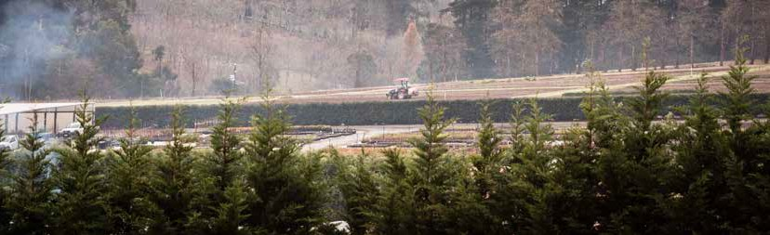

2 Yarra Ranges pandemic and storm impact survey

3 Yarra Ranges pandemic and storm impact survey

4 EDVOS Family Violence Report July 2020

* almost 5,000 properties impacted by flood
* more than 3,000 homes without power and internet for more than month
* a conservative estimate of 25,000 fallen trees across the region
* 34 communities lost NBN/internet service and were unable to call 000 for assistance extensive damage to roads
* 3,157 drainage/tree related requests for assistance from the community Unlike an environment after a bushfire where fire consumes the fuel, many

communities are still living amongst giant trees that are now destabilised as well as the remains of many trees which fell and have not yet been removed.

Initial estimates were that it would cost $65 million to resurrect public land, infrastructure, and support the community to rebuild both mentally and physically through a community led multi-agency response.

18 months after the storm event, recovery costs are now much clearer. As of September 2022, the total amount spent on recovery efforts has been $18 million while the total amount of recovery funding received by Yarra Ranges Council is $15.2 million.

The experience from the 2009 bushfires, as detailed in the ’10 Years Beyond Bushfires Report’, is that a proportion of the community most impacted by the disaster were still recovering up to 10 years after the event occurred. As such, it is acknowledged by Yarra Ranges Council that we are moving into a new phase in recovery that is more focussed on resilience for most. Much of the immediate response can wind back

without negatively impacting residents, but some ongoing support will be sought in response to the June 2021 storm event over the medium to longer term.

To this end, Yarra Ranges Council proposes that a medium to longer term recovery partnership between Council and the Victorian Government be piloted, with a focus on those activities that take longer to resolve:

* Rebuild and repair support
* Cross-government collaboration on temporary accommodation options for those rebuilding, and
* Ongoing support with a focus on trauma and private property clean-up

Yarra Ranges will be advocating with government agencies for ongoing funding in order to support recovery efforts in those specific areas over the medium to long term. The Action Plan located at the back of this document outlines a number of

advocacy actions designed to support these needs, as well as activity that will support residents, businesses, and country to recover.

While support will be required over the medium to longer term, longer-term recovery activities will engage a relatively smaller cohort consisting of those most impacted by the June storm. As such, Yarra Ranges Council’s Recovery Directorate is being progressively integrated into the organisation’s ongoing business units which will raise the organisation’s capacity in responding to impacted communities as well as reflecting the changing needs of the municipality.

Looking forward, it is anticipated that some elements of this recovery plan will be in effect until June 2026 with most activities having been completed by then. The few recovery activities beyond June 2026 will be captured and implemented through other Council plans.

Finally, while this Municipal Recovery Plan outlines the preferred model for recovery of the Yarra Ranges, many aspects will only be achievable with adequate support from the Victorian and Australian Governments.

5

1. **Background**
   1. **Key facts about the Yarra Ranges and its natural environment**

Yarra Ranges Council is the largest physical municipality in Greater Melbourne comprising of:

* + - 63% crown land
    - 31% primary production (agriculture/horticulture/viticulture)
    - 5% residential land

The vast majority of the Yarra Ranges consists of unpopulated areas with a small number of dispersed townships and some urban areas on the fringes - see the map below showing Yarra Ranges by land type for details.

Economically, Yarra Ranges boasts 6.7 billion in Gross Regional Product, $3.4 billion in exports, over 40,000 jobs and 13,600 businesses of which 98 percent are small businesses. 5

The natural beauty of the Yarra Ranges is one of its defining aspects. Extensive trees and forest are what makes the area unique and, in part, attracts residents and tourists to the area. Living within this environment has many benefits but also involves risk.

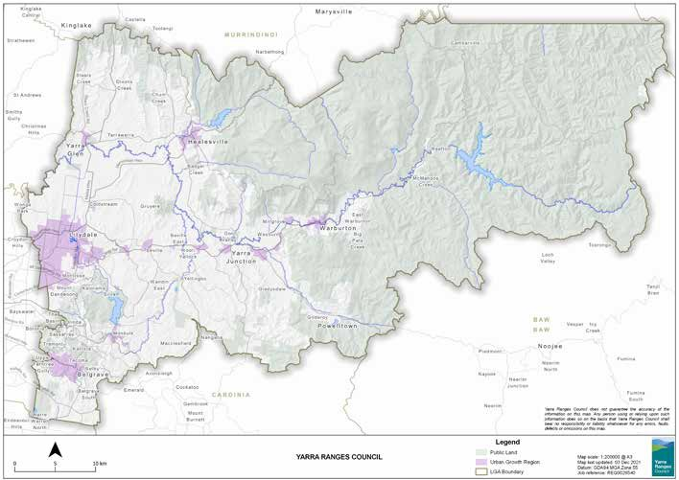

6 5 REMPLAN Economic Profile – Yarra Ranges LGA

The Dandenong Ranges is recognised as one of the highest risk environments for bushfire in the world which comes from a combination of a northerly aspect, steep slopes and gullies, being surrounded by forest, and residential areas along the ridge and throughout the region nestled into a forested environment.

The Dandenong Ranges are a significant recreational resource loved by the people of Melbourne, offering unique access to a number of National Parks, State Forests, and cultural opportunities.

Generally speaking, the housing stock across the Dandenong Ranges Hills region is old and septic reliant. Residents rebuilding here are faced with significant restrictions on what is now allowed. Notably, there are some areas identified under the erosion management overlay where landslips have occurred historically creating another

serious challenge to rebuilding. Overall, the area’s environment and topography mean that that there are greater risks from erosion and bushfire.

* 1. **Access to essential services**

Residents of the Yarra Ranges are used to managing life and business around unreliable, poor-quality telecommunications and vulnerable power supplies.

Council delivered a community survey on broadband connectivity in 2020 and commissioned independent testing of the mobile network in 2021. It was found that

98.4 per cent of survey respondents relied on the internet to access emergency information during bushfires and other disasters. However, a significant number of townships are serviced by NBN satellite and fixed wireless technologies, which are impacted by smoke and other climatic events.

Many residents are still using ADSL, with speeds lower than the NBN minimum. A specialist consultant tested mobile network quality at more than 24,000 locations

across the region – including schools, community centres, and CFA stations – with 25 per cent of those locations having unusable signal or no coverage.

Results from Council’s Storm Impact Survey conducted in June 2022, indicate that 33 per cent of respondents report frequent power outages, while 35 per cent report frequent internet outages. These statistics further support the case that power and internet infrastructure across the Yarra Ranges is often unreliable.

Notably, Council’s telecommunications advocacy through the Connecting Victoria

program has been highly effective, with the Victorian Government announcing funding for dozens of new mobile towers for Yarra Ranges. Council will be re-engaging with telecommunications providers to offer Council’s support (e.g. community engagement, planning advice etc) to ensure their delivery as soon as possible, which typically takes 2-3 years.

Monbulk has been included in Connecting Victoria’s NBN upgrade program and will receive fibre to the premises. Completion dates are yet to be advised, however the national program is due to be rolled out by mid-2025 with some locations complete from mid-2023. Ongoing advocacy is needed to improve NBN connection across other parts of the municipality.

Other utility infrastructure including gas and water, is ageing, and becoming less reliable. All of these dated services encounter issues - particularly during emergency events.

7

1. **Key social, health & wellbeing statistics**

The general health and wellbeing of the Yarra Ranges community is relatively poor in comparison to rates for Melbourne & Victoria overall:

* Yarra Ranges local government area ranked seventh highest for residents with mental health conditions within metropolitan Melbourne 6
* 35.2% of Yarra Ranges residents have one or more long-term health conditions, compared to 31.4% of Victorian residents 7
* The Yarra Ranges also has higher rates than Victoria for other common health conditions including arthritis (9.4%), asthma (9.6%), and cancer (3.2%) 8
* Yarra Ranges has one of the lowest levels in Melbourne of both rental properties and social housing (14% of dwellings are rented in the Yarra Ranges compared with the 28.5% for Victoria) 9
* Yarra Ranges has very little social housing with only 1% of occupied private dwellings being rented from a state or territory housing authority or from a community housing

provider 10

* Family violence rates are almost double the Victorian average 11

6 ABS Census 2021



8 7 ABS Census 2021

8 ABS Census 2021

9 ABS Census 2021

10 ABS Census 2021

11 EDVOS Family Violence Report July 2020

1. **2021 Census key statistics**

**- Yarra Ranges compared with Victoria**

The following infographic compares the Yarra Ranges community against Victoria for a variety of indicators. It illustrates that the Yarra Ranges community is potentially more vulnerable to the average Victorian in terms of:

* Rental and mortgage increases - Yarra Ranges residents are paying a higher

proportion of their income on rent or mortgage payments and may therefore be more vulnerable to rental increases and interest rate increases

* Occupied dwellings – A higher proportion of dwellings are occupied in the Yarra Ranges which means that there are few properties that can rented out or used to meet other housing needs
* Tertiary education – A smaller proportion of Yarra Ranges residents are attending tertiary education. This may make residents more vulnerable to being unemployed in the event of a recession
* Long term health conditions – A higher proportion of Yarra Ranges residents have long term health conditions. This is likely to indicate that demand for health services in the Yarra Ranges per capita is higher compared with the average for Victoria overall

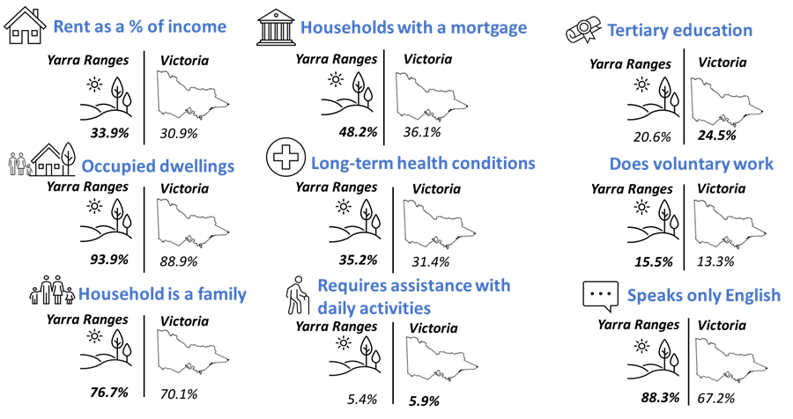

9

1. **Pandemic impact overview**

Pandemic restrictions shattered the local economy in Yarra Ranges and the community on many levels. Council obtained community feedback once restrictions began to build which demonstrated the isolation impacts on residents including teenagers and younger people.

When the five kilometre restrictions were implemented during Melbourne’s COVID-19 lockdowns, many residents had severely limited access to shops and no services or family within 5kms of their home.

Prior to the pandemic, the Yarra Ranges unemployment rate of 3.5 per cent was well below the Australian rate of 5.6 per cent. In October 2020, 8.4 per cent of the Yarra Ranges labour force were receiving JobSeeker or Youth allowance compared with the national rate of 6.9 per cent. 12

In 2020, 43 per cent of Yarra Ranges businesses were on JobKeeper support placing it within the top 20 per cent of local government areas receiving these payments. 13

Many older workers who lost their jobs, did not have sufficient computer literacy skills putting them at greater risk of not finding work longer term.

Research undertaken by Council has identified a number of cohorts that have been disproportionately affected by the pandemic including Indigenous and Torres Strait Islander people, people from Culturally and Linguistically Diverse (CALD) backgrounds, unpaid carers, people living with disability, women/girls, LGBTIQ+ people, people experiencing pre-existing economic disadvantage, people who are socially and/or geographically isolated, children, young people, and single parents.

Particular sectors of the local economy have also been affected by the pandemic. Townships with a high reliance on tourism and hospitality (e.g. Healesville, Warburton, Belgrave, Olinda) reported a disproportionate decline in business as a result of the pandemic.

And further exacerbating the pandemic impacts, businesses reported

telecommunication and internet issues as well as ongoing supply chain issues making it difficult to source products necessary to the running of their business.

Council has been tracking social impacts stemming from the pandemic over the 2021- 22 financial year. Results from the three Pandemic and Storm Impact Surveys indicate social connection, mental health, hardship, employment, and the financial stability of the community have all been adversely affected by the pandemic.

However, a positive trend is emerging with impacts across several key indicators showing improvements over the last 12 months, see the Impact Assessment section for survey details, suggesting that recovery in the community is beginning.

Economic impacts from the pandemic have also been tracked using Spendmapp expenditure data. This shows a clear correlation between the six lockdowns and a corresponding downturn in expenditure.

12 REMPLAN Economic Statistics produced using data sourced from the Australian Bureau of Statistics

10 13 REMPLAN Economic Statistics produced using data sourced from the Australian Bureau of Statistics

However, following the easing of restrictions in November 2021, expenditure in the Yarra Ranges grew by 7% in the first half of 2022 compared with the first half of 2021. This indicates a solid recovery in expenditure over the first half of 2022.

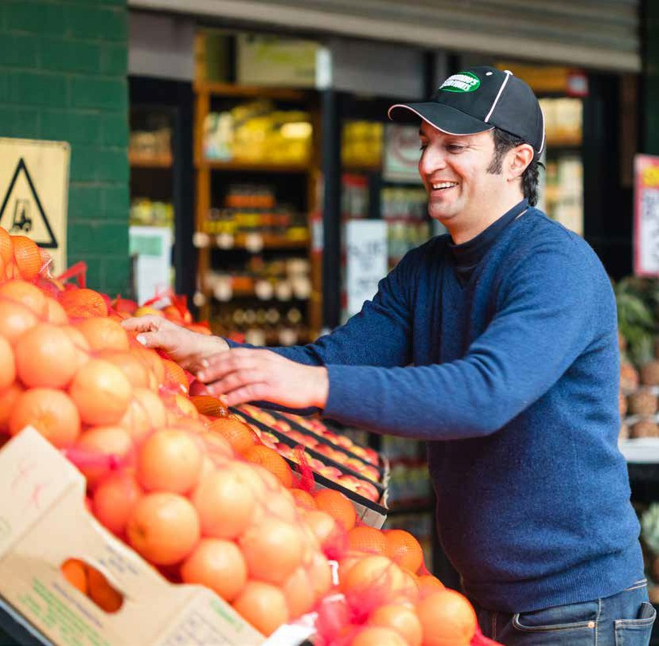

While there is evidence of some recovery from the pandemic, there are still ongoing impacts in significant sections of the community, particularly among those most

marginalised including young people, those with a disability, people experiencing

family violence, and people experiencing homelessness. Details on pandemic impacts to vulnerable cohorts is outlined in the Impact Assessment section of this document.

**The support**

**services available are non-existent within a 5km, or even reasonable distance, to**

**Warburton and other outlying communities.**

**“**

11

1. **June 2021 storm**

On Wednesday, 9 June 2021, just before Melbourne’s fourth pandemic lockdown was lifted, a violent storm hit the Yarra Ranges which resulted in widespread and catastrophic damage to homes, businesses, trees and vegetation, along with significant power, telecommunications, as well as water and gas outages.

### Prior to storm Post storm

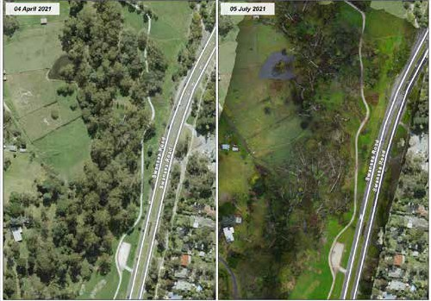

*Photos of Swansea Road in Lilydale before the storm with tree canopy and after the storm with a large loss of tree canopy.*

The strength and direction of this storm caused destruction unlike anything Yarra Ranges had seen before in terms of the sheer scale of loss and damage.

The total loss of communications, flooding, blocked roads, powerlines down, and properties with highly unstable trees added to the complexities of emergency response. When the mains power cut out during the storm, batteries at local mobile towers lasted mere hours before depleting, leaving residents and services completely cut off, unable to call 000 or connect with their workforces. As well as this there was also a risk of spreading COVID-19 to traumatized communities.

The epicentre of the storm was Kalorama in the Dandenong Ranges, with subsequent flooding occurring throughout the Yarra Valley and Upper Valley.

The immediate physical impacts included:

* 79 properties non-habitable and a further 50 being badly damaged
* more than 1,000 homes and business extensively impacted by storm debris
* almost 5,000 properties impacted by flood
* more than 32,000 customers were without power for up to 1 week, while 11,000

12

customers had to wait up to 2 weeks and 3,000 homes without power and internet for more than month

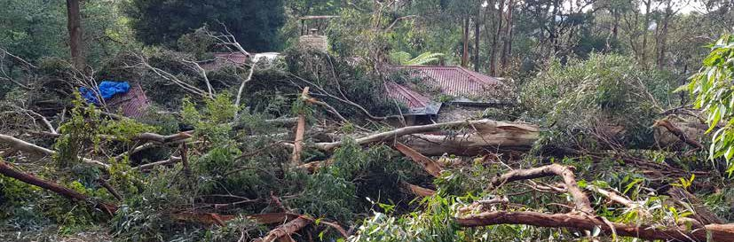

**I was very disconnected without internet for**

**months. It affected my ability to work,**

**community connection and relationships which I fear will never be the same.**

**“**

13

* a conservative estimate of 25,000 fallen trees across the region
* 34 communities lost NBN/internet service and were unable to call 000 for assistance
* 150kms of arterial roads and 300+ council managed roads were damage
* 13 fire access tracks inaccessible
* 2 bridges were impacted
* 3,157 drainage/tree related requests for assistance from the community

Water supplies were also impacted, with some contamination issues and damage to pipes. Some residents were still trying to resolve these issues five months later.

The Dandenong Ranges is one of the highest bushfire risk locations in Victoria. The clean-up of tree debris remains an ongoing concern as each fire season presents and the debris cures.

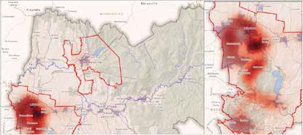

*Map with fire danger areas highlighted in red and most over Lilydale towards Mount Evelyn and the Hills area.*

More difficult however, is the number, scale, and inaccessibility of large logs impacting both private properties and government land. Removing these massive trees is financially unviable for many and continues to increase the risk profile as each summer passes.

The canopy loss incurred across the Dandenong Ranges is significant. Within the Dandenong Ranges National Park at least 300 hectares (approx. 9% of the parks area) experienced windthrow or broad acre uprooted trees. Significant portions of this windthrow area lost 90% of its canopy.

1. **Emergency storm response**

In the immediate days and weeks following the storm event, priority actions by Council, emergency services, relief agencies, community groups and utility companies were:

* clearing tree debris on roads and properties to support access
* restoring power and telecommunications to homes and businesses
* providing relief services and material aid to those in need
* keeping the community informed of how the relief effort was tracking
* maintaining effective liaison with stakeholders across all levels of government
* providing Shower and Power Hubs which supported 15,000 attendees
* supporting residents seeking assistance including welfare checks and those seeking accommodation
* providing building inspections, financial assistance, food relief, flood outreach calls and requests for generators

1. **Transition to recovery**

The Shower and Power relief hubs were consolidated and transferred to a recovery hub status on 16 July 2021 when management of the incident officially transferred from the SES to Council.

* 1. **Initial recovery activities**

In the weeks following the transition from emergency response to recovery, a number of initial recovery activities were undertaken as summarised below:

* + - Community Debrief Sessions were conducted at Community Recovery Hubs located in Olinda, Kalorama, and Mount Evelyn
    - Community Recovery Committees were established – bringing together the community to lead conversations and community driven recovery initiatives. Subsequently these committees were charged with identifying and overseeing programs that support local recovery
    - Community Recovery Hubs continued to support community and businesses with ongoing recovery needs over the weeks that followed
    - Subsequent community engagement was undertaken through community planning sessions, online community meetings as well as mental health and wellbeing sessions run by psychologist Rob Gordon
    - Community Mental Health First Aid Training Program was implemented which provided accredited Mental Health First Aid training to volunteers and staff at Neighbourhood Houses and Emergency Relief Services
    - The Assertive Outreach Project was implemented to support and enhance existing outreach services for people experiencing homelessness and/or adversity in Yarra

Ranges

14

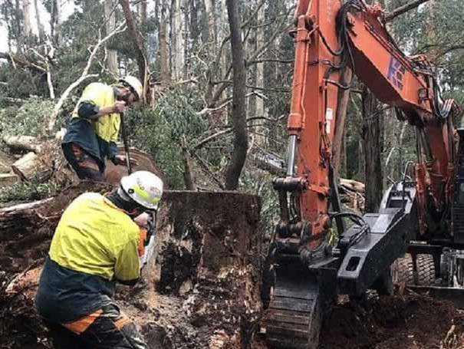

* 1. **Secondary impact assessment**

After the emergency response phase to the June storm was concluded, Council undertook a secondary impact assessment to quantify impacts from the storm in more detail. This included a broad range of areas including personal, residential, economic, environmental, and public infrastructure impacts.

The following is a sample of that information:

* + - 1700 storm impact residents recorded on Council’s case management system
    - 373 Ha of windthrow identified in and around the Dandenong Ranges.
    - -$13M (-8%) drop in economic expenditure from June 2021 vs Jun 2020
    - 26,000 cubic metres of storm debris collected
    - 50 nurseries & berry producers impacted
    - 12,255 hectares of farmland affected
    - 325 Livestock lost 308km of roads impacted
    - 37 parks and reserves impacted

My property was like a parkland prior to the storms and it is now still in ruins. I don’t think it will ever be the same again.

**“**

Power out for 14 days. Destruction all around us. Emotionally devastated. 14 days without power and poor communication. Very cold. Every day was about doing all we could to be safe and keep warm. Purchasing generators, trying to work from home off

a generator. One of the worst experiences of our lives.

15

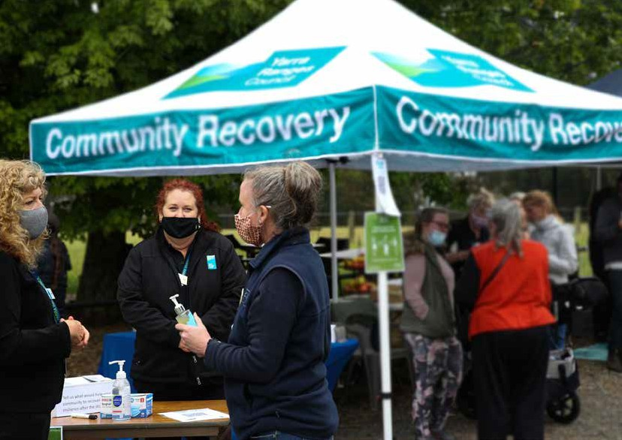

Our immediate concern is how on

**“**

earth is Council going to get all the fallen trees and debris

cleaned up before summer arrives?

There are mountains of tree branches stacked all over the

Ranges.

1. **RECOVERY**

Under Victorian emergency management arrangements, Council is responsible for coordination of recovery at the municipal level. As the level of government closest to community, Council is well placed to connect and work with affected communities.

Yarra Ranges Council is committed to support its community through the recovery process for as long as it takes. The following sections define how that task is

approached.

As part of recovery planning for the pandemic and storm impacts, Yarra Ranges Council will support community recovery activity through:

* Advocacy
* Providing Council services and recognising Council’s essential service provision to prioritise, enable and support community recovery
* Promoting the work of our partners and others
* Enabling and supporting our community partners
* Facilitating connection between community and community services

Yarra Ranges Council will consider the needs of the most affected or impacted sectors of our community throughout the recovery phase of COVID-19.

16

* 1. **Principles of recovery**

Yarra Ranges Council supports and adopts the National Principles for Disaster Recovery, which are underpinned by Council’s own vision. These include the following principles:

* + - Understand the context - Successful recovery is based on an understanding of the community context, with each community having its own history, values, and dynamics
    - Recognise complexity - Successful recovery responds to the complex and dynamic nature of both emergencies and the community
    - Use community-led approaches - Successful recovery is community-centred, responsive and flexible, engaging with community, and supporting them to move forward
    - Coordinate all activities - Successful recovery requires a planned, coordinated, and adaptive approach, between community and partner agencies, based on continuing assessment of impacts and needs
    - Communicate effectively - Successful recovery is built on effective communication between the affected community and other partners
    - Acknowledge and build capacity - Successful recovery recognises, supports, and builds on individual, community, and organisational capacity and resilience
    - Recognising vulnerable groups - Successful recovery recognises emerging

vulnerable groups including young people, the older workforce, newly homeless, and women experiencing family violence

* 1. **Recovery objectives**

The objectives that will guide the recovery response to the impacts of the pandemic and the June storm event are:

* + - To ensure recovery activities reinforce and build community leadership and capacity
    - To ensure community members have access to the support, services, and resources they need to address impacts; prevent the escalation of needs; and long- term negative impacts on health and wellbeing
    - To address the economic impacts, inclusive of those on individuals and households, small and large businesses, industries, primary producers, tourism, and the broader economy
    - To inform the priorities of whole-of-government recovery coordination arrangements so that affected communities receive timely and appropriate information, services, and support as they relate to the built and natural environment, and
    - To manage consequences and mitigate risks to the built and natural environment on public and private land.

Council understands and achieving these objectives will take time and is dependent on the readiness of individuals, the complexities they are managing, the reconnection and resilience in the community and the support available.

17

* 1. **Commitment to community led recovery**

A key tenant under the National Principles for Disaster Recovery is the recognition that successful recovery is achieved through community led approaches that empower the community to move forward.

Council recognises the importance of the following key principles in implementing community-led recovery:

* + - all communities are different, and there is no one-size-fits-all approach to community recovery
    - community groups are best supported through a partnership approach
    - community-led recovery is determined by broad and inclusive engagement
    - building the capacity and capability of the community
  1. **Cultural Recovery**

Cultural recovery has been identified as being an intrinsic need for storm recovery across Yarra Ranges. As such, work is underway to develop an understanding of the impact the storm has had on Aboriginal communities in the Yarra Ranges, and what can be done to improve the response immediately after an event.

The first step is to identify Aboriginal community response and recovery priorities that are not being addressed by other agencies, and to work with relevant Council staff to design appropriate responses. To this end, officers from Yarra Ranges Council held an engagement event in October 2022 with representatives from Aboriginal communities to discuss impacts from the June storm and to identify their priorities.

The key cultural recovery preparedness priorities consist of the following:

* + - Develop culturally safe education resources for Aboriginal families on how to respond to disaster situations
    - Ensure Aboriginal organisations are appropriately resourced to meet Aboriginal community needs during disaster relief and recovery processes including the

availability of infrastructure access, power generation, communications equipment, and social and emotional wellbeing supports

* + - Ensure the cultural safety capacity of mainstream relief and recovery agencies to ensure that the Aboriginal community can safely access services during and post disaster events
    - Ensure relief and recovery agencies adherence to Aboriginal appropriate protocols when engaging with the Aboriginal community during sensitive disaster situations and outcomes

The key cultural recovery priorities consist of the following:

* + - Resource initiatives to enable the Aboriginal community to develop a range of culture-based recovery programs using disaster generated resources such as fallen timber
    - Ensure traditional owners and Aboriginal land managers have immediate access to disaster affected areas to assess damage to Country and significant trees
    - Ensure Aboriginal perspectives on Country and culture are well understood and integrated into relief and recovery processes

18



* + - Develop healing and resilience building programs for landscapes and communities based on Indigenous knowledge systems as part of the recovery process
    - Engage traditional owner expertise to apply Indigenous knowledge systems for healing and rehabilitation of sensitive and/or prioritised areas affected by tree canopy loss
  1. **Regional Community Recovery Committees**

Regional Community Recovery Committees (RCRC) have been established to contribute to progressing the recovery priorities of their community. RCRCs have a crucial say into the long-term recovery from Covid-19, and the June storms that

impacted the Yarra Ranges and members are dedicated to advancing community-led social, economic, and environmental recovery.

Council has committed $800,000 for RCRCs to initiate Community Led Recovery Grant rounds and make recommendations for the allocations of grant funding for community-led recovery projects. Oversight and support for the funding processes will be managed by a partnership between the Council, Local Bendigo Community Banks of the Yarra Ranges, and the Community Enterprise Foundation™(CEF).

Since the establishment of RCRCs in November 2021 there have been a number of benefits delivered, particularly in terms of the collaboration and strengthening the relationships between recovery stakeholders. This is evidenced by:

* + - RCRCs delivering their first round of Community Led Recovery Grants, receiving 69 applications for Community Led projects with $448,000 worth of funding requested. As of October 2022, a total of $264,000 has been approved for the implementation of community led projects

19

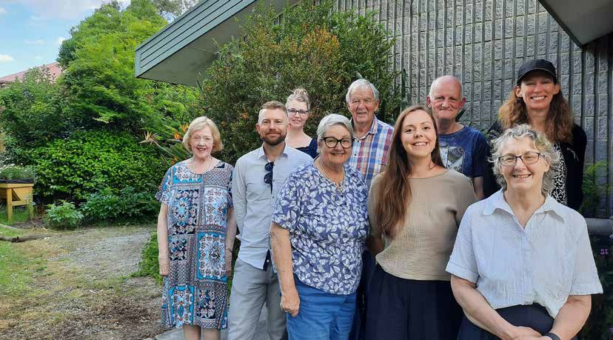

* Community Enterprise Foundation hosted three Grants Information Sessions and liaised extensively with RCRCs and community to ensure all stakeholder were well supported through the Grants process
* RCRCs initiated community surveys which provides additional insight into the key themes and recovery priorities of their region which is essential preparation for the development of regional Community-Led Recovery Plans
* The willingness for RCRC members to actively participate in operations of their committee and to enthusiastically execute their role

Over the last quarter of 2022, RCRCs will undertake a variety of activities including further engagement with the community and delivery of further grants.

* 1. **Recovery priorities by region – Regional Community Recovery Committees**

RCRCs engaged in consultation with the community over the June quarter of 2022. This was done through conducting surveys in each of the RCRC regions to ascertain the issues residents viewed as being important for recovery from the pandemic and June storm.

Map showing the geographical boundaries for each of the four Regional Community Recovery Committees

Based on analysis of collected data, priorities for each region are summarised as follows.

20

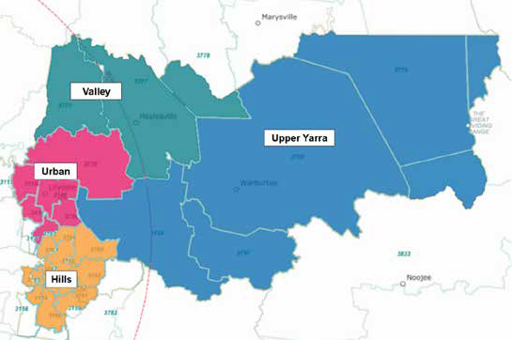

**Hills Region Priorities**

* + - **Community Support Networks** – Many residents reported that support they received from formal or informal community groups, volunteers, or neighbourhood cooperatives have been a great help either through the pandemic or after the storm. It is recommended these community groups and networks be made aware of available funding opportunities and identify what further support is needed to continue operating in the future
    - **Property Clean-up** – Identify residents who still need assistance with clearing storm debris from their property. Refer them to appropriate support services (Habitat for Humanity or Treasuring Our Trees) or reach out to community members who may be willing to volunteer their time to help.
    - **Emergency Planning and Preparedness** – Identify what the community is generally lacking when it comes to emergency planning and preparedness. Spread awareness about the importance of having an emergency plan and refer community members to education and support services.
    - **Build Community Connection** – Organise a series of community led events targeting residents with the aim of building upon existing local connections, creating new networks, and improving the social confidence of residents returning to regular community activities.
    - **Advocate for Improved Infrastructure** – Identify key concerns of residents around power, internet, and phone infrastructure, advocating on their behalf for an appropriate resolution to ongoing issues they may face.

21

**Urban Region Priorities**

* + - **Build Community Connection** – Organise a series of community led events targeting urban residents with the aim of building their community connections and encouraging them to return to regular community activities.
    - **Support for Community Groups** – Engage with community groups (volunteer organisations, youth groups, sports clubs etc.) to identify the present challenges they are facing and advocate within the community for residents to join community organisations and return to their pre-pandemic activities.
    - **Improve Public Spaces** – Identify what urban residents believe community spaces are lacking at present and advocate for improvements that will benefit the community. Aim to inform residents around what public spaces and resources are presently available and encourage community engagement with these facilities.
    - **Mental Health Awareness** – Identify present challenges urban residents face when trying to access mental health support services. Advocate for improved mental health resources and aim to build awareness around key mental health challenges that may be impacting the community.
    - **Engagement with Council** – Ensure residents are aware of the presence of urban RCRCs in the community, their objectives, and the roles they play within Yarra Ranges Council. Educate the community around how residents can effectively engage with the urban RCRCs and Council more broadly.

#### Healesville – Yarra Glen Region Priorities 14

* + - **Build social connection within the community** – Plan and implement activities encouraging residents to socially re-connect with friends, family, and others following the easing of pandemic restrictions.
    - **Build confidence in the community in returning to daily activities** – Hold a series of community events encouraging the community to get together with the aim of building upon existing local connections, creating new networks, and improving the social confidence of residents in returning to regular community activities.
    - **Improve the mental health and wellbeing of the community** – Implement evidence-based activities promoting mental wellbeing that target and appeal to the broader community including activities that specifically appeal to young people.
    - **Assist those who are struggling financially since the pandemic** – This focusses on those who have lost their employment since the pandemic and those on very low incomes.

22 14 Note that priorities for the Healesville – Yarra Glen region are based on data collected through Council’s Pandemic and Storm Impact survey conducted in June 2022. Priorities for the other three RCRC regions are based on data collected by RCRCs

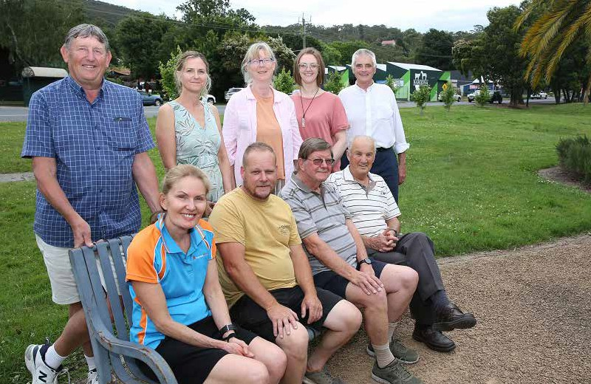

* Encourage residents to develop an emergency plan in response to future

**natural disasters** – This includes referring residents to reputable online resources to help them develop their own emergency plan.

**Upper Yarra Priorities**

* **Build strong community connection** - Organise a series of community led events targeting residents (rather than tourists) with the aim of building strong local connections and increasing confidence among the community in getting back to regular community activities.
* **Identify community spaces** – Identify spaces (outdoor and indoor) within the Upper Yarra region that are suitable and available to hold regular community connection events targeting residents.
* **Housing** – In consultation with the community, and potentially public and private sector housing services, explore options for secure housing that could be made available to those on low incomes and/or experiencing homelessness.
* **Improve the mental health and wellbeing of young people** - Implement evidence-based activities that promote mental wellbeing that target and appeal to young people.

23

* 1. **Common themes and differences among the four regions**

Several themes have emerged from the survey work conducted across the four regions of the Yarra Ranges. And among these, three common themes were identified across all regions consisting of:

* + - **Mental health** – This priority encompasses gaining access to mental health services and providing support to young people as well as the broader community
    - **Community connection** – Building a strong community connection is seen as a priority and will be achieved through a variety of approaches including community events and other activities.
    - **Community groups** – Supporting community groups, be they formal or informal, sporting clubs, youth groups, specialist hobby clubs, or other networks is seen as being very important to recovery across all four regions.

The survey data has also identified key differences in priorities specific to each local community. In the Hills Region, recovery priorities include advocating for more reliable power and internet services as well as having emergency event plans in place. While in the urban region, improving public spaces, which the community views as not being sufficient at present, is seen as having a higher priority.

Priorities for recovery identified in the Upper Yarra Region include the need for secure housing, particularly for those on low incomes or those experiencing

homelessness. And in the Healesville – Yarra Glen Region, recovery priorities include having emergency event plans in place as well as assisting those who are struggling financially since the pandemic.

* 1. **Advisory Committees**

Yarra Ranges Council has seven long-term cohort specific Advisory Committees that consider key aspects of Council’s business through their expert lens. These groups have been consulted in mid to late 2022 on any additional recovery actions that they see as being a priority going forward and to advise of any potential gaps in the plan overall.

Consultation has been undertaken with all seven of Council’s Advisory Committees to ensure that perspectives are canvassed from a diverse range of cohorts, with a particular emphasis on the Indigenous community, young people, and the disability sector.

Advisory Committees consist of:

* + - Disability Advisory Committee
    - Business Leaders Roundtable
    - Rural Advisory Committee
    - Positive Ageing Reference Group
    - Youth Advisory Group
    - Indigenous Advisory Committee
    - Sustainable Environment Advisory Committee

24

* 1. **Recovery governance**

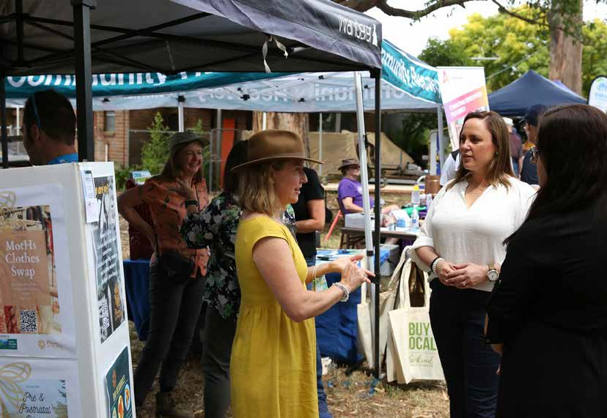

25

To support the recovery objectives and ensure their success, an emphasis on effective recovery coordination between Yarra Ranges Council, the Victorian State Government, responding agencies and the broader municipality is a high priority. With 55 townships and settlements across Yarra Ranges impacted by the pandemic and storm event, effective coordination of recovery will aim to reduce community fatigue and duplication of effort.

The main body monitoring the progress, coordination and impacts for the Storm and Flood event is the Municipal Storm Recovery Committee.

To ensure that all activities are driven by the needs of the community, the Community Recovery Committees, along with township groups and Council’s standard advisory committees, will have input and provide influence up, down, and across the governance structure.

* 1. **Establishment of the Recovery Directorate**

Following the six week emergency phase, the response transitioned to a recovery phase. At this point a decision was taken to establish a dedicated Recovery Directorate within Council. This was done to ensure that recovery actions would be delivered in the quickest, most effective, and targeted way over the ensuing 18 months of recovery. The next phase involves embedding medium and longer term recovery activities into Council’s existing functions. This will take effect from late 2022.

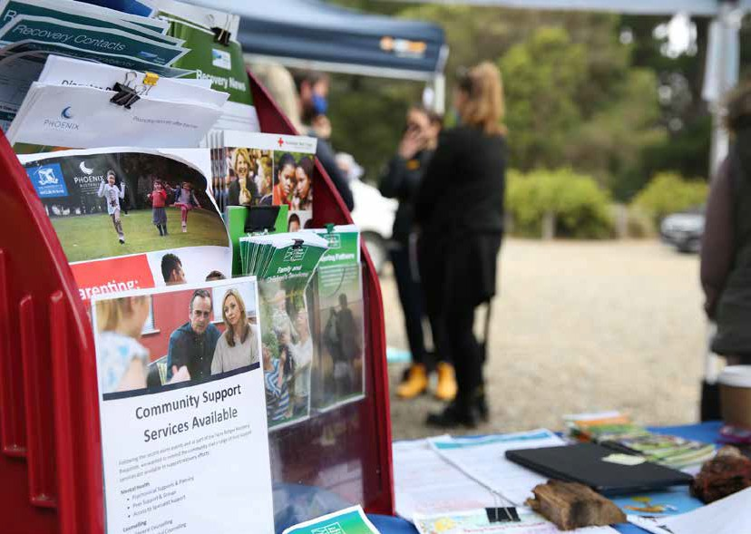

1. **Recovery Activities 2021-22**

In response to many of the serious impacts coming from the pandemic and June storm (mental health, access to mental and physical health services, family violence, and hardship), Council, in partnership with other agencies, has delivered a number of targeted activities.

A complete list of recovery activities that have been delivered to date is provided in Attachment 2 – Progress Against Recovery Activities. The attachment lists activities delivered over 2021 and 2022 with descriptions provided for each activity. Below are examples of activities listed against each recovery stream.

People, Culture and Wellbeing - key recovery activities

* Delivery of ‘Pop-up Recovery Hubs’ with a range of recovery partners and an Outreach Program to enable residents to connect with services
* A range of recovery activities have been delivered e.g. for families with young children, mental health first aid, and the significant ‘Healing In Our Gardens’ recovery program has now been launched
* A grant for community programs enabling townships and community groups to mark 12 months on from the June 2021 storm

26

**Business, Tourism, and the Economy - key recovery activities**

* Yarra Ranges JobLink - the online employment portal that connects jobseekers with employers in the Yarra Ranges.
* Hospitality training through a partnership with educators including CIRE and the Box Hill Institute.
* Buy/Enjoy/Employ Local – a marketing campaign developed to encourage the community to support local business.

**Planning and Rebuilding - key recovery activities**

* The ‘Reimagining your rebuild’ program is a series of workshops that provides expert planning and building guidance to residents whose homes were damaged by the June storm.
* Outreach to all 183 private property owners with storm damaged structures, and monitoring progress of application from these owners, with the team waiting on 51 potential planning applications.

**Environment and Biodiversity - key recovery activities**

* The two kerbside storm branch collections which picked up over 45000 cubic meters of branch debris from across the municipality including the Urban, Valley, and Hills regions.
* The private property clean-up program for community members who are financially or physically unable to clean up the extensive volume of storm related green waste on their properties. This work is supported by Council and is undertaken by not-for-profit organisations ‘Habitat for Humanity’ and ‘Treasuring our Trees’.
* Processing the timber debris collected by Council through the storm clean-up and returning it to the public as a resource; providing logs to community groups, returning over 50 hollow bearing logs to and bushland for habitat, milling logs into

planting stakes and fencing materials, and 18000 cubic meters of mulch going to the community and Council parks, with 2000 cubic meters of firewood to community.

**Public Infrastructure – key recovery activities**

* Works to repair 35 Council facilities, including the extensive works needed at the Monbulk Aquatic Centre, which re –opened in September 2022 and the relocation of the Mount Dandenong Preschool. Both of which caused significant disruption to local communities. Extensive works to restore major and minor Council roads, drainage systems, bridges, and tunnels as well as reinstatement of pavement surfaces.

27

1. **Recovery issues hampering recovery**

A number of issues have been identified that are acting to slow the pace of recovery from both the pandemic and the June storm. There are outlined below.



**Social Recovery Issues**



**Insurance issues –** major increases in insurance premiums, significant decreases in coverage and refusal for insurance for some previous policy holders considered to be in high-risk locations

**CPI -** Cost of living pressures with the CPI rate at 6.1% as at June 2022**

**Mental health -** Ongoing mental health impacts stemming from the pandemic with 15% of the community reporting significant impacts on mental health & 23% reporting trauma/anxiety from the June storm*

**Access to services -** Delays in access to mental health services (reported by 40% of YRC community) and physical health services (reported by 24% of YRC community)*

**Hardship -** Hardship arising from the pandemic reported by 26% of YRC community*

 **Daily activities -** Not being confident in returning to daily community activities reported by 22% of YRC community*

**Temporary housing -** Insurance funded temporary rentals (residents with storm damaged homes) which expired in Jun 2022 under many insurance policies.

 **Housing costs -** Housing and rental affordability getting worse due to interest rate rises being passed onto home loans and renters

**Power outages -** frequent power outages reported by 33% of YRC community*

 **Internet outages -** frequent internet outages reported by 35% of YRC community*

*\*YRC Pandemic & Storm Survey June 2022*

*\*\*Consumer Price Index Australia June 2022, ABS*

**Planning and Rebuilding**

 Rebuilding/repairs delayed by ongoing negotiations with insurance companies  Decision-making for residents around whether to demolish or not

 Homeowners rebuild delayed until demolition has occurred

 Shortage of builders, trades people and building materials further delaying rebuilding  Reported delays in being able to engage designers and architects

Large tree debris remains on some resident properties hampering private property clean-up

28

**Economic Recovery Issues**

 Tight labour market - Extreme labour market shortages with a record low unemployment rate of 3.1 % for Victoria as at August 2022. This is driven largely by 2 years of very low immigration and a reduction in overseas students

 Workforce absenteeism - Employee absenteeism due to contracting Covid

 Operating costs - Business operating costs increasing due inflation and upward pressure

on wages

 Supply chain issues – delays in supply chains are impacting sales of goods and services

 Insurance - Difficulty getting insurance, particularly businesses located in flood or bushfire

prone areas

 Private finances – The financial situation reported as being worse now than before the

pandemic by 30% of the YRC community*

*\*YRC Pandemic & Storm Survey June 2022*

* 1. **Climate change impacts by 2030**

##### Bushfire Risk by 2030 - Yarra Ranges LGA level

According to analysis by the Climate Council, by 2030 approximately 30% of properties located within the Yarra Ranges local government area will have a medium to high risk of bushfire. The implication of this assessment is that these properties may become uninsurable by 2030.

In comparison, the percentage of properties across Victoria estimated as medium to high risk by 2030 is 2.6%. This places the Yarra Ranges as being one the most bushfire risk localities in Victoria.

In addition, the Climate Council analysis suggests that 2.9% of Yarra Ranges properties are at a high risk of flooding by 2030. Surprisingly, the assessment by the Climate Council is that no properties in the Yarra Ranges are at high risk of extreme wind by 2030 – which is unexpected given the serious damage caused by extreme winds during the June 2021 storm event.

29

# Impact assessment at the end of 2021-22

This section outlines key impacts from the pandemic and storm at the end of the 2021- 22 financial year. It draws on data collected through three consecutive community surveys, community engagement undertaken by Regional Community Recovery Committees, outreach activity undertaken in the June quarter of 2022, and economic expenditure data collected through the Spendmapp application.

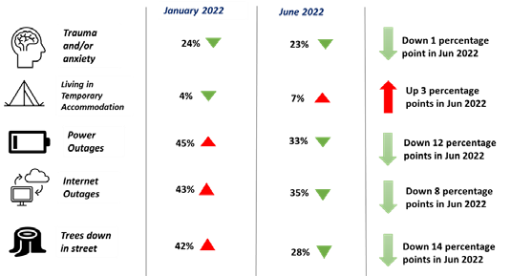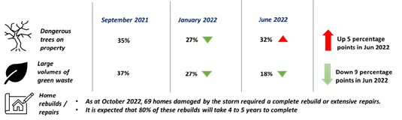

## Schools survey results

A total of 113 school staff (mainly teachers) from both primary and secondary levels took part in a survey to help Council better understand how the pandemic and storm impacted school aged children. The survey was conducted in September 2022.

Notably, the vast majority of responses were obtained from the urban region (84% of all responses). Therefore these results are heavily skewed towards those living in the urban areas of the Yarra Ranges.

Some of the key findings from the survey are as follows:

* + - 34% of school staff indicated that ‘most’ of their students experienced impacts on their mental wellbeing stemming from the pandemic

30

* + - 77% believe that students and families experiencing hardship are encountering delays trying to access mental health support
    - 27% of respondents indicated that staff believe the pandemic has a had a ‘major’ impact on students’ social lives and participation in after school activities
    - 32% of respondents believing that this will lead to ‘most’ students being at a disadvantage academically in the longer-term
    - 57% of school staff in the Yarra Ranges believe that since pandemic restrictions have eased, the negative impacts felt by students are now improving

These survey results support what was already known anecdotally, which is that the pandemic has had a significant impact on young people. Council has been developing a plan to address some of the worst impacts of the pandemic that specifically affect young people.

Yarra Ranges Council is working closely with the Department of Families, Fairness & Housing to support families, children, and young people directly and indirectly as well as advocating for ongoing support.

## Expenditure assessment for the Yarra Ranges

There were several downturns in expenditure across Yarra Ranges immediately following each pandemic lockdown. This was further exacerbated by the June 2021 storm (see chart below). However, analysis of expenditure data over the first half of 2022 showed local economies to be remarkably resilient.

Expenditure with businesses located within Yarra Ranges experienced solid growth in the first half of 2022 despite an increased presence of COVID-19 in the community. Key points are:

* + - Expenditure in the first half of 2022 increased by $79 million (up 7%) compared with the first half of 2021
    - Expenditure in the first half of 2022 increased by $265 million (up 28%) compared with the first half of 2020

These figures illustrate economic recovery in the Yarra Ranges, when measured in terms of total expenditure with businesses located within the Yarra Ranges, has shown solid growth over the first half of 2022. However going forward, the broader economy will come under increasing pressure due to factors including high rates of inflation, high interest rates, high energy costs and the possibility of recession.

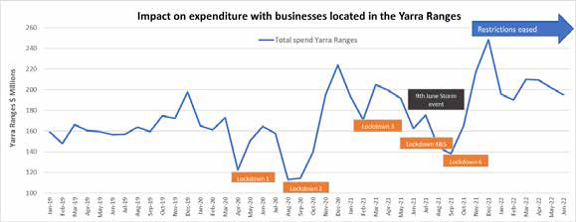

31

# Recovery over the medium to long term

## Experience from the 2009 bushfires

The 2021 report produced by Melbourne University titled ’10 Years Beyond Bushfires Report’ examines the impacts and recovery of the community from the 2009 Black Saturday bushfires in Victoria. It looks at three timeframes consisting of the short term (less than 3 years), medium term (up to 5 years) and the long term (up to 10 years).

Results and recommendations contained in that report are based on research undertaken with more than 1,000 community members who were affected by the 2009 bushfires. Data was collected through community meetings, surveys conducted at 3, 5, and 10-years after the fires, and in-depth interviews undertaken at 3-4 years after the fires.

#### Long term recovery

The report makes it clear that while people affected directly by the Black Saturday bushfires have shown a remarkable capacity to adapt and recover over the ten years following the fires, there remains a proportion of the community who are still recovering over the medium to longer term.

The two main themes of ongoing impact for these people were: 15

* + - mental health issues or severe distress at both 5 and 10 years after the event
    - financial stress was reported by 24 per cent of respondents at 5 years following the bushfires while 17 per cent reported financial stress at the 10 year mark

As such, the primary recommendation is Council establishes a 5-year framework for recovery in areas known to have longer recovery timeframes, and in doing so, support both recovery and community resilience building.

## Recovery Timeline – the next five years

In line with key recommendation coming from the ’10 Years Beyond Bushfires Report’ that a five- year framework for recovery from major disasters be established, this Municipal Recovery Plan sets out support and actions to enable recovery from the pandemic and storm over the medium to longer term, as indicated in the recovery

timeline below.

While support will be required over the medium to longer term, longer-term recovery activities will target a relatively smaller cohort consisting of those most impacted

by the June storm. As such, Yarra Ranges Council’s Recovery Directorate is being progressively absorbed back into the organisation to raise organisational capacity in responding to impacted communities as part of our sustained business model.

In conclusion, while understanding recovery activities will focus on a smaller cohort in the medium to longer term, Council is well placed in partnership with the State and Federal Government to support the longer-term need of impacted communities in:

32 15 Source: 10 Years Beyond Bushfires Report – Melbourne University March 2021

* Rebuild and repair support
* Cross-government collaboration on temporary accommodation options for those rebuilding / repairing
* Ongoing support for residents – with a focus on trauma and private property clean-up

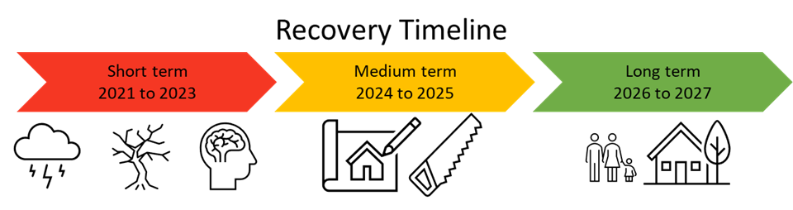

This proposal is supported by current evidence of the pace of our community’s recovery including:

* There are 51 potential planning applications for rebuild or repairs. It is expected that 80% of rebuilds will be completed within the next four to five years. Currently only one planning permit has been applied for and approved for a total rebuild.
* As of August 2022, there are 55 households that remain displaced from their homes awaiting rebuild or repairs. Of these households, the majority are renting or are reliant on family or friends for accommodation, while the situation for some households is not known. For many of these residents, their insurance no longer covers the cost of their rental fees and there is a known market shortage for rental properties across Yarra

Ranges

* As at June 2022, 16 (or 23%) of respondents to Council’s storm impact survey reporting ongoing trauma from the storm. In addition, 275 residents were being supported by case managers as at July 2022.
* More broadly, the 2021 Census identified that the Yarra Ranges municipality ranked seventh highest for residents with mental health conditions within metro Melbourne.

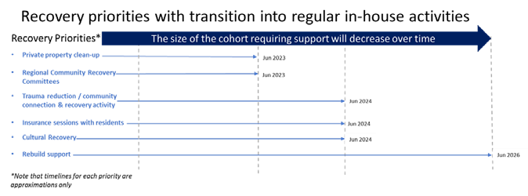

33

## Advocacy by Yarra Ranges Council

An increasingly important role to be played by Yarra Ranges Council is to advocate for the ongoing recovery needs of the community. This will include advocating with

government agencies for ongoing funding in order to support recovery efforts over the medium to longer term.

The Recovery Action Plan located at the back of this document outlines a number of advocacy actions. This includes:

* + - Advocating with State and Federal Government to provide recovery support for the total time that will be required
    - Undertaking advocacy on behalf of residents to address insurance as well as repairing and rebuilding issues
    - Advocating for ongoing funding of the Lilydale Youth Hub
    - Continuing to advocate for improved essential services, particularly the need for more reliable telecommunications and power supply
    - Supporting other agencies as they advocate for resources to support environmental and biodiversity recovery with State and Federal Governments.

## Funding Recovery

Delivering the full outcomes outlined in the Municipal Recovery Action Plan is estimated to cost $26 million. As at the end of September 2022, Yarra Ranges Council has expended $18 million on the recovery effort.

To date, there have been several announcements of support in addition to funding, including advances, received under Category A and B of the Disaster

Recovery Funding Arrangements (DRFA) that is supported by the Federal and State Governments in partnership.

$15.2 million has been received across the following areas, significantly easing the pressure on cashflow, and enabling the significant activity that has been summarised above, including:

* + - $3.8 million for staffing the Recovery Directorate for 2021-22 – received
    - $8.2 million approved DRFA claims and advances – received
    - $320k from Department of Environment, Land, Water and Planning for the Storm Rebuilding Support Service Scheme – received
    - $2.0 million Kerbside Storm Branch Collection – received
    - $161k under the Targeted Recovery Funding Initiative – received
    - $657k from ERV for Property Clean-up – received
    - $2.0 million for staffing the Recovery Directorate for 2022-23 – not yet received

In addition, the first payment of $2.4 million under the Preparing Australian Communities initiative was received in June.

While the grants and DRFA support is very welcome and does make a difference, Council is still no clearer on the overall level of funding support that will be made available by State and Commonwealth Governments.

34

## Strategic Links & Risk Mitigation

Council is required under Emergency Management legislation to provide a supporting role to the lead agency in terms of emergency response and coordinate relief and recovery at the local level.

Council’s recovery response is consistent with the current Yarra Ranges Council Plan, the Draft Council Plan 2021-25, the Health and Wellbeing Plan, and the Long-Term

Financial Plan.

## Recovery risk mitigation

**Risk Description Mitigation**

Bushfire

Telecommunications

Community Health & Wellbeing

Frequency and intensity of events is building

Unreliable internet and mobile connectivity, particularly following emergency events such as bushfire and severe storms.

Limited access by the community to critical services such as mental health may inhibit recovery by some residents, particularly those that are most vulnerable.

Fuel management Community Education & Preparedness

Advocacy by YRC with State Government, NBN.Co and mobile carriers seeking to resolve ongoing issues and improve reliability, particularly during emergency events.

Working with service providers to monitor demand for services and to ensure access is prioritised for vulnerable community members.

Increasing Frequency of Events and Support Levels to Local Government.

Cost shifting and being in a Consistent funding rate capped environment limits arrangements Building

Local Government’s ability to resilience to limit impacts

respond comprehensively

where possible

Cumulative impacts of multiple events

Multiplicity puts pressure onto everything. An example would be drains that are not designed for the scale of a severe storm event.

Continued advocacy

Ageing Infrastructure

Utilities infrastructure including power, gas, and water is ageing and becoming less reliable, particularly during emergency events such as bushfire and severe storms.

Continued advocacy on behalf of the community by Yarra Ranges Council with State Government and utilities companies.

35

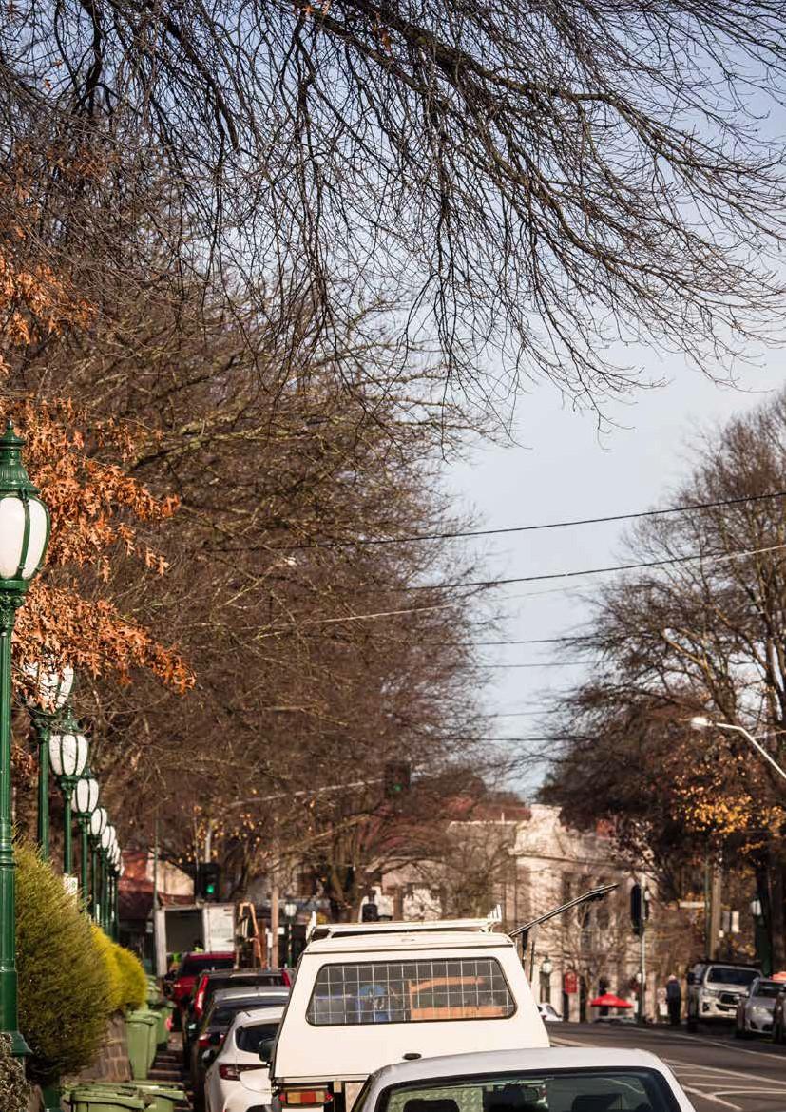

36

# RECOVERY ACTION PLAN

Council’s recovery journey requires us to start integrating significant events into business as usual, just as the community needs to adapt for higher preparedness to manage the changing reality and climate. The new normal may mean that the community has greater levels of awareness when events are forecast to occur and have firm action plans to respond accordingly.

Council has taken a project management approach to its’ delivery of recovery actions, with clear project scopes informed by extensive data collection on event impact, assessment of risks and with actions and timeframes developed to guide timely and effective delivery of services to assist the community.

We will continue to work in partnership with the State Government, particularly Emergency Recovery Victoria and local community services organisations to identify issues of concern and to deliver a coordinated, efficient, and effective recovery from both the pandemic and the storm event.

The development of these actions has been informed by:

* Initial and secondary storm impact assessments
* Pandemic and storm impact surveys
* Evidence from evaluations of previous recovery responses
* Feedback and planning undertaken with relevant council officers
* Feedback/information gathered through community meetings and the Regional Recovery Committees
* ERV Community Recovery Framework
* Council’s COVID-19 Pandemic Recovery Framework

While this recovery plan has been developed to address the 9 June 2021 weather event, it is extremely relevant this emergency occurred during the global COVID-19 pandemic. Many of the social impacts of the storm event have compounded the

impact of the pandemic. This plan incorporates a number of actions that were initially developed in response to the pandemic but will be significant in responding to the impact of the storm or in preparing for future emergency events as well.

37

**38 14.1 Advocacy Action Plan** 39

This plan has been developed to respond to the following objective:

To inform various government agencies of ongoing recovery themes, challenges, and needs in the community and to advocate for increased funding and support to assist with recovery efforts.

Note that advocacy work is unfunded and is being undertaken as part of Council’s BAU activities.

|  |  |  |  |  |  |
| --- | --- | --- | --- | --- | --- |
| **Theme/Issue** | **Risk / Challenge** | **Action** | **Responsibility** | **Time-frame** | **Funding Sources** |
| Services and support | Residents have been impacted by the pandemic, June 2021 Storm, and further significant weather events. Significant social, psychological, and economic impact has resulted. Evaluation of previous recovery events indicates that a 5-year recovery timeframe be planned for. | 1. Advocate to State and Federal Government to pilot a model with Council that enables and resources recovery for the full expected recovery duration. | YRC | Quarter 1 2022/2023 to Quarter 4 2025/2026 | Advocacy work is unfunded and undertaken by Yarra Ranges Council as part of BAU activities |
| Services and support | Residents have been impacted by the pandemic, June 2021 Storm, and further significant weather events. Significant social, psychological, and economic impact has resulted. Evaluation of previous recovery events indicates that a 5-year recovery timeframe be planned for. | 2. Advocate to State Government for relevant services to be adequately and consistently resourced to address the Financial, Legal, and Psychosocial impact  on residents of the June 2021 Storm. | YRC | Quarter 1 2022/2023 to Quarter 4 2023/2024 (anticipated) | Advocacy work is unfunded and undertaken by Yarra Ranges Council as part of BAU activities |
| Services and support | Residents have been impacted by the pandemic, June 2021 Storm, and further significant weather events. Significant social, psychological, and economic impact has resulted. Evaluation of previous recovery events indicates that a 5-year recovery timeframe be planned for. | 3. Raise awareness of and undertake advocacy relating to the insurance issues being experienced by residents, businesses, and community organisations. | YRC | Quarter 1 2022/2023, ongoing | Advocacy work is unfunded and undertaken by Yarra Ranges Council as part of BAU activities |
| Services and support | Residents with properties requiring significant repair or rebuild are likely to face financial, logistical, administrative and psychological challenges over an extended period of time. Some properties may not be restored for a further 5 years. | 4. Advocate to the State Government for financial supports to be made available for residents facing significant repairs/rebuilds (as provided in response to other recent disasters). | YRC | Quarter 1 2022/2023 to Quarter 4 2025/2026  (expected minimum) | Advocacy work is unfunded and undertaken by Yarra Ranges Council as part of BAU activities |
| Services and support | Young people have been disproportionately impacted by the pandemic and there are service gaps for Mental Health services across the Yarra Ranges. | 5. Advocate to the State Government for resources to implement a youth focussed recovery plan. | YRC | Quarter 1 to Quarter 2 2022/2023 | Advocacy work is unfunded and undertaken by Yarra Ranges Council as part of BAU activities |
| Inform the priorities of whole-of-government recovery coordination arrangements | Negative impact on economic and community  wellbeing. | 6. Continue to update and work with key areas and Ministers of the State and Commonwealth Government regarding solutions for the local challenges to business. | YRC | Quarter 2 2021/2022, ongoing | Advocacy work is unfunded and undertaken by Yarra Ranges Council as part of BAU activities |
| Manage and mitigate risks to the community | The Yarra Ranges remains at risk from disruption to essential services, particularly telecommunications and power. | 7. Advocate for improved essential services, notably improved telecommunications, and power infrastructure. | YRC | Ongoing | Advocacy work is unfunded and undertaken by Yarra Ranges Council as part of BAU activities |
| Inform the priorities of whole-of-government recovery coordination arrangements | Limited support for assets that are damaged by  compounding events. | 8. Advocate for State recognition that assets such as drainage systems, that experience compounding events that erode and stress these assets. | YRC | Quarter 2 2021/2022, ongoing | Advocacy work is unfunded and undertaken by Yarra Ranges Council as part of BAU activities |
| Services and support | Residents with properties requiring significant repair or rebuild are likely to face financial, logistical, administrative, and psychological challenges over an extended period of time. Some properties may not be restored for a further 5 years. | 9. Advocate to the State Government to continue the Rebuilding Support Service past June 2023 and for support in improving the systems and supplies needed by residents as they face the skills, materials, and other construction barriers to their rebuilding needs. | YRC | Quarter 1 2022/2023 to Quarter 4 2025/2026  (expected minimum) | Advocacy work is unfunded and undertaken by Yarra Ranges Council as part of BAU activities |
| Manage and mitigate risks to the natural environment | Ensuring there are resources to support environmental recovery from the loss of biodiversity and habitat | 10. Advocate to the State and Federal Governments for resources to enable support for effective environmental and biodiversity recovery. Support to include; biodiversity restoration, habitat and fauna monitoring, targeted weed and pest animal monitoring and control. | YRC | Quarter 1 to Quarter 4 2024/2025 | Advocacy work is unfunded and undertaken by Yarra Ranges Council as part of BAU activities |

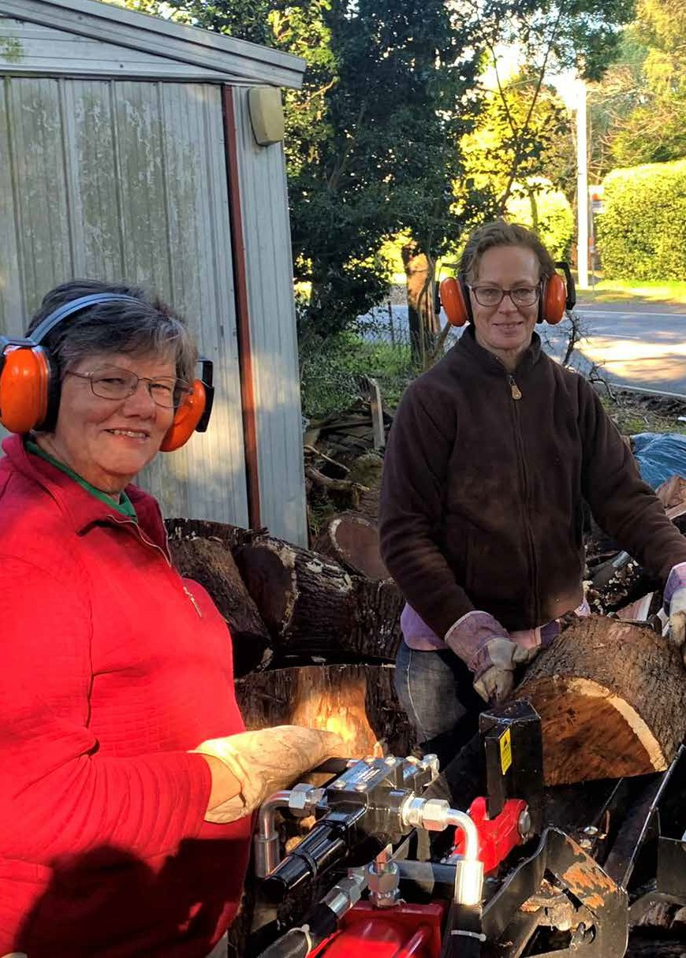

**40**

## People, Culture and Wellbeing Action Plan

This plan has been developed to respond to the following objective:

* + - To ensure people have access to the support, services, and resources they need to address the impacts of the emergency; prevent the escalation of needs; and long-term negative impacts on health and wellbeing.

##### People, Culture & Wellbeing Committee and Sub-committee representatives:

* + - Anglicare
    - Eastern Community Legal Centre
    - EACH
    - Red Cross
    - Emergency Recovery Victoria
    - Windermere
    - Inspiro
    - Department of Families, Fairness & Housing
    - Victorian Council of Churches
    - Department of Education & Training

##### Confirmed and potential implementation partners:

* + - Youth Service Providers/Youth Support Organisations
    - Oonah
    - Habitat for Humanity
    - Treasuring Our Trees
    - Insurance Council for Australia
    - Community Enterprise Foundation
    - Eastern Volunteers
    - Migrant Information Centre
    - Eastern Domestic Violence Service
    - Boorndawan Willam Aboriginal Healing Service
    - Neighbourhood Houses and all community organisations across the Yarra Ranges.

**41**

|  |  |  |  |  |  |
| --- | --- | --- | --- | --- | --- |
| **Theme/Issue** | **Risk / Challenge** | **Action** | **Responsibility** | **Time-frame** | **Funding Sources** |
| Timely and appropriate information | A number of residents will require support from a range of agencies to address their needs. Services will be most effective when integrated. Impacted residents may not be aware that services are available. | 11. Publicize information about available recovery support across impacted communities and provide events for residents to connect with services. | YRC | Quarter 1 2022/2023 to Quarter 4 2023/2024 | Yarra Ranges Council Council Support Fund (ERV)  Recovery Support Program  (DFFH) |
| Manage environmental risks on private land | Some residents lack the means and/or were unable to access support to remove tree debris from their residences | 12. Deliver the Community Clean Up Program assisting residents with  private property clean-up and support the repurposing of reclaimed timber in community projects. | YRC and community partners | Quarter 1 to Quarter 4 2022/2023 and potentially longer | Council Support Fund (ERV) Kerbside Collection (DELWP)  Private Property Clean-up Grant (ERV) |
| Services and support | Community members will recover at their own pace, and at different times. Evidence indicates that there will be an increase in unhealthy lifestyle behaviour such as alcohol consumption. The evidence base indicates the importance of:   * A range of appropriate acknowledgements of significant event anniversaries * Fun-family activities * Community- based low intensity interventions * Building the capacity of existing community   organisations  The evidence base indicates the value of debriefing and story-telling opportunities. | 13. Deliver the Healing In Our Gardens Program to restore resident gardens and promote community connection. | YRC and community partners | Quarter 1 to Quarter 4 2022/2023 and longer depending on identified benefit | Yarra Ranges Council  Community Led Recovery Grant - Anticipated (ERV) |
| Services and support | Research indicates that young people have been significantly impacted by the pandemic and that this will increase. This impact has been compounded in the Storm impacted Area. | 14. Develop and implement a youth focussed recovery plan, seeking additional resources from State Government as required. | YRC | Quarter 2 2022/23 to Quarter 4 2024/2025 | Unfunded currently |
| Services and support | A number of residents will require support from a range of agencies to address their needs. Services will be most effective when integrated. Impacted residents may not be aware that services are available. | 15. Provide a range of recovery support services (financial, legal, psychosocial) and transition any residents requiring further support to ongoing services as dedicated services cease. | Anglicare, EACH, Eastern Community Legal Centre, Inspiro, Windermere | Quarter 1 2022/2023 to Quarter 2 2023/2024  but longer may be required for some services | Recovery Support Program  (DFFH) |
| Services and support | A number of residents will face extended rebuilding times. Council will seek to build relations with all residents in this situation and provide information and access to other support. | 16. Provide an information and supported referral service for residents experiencing ongoing storm impacts. | YRC | Quarter 1 2022/2023 to Quarter 4 2023/2024  but longer may be required | Council Support Fund (ERV) |
| Services and support | Some residents may require extensive support to resolve insurance issues. | 17. Provide information sessions and advocacy support for residents requiring support with insurance matters. | YRC, IAC, ECLC | Quarter 1 to Quarter 4 2022/23 | Council Support Fund (ERV) |
| Services and support | A number of residents will require support from a range of agencies to address their needs. Services will be most effective when integrated. Impacted residents may not be aware that services are available. | 18. Facilitate a Community of Practice for agencies supporting storm impacted residents | DFFH (lead), Anglicare, Inspiro, EACH, YRC, Windermere | Quarter 1 2022/23 to Quarter 4 2023/2024 | Previously facilitated by DFFH |
| Enable Community Led Recovery | Community/individual recovery is most effective when community led. A range of opportunities need to be provided for community to participate and influence recovery. There is a strong desire from community to be better prepared for a future emergency which will assist their recovery. | 19. Implement four Regional Community Recovery Committees (RCRCs) and support each to fund recovery activities as they determine. | YRC in partnership with Community Enterprise Foundation | Quarter 1 2022/2023 to Quarter 4 2022/2023 with project delivery up until Quarter 4 2023/2024 | Yarra Ranges Council Council Support Fund  Community Led Recovery Grant - Anticipated (ERV) |

42 43

|  |  |  |  |  |  |
| --- | --- | --- | --- | --- | --- |
| **Theme/Issue** | **Risk / Challenge** | **Action** | **Responsibility** | **Time-frame** | **Funding Sources** |
| Services and support | Community members will recover at their own pace, and at different times. Evidence indicates that there will be an increase in unhealthy lifestyle behaviour such as alcohol  consumption. The evidence base indicates the  importance of:   * A range of appropriate acknowledgements of significant event anniversaries * Fun-family activities * Community- based low intensity interventions * Building the capacity of existing community   organisations  The evidence base indicates the value of debriefing and story-telling opportunities | 20. Work with community groups and other relevant stakeholders to develop and deliver recovery programs and activities that promote community connection and wellbeing across the Storm Impacted area. | YRC and community partners | Quarter 1 2022/23 to Quarter 4 2023/2024 | Yarra Ranges Council Council Support Fund (ERV)  DFFH Targeted Recovery Fund |
| Services and support | Community members will recover at their own pace, and at different times. Evidence indicates that there will be an increase in unhealthy lifestyle behaviour such as alcohol  consumption. The evidence base indicates the  importance of:   * A range of appropriate acknowledgements of significant event anniversaries * Fun-family activities * Community- based low intensity interventions * Building the capacity of existing community   organisations  The evidence base indicates the value of debriefing and story-telling opportunities. | 21. Support community to provide events they consider appropriate at the 24-month mark through a further small grant application round. | YRC | Quarter 4 2022/2023 to Quarter 4 2025/26 | Yarra Ranges Council |
| Services and support | The severe weather event and pandemic have had a significant impact on the mental wellbeing of residents | 22. Implement Mental Wellbeing Project to strengthen community mental wellbeing and resilience. | YRC | Quarter 1 2022/23 to Quarter 4 2024/25 | Yarra Ranges Council |
| Enable Community Led Recovery | It is recognised that the exploration of Indigenous ways of knowing will enable Council to respond more effectively in future emergencies. | 23. Develop a Cultural Recovery Program informed by consultation with relevant Aboriginal Traditional Owner and Community stakeholders. | YRC and Aboriginal Community Controlled Organisations, Traditional Owner Groups, Indigenous Advisory Committee and Indigenous Advisory Committee | Quarter 1 2022/23 to Quarter 4 2023/2024 | Yarra Ranges Council Council Support Fund  Community Led Recovery Grant - Anticipated (ERV |
| Services and support | The most vulnerable and marginalised residents will require support from emergency relief networks and targeted recovery support engagement. | 24. Strengthen provision of emergency relief through implementing the recommendations from the review of Yarra Ranges Emergency Relief Network. | YRC and YERN | Quarter 1 to Quarter 4 2022/2023 | Yarra Ranges Council  Preparing Australian Communities  Fund |
| Manage and mitigate risks to the community | Evidence indicates that there will be an increase in aggressive behaviour and in family violence in the community. | 25. Identify opportunities to prevent the escalation of male violence against women in the most impacted areas. | YRC, Women’s Health East &  Partners | Quarter 2 to Quarter 4 2022/2023 | Yarra Ranges Council |

44 45

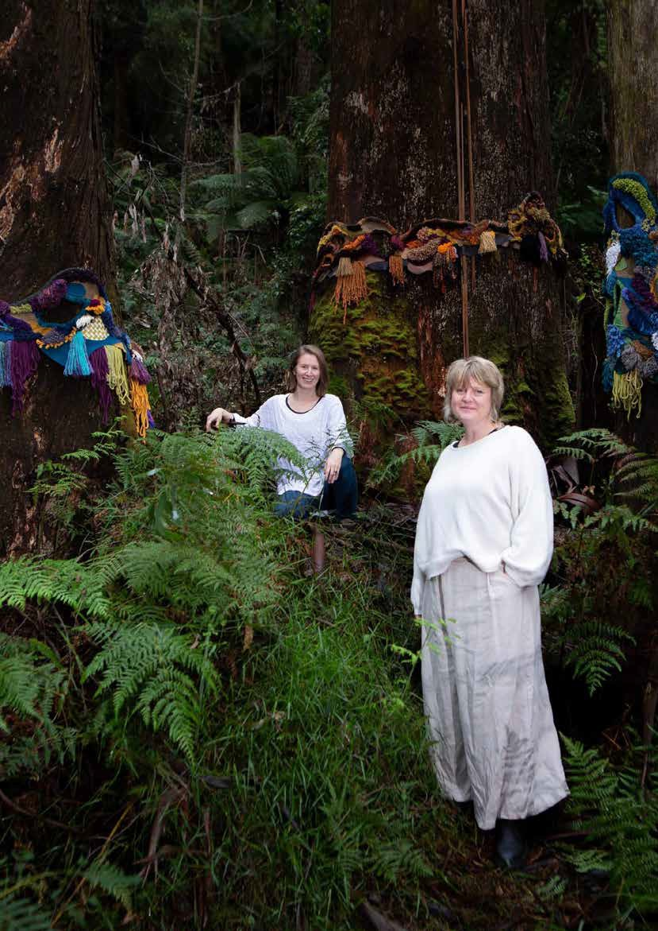

46

## Business, Tourism and Economy Action Plan

This plan has been developed to respond to the following objective:

* + - To address the economic impact of an emergency, including impacts on individuals and households, small and large businesses, industries, primary producers, tourism, and the broader economy.

Business, Tourism and Economy Committee and Sub-committee representatives:

* + - Yarra Range Government Agencies
    - ERV
    - DJPR
    - Small Business, Agriculture Victoria, and Metropolitan Partnerships
    - Yarra Ranges Tourism
    - Box Hill Institute
    - CIRE

Confirmed and potential implementation partners:

* + - Eastern Regional Libraries
    - OELLEN
    - Yarra Ranges Business, Industry and Traders Groups
    - Neighbourhood Houses
    - Yarra Ranges Tech School

47

|  |  |  |  |  |  |
| --- | --- | --- | --- | --- | --- |
| **Theme/Issue** | **Risk / Challenge** | **Action** | **Responsibility** | **Time-frame** | **Funding Sources** |
| Inform the priorities of whole-of-government recovery coordination arrangements | Negative impact on economic and community  wellbeing | 26. Implement a regional program that will  (i) address workforce shortages, (ii) reduce barriers for job-seekers, and (iii) increase incentives for employers. | YRC  Coordinator, ROC Worker, Coms | Quarter 1 2022/2023 -Quarter 4 2023/2024 | Council Support Fund (ERV) |
| Inform the priorities of whole-of-government recovery coordination arrangements | Negative impact on economic and community  wellbeing | 27. Deliver a small grants program for Business & Traders to activate economic recovery. | YRC, Trader, Coordinator | Quarter 1-Quarter 4 2022/2023 | Yarra Ranges Council |
| Services and support | Negative impact on economic and community  wellbeing | 28. Produce regular marketing message information sheets for distribution to all businesses to use in their promoting the region. | YRC Eco Recovery Team | Quarter 1-Quarter 4 2022/2023 | Council Support Fund (ERV) |
| Services and support | Limited community awareness and accessibility of available services and programs | 29. Collate business support initiatives from various services, banks, Government  Agencies and ensure effective dissemination  to businesses and their employees | YRC Eco Recovery Team | Quarter 1-Quarter 4 2022/2023 | Council Support Fund (ERV) |
| Services and support | Businesses wish to develop their resilience to future events in addition to recovering economically | 30. Facilitate a series of forums or workshops via partnerships relating to economic  recovery, resilience, employment and disaster management open to local businesses and industry groups. | YRC Eco Recovery Team | Quarter 1-Quarter 4 2022/2023 | Council Support Fund (ERV) |
| Timely and appropriate information | Inaccurate information on the extent of  economic impacts | 31. Undertake business engagement to develop evidence-based arguments to state and commonwealth government for adequate business assistance. | YRC Eco Recovery Team | Quarter 1-Quarter 4 2022/2023 | Council Support Fund (ERV) |
| Timely and appropriate information | Inaccurate information on the extent of  economic impacts | 32. Use the local evidence base to better inform decision making, planning and advocacy. | YRC Eco Recovery Team | Quarter 1-Quarter 2 2022/2023 | Council Support Fund (ERV) |

48 49

## Public Infrastructure Action Plan

This plan has been developed to respond to the following two objectives:

* + - To inform the priorities of whole-of-government recovery coordination arrangements so that affected communities receive timely and appropriate information, services, and support as they relate to the built and natural environment.
    - To manage consequences and mitigate risks to the built and natural environment on public and private land

Public infrastructure working group confirmed/proposed members:

* + - Yarra Ranges Council (YRC)

|  |  |  |  |  |  |
| --- | --- | --- | --- | --- | --- |
| **Theme/Issue** | **Risk / Challenge** | **Action** | **Responsibility** | **Time-frame** | **Funding Sources** |
| Manage and mitigate risks to the built environment | Return infrastructure impacted by storm to pre-  existing service levels | 33. Oversee and coordinate the delivery of the Road Reconstruction Program funded through DRFA category B works for 12 projects. | YRC | Quarter 2 2021/2022 to Quarter 2 2022/23 | DRFA |

## Environment and Biodiversity Action Plan

This plan has been developed to respond to the following two objectives:

* + - To inform the priorities of whole-of-government recovery coordination arrangements so that affected communities receive timely and appropriate information, services, and support as they relate to the built and natural environment.
    - To manage consequences and mitigate risks to the built and natural environment on public and private land.

Environment & Biodiversity working group confirmed/proposed members:

* + - Yarra Ranges Council (YRC)
    - Emergency Recovery Victoria (M)
    - Melbourne Water
    - Parks Victoria

|  |  |  |  |  |  |
| --- | --- | --- | --- | --- | --- |
| **Theme/Issue** | **Risk / Challenge** | **Action** | **Responsibility** | **Time-frame** | **Funding Sources** |
| Manage and mitigate risks to the natural environment | Lack of uniform environmental outcome  considerations in emergency response activity | 34. Deliver the Habitat and Hollows pilot program, which will establish new cavities to replace lost habitat suitable for local wildlife across six Council sites. | YRC | Quarter 2 2021/2022 to Quarter 2 2022/23 | DRFA |
| Manage and mitigate risks to the natural environment | Supporting community and environmental volunteer's recovery from the loss of biodiversity and habitat | 35. Deliver a program complementary to the Habitat and Hollows pilot for Biodiversity Restoration on 15 private properties impacted  by the storms. | YRC | Quarter 1 2022/23 to Quarter 4 2022/23 | Recovering Our Landscape (DELWP) |
| Services and support | Supporting the community to reduce fire risk through fuel management | 36. Develop third round Storm branch collection for storm impacted suburbs. | YRC | Quarter 1 2022/2023 to Quarter 2 2022/2023 | Kerbside Collection (DELWP) |

50 51

## Planning and Rebuilding Action Plan

This plan has been developed to respond to the following two objectives:

* + - To inform the priorities of whole-of-government recovery coordination arrangements so that affected communities receive timely and appropriate information, services, and support as they relate to the built and natural environment.
    - To manage consequences and mitigate risks to the built and natural environment on public and private land

Planning and Rebuilding working group confirmed/proposed members:

* + - Yarra Ranges Council (YRC)
    - Emergency Recovery Victoria (ERV)
    - Department of Environment, Land, Water and Planning (DELWP)
    - Country Fire Authority (CFA)

|  |  |  |  |  |  |
| --- | --- | --- | --- | --- | --- |
| **Theme/Issue** | **Risk / Challenge** | **Action** | **Responsibility** | **Time-frame** | **Funding Sources** |
| Timely and appropriate information | Incomplete impact data quality of damaged and destroyed private property. | 37. Complete the Municipal Building inspections for homes destroyed and / or damaged by 9 June storms and continue to issue, monitor, and enforce emergency and building orders. | YRC | Quarter 2 2021/2022 to ongoing | Yarra Ranges Council |
| Timely and appropriate information | Incomplete impact data quality of damaged and destroyed private property. | 38. Maintain centralised list of damaged private property with associated overlays (bushfire, erosion) size, age, connection to sewer and reticulated water supply. | YRC | Quarter 1 2022/2023 to Quarter 4  2025/2026 (expected minimum) | Council Support Fund (ERV) |
| Services and support | Navigating residents successfully through the complicated planning processes required to rebuild. Evaluation of previous recovery events indicates that a 5-year recovery timeframe be planned for. | 39. Continue to provide advice and support through the Planning and Rebuilding teams for storm impacted residents. Including  the assessment of planning applications, coordinating with Country Fire Authority to provide advice on pre-application queries and coordinating with public health team on septic and related issues. | YRC | Quarter 1 2022/2023 to Quarter 4  2025/2026 (expected minimum) | Yarra Ranges Council |
| Services and support | Addressing the cost and accessibility barriers faced by residents engaging in planning processes to rebuild. | 40. Continue to provide the Rebuilding Support Service to storm impacted residents including access to planning related experts, providing small group sessions and one on one planning advice in navigating the planning scheme. | YRC | Quarter 2 2021/2022 to Quarter 4 2022/2023 | Rebuilding Support Service (DELWP) |
| Whole-of-government recovery coordination arrangements | Simplifying and streamlining planning and rebuilding processes and systems for storm impacted communities | 41. Continue to offer relief options such as fee waiving for storm impacted landowners. | YRC | Quarter 2 2021/2022, ongoing | Yarra Ranges Council |
| Services and support | Supporting the community to build better social and built form resilience to help reduce the impacts of natural disasters | 42. Oversee the research and reporting on the Landslip Risk Assessment | YRC | Quarter 4 2021/2022 to Quarter 3 2022/2023 | Council Support Fund (ERV)  Preparing Australian Communities Fund |

52 53

Yarra Ranges Council PO Box 105

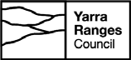Lilydale VIC 3140

###### 1300 368 333 | [mail@yarraranges.vic.gov.au](mailto:mail@yarraranges.vic.gov.au) yarraranges.vic.gov.au