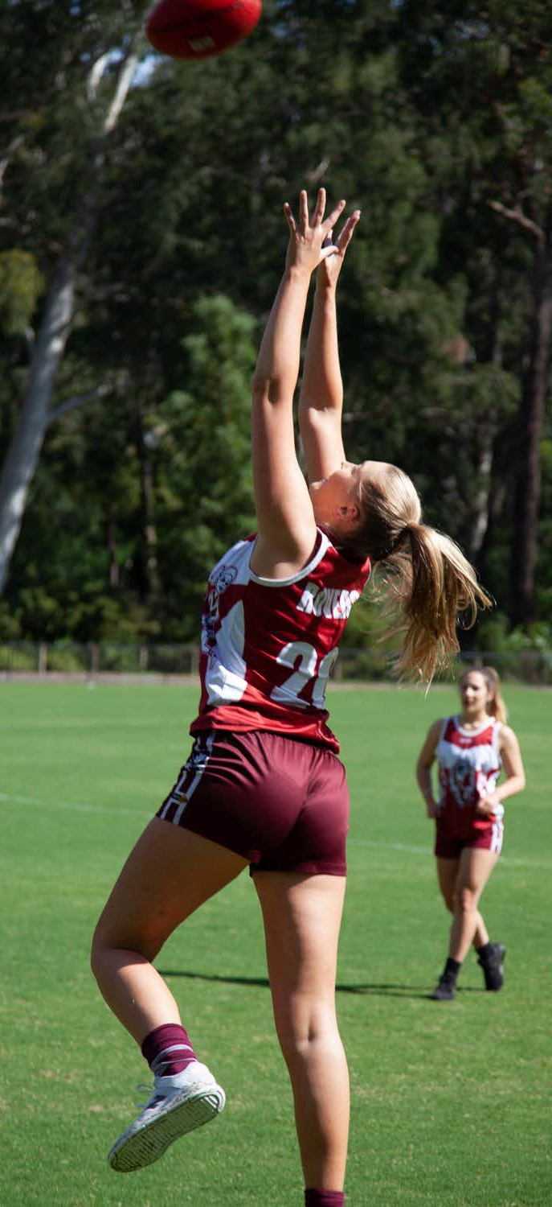
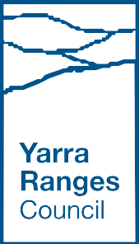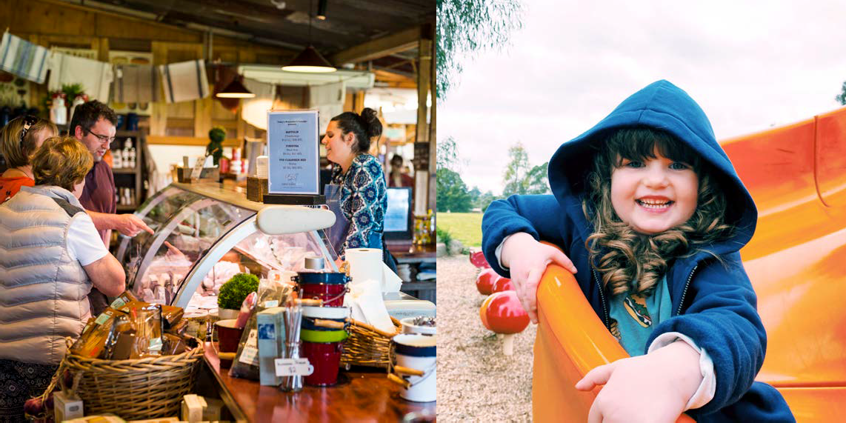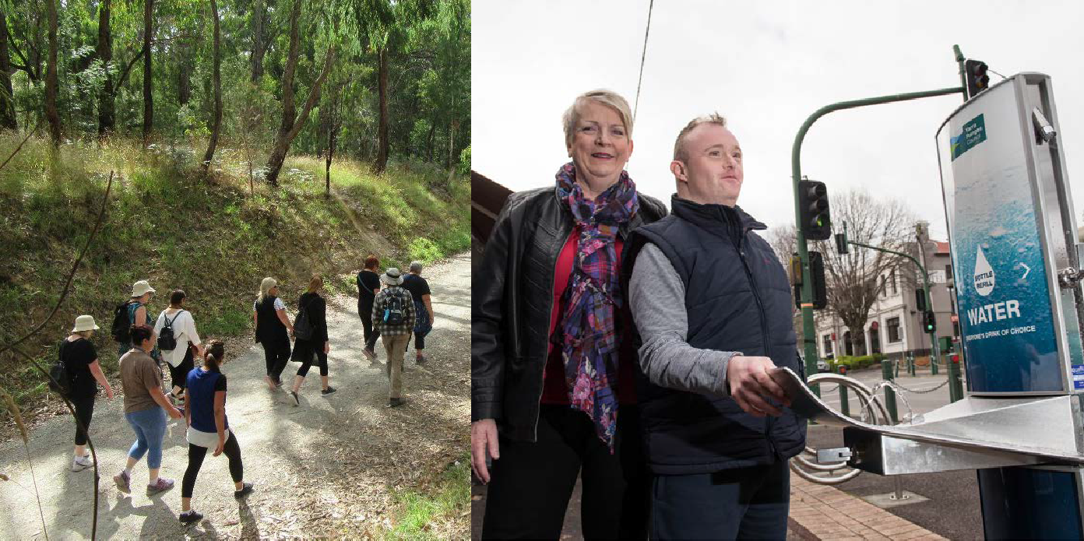

Yarra Ranges
Health and Wellbeing Plan
2021–2025
Yarra Ranges Health and Wellbeing Plan 2021–2025 | 1

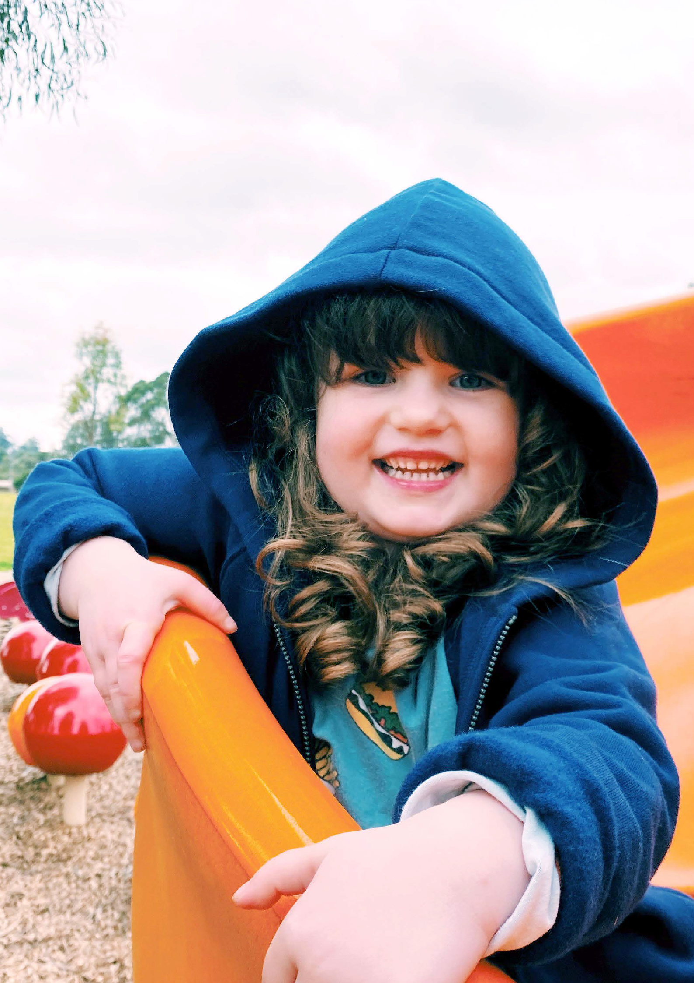

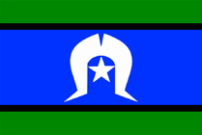

Acknowledgement of Country
We respectfully acknowledge the Traditional Owners, The Wurundjeri People as the Custodians of this land. We also pay respect to all Aboriginal community Elders, past and present, who have resided in the area and have been an integral part of the history of this region. Council also acknowledges Indigenous ways of being, knowing and doing that led to sustainable and health-giving societies thriving across Australia, for thousands of years.

Yarra Ranges Health and Wellbeing Plan 2021–2025 | 3
2 | Yarra Ranges Health and Wellbeing Plan 2021–2025

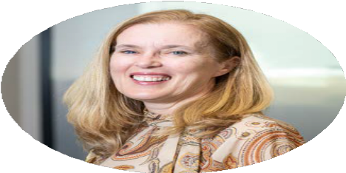
From the Mayor
Cr Fiona McAllister
Our community has great strength, and this has never been clearer than over the past year through the pandemic and then the storm emergency. The context for this Health and Wellbeing Plan is unlike any other, with the pandemic affecting everyone in our community, albeit differently.
This Plan gives Council guidance in the coming four years for how we can support communities to return to health and wellbeing both physically and mentally. One of the biggest assets for achieving this is our community: our leaders, our volunteers, the services and our business people; and the neighbours who look out for and show kindness to each other.
Ours is a place of historic significance, home to Wurundjeri people and Coranderrk. It is a unique place with natural environments that others want to visit and in 2021, some of these beautiful places have been devasted by natural disaster. Our priorities to tackle the health impacts of climate change and public health emergencies underscore our commitment to doing our part to build back better.
This Plan aligns with the Council Plan and expands on how Council will support mental wellbeing which is a major initiative of the new Council Plan. Social connection, eating nutritious food and being physically active are all powerful ways for us to have good mental and physical health. Council’s role to advocate for local needs will also continue.
I invite your participation in the journey and acknowledge your contributions to wellbeing. I know that by working together we can create a healthier Yarra Ranges.

From Chief Executive Officer Tammi Rose
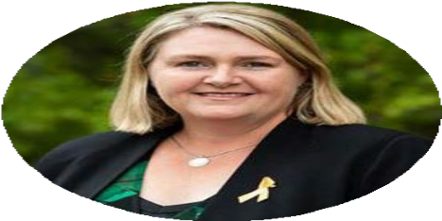
Council has many ways it supports health and wellbeing and while this Plan outlines how we will work to improve the top health issues, I want to acknowledge the broader Council effort. Whether it be collecting and recycling waste, delivering meals to older residents or responding on all fronts to emergencies, we are here to serve our communities.
Council is fortunate to have strong partnerships; the success of this Plan very much depends on the skills and efforts of our partners and community members who act every day in their communities. I am pleased that Council has been able to provide additional grants to support relief and recovery projects and this will continue over coming years through soon to be established Community Recovery Committees.
We will continue a collective impact approach for some of our health priorities, bringing skills and resources from across the Council and our external partners, to the priorities of, improving mental wellbeing and increasing healthy eating.
Our commitment to gender equality also continues, both within the Council and with communities. The Plan and the work coming out of it, applies a gender lens in line with the Gender Equality Act. I look forward to leading the organisation in its many efforts to support health and wellbeing over coming years.

4 | Yarra Ranges Health and Wellbeing Plan 2021–2025 Yarra Ranges Health and Wellbeing Plan 2021–2025 | 5

Acknowledgment of partners involved in developing this plan
Council acknowledges the many people and partners who gave their time, expertise and insights to help develop this Plan. The members of the Health and Wellbeing Advisory Group brought their knowledge and commitment to help set directions for the ongoing wellbeing of the Yarra Ranges community. In a year when Covid 19 and a devastating storm changed all our plans, this was particularly appreciated.
Health and Wellbeing Advisory Group
- Cr Sophie Todorov Chair 2020-21
- Cr Richard Higgins Chair 2017-20
- Christine Farnan (Dept Health)
- Jacky Close/Kylie Osborne (OEPCP)
- Tracey Higgins (Inspiro)
- Naveen Yadav (EMPHN)
- Lisa Currie (Urban Area community representative)
- Andrew Fullagar (Hills community representative)
- Siu Yin Chan (Valley community representative)
- Debbie Stanley/Di Collins (EACH)
- Jo Stanford, Josette O’Donnell (Eastern Health Community Health)
- Kristine Olaris (Women’s Health East)
- Daisy Brundell (Inspiro)

Advisory Committees of Council
- Disability Advisory Group
- Indigenous Advisory Group

Abbreviations
Abbreviations used in this plan are listed in Appendix 1.

Community Survey
- Over 280 respondents contributed their views.
- 109 comments were left on the Shaping Yarra Ranges webpage made by 21 individuals during the final consultation phase.

6 | Yarra Ranges Health and Wellbeing Plan 2021–2025 Yarra Ranges Health and Wellbeing Plan 2021–2025 | 7
Council Reference Group
- Officers from across the Council brought their expertise to the development of this Plan and connected health and wellbeing with their area.
- Yarra Ranges Youth Ambassadors

Engagements
- A list of local networks and services engaged in the development of the Plan is included in a separate report on engagement findings.

Contents

Sections  The Plan at a Glance Executive Summary Yarra Ranges Council  About Yarra Ranges: demographics Health and Wellbeing Achievements of Previous Plans  Developing the Health and Wellbeing Plan | 10  12  16  22  26  30  36
Our Priorities  Health and Wellbeing Priorities 2021  Respond to public health impacts of emergencies Tackle climate change and its impacts on health Increase healthy eating  Increase active living  Improve mental wellbeing and social connection Prevent violence against women and children Reduce harmful alcohol and drug use | 54  57  71  85  101  115  133  147
References | 166
Action Plan
Appendices  Appendix 1: Abbreviations  Appendix 2: Gender and intersectionality - health factors | 174

8 | Yarra Ranges Health and Wellbeing Plan 2021–2025 Yarra Ranges Health and Wellbeing Plan 2021–2025 | 9

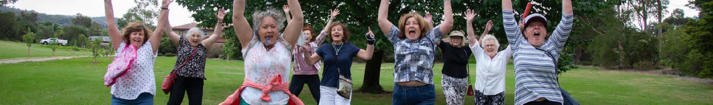
The Plan at a glance
Health and Wellbeing Priorities and Goals
Priority 1 | Respond to public health emergencies  Communities recover from Covid 19 and other emergencies.
Priority 2 | Tackle climate change and its impact on health  People and businesses are resilient, prepared, and able to mitigate the potential health impacts of climate change.
Priority 3 | Increase healthy eating  People have the capacity to consume healthy food, built on a sustainable system providing access to healthy, affordable food for all.
Priority 4 | Increase active living  People have capacity to walk and be physically active in an inclusive culture.
Priority 5 | Improve mental wellbeing and social connections  People have good mental wellbeing through strong community connections, family supports and ease of access to mental health services.
Priority 6 | Prevent violence against women and children  Women and children live free from abuse and violence in a culture of gender equity and respect.
Priority 7 | Reduce harmful alcohol and drug use  People are safe from the harmful effects of alcohol and other drugs.

The Yarra Ranges Council Health and Wellbeing Plan 2021-2025 provides a strategic road map for Council to support optimal health and wellbeing of communities across the municipality. The plan reflects and leverages where Council has responsibility, capability, influence, roles and resources to support health and wellbeing.

Improving health and wellbeing
Optimal health and wellbeing are fundamental to a thriving community and prosperous municipality. Residents are generally healthy but not in every way.
Compared to all of Victoria, Yarra Ranges adults have poorer health and wellbeing related to:
- Family violence incidents
- Food insecurity and drinking sugary drinks
- Anxiety, depression and other mental health-related problems
- Excess alcohol consumption
- Diagnosis of multiple chronic diseases

How the Plan was developed  - Through community consultation.  - Build on achievements of previous Health and Wellbeing Plans  - Articulate with other Council plans and the Victorian Public Health and Wellbeing Plan 2019-23 | Approaches of the Plan  - Healthy and sustainable environments  - Whole of Council  - Partnership and collective impact  - Prevention - protective and risk factors  - Asset based community development  - Placed-based  - Life-course  - Evaluation and monitoring
Principles of the Plan  - Evidence informed  - Gender equity and intersectionality  - Social determinants of health  - Human rights and health equity | How the Plan will be implemented  - Directly by Council and via partnerships with other agencies and communities  - Action Plans for each priority

10 | Yarra Ranges Health and Wellbeing Plan 2021–2025 Yarra Ranges Health and Wellbeing Plan 2021–2025 | 11

Executive Summary
The Yarra Ranges Council Health and Wellbeing Plan 2021-2025 (the Plan) articulates what we want to achieve over the coming four years.
The Plan is a strategic road map for how Council can support optimal health and wellbeing of communities and meets the requirement of the Public Health and Wellbeing Act 2008.

The Plan:
- describes priority areas for action to improve health and wellbeing, principally through Council’s work and work in partnerships with other agencies and communities
- reflects where Council has responsibility, capability, influence, roles and resources to support health and wellbeing.

The Health and Wellbeing Plan is part of how Council delivers its strategic objective of a Connected and Healthy Community . Council has additional service delivery roles that support good health, such as immunisation, maternal and child heath, wastewater management and food safety, to name a few. These are vital to community health and generally, are not the focus on this Plan.

Health and Wellbeing Priorities

1 | Respond to public health impacts of emergencies
2 | Tackle climate change and its impact on health
3 | Increase healthy eating
4 | Increase active living
5 | Improve mental wellbeing and social connection
6 | Prevent violence against women and children
7 | Reduce harmful alcohol and drug use

12 | Yarra Ranges Health and Wellbeing Plan 2021–2025 Yarra Ranges Health and Wellbeing Plan 2021–2025 | 13

These health priorities reflect the most significant preventable causes of poor health and wellbeing in Yarra Ranges. They were informed by
residents’ priorities for improving health and wellbeing. Local health and community organisations also share priorities with Council. Five of the priorities continue work from the 2017-2021 Health and Wellbeing Plan. Actions for each priority describe the outcomes we hope to achieve, who in Council is involved, our partners, measures of success and related Council plans or strategies.
A comprehensive approach is required to plan for and deliver improved health and wellbeing outcomes for all residents of Yarra Ranges. A set of principles and approaches guide this Plan and the way Council works with the community and our partners to improve health and wellbeing.
Applying these principles and approaches will ensure that the benefits of population-level health planning extend to all members of the community.

Principles
Evidence informed
Gender Equity lens
Intersectionality and discrimination
Social determinants of health
Human rights and health equity
Indigenous ways of knowing, being and doing
Council embeds gender equity and intersectionality into its strategies. Research, consultation and data analysis through a gender and intersectionality lens gives a more nuanced understanding of our communities to inform Council action.
The 2017-2021 Health and Wellbeing Plan took a new approach to changing entrenched health issues through three major initiatives on: walking, water and Indigenous health. This collective impact approach provided a framework to tackle health issues from multiple perspectives, harnessing different skills and resources.
Taking a deliberate learning approach, this was a new way of working for Council. The approach will evolve in the 2021-2025 plan with a new collaboration proposed for mental wellbeing and another to focus on nutrition and the food system. These priorities will also support recovery from the recent public health emergency of Covid 19 and the storms of 2021.
Good health and wellbeing are fundamental to a thriving community and a prosperous municipality. Yarra Ranges Council views health and wellbeing as vital for our residents and communities. Improving the health and wellbeing of our community is everyone’s business. Different institutions and levels of government play different roles in people’s health and wellbeing. Yarra Ranges Council plays a central role in shaping a healthy and liveable region which promotes and supports health and wellbeing.

Approaches
Healthy and sustainable environments
Whole of Council
Partnership and collective impact
Prevention - protective and risk factors
Asset based community development
Place-based
Life-course
Evaluation and monitoring

14 | Yarra Ranges Health and Wellbeing Plan 2021–2025 Yarra Ranges Health and Wellbeing Plan 2021–2025 | 15

Yarra Ranges Council
Council vision 2036

Whether you live here or visit, you will see how much we care for Country, how inclusive and connected our communities are, and how sustainable balanced growth makes this the best place in the world.
The Council Plan 2021-2025 sets the road map for each four-year term of the Council. It describes what Council stands for, its priority activities, strategic directions and outcomes for the Council term.
This Health and Wellbeing Plan directly delivers on the Council Plan objective of Connected and Healthy Communities.
The Council Plan development was informed by a community engagement process. Priorities developed by three area-based community panels show a focus on our environment and community wellbeing. Themes identified by the Community Panels for the Council Plan align with many of the priorities of this Plan.

Council services and regulatory roles to support health and wellbeing

Council improves, supports and protects health and wellbeing through services, programs and regulatory roles to protect health and the environment. Council also leads and works with others to advocate for funding for services and facilities. Council has many roles to improve the health and wellbeing of residents, including:
- delivering infrastructure, services, planning and facilities that support people to be healthier
- planning functions such as strategic land planning
- regulatory functions such as, statutory planning, building and health. Council also assesses the social and economic impacts of new electronic gaming machines and reviews alcohol license applications
- partnerships - leveraging skills, resources, expertise and working together for collective impact
- building capacity of communities through grants, community development, training and skills building, and leadership development
- advocating for systemic change to improve the underlying causes of poor health.

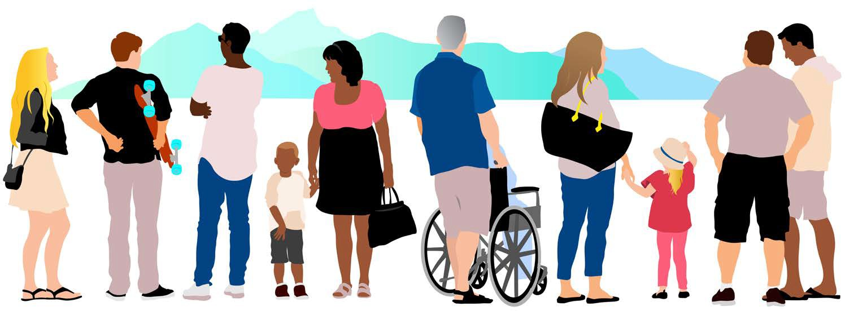
16 | Yarra Ranges Health and Wellbeing Plan 2021–2025 Yarra Ranges Health and Wellbeing Plan 2021–2025 | 17

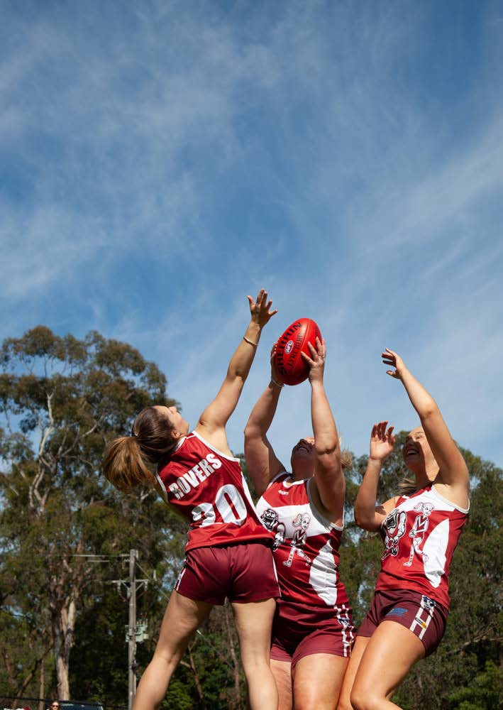
“
Gender equity is not only a fundamental human right, but a necessary foundation for a peaceful, prosperous and sustainable world
- UN Sustainable Development Goal 5 (1)
18

Gender Equality and Intersectionality

The Gender Equality Act 2020 requires Council to undertake a Gender Impact Assessment when developing a Plan such as this and embed gender equity and intersectionality impacts into its strategies. All areas of Council must show how they are contributing to a vision for gender equality.

Our Vision for Gender Equality in Yarra Ranges
The following Vision was developed by Council’s leadership team to direct the organisation’s work to reduce gendered violence in Yarra Ranges. It recognises the absolute requirement to change the
underlying conditions that lead to this form of violence, such as gender stereotypes, expectations and roles.

Yarra Ranges is gender equitable, inclusive and diverse. Women, men and gender diverse people have equitable access to resources, power and opportunities. We are brave and fierce in our pursuit of gender equality and human rights, and we all have a role to play. We demand this for ourselves and our community.
The Plan reflects the commitments made in this vision and describes a range of Council work to help achieve it. Further details on gender equality and intersectionality are in Appendix 3.

Yarra Ranges Health and Wellbeing Plan 2021–2025 | 19

Disability
Council also has an important and legislated role to support people with disability and their carers to participate equally in their community. Council’s vision for this is that:

Yarra Ranges is an accessible, inclusive and equitable community that enables people with a disability to fulfil their potential equitably and as valued citizens.
Almost 7,000 people identify as having a disability that requires them have assistance with daily living (2016 ABS Census). The need for assistance relates to severe or profound disability. The prevalence
of people who need support in the community, and information on unpaid care to a person with a disability, informs Council’s planning and support.
Council’s Disability Advisory Group provided input to development of the Plan and will help guide implementation, bringing lived experience to decisions.

Young People
During the consultation process to develop the Plan, five Youth Ambassadors for Yarra Ranges Council were consulted. The Youth Ambassadors gave an important perspective and they were well informed of the issues. Their insights will help inform advocacy and action over the life of the Plan.
Men
Data on men’s health in this Plan show in some areas men have worse health outcomes. This is true for suicide, life satisfaction and harms associated with alcohol consumption. Short-term harms from alcohol misuse, such as injury, are experienced more often by men than women. (48)
More data is needed on the challenges for men’s help seeking behaviour for both mental and physical health issues. Coupled with poor service access in some areas of Yarra Ranges, this can lead to negative health outcomes. Early intervention approaches such as
supporting new Dads in their parenting role can support good health as well as reduce the risk of family violence.
Council supports prevention activities in men’s health, through its grant programs, support for men’s sheds and support for new fathers. During the life of the Plan data will be monitored to better understand service access by men and other groups who may experience greater barriers, including people from diverse cultural background, people with disability, people who are homeless, those in more remote areas, and LGBTIQA+ community members.

Socio-economic factors
Longer-term harms including cancers, cardiovascular diseases and digestive diseases are more likely to be experienced by people with low socio-economic backgrounds.

20 | Yarra Ranges Health and Wellbeing Plan 2021–2025 Yarra Ranges Health and Wellbeing Plan 2021–2025 | 21

About Yarra Ranges

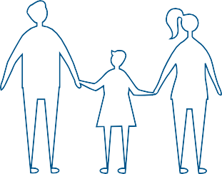

Almost 7,000 identified as having a severe or profound disability and 15,157 provided assistance to
a person with a disability in 2016
YR 16.3%
GM 33.8%

1,359 Aboriginal and Torres Strait Islander peoples reside in

159,955 estimated resident population in Yarra Ranges (2020)(2)
Residents born overseas compared with Greater Melbourne (2016)
the Yarra Ranges (2016) - the largest population in the Eastern Metropolitan Region (EMR)

Overall population socioeconomically advantaged

20%
- Top 20% in Vic
However, high disadvantaged areas in Yarra Junction and Warburton
Emerging population trends

3,000+
new households expected over next 20 years due to increased population growth from new Lilydale development (3)
2016 Census Snapshot
Total people (usual residence) | Yarra Ranges |  | Greater Melbourne
Population group | Number | % | %
Females | 75,717 | 50.6 | 51.0
Aboriginal and Torres Strait Islander population | 1,359 | 0.9 | 0.5
Australian citizens | 133,014 | 89.0 | 79.6
Eligible voters (citizens 18 years and older) | 100,965 | 67.5 | 60.8
Population over 15 years | 121,081 | 81.0 | 81.7
Employed Population  Source: Australian Burea Census of Population and | 74,423  u of Statistic Housing 20 | 95.4  s,  16. | 93.2

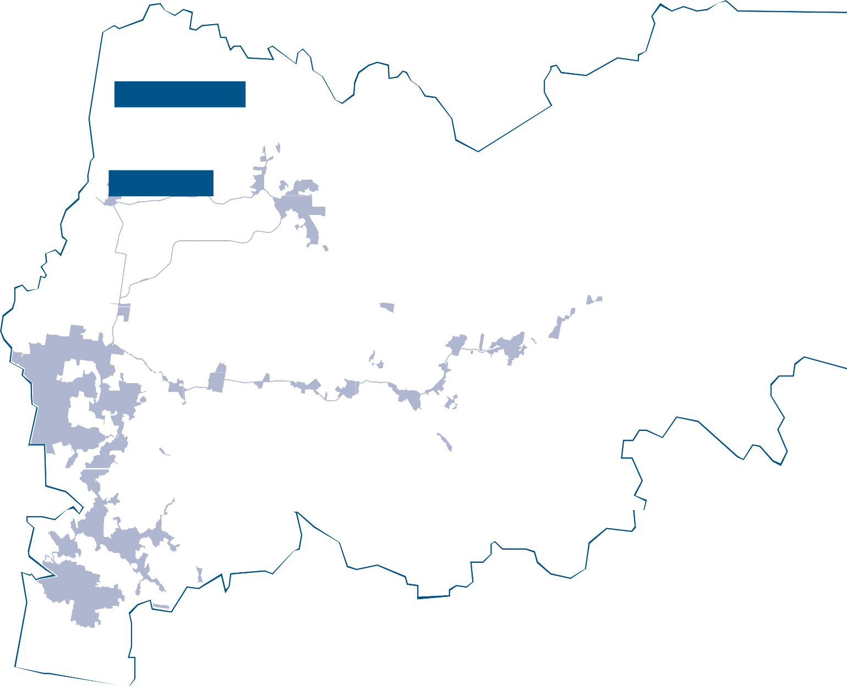
Dixons Creek
Fernshaw
Yarra Glen
Healesville
Reefton
Mcmahons Creek
Coldstream
Badger Creek
Warburton
Lilydale
Yarra Junction
Mooroolbark
Mount Dandenong
Hoddles Creek
Powelltown
Macclesfield
Belgrave
Our places
Yarra Ranges is made up of diverse places and communities with distinct geographies and identities. There are 55 townships across the almost 2,500 square kms of the municipality. Council uses four planning areas that reflect our distinct places: The Hills, Urban, Valley and Upper Yarra areas. The map below shows 17 of the larger townships, shading of the more populous urban areas and extensive forested areas that make up Yarra Ranges.
The urban areas of Yarra Ranges are on the fringe of Melbourne. The urban area which is 3% of the land mass of the municipality, is where around 70% of the population live. The central and eastern parts of Yarra Ranges are more rural.
Rural land is used for agriculture, horticulture, tourism and viticulture. Significant forests and State parks edge the municipality. The natural beauty and proximity to Melbourne attracts an increasing number of visitors.
Yarra Ranges Health and Wellbeing Plan 2021–2025 | 23

22 | Yarra Ranges Health and Wellbeing Plan 2021–2025
Infill development has increased population density in urban areas

Affordable housing and lifestyle change among top reasons people moving to Yarra Ranges

Increase in cultural diversity – most new overseas arrivals coming from Asia-Pacific region

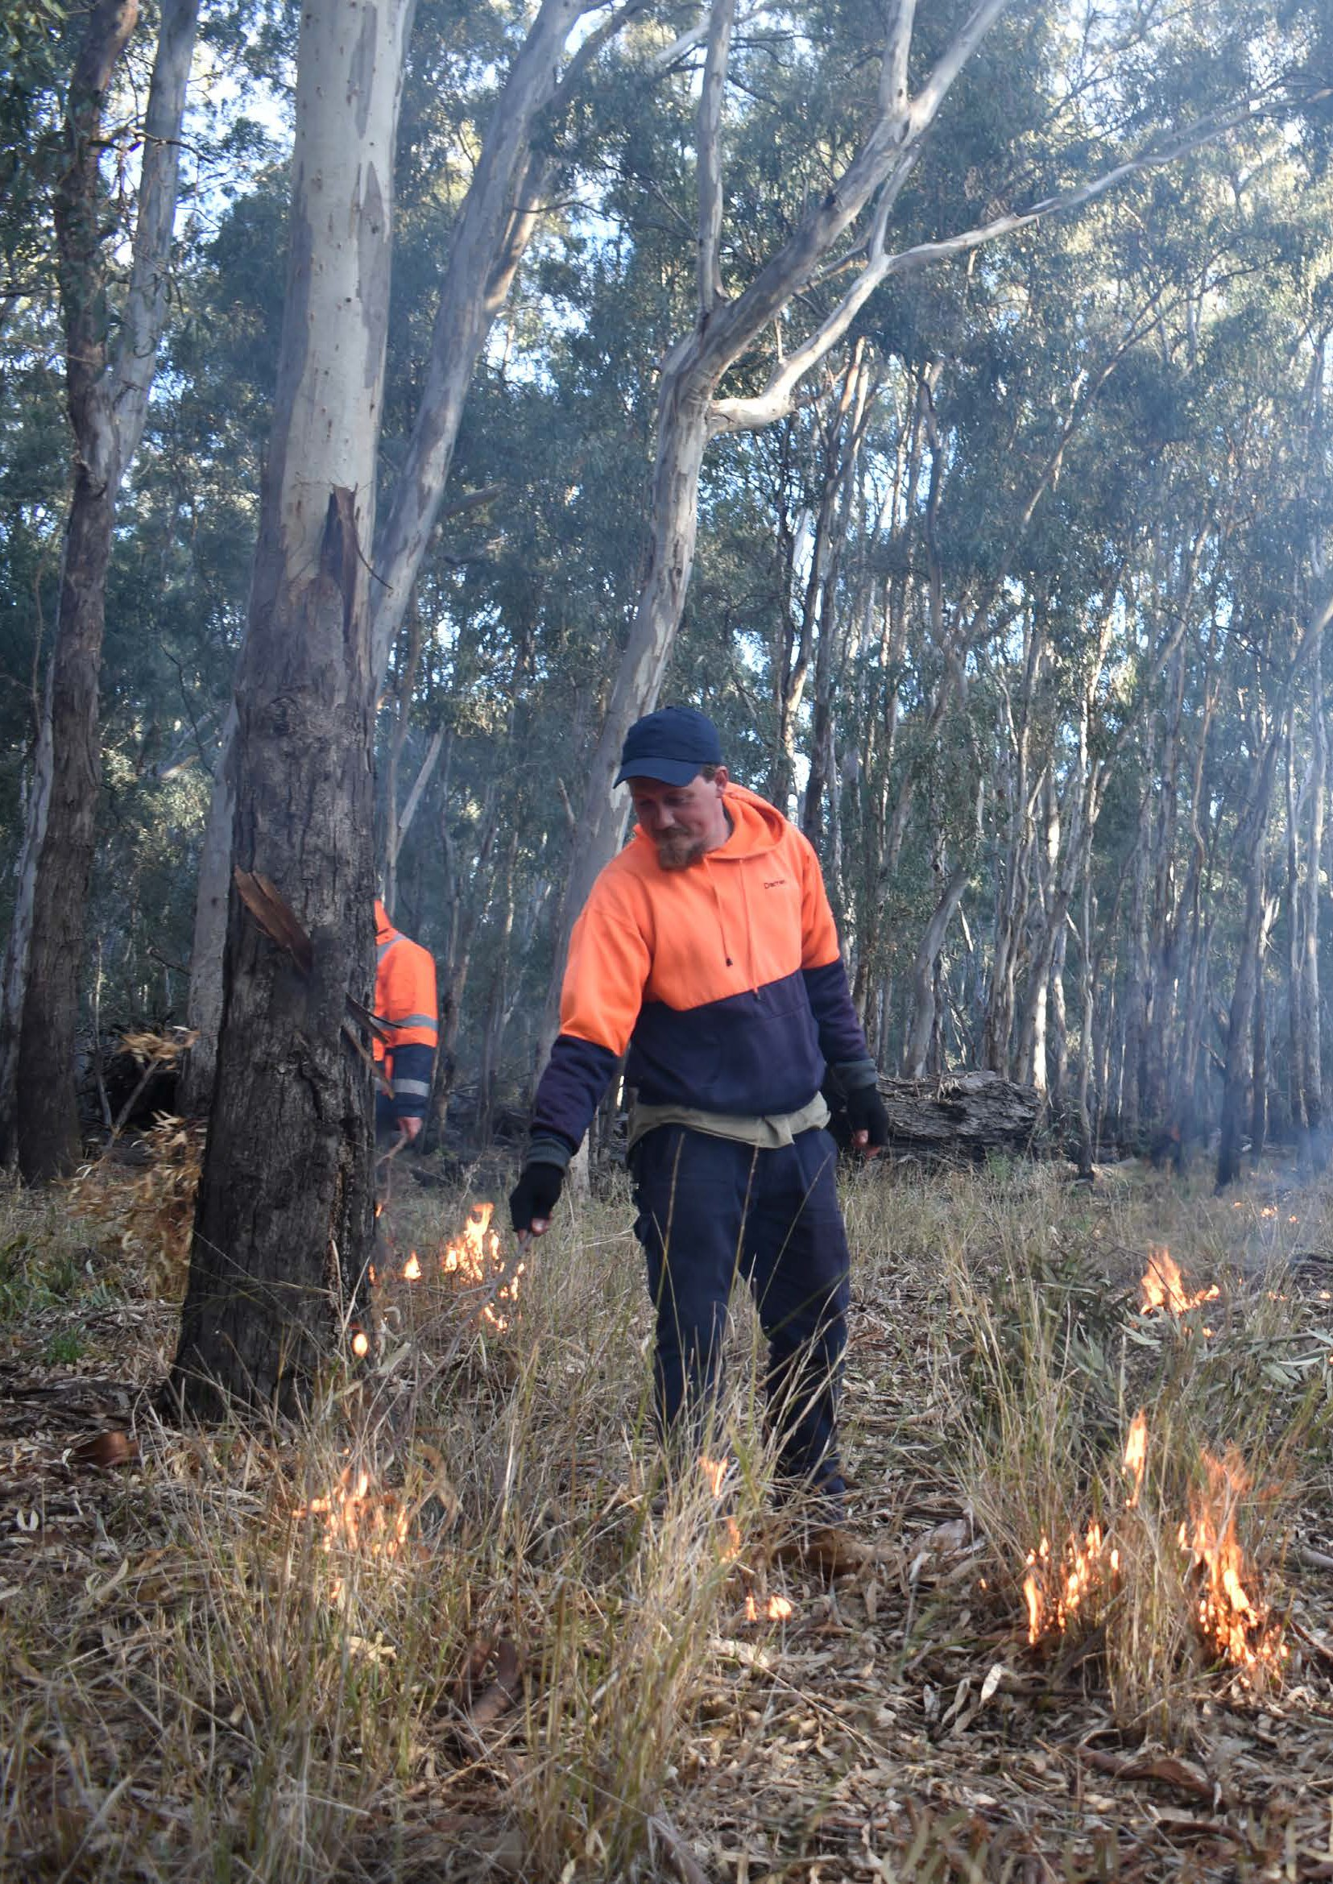

Caring for Country
Council is proud of the partnerships developed over many years with Indigenous Elders, community members, services and organisations. A shared commitment to improving health and closing the Indigenous health gap includes improving the health of Country, as climate change and natural disasters have greater impact.
The Yarra Ranges Indigenous Advisory Committee guides Council’s understanding of the intrinsic connection between healthy Country and human health. Ancient understanding held by Indigenous peoples, confirms the inter-dependence of the health of our environments
and the health and wellbeing of people. Indigenous knowledge such as the Firestick approach to caring for and managing Country, is gaining momentum as a more sustainable way to protect from catastrophic fires. Council is committed to building knowledge and
cultural awareness through this and other strategies and learning from Indigenous ways of knowing, being and doing.

24 Image: Timothy Neale Yarra Ranges Health and Wellbeing Plan 2021–2025 | 25

Health
and Wellbeing
2015 Australia wide burden of disease
38% could be prevented by reducing exposure to modifiable risk factors
Tobacco use had the highest burden of the measured risk factors at 9.3%
7.3% due to dietary risks
2.7% was due to illicit drug use
2.5% due to physical inactivity
4.5% due to alcohol use
0.7% due to intimate partner violence
2.2% was due to child abuse and neglect
0.3% due to unsafe sex (5)

Good health and wellbeing are fundamental to a thriving community and prosperous municipality. Yarra Ranges residents are generally healthy but not in every way.
Headline indicators, compared to all of Victoria, show Yarra Ranges adults have poorer health and wellbeing related to:
  - family violence incidents
  - food insecurity and drinking sugary drinks
  - anxiety, depression and other mental health-related problems
  - excess alcohol consumption
  - diagnosis of multiple chronic diseases.
The self-reported data in the headline indicators below are from the 2017 Victorian Population Health Survey. (4) Results for 2020 will be available after the development of this Plan. Council will monitor the findings carefully.
These headline indicators for each priority of the Plan, are used in conjunction with other kinds and sources of data to give a more complex assessment of the health status of Yarra Ranges residents.
To assess the full impact of health risk factors, the total burden of disease is measured in terms of disability-adjusted life years. That is, healthy years of life lost either through dying prematurely, or
through living with illness due to disease and injury. Burden of disease information for Yarra Ranges is not available.

26 | Yarra Ranges Health and Wellbeing Plan 2021–2025 Yarra Ranges Health and Wellbeing Plan 2021–2025 | 27

Violence against women and gender inequality

Headline Health Indicators

12%
7%

Yarra Ranges Victoria
Increase in number of family violence incidents.

5%
11%

Yarra Ranges Victoria
Increase in rate of family violence incidents.

Risk factors

29%
25%

Yarra Ranges Victoria
Two or more chronic diseases (high blood pressure, diabetes etc).
Healthy eating

10%
6%

Yarra Ranges Victoria
Experienced food insecurity.

4%
4%

Yarra Ranges Victoria
Met dietary guidelines for fruits and vegetables.

10%
15%

Yarra Ranges Victoria
Consume take-away meals, or snacks more than once a week.

15%
10%

Yarra Ranges Victoria
Consume sugar-sweetened drinks daily.
Mental health

14%
15%

Yarra Ranges Victoria
High/very high levels of psychological distress.

25%
18%

Yarra Ranges Victoria
Sought help for a mental helth-related problem in the last 12-months.

14%
15%

Yarra Ranges Victoria
Ever diagnosed with anxiety or depression.

Physical activity

40%
46%

Yarra Ranges Victoria
Sedentary, or insufficient physical activity.

58%
51%

Yarra Ranges Victoria
Met physical activity guidelines.
Risky alcohol consumption

50%
43%

Yarra Ranges Victoria
Increase risk of alcohol related harm from a single occasion of drinking.

67%
60%

Yarra Ranges Victoria
Increase lifetime risk of alcohol
- related harm.

24%
19%

Yarra Ranges Victoria
Drank more than 2 standard drinks per day.

10%
12%

Yarra Ranges Victoria
Drank more than 4 drinks in one go (weekly basis).

28 | Yarra Ranges Health and Wellbeing Plan 2021–2025 Yarra Ranges Health and Wellbeing Plan 2021–2025 | 29

Achievements
Walking - the way to go MIP
Constructing and maintaining infrastructure that supports walking as a free and widely accessible activity was the focus of this MIP.

Outcomes include:
- elevating walking and pedestrian travel in the new Integrated Transport Strategy
- cross Council officer training on the value of walking and walking infrastructure for community wellbeing
- external funding for iconic projects - Rivers and Ridges
- implementing new and existing footpath construction programs, retrofitting pram crossovers and improving accessibility of paths of travel in activity centres
- design changes to the Warby Trail to enable Adaptive Mountain Bike users to access the trail independently.

of previous Plans
The Yarra Ranges Council Health and Wellbeing Plan 2021-2025 is the fourth plan developed by Council to comply with the Victorian Public Health and Wellbeing Act 2008. The new Plan builds on the approaches, partnerships and achievements of previous plans.
A key component of the 2017-2021 Health and Wellbeing Plan (6) was an innovative cross Council approach to generate collective impact in three Major Initiatives Projects (MIPs) designed to improve health and wellbeing by:
  - encouraging walking
  - promoting drinking water instead of sugary drinks
  - working to close the Indigenous health gap.
To undertake each MIP, partnerships were drawn from across Council. Achievements of each MIP are described below. Feedback via partnership surveys on this new cross-Council approach has been positive and shown increased awareness of the Health and Wellbeing Plan and the three priority projects. The collaborative approach
taken has involved a sharp learning curve for members of the three MIP project groups, including skill building in collective impact work, outcomes thinking and progress measurement.

30 | Yarra Ranges Health and Wellbeing Plan 2021–2025 Yarra Ranges Health and Wellbeing Plan 2021–2025 | 31

Water - the drink of choice MIP
A range of outcomes were achieved to increase access to water and reduced access to sugary drinks, including:
- installation of ten new water refill stations by Council, branded with the Water the Drink of Choice graphic. Yarra Valley Water is working with Councils to increase access to water in public spaces and agreed to install an additional six water stations during 2020 (installation delayed). These will be co-branded. Council capital funding will continue Council’s installation of new water stations
- reduced availability of sugary drinks and less nutritious food options in several Yarra Ranges schools and sports clubs, through the Healthy Active Living project. This is a partnership of local services and Council and supported by health promotion workers in local community health services
- changes to grants guidelines were made to promote increased access to healthy drink options
- sugary drinks now make up less than 20% of the drinks available, or on display in five out of the six Council sport and recreation facilities. The work to achieve this has been part of Council’s Water in Sport project, funded by a VicHealth grant
- water is provided at all Council cultural facilities, and the range of sugary drinks is substantially reduced
- health promotion has occurred across Council’s sport and recreation centres, to increase community awareness of the negative health impacts of sugary drinks.

Indigenous health MIP
The Indigenous Health MIP increased the cultural literacy of Council staff in the MIP and across Council more broadly, as a result of a cultural audit undertaken to capture Council’s current level on the cultural competency continuum.
The recommendations from the audit have provided the foundation and inspiration for the development of the next iteration of Council’s Reconciliation Strategy. This will take Council on a cultural journey, creating the platform to significantly increase the understanding of Indigenous ways of knowing, being and doing. It will embed cultural
principles and values into the broader practices and procedures across Council, making our services and facilities more accessible and culturally safe for Indigenous community members.

32 | Yarra Ranges Health and Wellbeing Plan 2021–2025 Yarra Ranges Health and Wellbeing Plan 2021–2025 | 33

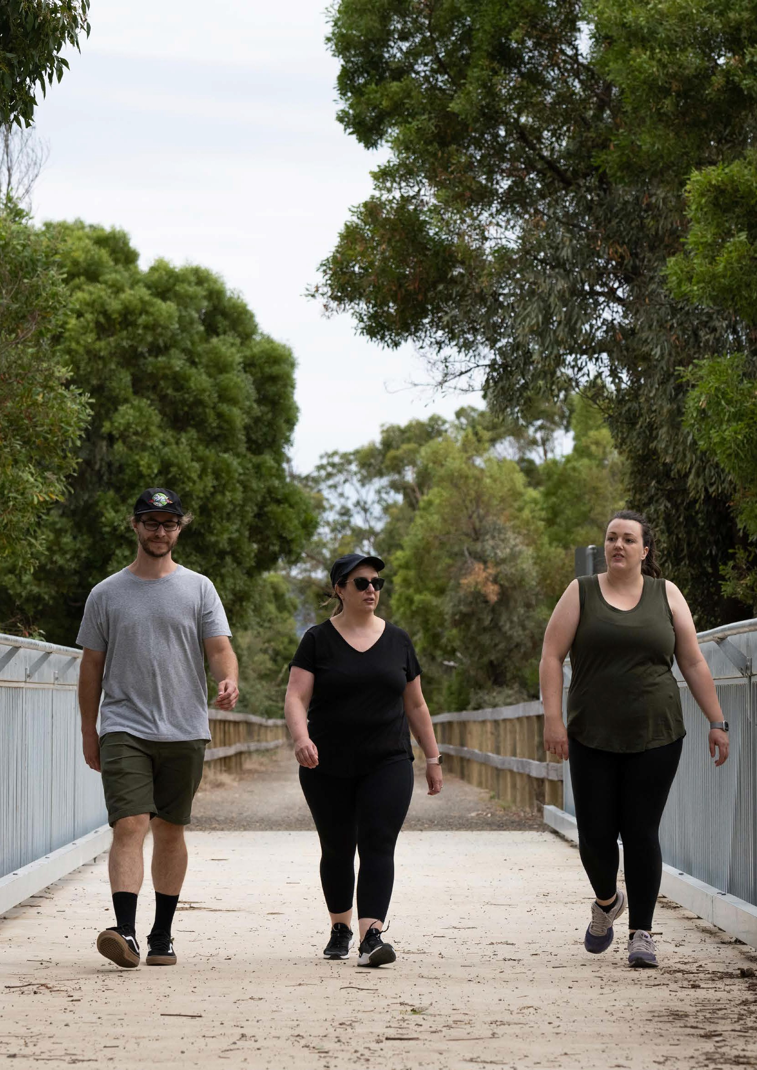
35

Other achievements
Additional achievements of the 2017-21 Health and Wellbeing Plan include:
- Healthy Active Living - a collaboration of Council, local community health services and partners to:
− work with schools, sports clubs and other recreational venues to increase access to healthy food and drink choices in canteens
− research community support for healthier choices, this has shown strong community support for these options
− consult with the community to increase understanding of what a healthy and sustainable food system is (in progress)
- the Water in Sport project funded by VicHealth. This supported people to choose water and reduce their consumption of sugary drinks
- Upper Yarra Partnership, a place-based initiative to support families and children, increase access to services and strengthen community connections
- Council grants for projects with a range of health outcomes:
− healthy eating and increasing access to healthy foods
− supporting social connection and breaking down isolation
− increasing gender equity
− addressing homelessness
- Covid 19 relief and recovery grants to support mental wellbeing, social connection and relief needs - funded by Council’s Recovery Fund
- gender equity work to prevent violence against women, including 16 Days of Activism campaigns, training for Council leaders and community capacity building
- advocacy to improve health and wellbeing in the areas of: social housing and homelessness and improving mental health services for young people. Achievements include a local Headspace and Integrated Youth Health Hub
- promotion of safe alcohol consumption through partnerships with community organisations and sports clubs (affected by Covid 19)
- increased participation of people with disability and their carers in the community through walking and engaging in recreation and cultural activities. Promoting the contribution and voice of people with disability and carers through an International Day for People with Disability event
- community infrastructure, recreation facilities and open space improvements, including an award for increasing access to the Warby Trail for wheelchair users, developed through engagement with community.

34 | Yarra Ranges Health and Wellbeing Plan 2021–2025

Developing the 2021–2025 Plan
State level
Victorian government departments; peak bodies, professional organisations and specialist agencies.

Council’s Health and Wellbeing Advisory Group provided guidance to develop the 2021-2025 Health and Wellbeing Plan. Our community engagement reached across our community, including to children and young people and people with diverse life experiences and
Local level
Local government; regional and metropolitan partnerships; social and aged care services; early childhood services and schools; women’s health services; workplaces.

backgrounds. The contributions of partner organisations and community groups were instrumental. Community surveys and engagement offered a more nuanced picture of health and peoples’ experience.
Service level
Hospitals; community health and primary care organisations; Aboriginal Community Controlled Health Organisations; human services provider agencies, community organisations.

Analysis of health data for Yarra Ranges underpins this Plan. This data is available on Council’s website. It is a resource for local services, agencies, students and community.

Connecting with Victorian State Priorities
The Plan aligns with the principles, priorities and focus areas of the Victorian Public Health and Wellbeing Plan 2019-23. (5) The State vision for Victorians is:

‘A Victoria free of the avoidable burden of disease and injury so that all Victorians can enjoy the highest
attainable standards of health, wellbeing and participation at every age’.
The State Plan lists roles and contributions made in different organisations to improve Victorian population health and wellbeing.
The Victorian Plan notes...

‘Taking an evidence-informed and coordinated approach can maximise opportunities across communities and within settings and services to support Victorians to live healthy lives. The wider determinants of health are integral to the long-term vision for public health and wellbeing interventions. Place-based and co- design approaches are also important mechanisms for driving improvements in wellbeing in Victoria and should be considered when designing and delivering public health and in public health and wellbeing.’ (7)

36 | Yarra Ranges Health and Wellbeing Plan 2021–2025 Yarra Ranges Health and Wellbeing Plan 2021–2025 | 37

Principles and Approaches of the Plan
A comprehensive approach is required to plan for and deliver improved health and wellbeing outcomes for all residents of Yarra Ranges. A
set of principles and approaches guide this Plan and the way Council works with the community and partners to improve health and wellbeing. The principles and approaches are described in Appendix 4 that accompanies the Plan. While each approach and principle
are described separately, it is the combination that is foundational to development and implementation of this Plan.
Council has many roles and influences in addressing the social determinants of health as part of improving health and wellbeing in Yarra Ranges. This is depicted in the diagram below. Principal among them is housing, particularly advocacy for social housing
and homelessness. The actions of Council in addressing the social determinants of health are included in the Action Plan of each priority of the Plan.
The social determinants of health and two other important determinants are outlined below. These determinants impact on many of the foundations, or fundamentals of health and wellbeing.
* ABCD is a globally adopted approach that recognises and builds on the strengths, gifts, talents and resources of individuals and communities to create strong, inclusive and
sustainable communities. Jeder Institute 2020 (66)
Principles
Evidence informed
Gender Equity lens
Intersectionality and discrimination
Social determinants of health
Human rights and health equity
Indigenous ways of knowing, being and doing

Approaches
Healthy and sustainable environments
Whole of Council
Partnership and collective impact
Prevention - protective and risk factors
Asset based community development (ABCD*)
Place-based
Life-course
Evaluation and monitoring

38 | Yarra Ranges Health and Wellbeing Plan 2021–2025 39
Yarra Ranges Health and Wellbeing Plan 2021–2025 |

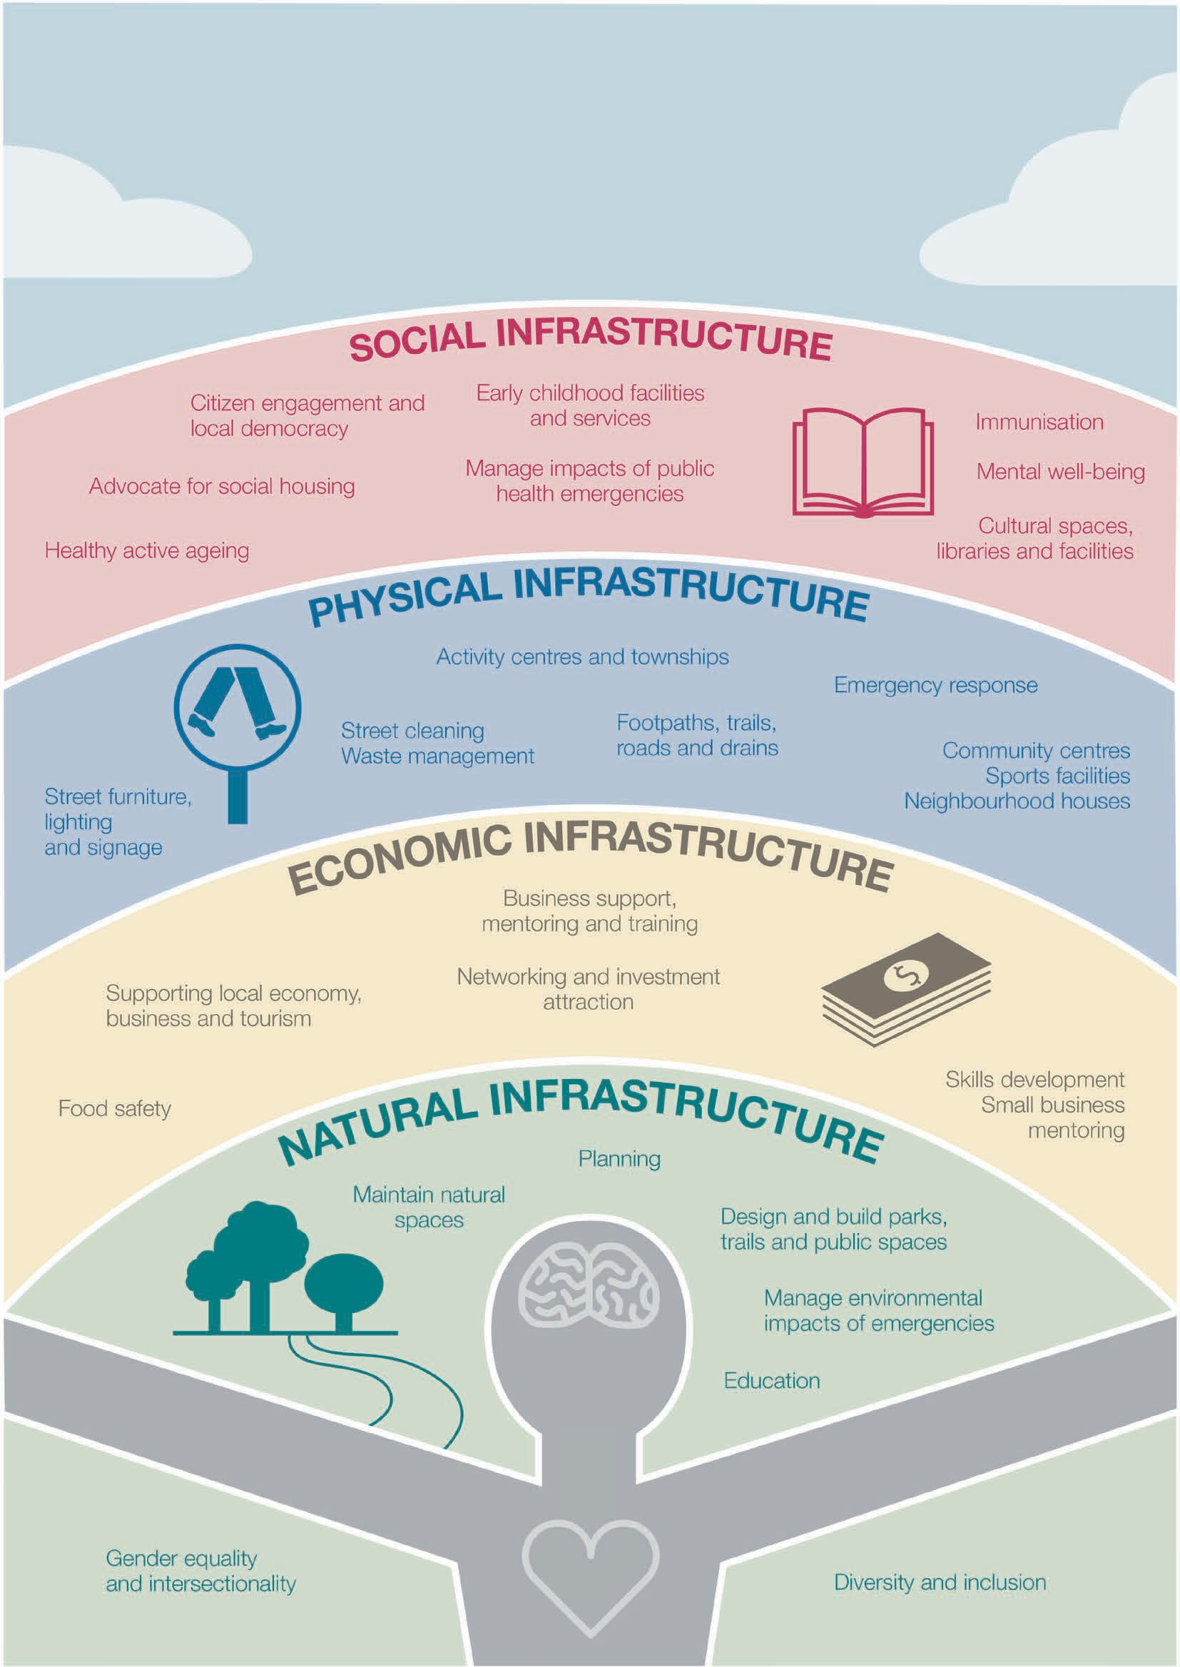
COUNCIL’S ROLE IN CREATING ENVIRONMENTS FOR HEALTH
Investments in the Social Determinants
41

The Social Determinants of Health
The social determinants of health are the conditions we are born into: the economic, social and environmental influences and opportunities. They are particularly relevant in Yarra Ranges given our diverse communities and places.

‘...the single strongest predictor of our health and wellbeing is our position on the social gradient.
Whether measured by income, education, place of residence or occupation, those people at the top of the gradient have the most power and resources, and on average live longer and healthier lives. Those people at the bottom have the least power and usually run at least twice the risk of serious illness and premature death as those near the top.’ (8)
Housing, education, employment, services, social and community networks and the quality of natural and physical environments are all social determinants of health.

40 | Yarra Ranges Health and Wellbeing Plan 2021–2025

Housing
Council acknowledged the centrality of secure and affordable housing to health and wellbeing in a set of Guiding Principles for Housing and Homelessness in 2020. Council is a long-time member of the Eastern Affordable Housing Alliance which advocates for improved housing affordability in the eastern metropolitan region.
Yarra Ranges is a partner with 12 other local Councils in a Charter Group formed to:

‘...advocate for more social housing and wrap around services for people experiencing
homelessness and working in partnership with all levels of government to innovate to address housing needs.’
Council recognises the impacts of the gap in housing affordability, particularly for people in the lowest income bracket of our community, due to a shortfall in social housing. This gap can have devastating impacts on people’s lives, including for children who experience homelessness or insecure housing. The pressures of housing stress are significant and include having limited household funds for other vital needs: food, school costs, travel and utilities. In mid-2021 only 5.6% of dwellings in Yarra Ranges were affordable for 2 adults and a child on Centrelink payments.

2,638 people from Yarra Ranges Of these, 590 were presented for homelessness homeless and 1,852 were support in 2017-18 at risk of homelessness.

This contrasts with the last Census estimate of 360 people experiencing homelessness.

The impacts of homelessness and insecure housing affect women, men and gender diverse people differently. Women’s risk of homelessness is worsened by family violence, income inequality, lack of financial independence and lack of affordable housing. Women
on low incomes, older women, Aboriginal and Torres Strait Islander women, women without permanent residency, and women with disabilities are at particular risk. (9) LGBTIQ communities can experience homelessness and insecure housing due to breakdown of family relationships and discrimination. (10)
Engagement with community members on the Plan highlighted the need for more social housing to meet local needs.

Data from homelessness services in Yarra Ranges, Anchor, Salvation Army, and Uniting

42 | Yarra Ranges Health and Wellbeing Plan 2021–2025 Yarra Ranges Health and Wellbeing Plan 2021–2025 | 43

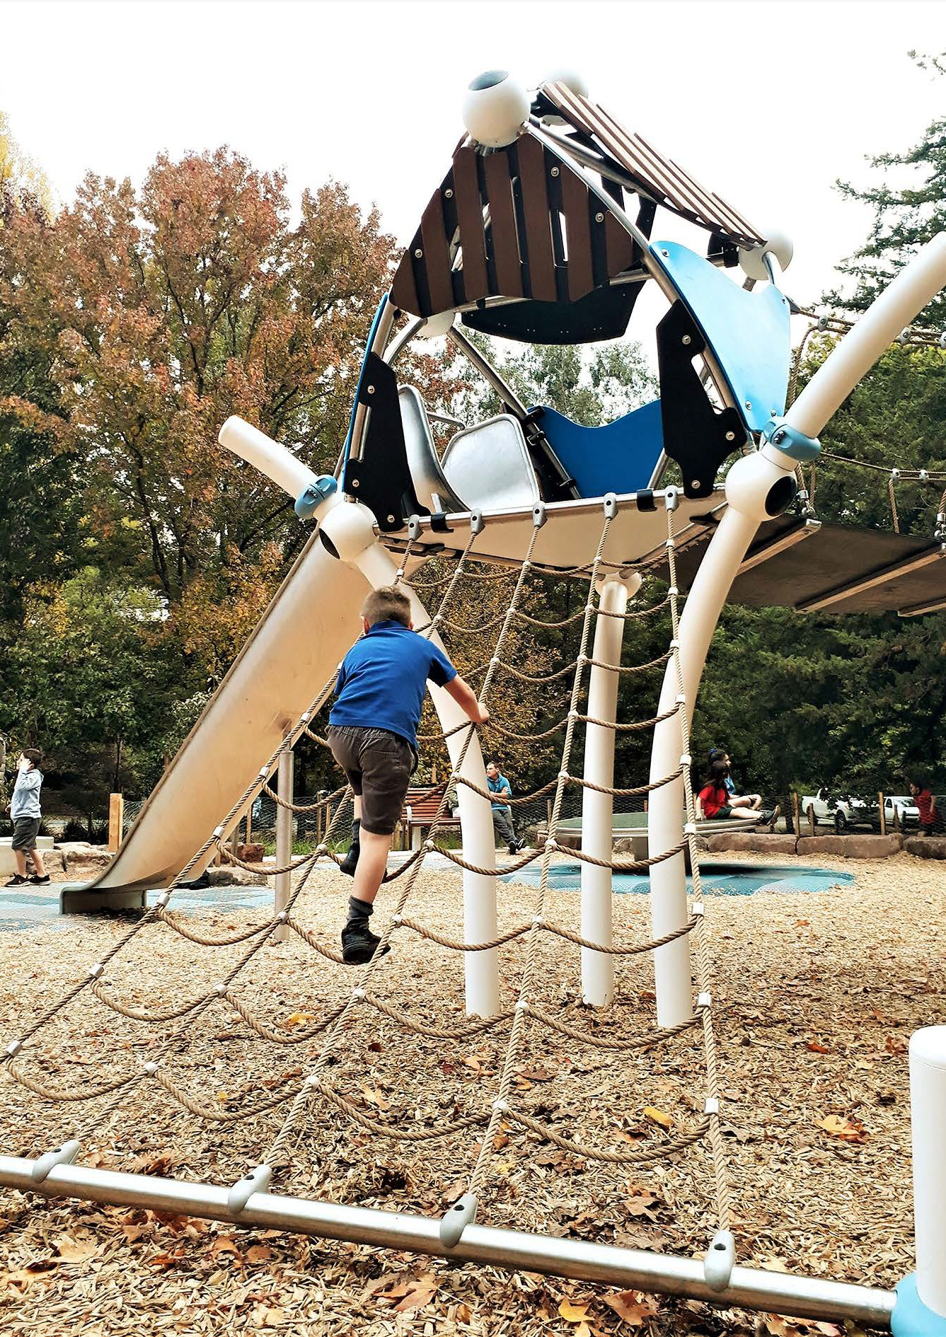

Child Safety
The safety of children and young people are highlighted because of the impact of early childhood experiences on many of the foundations for health and wellbeing. Council takes a zero-tolerance approach to child abuse and commits to:
  - safety, wellbeing and positive social outcomes of children and young people
  - prevention of abuse and neglect to avoid devastating and life-long impacts on health.
Council has a range of measures in place to become a strong, child safe organisation. This Plan includes actions to protect the safety
of children and young people in the priorities of mental wellbeing, preventing violence against women and children and alcohol, tobacco and other drugs.

44 | Yarra Ranges Health and Wellbeing Plan 2021–2025 Image: Cathy Ronalds 45

The Covid 19 pandemic and storm emergency
This Plan was developed during the global public health emergency of Covid 19. Research on the health impacts of Covid 19 inform this Plan. The Plan includes how Council will work to support community recovery. Recovery work takes an asset (strengths) based community development approach wherever possible to tap into the skills, wisdom and resources of communities.
Some people in our community will continue to experience greater impacts of the pandemic or are at higher risk of longstanding negative impacts. The wellbeing of young people, people with disability and their carers, Indigenous community members, people from diverse cultural backgrounds, those experiencing homelessness and single parent families, may have been disproportionately affected by the pandemic. Council is committed to supporting community members who are more affected during recovery. The long-term impacts expected from the pandemic will be monitored over time to inform actions to support social recovery.
Many health priorities and existing areas of concern in Yarra Ranges have worsened due to the pandemic and the 2021 storm:
  - mental health, mental wellbeing and social isolation
  - rates of family violence
  - employment and economic wellbeing
  - homelessness and housing issues
  - social inclusion, employment and educational outcomes for young people.

Research shows that women were disproportionately affected by the pandemic in a range of ways including:
  - employment impacts with female dominated industries in Yarra Ranges disproportionately affected e.g. tourism, hospitality
  - caring roles - women were primarily responsible for remote learning and caring for children, elderly, people with disabilities
  - mental health – isolation, insecure work and home schooling affected mental wellbeing.
Family violence incidence is also a concern with increased risk and incidents for women during and following the emergency including limited options to seek support and more opportunities for coercive control. This included Elder Abuse. (11) (12) In the initial aftermath of the storm Council received requests for help from women experiencing family violence and this will need to be a focus of recovery efforts.
Economic wellbeing is a powerful determinant of health. Council’s Economic Development and Investment team monitored businesses throughout the pandemic and storm event and provided support and information to assist businesses to access grants and other supports. A new Economic Development and Investment Strategy will set a roadmap for the future, including how Council can support employment and thriving local businesses.

46 | Yarra Ranges Health and Wellbeing Plan 2021–2025 Yarra Ranges Health and Wellbeing Plan 2021–2025 | 47

Our vision for
health and wellbeing
The vision of the 2021-2025 Health and Wellbeing Plan reflects where Council has responsibility, capability, roles and resources to improve health and wellbeing.
The Council Health and Wellbeing Plan must align local health priorities with the 2019-2023 Victorian Health and Wellbeing Plan . (5) The state Plan has 10 priorities and within this, four focus areas.

Yarra Ranges has connected and healthy communities that are resilient, fair and inclusive. Our places are liveable and sustainable.

The Plan is mostly about Council’s work to improve health and wellbeing. This is both direct work and work in partnership with other agencies and communities. Seven health and wellbeing priorities
are identified. These priorities reflect the most significant preventable causes of poor health and wellbeing in Yarra Ranges, and have been strongly confirmed by our community engagement. Each priority has a goal articulating the future we hope to see.

State priorities and those for Yarra Ranges closely align. Local health data and consideration of Council’s role, responsibility and influence indicate there are six shared priorities. Council adds the health impacts of emergencies like Covid 19, storms and other emergencies, to this list. The State plan was developed pre-Covid.
State Priorities
Reducing injury
Preventing all forms of violence
Decreasing the risk of drug resistant infections in the community
Improving mental wellbeing
Improving sexual and reproductive health
Reducing harmful alcohol and drug use
State Focus Areas
Tackling climate change and its impact on health
Increasing healthy eating
Increasing active living
Reducing tobacco-related harm

48 | Yarra Ranges Health and Wellbeing Plan 2021–2025 Yarra Ranges Health and Wellbeing Plan 2021–2025 | 49

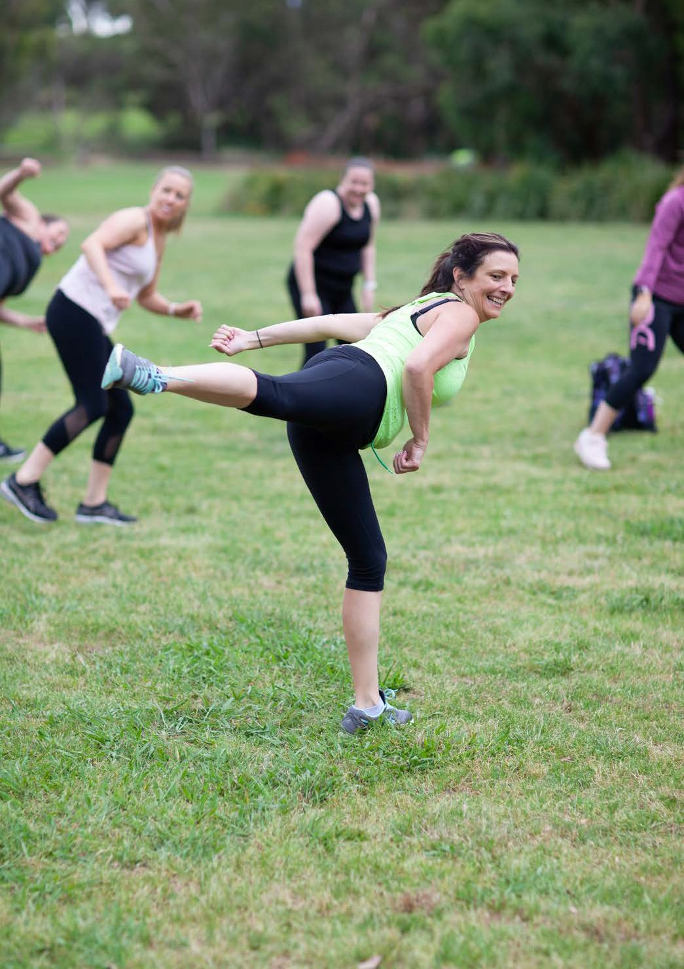

Local partnership to progress shared goals
Local community health organisations share priorities for improving health and wellbeing with Council. Collaborative planning by Council, Eastern Health Community Health, Inspiro and EACH has resulted in agreement to work on the following priorities over the next four years:
  - Healthy Eating: Increase consumption of healthy food and drink to enable better physical and mental health.
  - Physical Activity: Increase physical activity and enable people to lead active lives.
These two priorities will include a gender equity lens and build on previous collaborations in Yarra Ranges to reduce violence against women and children. Work to help prevent women and their children from experiencing violence and discrimination will support our communities to practice healthy and respectful relationships, and live free from gender inequalities.

Approach to gender equity
Council commits to implementing the legislated requirement to apply a gender impact assessment to all new and revised policies, programs and services. The Plan applies this lens to ensure actions are gender equitable and inclusive and contribute to achieving Council’s vision.

50 | Yarra Ranges Health and Wellbeing Plan 2021–2025 Yarra Ranges Health and Wellbeing Plan 2021–2025 | 51

Advocacy priorities
In addition to the priorities of the Plan, there are other issues where Council will primarily take an advocacy role. These advocacy priorities point to important systemic issues, the social determinants. Many are a longstanding focus for Council:

increase access to health services including mental health, with a focus on the mental health of young people
increase social housing and reduce homelessness
secure funding for an integrated Aboriginal community-controlled health service
improve public transport, increase service access in outer areas of Yarra Ranges.

What you told us...
This Plan has been developed with engagement and consultation with community, our partners and across Council. Through a survey and other engagements, community members and local
organisations confirmed the priorities and provided important insights into what assists in building healthy local people and communities.
In a simple rating exercise, community members prioritised, mental health, preventing violence against women and the health impacts of emergencies as their highest concerns.
The health and wellbeing priorities of the Plan were previously validated in community engagements for the Liveable Climate Plan and the development of the 2021-2025 Council Plan, which told us people value social connections and inclusion, our natural environments and give high priority to recovery from the Covid 19 pandemic.
The 280+ people who completed a survey on the priorities of the Plan provided important insights on the 7 priorities. The response rate was a credible sample, noting that only 20% of respondents were male and over 40% were aged 50 and over. However, views among men and women on the priorities mostly aligned. People who care for someone with a disability or older adult were well represented.
Young people were under-represented in the survey. Engagements with Council’s Youth Ambassadors helped fill this gap in the survey. An overview of what community shared with us through the survey is available on Council’s website. Throughout the life of this Plan Council will continue to talk with and engage with community members on the priorities.



52 | Yarra Ranges Health and Wellbeing Plan 2021–2025 Yarra Ranges Health and Wellbeing Plan 2021–2025 | 53



Health and Wellbeing Priorities 2021
Priority 4
Increase active living
Goal | People in Yarra Ranges have capacity to walk and be physically active through accessible footpaths, trails, parks, play spaces and an inclusive culture that supports participation in all forms of physical activity.

Priority 1
Respond to public health impacts of emergencies
Goal | Communities in Yarra Ranges recover from Covid 19 and other emergencies and restore social connections, mental and physical health and wellbeing, thriving local places and economies, and access to services and resources needed.

Priority 5
Improve mental wellbeing and social connection
Goal | People in Yarra Ranges have good mental wellbeing through strong community connections, family supports and ease of accessto mental health services

Priority 2
Tackle climate change and its impacts on health
Goal | People and businesses in Yarra Ranges are resilient, prepared, and able to adapt and protect against the potential health impacts of climate change.

Priority 6
Prevent violence against women and children
Goal | Women and children in Yarra Ranges live free from abuse and violence through a culture of gender equity and respect.

54 | Yarra Ranges Health and Wellbeing Plan 2021–2025 Yarra Ranges Health and Wellbeing Plan 2021–2025 | 55
Priority 3
Increase healthy eating
Goal | People in Yarra Ranges have the capacity to consume healthy food, built on a sustainable food system that provides access to healthy, affordable food for all.

Priority 7
Reduce harmful alcohol and drug use
Goal | People in Yarra Ranges are safe from the harmful effects of alcohol and other drugs - particularly from alcohol and tobacco, through preventing uptake and support for safe alcohol use.

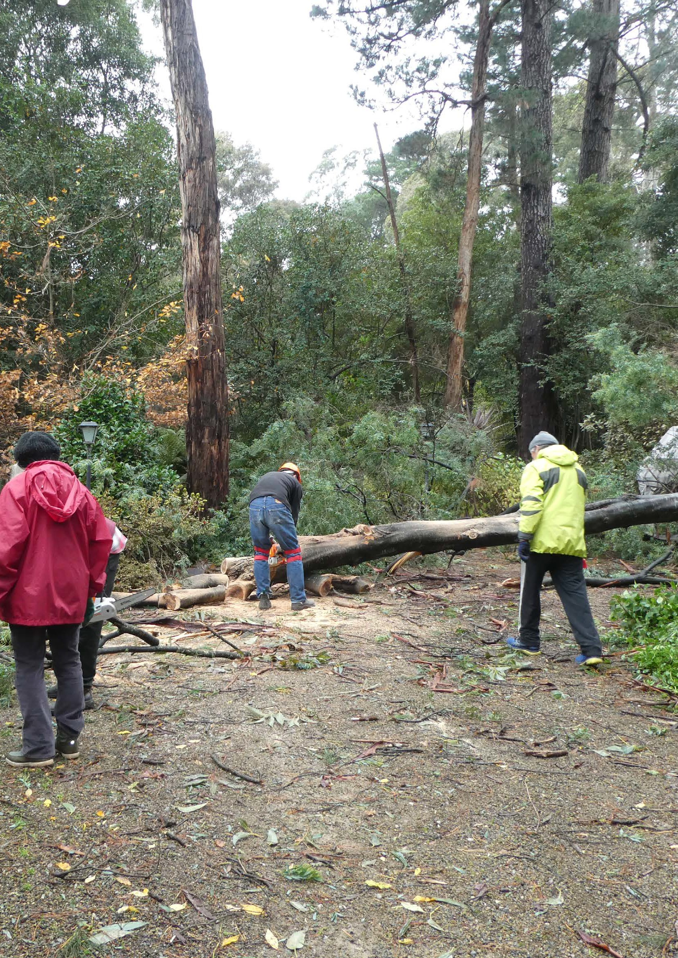

Priority 1

Respond to public health impacts of emergencies

Our goal for preparing and responding to the health impacts of emergencies:
Communities in Yarra Ranges recover from Covid 19 and other emergencies and restore:
strong and sustainable social connections
mental and physical health and wellbeing
thriving local places and economies
access to the services and resources needed.

This section outlines: why this is a health and wellbeing priority, the data for Yarra Ranges, what a gender and intersectionality lens reveal, our approach to improve health and wellbeing, and our priority actions. A detailed action plan is included at Appendix 1.

56 Yarra Ranges Health and Wellbeing Plan 2021–2025 | 57

Why responding to the health impacts of emergencies is a priority

P1

Public health emergencies in Yarra Ranges can include: pandemics; bushfires; storms, flooding; infectious disease outbreaks and toxic chemical spills.
This plan will provide guidance to:
  - support recovery from the Covid 19 pandemic and the 2021 storm event
  - prepare for public health emergencies
  - respond to and provide relief in public health emergencies
  - support community led recovery in new emergencies such as bushfire and flood.
Council has a legislated role to respond to emergencies and assist community led recovery. It has other roles directed by the State in relief operations depending on the kind of emergency.
Council’s work is informed by past emergencies and best practice principles. Social and economic recovery from the impacts of Covid 19 which affected everyone, and the devastating and concurrent emergency of the 2021 June storm, will be a focus for the coming years. This priority is closely connected with the impacts of climate change on health (Priority 2).

The Centre for Social Issues and Professor Ian Hickey 2020 paper comment on what is most needed for mental wellbeing with ongoing lockdowns:

…public health messages are required that engage people to be community-minded and active in their local settings to support and care for each other in really testing times… supporting each other, and those who are distressed, within our families, workplaces, communities…
They also note that drivers of substantive health risks (resulting from lockdowns) to monitor are:
  - Job losses, social disconnection and, for young people, the lack of availability of support for ongoing education and training.
  - Industries like hospitality, tourism and the arts that were already devastated in past lockdowns.

58 | Yarra Ranges Health and Wellbeing Plan 2021–2025 Yarra Ranges Health and Wellbeing Plan 2021–2025 | 59

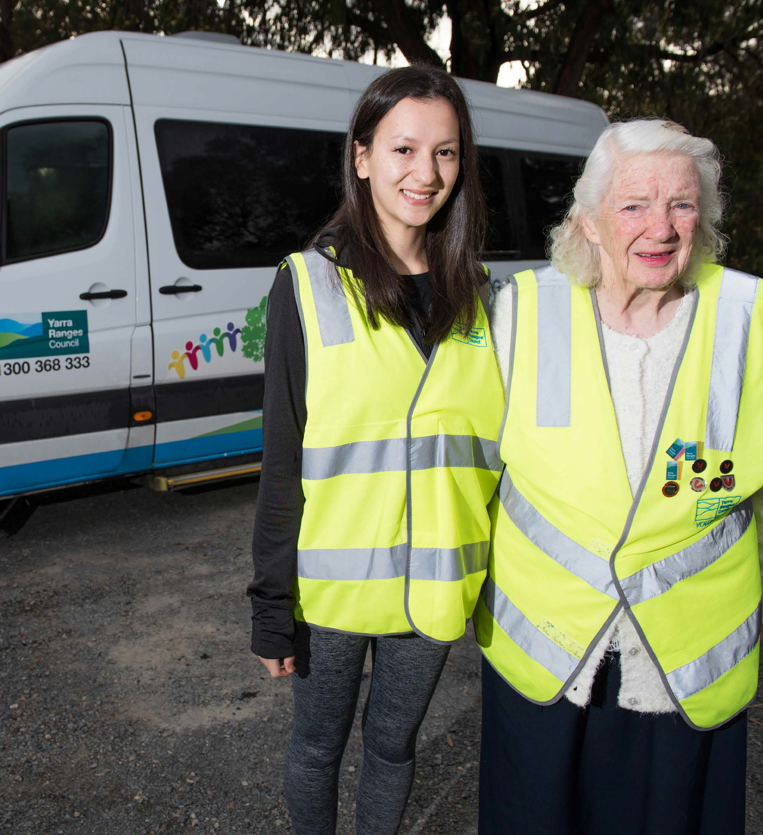

P1

Public health emergencies in Yarra Ranges
Covid 19 impacted both Yarra Ranges residents and businesses. During 2020-21, Council undertook community surveys to track and understand the impacts of Covid 19 and assess the needs of residents to inform Council action and advocacy. Information from the surveys inform this Plan. Council will continue to monitor the impact of the pandemic and storm through surveys over the next few years.
On top of the effects of Covid 19, the June 2021 storm event caused widespread destruction of homes and our natural environment. It required concurrent responses to a lockdown and storm, to support communities across Yarra Ranges.
Council has a role in emergency relief and response in partnership with government and local agencies. It has a central role in recovery.
The impacts of the storm will require immediate, medium, and long-term action and the recovery plan in place for Covid 19 will be adapted to include storm impacts.

60 | Yarra Ranges Health and Wellbeing Plan 2021–2025 61

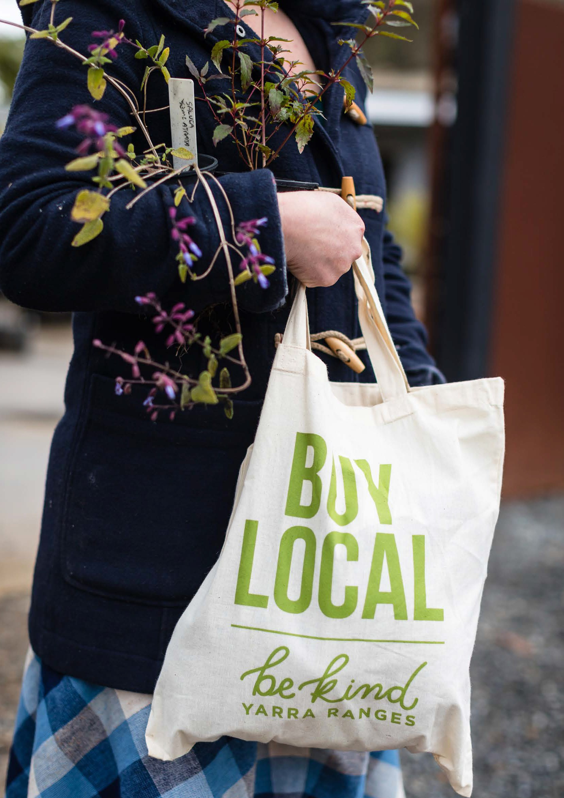
Image: Cathy Ronalds
63

P1

Council programs and activities to support communities in 2020
supported businesses and communities including a Be Kind campaign and Buy Local for the 2020 festive season
offered grant funding to not-for-profit community groups, artists and organisations to respond to relief and recovery needs
established the model for regional (area-based) Community Recovery Committees to facilitate community led recovery
offered mental Health First Aid courses for community leaders and volunteers
funded the emergency relief network to increase coordination, strengthen governance, assist with increased demand during and after lockdowns and re-engage volunteers
advocated to other levels of government: air quality monitors for Healesville and Warburton, employment impacts of Covid 19 and on homelessness through regional advocacy
made over 18,500 outreach calls to older residents, volunteers, U3As and seniors’ groups during the pandemic to check on their welfare and distributed 24,000 newsletters
ensured Council’s Meals on Wheels program was maintained by redeploying Council staff. Provided alternate activities for older adults during lockdown
adapted events to online e.g. Reconciliation Week and International Day for People with Disability forums, significantly increasing participation. Creative Communities activities and workshops were also offered online.

62 | Yarra Ranges Health and Wellbeing Plan 2021–2025

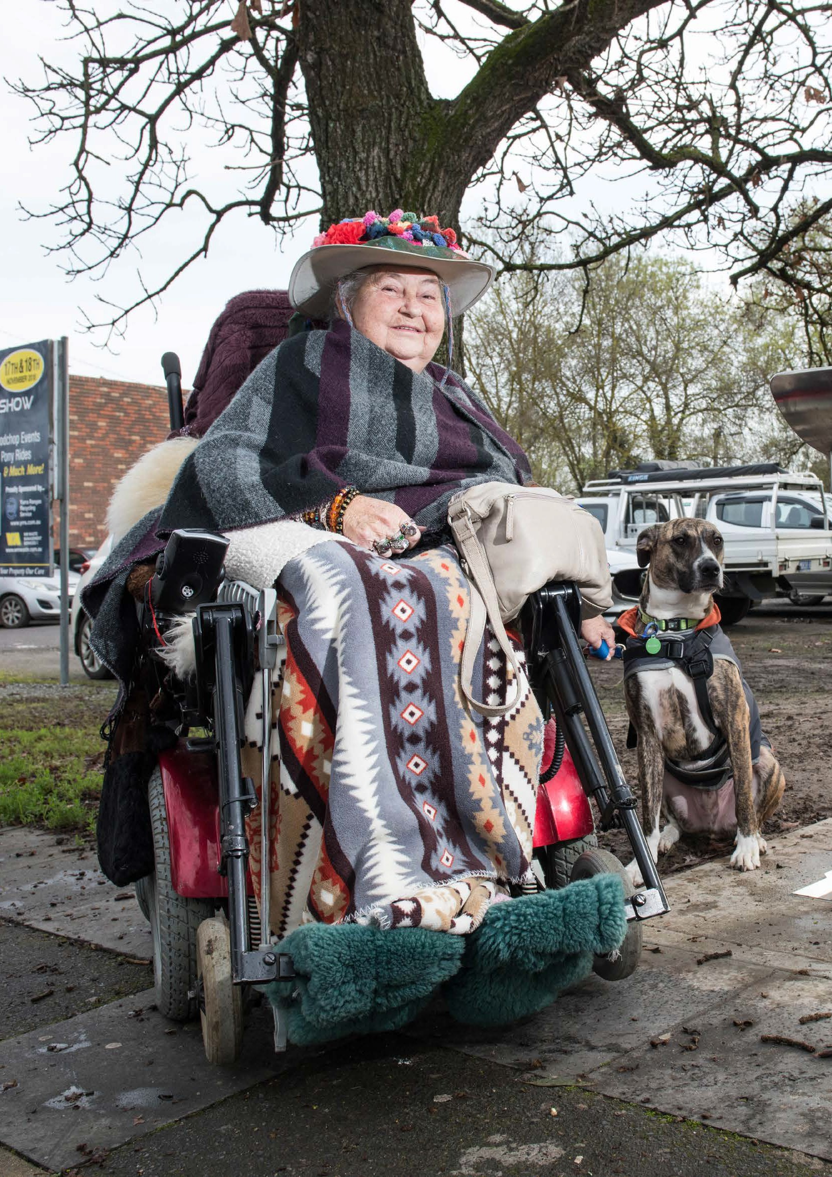
Image: June Smith
65

P1

Gender equity and intersectionality impacts
During times of emergency, such as Covid-19, people are more likely to take up traditional gender roles and gender inequalities may increase. There can be disproportionate impacts of the emergency on different genders. This was seen during Covid 19 with women in
Victoria spending the most time helping children (72% of women) and women aged 18-24 experiencing significant job loss during the first lockdown (26% compared to 11% of men). (12) More than a quarter (26%) of women aged 18-24 lost their job during the first lockdown, compared to 11% of young men. Data is not sufficient to report on gender diverse community members’ experience.
Access to services and supports for people with disability and carers were affected by Covid 19. Local engagement has shown some carers of people with disability have experienced greater isolation and increased caring load during Covid 19. Older carers with
limited access to the internet and those living in our rural areas were particularly affected. Disability services pivoted quickly to offer Covid Safe supports.
Anecdotal information indicated that during the Covid 19 pandemic, women with disability and carers were particularly affected by the social isolation caused by lockdowns and other restrictions. This was the case more generally for people with disability and those who care for them.
In 2021 the new National Commission for Children highlighted the need to have greater focus on the needs of young children’s development due to interruptions to schooling during Covid.

64 | Yarra Ranges Health and Wellbeing Plan 2021–2025

P1

Our approach
Covid 19 is an emergency like no other and affected everyone. Best practice principles for community led recovery apply to the Covid 19 pandemic:
  - understand community context where each community has its own history, values and dynamics
  - respond to the complex and dynamic nature of emergencies and the affected community
  - apply community-centred, responsive, flexible approaches, engaging with community and supporting their futures
  - take a planned, coordinated and adaptive approach between community and agencies.
  - continuous assessment of impacts and needs
  - ensure effective communication between affected communities and other partners
  - recognise, support and build on individual, community and organisational capacity and resilience
  - apply gender equitable and inclusive responses that recognise that women, men and gender diverse people will have experienced the pandemic in different ways
  - understand diversity, Indigenous people, young people, people from culturally diverse backgrounds and people with disabilities are also likely to have different experiences that need to be well understood.

Community recovery can include:

advocacy to all levels of government to meet local needs
Council delivering community support and other services and facilities

enabling and supporting partners and promoting the work of others
connecting community with other services and resources.

Through its role in planning and preparedness for public health emergencies and co-ordinating recovery, Council is well placed to connect and work with affected communities. It is paramount that Council considers the needs of those people who are most affected in our community and applies a gender lens to understand the nuances of how emergencies affect people of different gender identities in different ways. Community involvement in recovery will strengthen resilience.
Communities are best placed to identify priority areas for recovery and lead or support programs and activities to address these priorities.
Building strong and sustainable social connections is instrumental in responding to public health emergencies such as the Covid 19 pandemic and the 2021 storm event. The Priority to improve mental wellbeing and social connection lists what we aim to achieve and our top actions to improve mental wellbeing, which will also be critical to recovery.

66 | Yarra Ranges Health and Wellbeing Plan 2021–2025 Yarra Ranges Health and Wellbeing Plan 2021–2025 | 67

P1

Community survey
Priority actions areas
To attain our goal in responding to the public health emergencies, we aim to achieve:
- strong and sustainable social connections
- thriving local places and economies
- accessible services and resources needed by communities.
- protected local amenity through resilient infrastructure
- easy to find and use services and resources needed by communities in emergencies.

85% of people nominated
‘responding to the health impacts of emergencies’
as the top priority
Results obtained by a survey completed
mid-2021

T“he Council has a crucial role in emergencies as they know so much about the local area in terms
Based on the principles and approaches of the plan described in Appendix 3, the Action Plan to progress these achievements lists the:
- priority action areas for Council in partnership with others
- sections of Council that are responsible, and our external partners
- measures of success and related Council plans.

of access and safe routes and resources to assist with response. They have strong partnerships with business, health providers, clubs, community to bring together the correct groups to enact and coordinate responses.
Mutually reinforcing work across Goals
Actions and projects to achieve the goal of each Priority often intersect. Work in one area being mutually reinforcing of the goals in other areas. Actions for public healthemergencies may reflect work and co-benefits in other Priorities of the Plan, particularly:
Priority 2 | tackle climate change and its impacts on health
Priority 5 | improve mental wellbeing and social connections
Priority 6 | prevent violence against women and children

68 | Yarra Ranges Health and Wellbeing Plan 2021–2025 Yarra Ranges Health and Wellbeing Plan 2021–2025 | 69

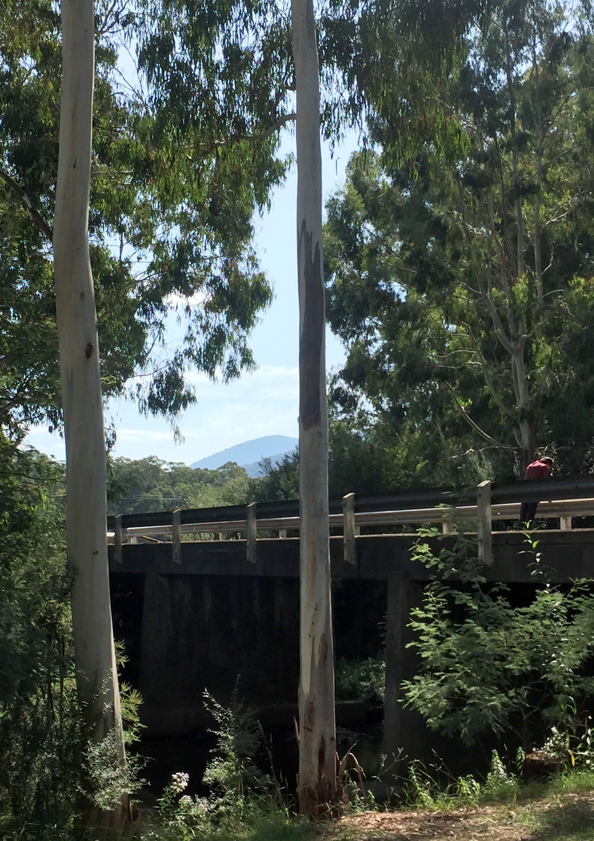

Priority 2

Tackle climate change and its impacts
on health

Our goal for tackling climate change and its impacts on health:
People and businesses in Yarra Ranges are resilient, prepared, and able to adapt and protect against the potential health impacts of climate change.

This section outlines why this is a health and wellbeing priority, the data for Yarra Ranges, what a gender and intersectionality lens reveal, our approach to improve health and wellbeing, and our priority actions. A detailed action plan is included at Appendix 1.

70 Yarra Ranges Health and Wellbeing Plan 2021–2025 | 71

Why climate change is a health priority

‘Climate change as the defining issue for public health in the 21st century. It is an urgent challenge, with
implications at the global, national and community levels.’ ‘Our lives depend on a healthy planet’
- World Health Organization 2016 (13)
Local government is identified in the Climate Change Act 2017 as a decision maker which must consider climate change when preparing this Plan. Tackling climate change and its impact on health is one
of four priorities identified as a focus in the Victorian Public Health and Wellbeing Plan 2019-2023. (5) The Victorian Public Health and
Wellbeing Outcomes Framework includes the outcome that Victorians belong to resilient and liveable communities, indicated by increased
adaptation to the impacts of climate change. (14)

Climate change, health, and the determinants of health

‘Health of humankind is intricately connected to the health of the overall environment and with other living beings.’
- United Nations Climate Change 2017 (15)
Climate change is expected to directly cause increased intensity and frequency of extreme weather events, such as prolonged heatwaves, floods and bushfires. Indirectly, climate change will cause worsening air quality; risks to food safety and drinking water quality; and ecological and land use change, as represented below from the Lancet Commission of Climate and Health. (16)
The direct health impacts of climate change are predicted to include deaths, injuries and ill-health due to increases in respiratory diseases, cardiovascular diseases, infectious diseases, mental health issues, allergies, injuries, poisoning, dehydration and malnutrition.
Respiratory diseases
Cardiovascular diseases
Infectious diseases Mental illness Allergies
Injuries
Poisoning Undernutrition
Health impacts
Social determinants of health
Socioeconomic status
Education Housing Transportation Food security Social capital Age
Gender
Indirect effects

Water quality Food safety Air quality
Ecological and
land use change

Direct effects

Extreme heat Bushfires Drought Floods
Source: Adapted from Lancet Commission of Climate and Health (16)
In addition, climate change is expected to indirectly impact the major determinants of health, including socio-economic status, education, housing, transport, food security, social capital and social connections. People will also suffer different levels of impact depending on many of these factors e.g. income, housing security and through individual factors such as age, gender, disability and Indigenous status.

72 | Yarra Ranges Health and Wellbeing Plan 2021–2025 Yarra Ranges Health and Wellbeing Plan 2021–2025 | 73

Climate change in Victoria and Yarra Ranges
Victoria’s climate has become hotter and drier over the past few decades. Over the next thirty years, climate change is forecast to lead to increased average temperatures, high-heat days, high fire danger days and sea levels. In addition, climate is expected to lead to reduced snowfall, but more intense rainfall.
These changes then lead to increased intensity and numbers of extreme weather events such as heatwaves, bushfires, storms, drought and floods. Indirectly these events may impact water quality, food safety, air quality, land use, the ecological system and biodiversity.
The 2021 storm event caused widespread power outages and damage to property from trees down. It affected access to water, safe food storage and sewerage systems in many areas. Road access was blocked and the ability to stay warm and get adequate nutrition was diminished. Education and employment were severely affected and our reliance on technology showed a lack of resilience and preparedness, particularly in communications systems.
A particularly severe heatwave in the summer of 2003 resulted in more than 70,000 excess deaths across Western Europe. Health systems were unprepared and quickly overwhelmed. (16) In 2009 Victorian experienced a heatwave which led to the Black Saturday fires and directly affected communities in Yarra Ranges. As a direct result of
the heatwave in the lead-up to the fires, 374 Victorians died through causes such as heat stroke and heart attacks.

Gender equity and intersectionality impacts
Climate-related disasters can lead to existing gender inequalities worsening, greater adherence to gender roles and stereotypes and increased risk of family violence. It is internationally recognised that gender must be central to efforts to adapt and build resilience, to counter the impact of climate change.
Women are disproportionally affected by the impacts of climate change. Globally, women and children are significantly more likely than men to die during climate-related disasters, and they comprise up to 80 percent of those displaced by natural disasters. In our engagement, young people consistently raised concerns about climate change as a priority. They also express concern at the future they face because of climate change.
Five Council Youth Ambassadors rated climate change as their second highest priority after mental wellbeing, noting the two are linked.
They reported that their peers feel a sense of hopelessness and the need to share information about what individuals can do to help.
They encouraged Council to show this is an issue it cares about, to help people feel less anxious. The young people also proposed more education on sustainability actions such as eating more plant-based foods, less fast fashion. One Ambassador noted:

“the world is full of good people that can make the changes needed.”

74 | Yarra Ranges Health and Wellbeing Plan 2021–2025 Yarra Ranges Health and Wellbeing Plan 2021–2025 | 75

P2
Health and climate: co-benefits

Our approach
Health benefits
Example interventions
To tackle climate change and its impacts on health, the Victorian Government wants to achieve:
Better mental  health | Fewer deaths from  extreme heat | Less cardiovascular  disease | Less respiratory  disease | Lower rates of  cancer | Lower rates of  obesity

  - resilient and safe communities that are adapting to the public health impacts of climate change
  - decreased health impacts associated with climate change for example, fewer deaths from extreme heat events, fewer mosquito- borne diseases, fewer food poisoning outbreaks, fewer algal blooms in drinking water catchments
  - increased action to reduce greenhouse gas emissions and realise health co-benefits. (5)
Reducing climate change has considerable health co-benefits (see diagram). (17) Actions by Council to mitigate and adapt to climate change will reduce negative impacts on our environment and promote physical health and wellbeing.

Produce more renewable  energy | Improve insulation in homes | Encourage use of lower emission  vehicles | Promote active transport | Reduce solid fuels used for  cooking | Less food from animal sources | Encourage locally produced  fruit and veg

Example co-benefits

Fewer fossil fuels  Lower CO₂ levels | Improved air quality  Thermal comfort | Reduced humidity and damp  Less noise | Reduced heat in urban areas | Reduced livestock production | Less deforestation | Less meat consumed

Source: Adapted from Health and climate: co-benefits diagram (17)

76 | Yarra Ranges Health and Wellbeing Plan 2021–2025 77

P2

During recent incidents relating to climate change in Victoria, the main loss of life has occurred through extreme weather events leading to bushfires, storms and floods; and high heat days causing heat stress amongst residents. (18) Interventions by Councils that could reduce illness and deaths from heatwaves include to:
  - increase community awareness of projected impacts, frequency and intensity of: bushfires, storms, floods and heatwaves on health and preventing impacts
  - implement urban greening and cooling strategies
  - encourage leadership in local development through low carbon and climate-adapted neighbourhoods
  - support programs that improve energy efficiency and thermal comfort, maintain safe indoor temperatures and reduce bill stress including for older people and those more affected
  - ensure emergency management plans and strategies consider projected changes in climate and climate-related health risks
  - plan for and invest in cooler and cleaner air spaces to provide community respite
  - link Council service users into appropriate services e.g. hardship schemes for utility retailers
  - monitor water quality and foodborne disease outbreaks during heatwaves (Environmental Health teams).
Council has already acted to incorporate climate change into health planning. The impact of climate change on the community is on the agenda through:
  - declaring a Climate Emergency
  - developing a Liveable Climate Action Plan
  - identifying climate change as a key health and wellbeing priority
Partnerships identify how Council and the community can work together to support a healthy, sustainable food system, which is linked to both health and climate change, and with clear health co-benefits.
While this Plan is focused on adapting to and preventing the health impacts of climate change, action to mitigate climate change is essential to reducing the direct and indirect health impacts. Council’s work on climate change mitigation is captured in its 2020 Liveable Climate Action Plan.
A focus on supporting community adaptation is also needed because a certain amount of climate change is now inevitable due to for example population growth and increased emissions. Action needs to include:
  - continued emphasis on understanding and assessing the risks of climate change to public health
  - promoting community adaptation and preparedness for the public health risks associated with climate change
  - assessing the health co-benefits of measures to reduce greenhouse gas emissions.

P2

78 | Yarra Ranges Health and Wellbeing Plan 2021–2025 Yarra Ranges Health and Wellbeing Plan 2021–2025 | 79

P2

Community Survey
Priority actions areas
To attain our goal in tackling climate change and its impacts on health, we aim to achieve:
- healthy and resilient country in face of climate change
- creation of places of respite for those who most need them during extreme weather
- increased community awareness of the health impacts of climate change and increased capacity to prevent them.

Young people rated ‘tackling the climate change
impacts on health’ higher than other age groups
Young people account for 9% of survey
75% rated this priority as important or extremely important
Women placed more importance on this priority
80% of women and 73% of men

I believe it is the most important issue of our time and the Council has an opportunity to be a leader in this space.
“
“
Based on the principles and approaches of the plan described in Appendix 3, the Action Plan to progress these achievements lists the:
- priority action areas for Council in partnership with others
- sections of Council that are responsible, and our partners
- measures of success and related Council plans.

Mutually reinforcing work across Goals
Actions on climate change and health may reflect work and co-benefits in other Priorities, particularly:
Priority 1 | respond to health impacts of emergencies
Priority 5 | improve mental wellbeing and social connections
Priority 6 | prevent violence against women and children

Shade trees in paved community spaces will help stop heat radiating off the paving.

The use of pesticides on health was also raised during the engagement.
Council’s use of pesticides is very limited, and it has reduced the use of herbicides through the implementation of other treatment options such as mechanical works and mulching. Council continues to look at alternative treatments across the open space network.

80 | Yarra Ranges Health and Wellbeing Plan 2021–2025 Yarra Ranges Health and Wellbeing Plan 2021–2025 | 81

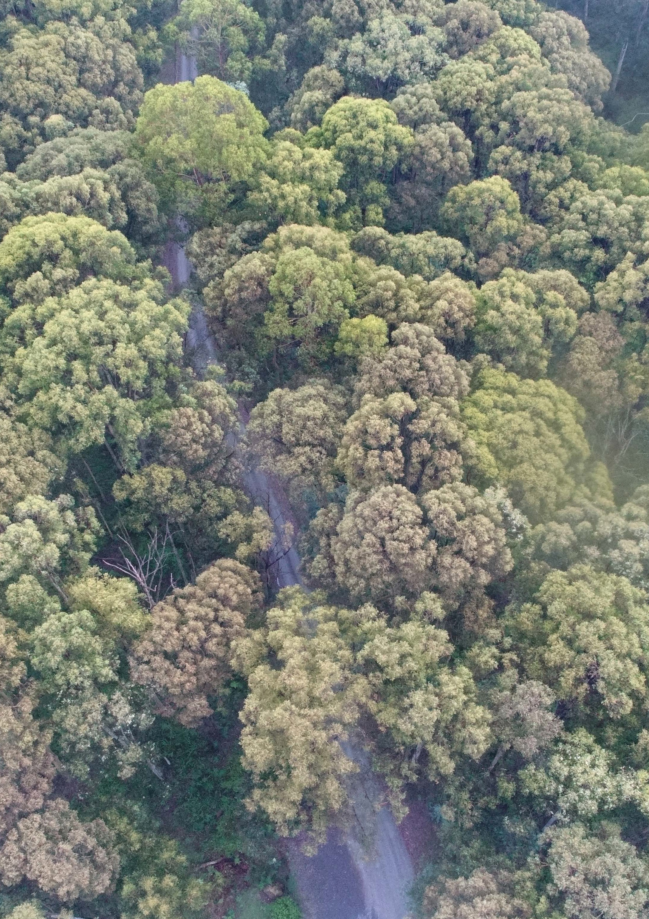
83

P2

While this Plan is focused on adapting to and preventing the health impacts of climate change, action to mitigate climate change is essential to reducing the direct and indirect health impacts. Council’s work on climate change mitigation is captured in its 2020 Liveable Climate Action Plan.
A focus on supporting community adaptation is also needed because a certain amount of climate change is now inevitable due to for example population growth and increased emissions. Action needs to include:
  - continued emphasis on understanding and assessing the risks of climate change to public health
  - promoting community adaptation and preparedness for the public health risks associated with climate change
  - assessing the health co-benefits of measures to reduce greenhouse gas emissions.

82 | Yarra Ranges Health and Wellbeing Plan 2021–2025

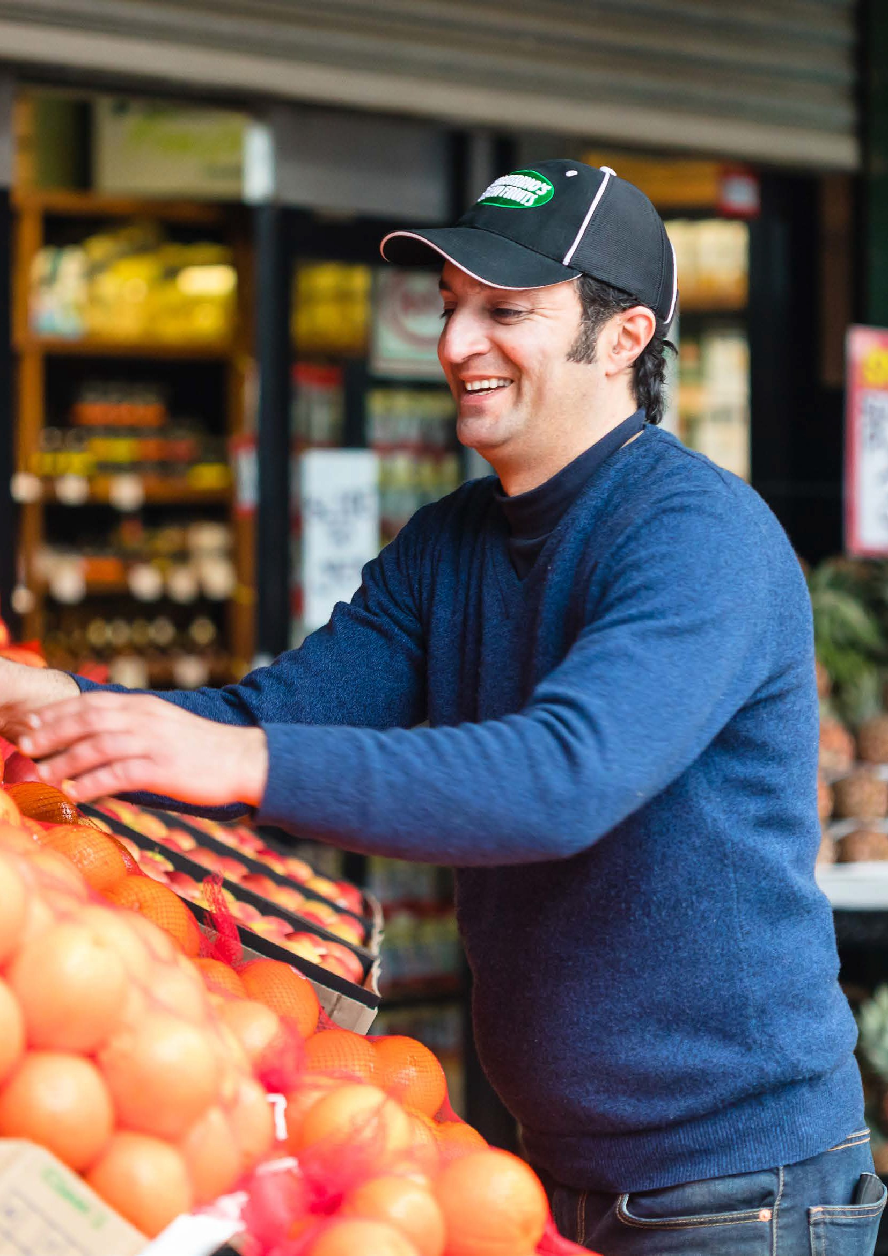

Priority 3

Increase healthy eating

Our goal to increase healthy eating:
People have the capacity to consume healthy food, which is built on a sustainable food system that provides access to healthy, affordable food for all.

This section outlines: why this is a health and wellbeing priority, the data for Yarra Ranges, what a gender and intersectionality lens tell us, our approach to improve health and wellbeing, and our priority actions. A detailed action plan is included in Appendix 1.

84 Image: Cathy Ronalds Yarra Ranges Health and Wellbeing Plan 2021–2025 | 85

Why healthy eating is a priority

P3
Increasing healthy eating is one of ten priorities identified in the Victorian Public Health and Wellbeing Plan 2019-2023 . (5) This has been a priority of previous Council plans because of the significant relationship between nutrition and health. The Victorian Public Health and Wellbeing Outcomes Framework includes the outcome that Victorians act to protect and promote health indicated by an increase in healthy eating and active living. (14)
Healthy eating is central to good health and wellbeing. Diet is arguably the single most important behavioural risk factor that can be improved to have a significant impact on health. (19)
What we eat and the food environment changed substantially over the past three decades. This shift has contributed to chronic diseases such as cardiovascular disease, type 2 diabetes and some cancers. Two-thirds (68%) of Victorian adults are overweight or obese (20) - applied to Yarra Ranges this is an estimated 90,000 adults.
“

Food consumption and production disproportionally affect human health and environmental sustainability; food is the single strongest lever in optimising health for humans and the environment.
- EAT-Lancet Commission (21)

Achieving health and wellbeing - nurturing and celebrating all bodies
Unhealthy weight is a complex and global population health reality. Not including enough high nutrition foods contributes substantially to weight gain. Around the world, obesity has risen among children and adults in recent decades. This rise is leading to significant
consequences for the health of the affected individuals, along with an increasing burden on health services, social support and economic productivity. Being underweight contributes to a weakened immune system, fragile bones and fatigue.
For many decades health policy and clinical practice have been based on weight-centred principles. This coupled with our objectifying body culture brings much confusion and distress about weight and shape issues across communities, particularly for women and girls. Focusing on weight and weight loss can lead to:
  - weight stigma
  - poor body image
  - exercise avoidance
  - unhealthy dieting and eating behaviours
  - a range of mental health issues including eating disorders
  - substance abuse
  - weight cycling and/or weight gain. (22)
People with positive body image appreciate their bodies primarily for what they can do, their functionality and their health. They are more likely to engage in regular pleasurable activity and have a flexible approach to exercise, food and eating. Having positive body image means an individual is more likely to listen to their body in relation to what and how much to eat, eat foods that are healthy, and help their bodies to perform well.

86 | Yarra Ranges Health and Wellbeing Plan 2021–2025 Yarra Ranges Health and Wellbeing Plan 2021–2025 | 87

Social determinants of healthy eating
Social determinants are highly influential in an individual’s choice of food, especially:
88 | Yarra Ranges Health and Wellbeing Plan 2021–2025

Healthy eating and food security in Yarra Ranges
Many Yarra Ranges adults, as for all of Victoria, do not consume enough of the foods and drinks required to keep them healthy e.g. fruit and vegetables, wholegrain foods and water. Many consume too many discretionary and processed foods and drinks, often high in saturated fat, sugar, salt or alcohol. More than half (58%) of Australians’ food spending is on discretionary food and drinks, such as fast food and sugary soft drinks. Some populations are more at risk of unhealthy eating patterns, particularly those living in disadvantaged areas, and Indigenous residents. (24)
economic determinants such as cost and income
physical determinants such as access, education, skills and time
socio-cultural determinants such as culture, and social context. (23)

In 2017, these data were for Yarra Ranges adults: (4)
- 10% had been affected by food insecurity in the past 12 months. In 2014, 16% of adults in Yarra Ranges worried about food insecurity with hunger, the highest in the EMR; 11% of parents relied on low- cost food to avert food insecurity
- 15% consumed sugar sweetened drinks daily, compared to 10% across Victoria.
- Often consumed takeaway and other processed foods in place of fresh fruit and vegetables - 16% of adult residents having take- away meals or snacks more than once each week
- only 4% of adults ate enough fruit and vegetables, with 6% meeting the vegetable consumption guidelines. Most residents ate less than half the recommended level of vegetables per day.
While Yarra Ranges generally has access to high quality food, the cost of healthy food and public transport access remain issues for a proportion of the community. (25) New data will be available later in 2021 and will be reviewed with an eye to impacts of Covid 19.

Yarra Ranges Health and Wellbeing Plan 2021–2025 | 89

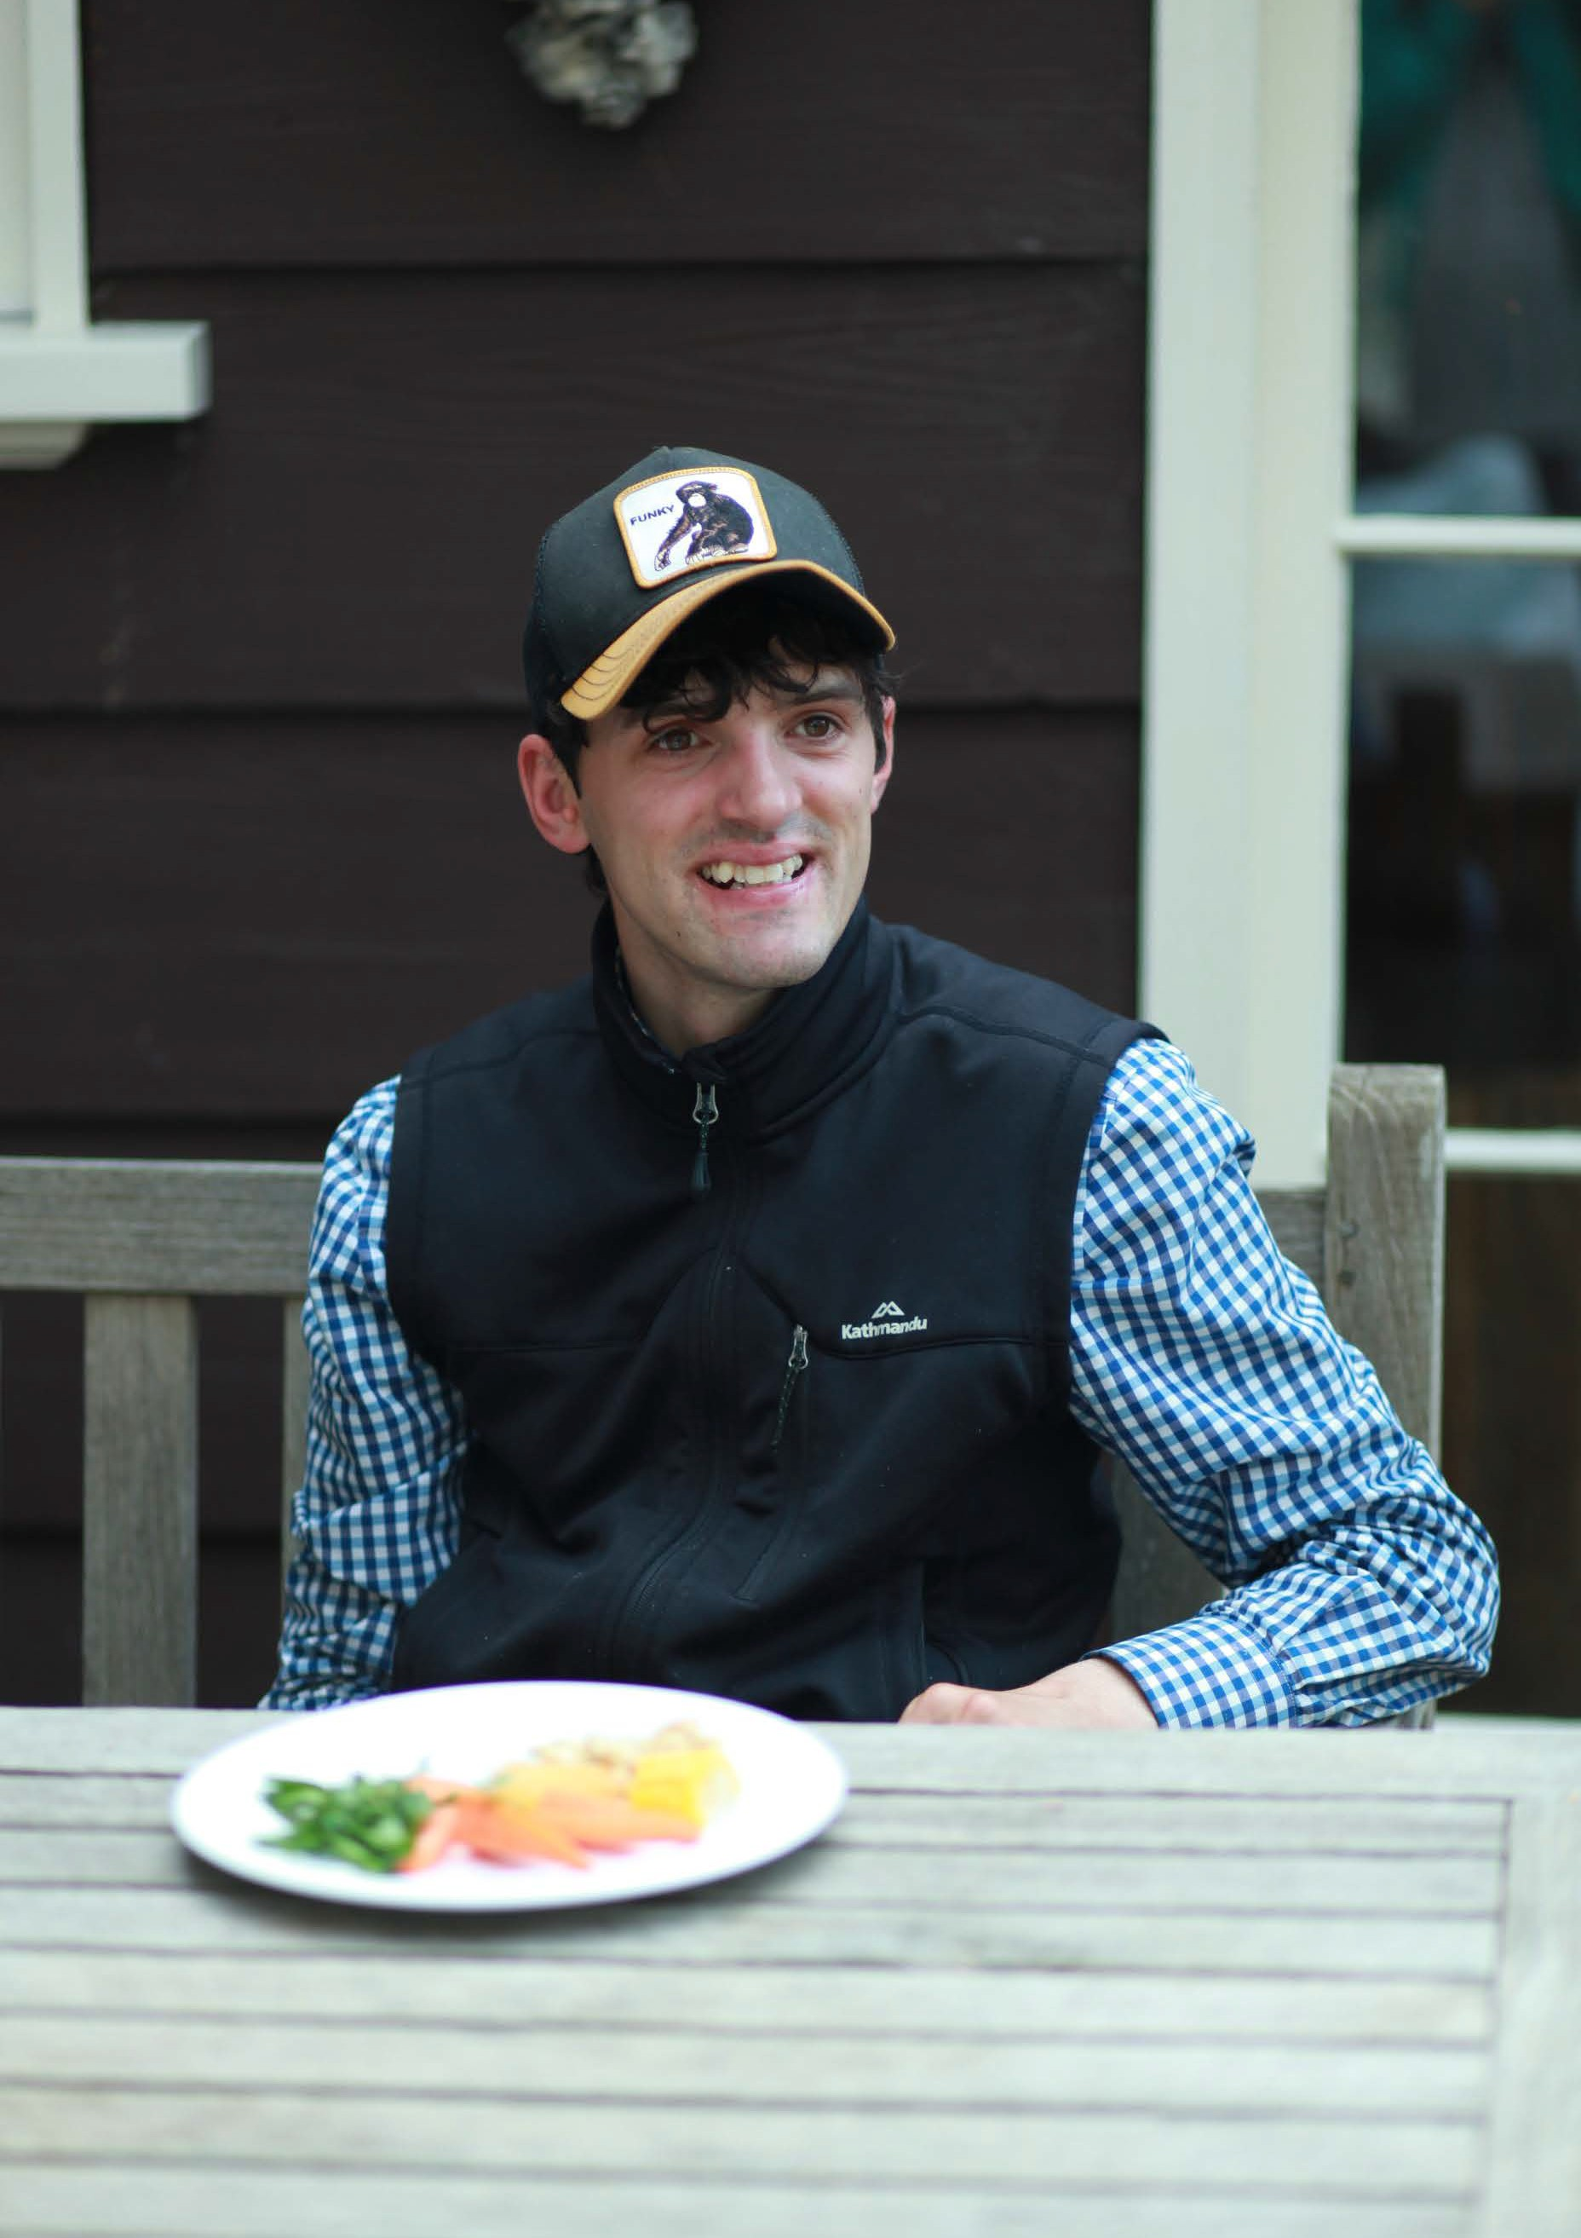
91

P3

Healthy eating during Covid 19 pandemic
The Covid 19 pandemic exacerbated unhealthy eating and food insecurity. Yarra Ranges Council surveyed residents during lockdown. Healthy eating was one of the main concerns. Nearly 20% of parents and carers of children and teenagers had contacted food relief services during lockdown. (26)
Local challenges to healthy eating during the pandemic were reflected across Victoria and Australia. One in five Australians experienced problems maintaining a healthy lifestyle due to Covid 19. (11) They consumed more unhealthy snacks, more takeaway and delivered foods and more alcohol.
For Victorian adults during Covid 19 lockdown: (12)
  - sugary drink consumption more than tripled, with nearly one-third of respondents living in the metro/rural interface having sugary drinks every day
  - food insecurity nearly doubled - 7% of respondents ran out of food and could not afford to buy more. Indigenous residents had higher food insecurity
  - metro/rural interface areas had the lowest vegetable consumption
- only 4% of respondents were eating enough (8% across Victoria); 29% were likely to rely on low-cost unhealthy food due to financial issues; 7% went without meals; 9% used food relief agencies; 17% worried about having enough money to buy food; and 11% skipped meals to feed their households
  - young people aged 18-24 and adults aged 25-34 years had much higher food insecurity than older adults.

90 | Yarra Ranges Health and Wellbeing Plan 2021–2025

P3

Our approach
To achieve the benefits of healthier eating, the Victorian Government wants to:

Increase
access to healthier food and drinks
capacity to breastfeed, and prepare and consume healthier foods and drinks
capacity to not consume discretionary food and drinks
socio-cultural norms reinforcing healthier eating, drinking and breastfeeding
purchase of healthier food and drinks and decrease purchase of discretionary food and drinks.

Decrease
access to discretionary foods and drinks
sodium, saturated fat and added sugar, and increase fruit, vegetables, wholegrains and dairy/alternatives in processed and ready-to-eat foods
the quantity of discretionary food and drinks served eating out and at home
exposure to marketing of discretionary foods and drinks and increase exposure to marketing of healthier food and drinks. (5)

The Food System
A sustainable food system delivers food security and nutrition for all without compromising the economic, social and environmental pillars to generate food security and nutrition for future generations. This means that it:
  - is profitable throughout (economic sustainability)
  - has broad-based benefits for society (social sustainability)
  - has a positive or neutral impact on the natural environment (environmental sustainability).
Increasing healthy eating in Yarra Ranges is dependent on a sustainable food system. Council, all levels of government, communities, businesses and the individual all have a role in establishing and maintaining a system to support healthy eating, as shown in the diagram on the following page. (27)
Local Councils are uniquely positioned to address health issues by increasing access to healthy, sustainable and affordable food for all community groups including populations at risk of food insecurity.

Inclusive approaches
Council supports taking a weight inclusive approach. Building on positive strategies already in place, partner led programs will focus on prevention and early intervention of eating disorders and weight stigma and the promotion of positive body image across all sectors of our community. Weight inclusive aims, backed by research,
include: creating environments where people with bodies of all shapes and sizes thrive, and where access to and motivations for health enhancing behaviours are nurtured through self-acceptance, care and compassion rather than shame, fear and guilt.

92 | Yarra Ranges Health and Wellbeing Plan 2021–2025 Yarra Ranges Health and Wellbeing Plan 2021–2025 | 93

P3

How can governments support healthy food preferences?
The food system is an interconnected network of producers, industry, and institutions. But at its heart is the individual. Policy can affect all parts of the network, influencing a cultural shift towards healthier food preferences.

Government policies

Food system and individual changes

Governments

Set food standards in schools

Incentivise healthy food retailers to enter low income areas

Restrict marketing to children

Tax unhealthy foods

Provide healthy eating education

Schools

Regulate to prevent positioning unhealthy food outlets where children gather

Legislate for consumer-friendly nutrition labelling

Subsidise healthy foods to increase availability/ affordability

Influence each other
as role models, caregivers and peers

Provide healthy foods to children

Individuals

Redesign the choices available at point
of sale and increase the availability of healthy options

Invest in infrastructure for producing healthier foods

Reformulation of products to reduce unhealthy ingredients

Increased demand
for healthier choices

Retailers

Food producers

Change in demand for healthier choices

Increased shelf-space for healthier choices

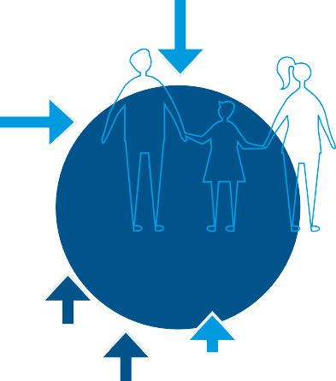

94 | Yarra Ranges Health and Wellbeing Plan 2021–2025 Source: (27) 95

P3

Community Survey
Priority actions areas
To attain our goal of increasing healthier eating, we aim to achieve:
- a healthy, sustainable food system with healthy food available to all in Yarra Ranges
- community led action on healthy eating supported by Council grants
- collaborative approaches to nutrition that increase access to healthy and affordable food
- community gardens that thrive as places that build skills in growing and preparing food
- community members able to access healthy and affordable food from a range of sources
- girls and boys with the skills to prepare and enjoy healthy food, free from stereotypes and rigid gender roles
- a community that nurtures and celebrates all bodies and reduces stigma
- Council contracted services and catering policy that advance healthy eating through clear standards and expectations.

75% of people rated ‘increasing healthy eating’
as extremely or very important
Healthy eating had lowest level of prioritisation
People aged 65–74 rated this priority as most important

I see a lot of potential in partnering … to provide educational opportunities for community members to learn how to cook healthier meals.
“
“

Reduce food miles by supporting local growers and helping local growers to re-diversify back to what the Yarra Valley once had, not that long ago.
Based on the principles and approaches of the plan the Actions to progress these achievements lists the:
- priority action areas for Council in partnership with others
- sections of Council that are responsible, and our partners
- measures of success and related Council plans.
“

No more chips at Council venues.
Mutually reinforcing work across Goals
Actions to increase healthy eating may reflect work and co-benefits in other Priorities of the Plan, particularly:
Priority 4 | increase active living
Priority 5 | improve mental wellbeing and social connections

96 | Yarra Ranges Health and Wellbeing Plan 2021–2025 Yarra Ranges Health and Wellbeing Plan 2021–2025 | 97

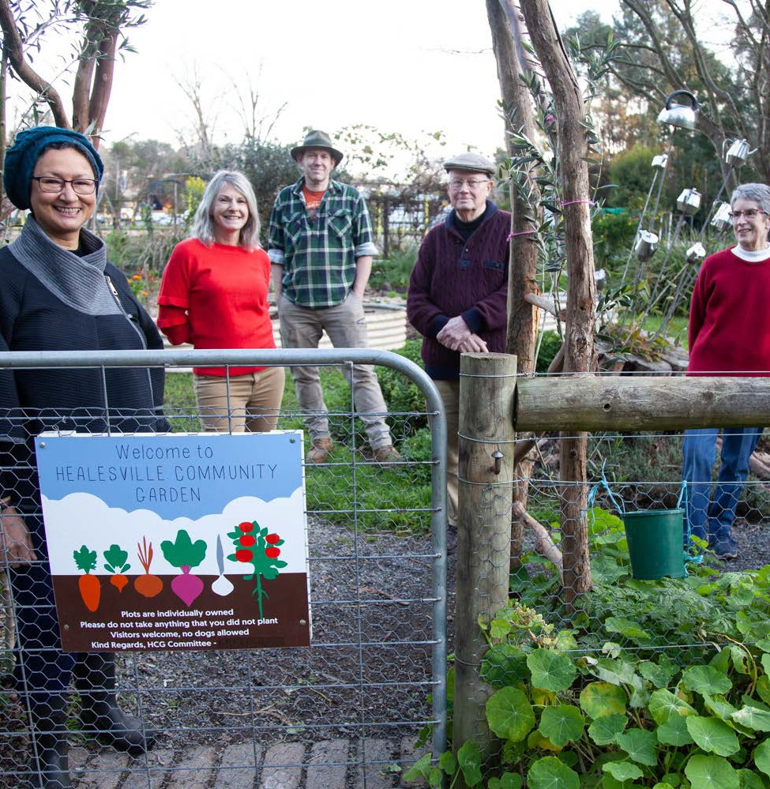P3

Council is a partner in the Healthy Active Living Group, which is currently focusing on developing a plan to improve the resilience and sustainability of the food system in Yarra Ranges, with a focus on access to healthy and sustainable food.

Partnerships
Recent work of the Healthy Active Living Group has focused on engaging with the community and stakeholders. This engagement aims to:
  - understand community and stakeholder priorities, including gendered differences
  - widen the range of stakeholders involved in the project
  - increase awareness of the work being done on food systems and map existing work
  - identify key strategic and research priorities for 2022-2025.
By the end of 2021, a report on the engagement findings will inform an action plan for 2022-2025.
Council is a member of the SUSTAIN food system network which supports collaboration with other local governments; and collates research on food systems and plans in other regions and examines best practice for food systems planning.

98 | Yarra Ranges Health and Wellbeing Plan 2021–2025 99

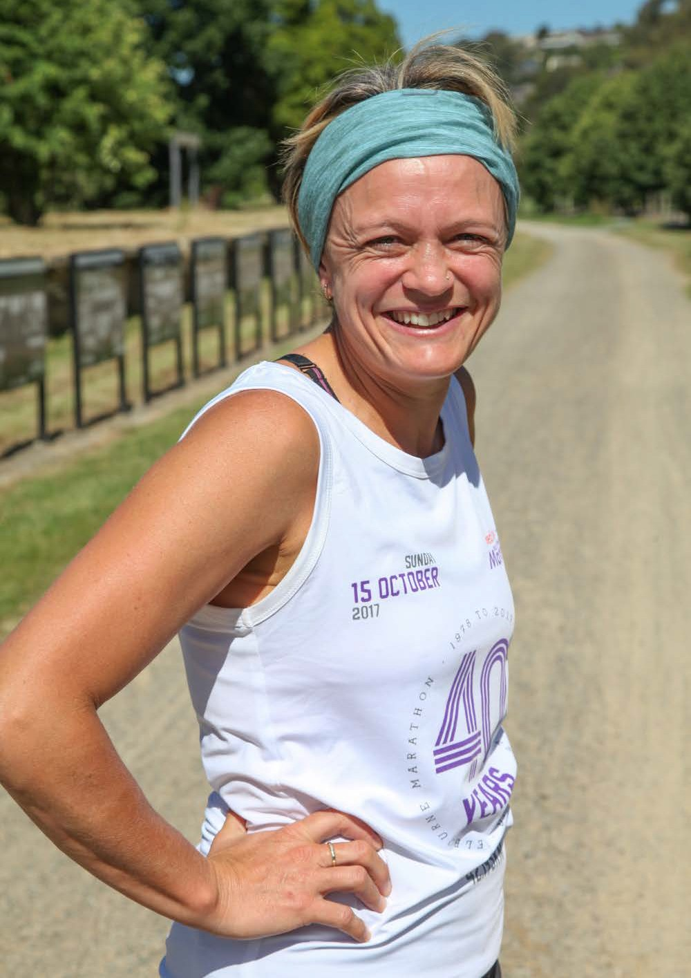

Priority 4

Increase active living

Our goal to increase active living:
People in Yarra Ranges have the capacity to walk and be physically active through accessible footpaths, trails, parks and play spaces, and an inclusive culture that supports participation by as many people as possible in all forms of physical activity.

This section outlines: why this is a health and wellbeing priority, the data for Yarra Ranges, what a gender and intersectionality lens tell us, our approach to improve health and wellbeing, and our priority actions. A detailed action plan is at Appendix 1.

100 Yarra Ranges Health and Wellbeing Plan 2021–2025 | 101

Why active living is a priority
Increasing active living is one of four priorities identified as a focus in the Victorian Public Health and Wellbeing Plan 2019-2023 and was a priority in the previous Council Plan. The Victorian Public Health and Wellbeing Outcomes Framework includes the outcome that Victorians act to protect and promote health, indicated by an increase in healthy eating and active living. (14)
Leading an active life improves people’s health and wellbeing. Moving more and sitting less, reduces the risk of ill-health and death. Regular physical activity can help prevent and treat diseases such as heart disease, stroke, some cancers, diabetes, osteoporosis, dementia, musculoskeletal conditions and depression.
Being physically active in combination with having a healthy diet helps to reduce the prevalence of other health risk factors, such as high blood pressure and high blood cholesterol, and can help maintain a healthy weight. Incorporating physical activity into daily living is also associated with improved mental health, ageing well and increased levels of happiness.

How does active living help our communities?
Active communities experience other benefits. Higher levels of physical activity are associated with better academic performance throughout early childhood and school, and with increased workplace productivity.
Neighbourhoods which are designed to encourage walking, cycling and use of public transport promote positive social connections and feelings of safety and belonging; support local business activity; and reduce environmental impacts from car emissions and traffic congestion. Car emissions contribute to climate change; increasing the number of trips made and using sustainable transport modes is therefore important to mitigating climate change.
Sport and active recreation play an important role in the social and cultural life of Yarra Ranges. They can help to challenge and shift socio-cultural norms, and to reduce inequalities and discrimination
within communities. Sport and active recreation also deliver substantial economic benefits. Sport and recreation environments can be important places to challenge attitudes and behaviours that excuse or support disrespect, gender inequality and violence against women. (28)

102 | Yarra Ranges Health and Wellbeing Plan 2021–2025 Yarra Ranges Health and Wellbeing Plan 2021–2025 | 103

Social determinants of active living
The quality of the built environment is a major determinant of physical activity. The built environment can either enable, or be a barrier to, active living. Neighbourhoods where residents can walk to local services such as schools, sport and recreation facilities, public transport and destinations near people’s homes, can encourage higher levels of physical activity.
Characteristics of the built environment supporting health and wellbeing, particularly active living, include, distances to playgrounds, daily living destinations, public open spaces and parks, and street connectivity.

Active living in Yarra Ranges
In 2017 in Yarra Ranges, 58% of adults did enough physical activity to support good health. (4) This is greater than the 51% for all of Victoria. Location, Indigenous status, socio-economic advantage, disability and gender all affect levels of activity. Physical activity is significantly lower amongst people living in Australia’s most disadvantaged areas.
The level of residents with insufficient physical activity dropped from 55.5% in 2014 to 38% in 2017. This met the state government’s target of a 10% increase in the level of adults with sufficient physical activity. More people have active occupations in Yarra Ranges, with residents less likely to sit for 7 or more hours per day at work. Walking is the most popular physical activity of adults in Australia.

104 | Yarra Ranges Health and Wellbeing Plan 2021–2025 Yarra Ranges Health and Wellbeing Plan 2021–2025 | 105

Active living during the Covid 19 pandemic
A Council survey in September 2020 highlighted impacts of the pandemic. (26) Reduced physical activity and lack of access to usual physical exercise opportunities negatively affected wellbeing. The loss of sport and other exercise such as gyms, also exacerbated social isolation.
A VicHealth survey in May 2020 found that 37% of respondents were doing less physical activity during lockdown. (12) Physical activity varied substantially by area. Only 29% of residents in interface areas were exercising five or more days per week.
Building access to quality public places, walking paths and trails and lighting for use in future lockdowns and restrictions during public health emergencies such as the Covid 19 pandemic, is an effective way to support residents to maintain active living and support the co- benefit of mental wellbeing.

Gender equity and intersectionality impacts
In 2017, men and women had similar levels of physical activity. (4) There is no information on physical activity levels for people in Yarra Ranges of other socio-demographic groups. For adults in Victoria in 2018 getting enough physical activity was higher for employed adults and those on higher incomes. (29) Further details are provided in Appendix 3.
Although many women and girls participate in recreational and structured sports activities, a lot remains to be done in the sphere of gender equality. (30) Many women are today still unable to find the
right environment in which to develop their full potential. Many factors, external to sport, can affect women’s levels of participation. These include gender stereotypes about where and how women can be active, the situation at home and the role of physical education at school.
Many factors are at play within the sport sector which can hamper the participation of women, for instance a lack of coaches able to create a gender friendly and safe sport environment and low interest from decision making boards, often dominated by men, for sustainable gender equality policies that lead to real changes.

106 | Yarra Ranges Health and Wellbeing Plan 2021–2025 Yarra Ranges Health and Wellbeing Plan 2021–2025 | 107

Spotlight on women in sport & physical activity in Yarra Ranges
Motivators
positive social aspects of physical activity
caregiving responsibilities as the main reasons for visiting parks and open spaces is to spend time with family
paths are accessible for prams, good seating areas, public toilets.

A survey of residents provided the following local insights into participation.
Enablers
well designed and inclusive built environment to facilitate participation in physical activity
well located disability parking spaces
low-cost activities.

Top 5 activities in our open spaces:
walking or running
sitting and relaxing
meeting up with friends
walking the dog
having a picnic.

Unstructured activities
women and girls engage more in unstructured activity than structured sports compared to males:
 | females | males
walking is the most popular activity | 96% | 55%
bushwalking and trail running | 73% | 47%
swimming | 49% | 25%
fitness/gym | 48% | 26%

Barriers
footpaths and cycling/walking trails are missing/unsafe
not enough lighting
work commitments
lack of shelter/shade and not enough rest areas and seating rank.

108 | Yarra Ranges Health and Wellbeing Plan 2021–2025 Yarra Ranges Health and Wellbeing Plan 2021–2025 | 109
Perceptions of safety & other barriers
perceptions of safety, fear of judgment, exercising alone, time constraints and poor accessibility to open space due to lack of public transport
barriers are amplified for women who experience intersecting forms of discrimination, or who are victims of trauma and domestic violence.

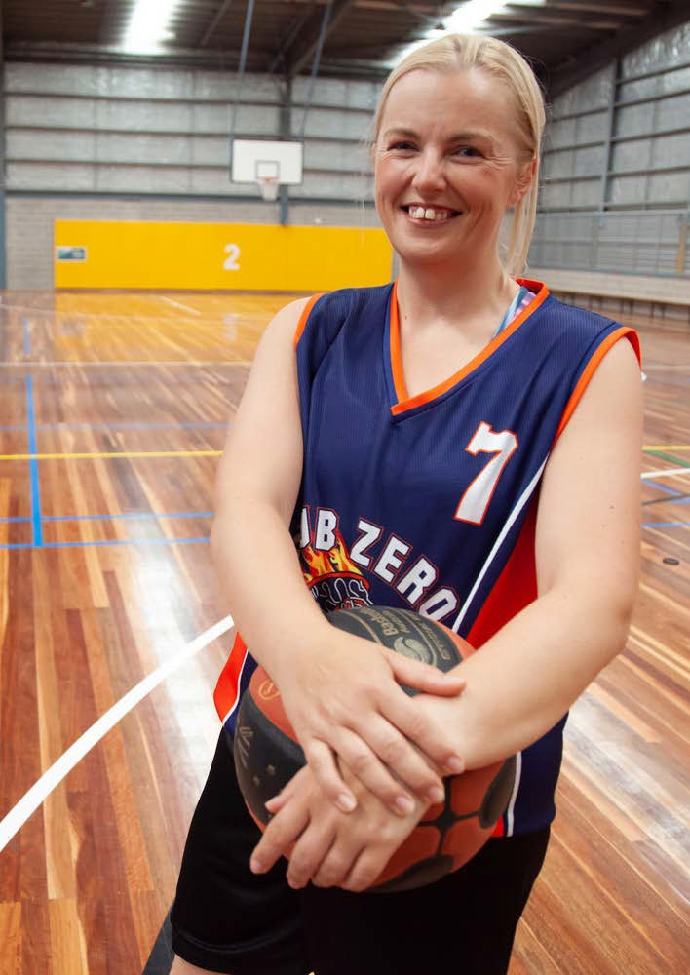
111

P4

Our Approach
To achieve the health impacts of active living, the Victorian Government wants to:
  - improve neighbourhood and precinct planning to better support active living
  - increase accessible and adaptable spaces for active living, ensuring compliance with appropriate state and national regulations and standards
  - increase socio-cultural norms reinforcing active living
  - increase capacity to be more physically active and less sedentary
  - improve integration and accessibility of public transport
  - increase active transport
  - increase participation in sport and active recreation activities
  - decrease sedentariness in workplaces, schools and early learning centres and during leisure time. (5)

110 | Yarra Ranges Health and Wellbeing Plan 2021–2025

P4

Community Survey
Priority actions areas
To attain our goal in increasing active living, we aim to achieve:
- universal access of footpaths and trails
- accessible and inclusive parks, recreation facilities and Playspaces
- active residents - participating in walking and physical activity
- culture change that supports participation of women, men and gender diverse community members in sport and recreation
- inclusive cultures that support participation by all, in all forms of physical activity.

82% of people rated ‘increasing active living’ as extremely or very important

It was more important for people living in urban areas and people 75 years and over

Support and increase participation in sports and recreation for older adults.
“
“
Based on the principles and approaches of the Plan, the Actions to progress these achievements lists the:
- priority action areas for Council in partnership with others
- sections of Council that are responsible, and our partners
- measures of success and related Council plans.

While physical activity is important, it’s also important to include diversity and not focus on just one activity which caters mostly for a specific gender and age group.
“
Mutually reinforcing work across Goals
Actions to increase physical activity may reflect work and co- benefits in other Priorities of the Plan, particularly:
Priority 3 | increase healthy eating
Priority 5 | improve mental wellbeing and social connections
Priority 7 | reduce harmful alcohol and drug use

Lighting of facilities is very important for women to feel safe when they exercise early morning or
late at night.

112 | Yarra Ranges Health and Wellbeing Plan 2021–2025 Yarra Ranges Health and Wellbeing Plan 2021–2025 | 113

Priority 5

Improve mental wellbeing and social
connection

Our goal for improving mental wellbeing and social connection:
People have good mental wellbeing through strong community connections, family supports and ease of access to mental health services.

This section outlines: why this is a health and wellbeing priority, the data for Yarra Ranges, what a gender and intersectionality lens tell us, our approach to improve health and wellbeing, and our priority actions. A detailed action plan is at Appendix 1.

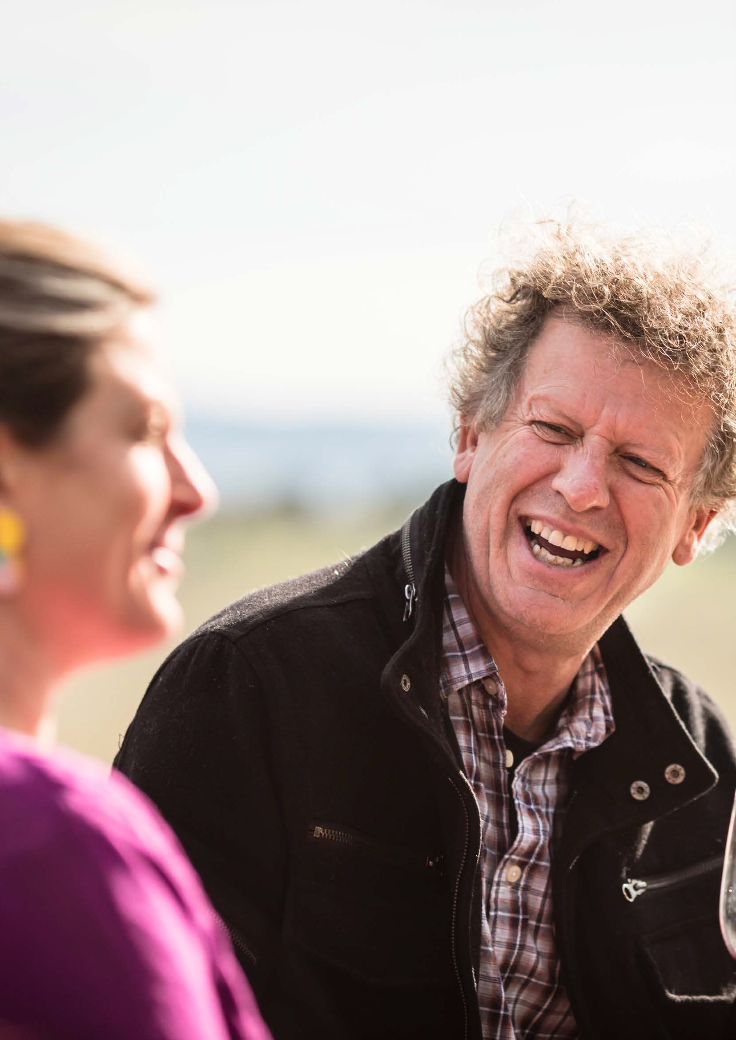114
Image: Cathy Ronalds
Yarra Ranges Health and Wellbeing Plan 2021–2025 | 115

Why mental wellbeing and social connection is a priority
P5

‘As a herd species, human beings have an inherent need to live in small groups, herds, and belong to tribes for nurturing, sustenance and protection.
Because we are social beings the only identity that makes sense is the identity that’s related to where we belong and where we fit into the networks we belong to…’
Hugh MacKay Social Researcher - The Art of Belonging 2015

Improving mental wellbeing was a priority in the last Council Health and Wellbeing Plan. It’s also one of ten priority areas in the Victorian Public Health and Wellbeing Plan 2019-2023. The Victorian Public Health and Wellbeing Outcomes Framework includes the outcomes: Victorians have good mental health, and Victorians are socially engaged and live in inclusive communities. (14)
The 2021 Council Plan identifies improving mental health as a major initiative. The following action will guide our work to improve mental wellbeing:
‘Improve mental health outcomes for the community, strengthen social connections, and advocate for equitable and accessible
mental health services across the municipality’.

Mental health conditions are one of the top five causes of burden of disease and death in Australia. (5) Having good mental health supports people to fully live their lives, cope with life stresses, work productively, and contribute to their communities. (31) Mental health and physical health are inextricably linked. Compared to the general population, people with mental illnesses are more likely to develop physical illnesses such as cardiovascular disease, respiratory disease and cancer; and to have a reduced life expectancy. (32)
Mental health conditions may also intersect with chronic diseases such as diabetes, cardiovascular disease, cancer. Harms from alcohol and substance use, and problem gambling may also intersect with mental health.

Social connection
The benefits of social connections for good mental health are numerous:
  - strong, healthy relationships can help to strengthen the immune system, help recover from disease, and may even lengthen life
  - social ties are a potential resource that can be harnessed to promote population health
  - proven links of social connection include lower rates of anxiety and depression, higher self-esteem, greater empathy, and more trusting and cooperative relationships. (33)

116 | Yarra Ranges Health and Wellbeing Plan 2021–2025 Yarra Ranges Health and Wellbeing Plan 2021–2025 | 117

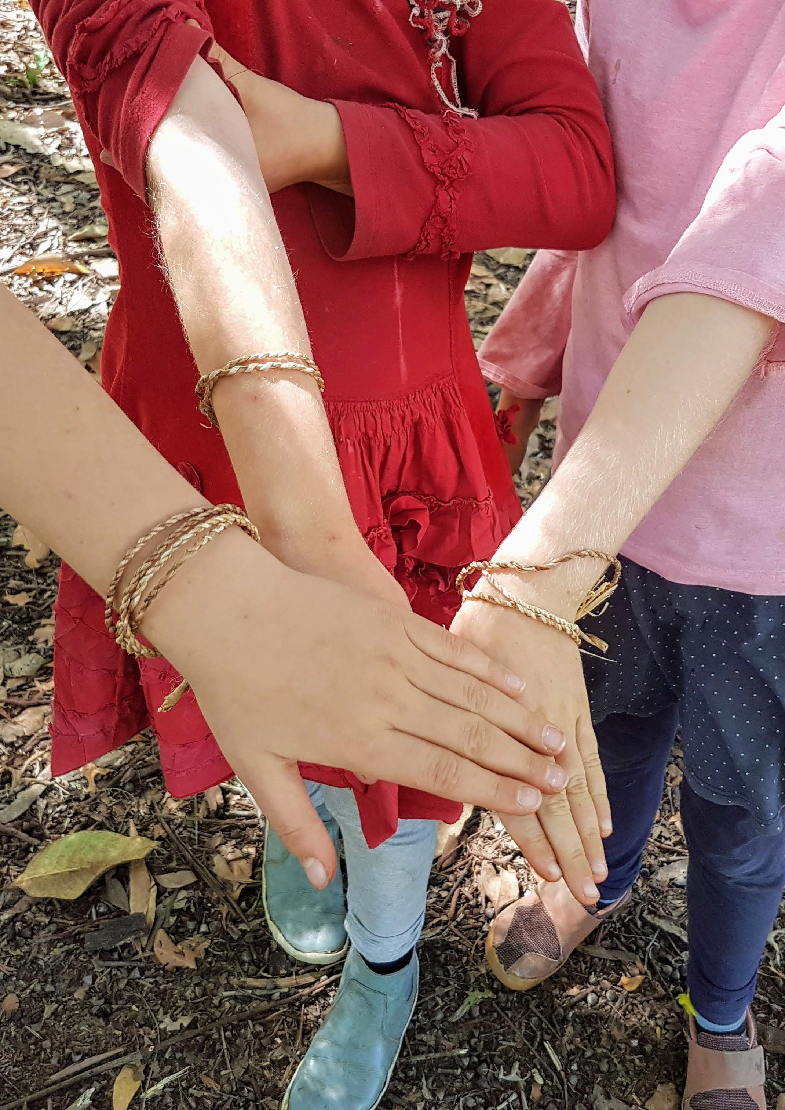
Image: Ephemeral Art Play Healesville March 2021
119

P5

Social determinants of mental wellbeing
The World Health Organisation recognises that (34)
“.. a person’s mental health and many common mental disorders are shaped by various social, economic, and physical environments operating at different stages of life. Risk factors for many common mental disorders are heavily associated with social inequalities, whereby the greater the inequality the higher the inequality in risk.
It is of major importance that action is taken to improve the conditions of everyday life, beginning before birth and progressing into early childhood, older childhood and adolescence, during family building and working ages, and through to older age. Action throughout these life stages would provide opportunities for both
improving population mental health, and for reducing risk of those mental disorders that are associated with social inequalities”.
As social connection is one of the key determinants of mental wellbeing, Council policies and programs designed to promote a sense of belonging, increase awareness and acceptance of diversity, prevent violence, increase access to affordable housing and build community resilience, can all support mental wellbeing.

118 | Yarra Ranges Health and Wellbeing Plan 2021–2025

Mental wellbeing and social connection in Yarra Ranges
The 2017 Victorian Population Health Survey shows adults in Yarra Ranges had strong social connections: (4)

However, residents of Yarra Ranges experience significant rates of mental health related issues:

87%

Yarra Ranges

82%
Victoria

39%

Yarra Ranges

36%
Victoria

25%

Yarra Ranges

18%

Victoria
In 2018-19, children in Yarra Ranges (0-14 years) had higher rate of hospital admission rate for mental and behavioural disorders, than the Victorian average (35)
Mental and behavioural disorders
were the third-highest reason for admission to hospital for young people (15-24 years) in Yarra Ranges.
Females of all ages had a 33%
higher admission rate than men. (35)
1in 5
One in five Victorian adults will experience a mental health condition each year and 45% will experience a mental health condition within their lifetime. (36)

could definitely get help from family when they needed it

93%
88%

Yarra Ranges Victoria
could definitely get help from friends or relatives for care in an emergency

52%
48%

Yarra Ranges Victoria
more likely to feel valued by society
volunteer regularly or sometimes

77%
77%

Yarra Ranges Victoria
had high or very high life satisfaction

81%
81%

Yarra Ranges Victoria
had a high feeling of life being worthwhile
(adults) sought help for a mental health- related problem during the past 12 months.

Yarra Ranges ranked second highest in Melbourne (2017)
Women (29%) had higher prevalence than men (24%) (4)

38%
27%
Rose from 27%

Yarra Ranges Victoria
people diagnosed with anxiety or depression

Yarra Ranges ranked highest within Melbourne

15%
15%

Yarra Ranges Victoria
(adults) had high or very high levels of psychological distress

120 | Yarra Ranges Health and Wellbeing Plan 2021–2025 Yarra Ranges Health and Wellbeing Plan 2021–2025 | 121

Mental wellbeing during the Covid 19 pandemic
During the pandemic there was a rise in mental health patients in Yarra Ranges. Between 2019 and 2020, the number of active mental health patients in Yarra Ranges increased by 90%, to nearly 10,000 people. EMPHN, 2020 - COVID-19 Community Update
Social isolation and mental health were the main impacts for residents of the pandemic and resultant lockdowns. (26) The key issues were: social isolation (nearly 70% of survey respondents); and survey respondents’ personal mental health (nearly 50%), and that of their families (44%) and their children (35%). Relationship strain was also an issue for nearly 20% of respondents. One quarter of respondents had contacted mental health services for assistance.
Mental health was identified as a key concern for parents and carers across the community. About two thirds of parents and carers (64%) reported medium to high levels of concerns around social isolation, mental health of a child (63%), family member (60%), or self (53%). Similar concerns were reported for respondents aged 18-24 years around social isolation (66%) and mental health (69%).
During the Covid 19 pandemic, women experienced greater negative mental wellbeing impacts that men.
Women at particular risk of mental health issues as a result of Covid19 included:
  - women experiencing family violence, pregnant women and new mothers, women with disability, older women, and women from migrant and refugee backgrounds. (37)
Women were overrepresented in industries impacted by the pandemic such as retail, hospitality and the arts. They were also more likely to be on the frontline - aged care, nurses, childcare workers. This has led to higher levels of anxiety and stress for women. (37)

Mental wellbeing co-benefits across all Plan priorities
Achievements in each of the other six priorities of the Health and Wellbeing Plan will help to improve mental wellbeing in Yarra Ranges. These co-benefits will occur at both personal and community level.
Co-benefits for mental wellbeing and in many cases social connection, will result from activities to:
  - reduce stress and anxiety as a result of public health emergencies
  - act on climate change mitigation and adaptation
  - deliver group activities as part of active living such as sport and walking groups, healthy eating, such as community gardens, and support groups for specific issues such as women’s participation in sport and people with disability participation in cultural activities
  - increase healthy lifestyles resulting in healthier eating, more activity, less smoking and alcohol - each resulting in improved quality of life and mental wellbeing
  - reduce gender inequality and the social context for men’s violence against women, creating freedom from violence and discrimination.

122 | Yarra Ranges Health and Wellbeing Plan 2021–2025 Yarra Ranges Health and Wellbeing Plan 2021–2025 |

123

Gender equity and intersectionality impacts
In 2017, men in Yarra Ranges were more likely to report low or medium life satisfaction than women, where the prevalence for men was higher than for all of Victoria. (4) A similar proportion of women and men in Yarra Ranges reported high or very high levels of psychological distress, which were like the Victorian average for each.
Women were 75% more likely to report moderate distress than men. The prevalence of distress in Yarra Ranges women was higher than the state average. Women in Yarra Ranges were more likely to be diagnosed with anxiety or depression by a doctor than the state average.
Mental wellbeing for children and young people is of increased importance and focus, as it can affect wellbeing across a lifetime. Early support or treatment can prevent future mental illness. Five Council Youth Ambassadors rated mental wellbeing as their highest priority.
Their concerns included addressing the social aspects and socio- economic factors affecting mental wellbeing. They also noted the benefits of preventive approaches such as social prescriptions, self- care, walking and taking time to look after yourself.
Carers of people with a disability also reported increased depression and anxiety due to isolation and lack/loss of supports as a result of Covid 19.
There is no information on mental wellbeing and social connections for people in Yarra Ranges of other socio-demographic groups.
For adults in Victoria in 2018 the prevalence of social connection, mental wellbeing and mental health issues varied between population groups. (29) Further details are provided in Appendix 2.
In Yarra Ranges, parents and carers reported challenges balancing working from home with home-schooling. Of parents and carers 58% expressed medium to high concerns about being present and available for their children, and 51% expressed similar concerns in providing a remote learning environment. (26)
Consistent with this, in Victoria 72% of females were spending the most of their time helping their child with school at home, compared with 26% for males. Given almost 80% of single parent households in Australia are headed by women, (38) they are disproportionately affected by the increasing burden of unpaid labour in the home and supporting remote learning for children.
In Australia, women experienced higher levels of depression, anxiety and stress than men in response to Covid 19. 39% of females report moderate to severe levels of psychological distress compared with 31% of males, while 35% of females report moderate to severe levels of depression, compared with 19% of males. (39) For young people aged 18-24, 37% of women reported suicidal thoughts, compared to 17% of men.
LGBTIQ+ Victorians are a diverse community and they continue to face stigma and discrimination.
They are more likely than the broader community to experience poor mental health, suicidal thoughts, homelessness, substance abuse and intimate partner and family violence.
The COVID-19 pandemic has exacerbated challenges being faced by some LGBTIQ+ Victorians.
Many people experiencing homelessness also experience declining mental health or serious mental illness.

124 | Yarra Ranges Health and Wellbeing Plan 2021–2025 Yarra Ranges Health and Wellbeing Plan 2021–2025 | 125

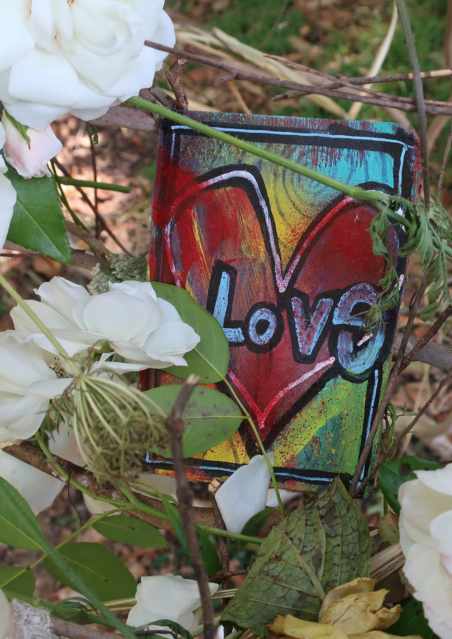
Image: Betsy Sue Clarke- Ephemeral Art Play Healesville March 2021
127

P5

Our approach
To improve mental wellbeing the Victorian Government wants to achieve: (5)
  - a reduction in the prevalence of mental illness, and increased resilience among Victorian individuals, families and communities
  - reductions in the gap in social and emotional wellbeing for at-risk groups, including Aboriginal Victorians, with an emphasis on loneliness and increasing social connectedness
  - reductions in the occurrence of suicide deaths, suicidal ideation and suicidal attempt, and the gap between the suicide rates for vulnerable groups and the general population. (5)
At an individual level, the UK National Health Service recommends five steps people can take to improve mental health and wellbeing: (40)

1 | Connect with other people
2 | Give to others
3 | Be physically active
4 | Pay attention to the present moment (mindfulness)
5 | Learn new skills

Critical to enabling and supporting individuals to take these steps is addressing the social determinants of health and providing access and opportunities to culturally and age-appropriate facilities, services and groups to undertake each step.

126 | Yarra Ranges Health and Wellbeing Plan 2021–2025

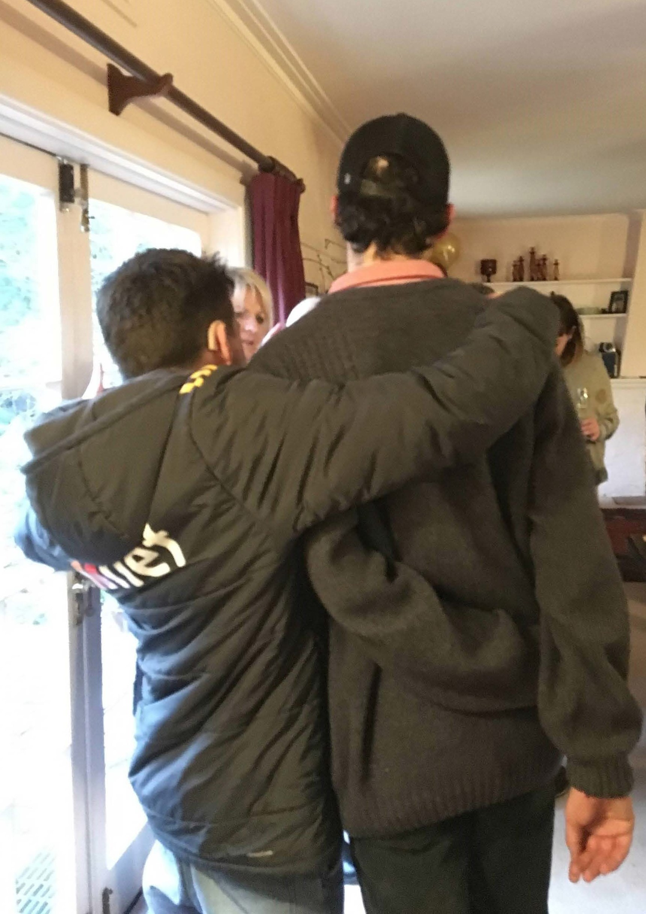

P5

In this Plan, Council will have a strong focus on supporting social connection and reducing loneliness. This is a protective factor for good mental health. Council strengthens social connection in many ways:
  - provision and funding of social support programs
  - provision of programs and activities that build social connection
  - funding and grants to organisations for projects for community connection
  - funding and support for sport and clubs
  - designing and constructing great places and facilities in communities where people can connect
  - advocacy for improved mental health services and increased supply of social housing.
Council also has a role in responding to factors forecast to contribute to worsening mental health as a result of the pandemic and the 2021 storm event, and will:
  - support community connection in as many ways as possible, e.g. through community clubs and sport, volunteering and funding for community led festivals and events
  - support economic development to mitigate business disruption and job losses
  - facilitate opportunities for work, education and training including for young people
  - advocate for increased access to essential services and infrastructure, particularly mental health services and affordable housing, noting that:
− gender analysis reveals women and children escaping family violence and older single women to be at higher risk of homelessness.

128 | Yarra Ranges Health and Wellbeing Plan 2021–2025 129

P5

Community survey
Priority actions areas
To attain our goal in increasing mental wellbeing and social connection, we aim to achieve
- increased social connection through participation in group activities, volunteering, community life and civic engagement
- reduced loneliness and isolation
- improved access to mental health services through our advocacy and increased community mental health literacy
- support for people whose mental wellbeing has been most affected by Covid 19, the 2021 storm and other emergencies
- well supported families and children through the critical years of early childhood development
- increased mental wellbeing, recognising the centrality of this in a Covid 19 and post storm emergency recovery environment.

Improving mental wellbeing and social connection
was rated the top priority
87% rated extremely or very important
Respondents saw a clear advocacy and support role for Council in terms of social connection and mental wellbeing:
89% advocating for affordable and appropriate housing 88% advocating local businesses to create employment 87% advocating for more mental health services

Affordable and long-term housing is very important for mental health...
Based on the principles and approaches of the Plan, the Actions to progress these achievements lists the:
- priority action areas for Council in partnership with others
- sections of Council that are responsible and our partners
- measures of success and related Council plans.
“
“

...if people are eating well and feel welcomed to join local groups or meet at local events, this is one of the best ways to promote mental health but also support those who have a mental illness to connect...
Mutually reinforcing work across Goals
Actions to increase physical activity may reflect work and co-benefits in other Priorities of the Plan, particularly:
Priority 2 | tackling climate change
Priority 3 | increase healthy eating
Priority 4 | increase active living
Priority 6 | preventing violence against women and children
Priority 7 | reduce harmful alcohol and drug use

130 | Yarra Ranges Health and Wellbeing Plan 2021–2025 Yarra Ranges Health and Wellbeing Plan 2021–2025 | 131

Priority 6

Prevent violence against women
and children

Our goal to reduce and prevent violence against women:
Women and children in Yarra Ranges live free from abuse and violence through a culture of gender equity and respect.

This section outlines: why this is a health and wellbeing priority, the data for Yarra Ranges, what a gender and intersectionality lens tell us, our approach to improve health and wellbeing, and our priority actions. Appendix 1 is a detailed action plan.

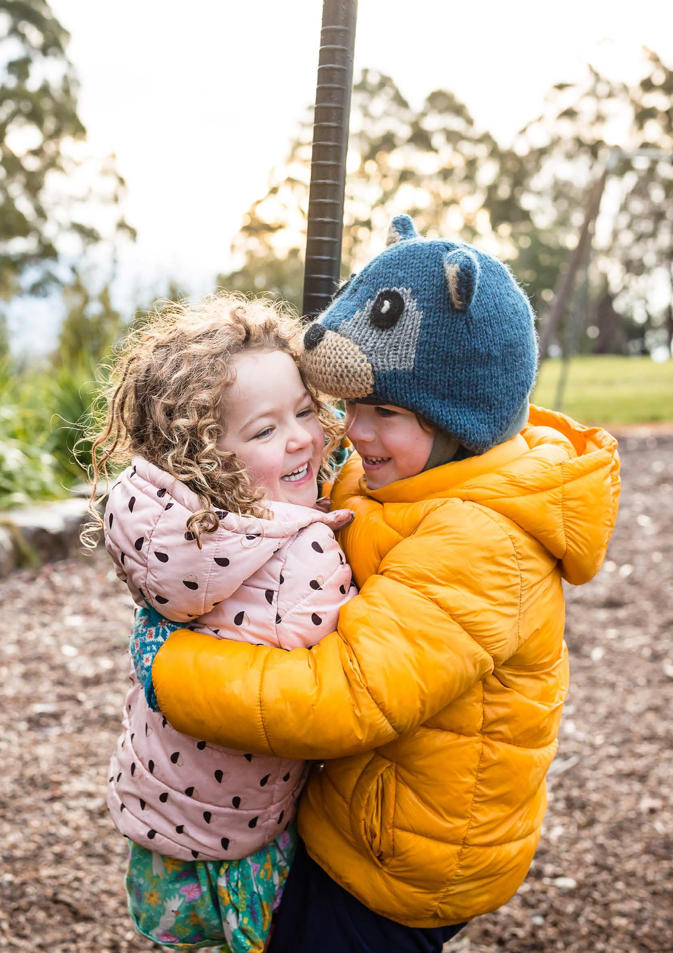132

Image: Cathy Ronalds
Yarra Ranges Health and Wellbeing Plan 2021–2025 | 133

Why preventing violence against women and children is a priority

P6
All people have the right to live safely and free from all forms of violence. Violence impacts people of all genders but is
disproportionately experienced by women and by male perpetrators.
Gender equity to prevent violence against women was a priority in the last Council Health and Wellbeing Plan. Preventing all forms of violence is one of ten priority areas in the Victorian Public Health and Wellbeing Plan 2019-2023. The Victorian Public Health and Wellbeing Outcomes Framework includes the outcome Victorians live free from abuse and
violence. (14)

‘The term violence against women means any act of gender-based violence that results in, or is likely to result in, physical, sexual or psychological harm or suffering
to women, including threats of such acts, coercion or arbitrary deprivation of liberty, whether occurring in public or private life.’
- United Nations Declaration on the Elimination of Violence against Women (41)

The 2015 Royal Commission into Family Violence led to the Victorian Public Health and Wellbeing Act being amended to require councils to specify what they will do to prevent family violence and how they respond to victims of family violence, when preparing their Health and Wellbeing Plans.
All people have the right to live safely and free from all forms of violence. Violence impacts people of all genders but is
disproportionately experienced by women by male perpetrators. Violence is a significant but modifiable risk factor for ill-health amongst women, particularly those of child-bearing age. (5) Family violence causes physical injury, psychological trauma and emotional suffering, which can affect victims and their families for the rest of their lives. In its most extreme form, it causes senseless and preventable deaths.
(42) The personal impacts include pain, suffering and early death, with substantial physical and mental health impacts; loss of income and reduced financial security; loss of housing; loss of or limited access to employment; disconnection from family and friends; and property damage.
Family violence can also affect child development. If family violence is combined with other problems, such as drug and alcohol abuse, or mental health issues, children are placed at even greater risk of developing emotional, behavioural, health, social and educational problems. (5)

134 | Yarra Ranges Health and Wellbeing Plan 2021–2025 Yarra Ranges Health and Wellbeing Plan 2021–2025 | 135

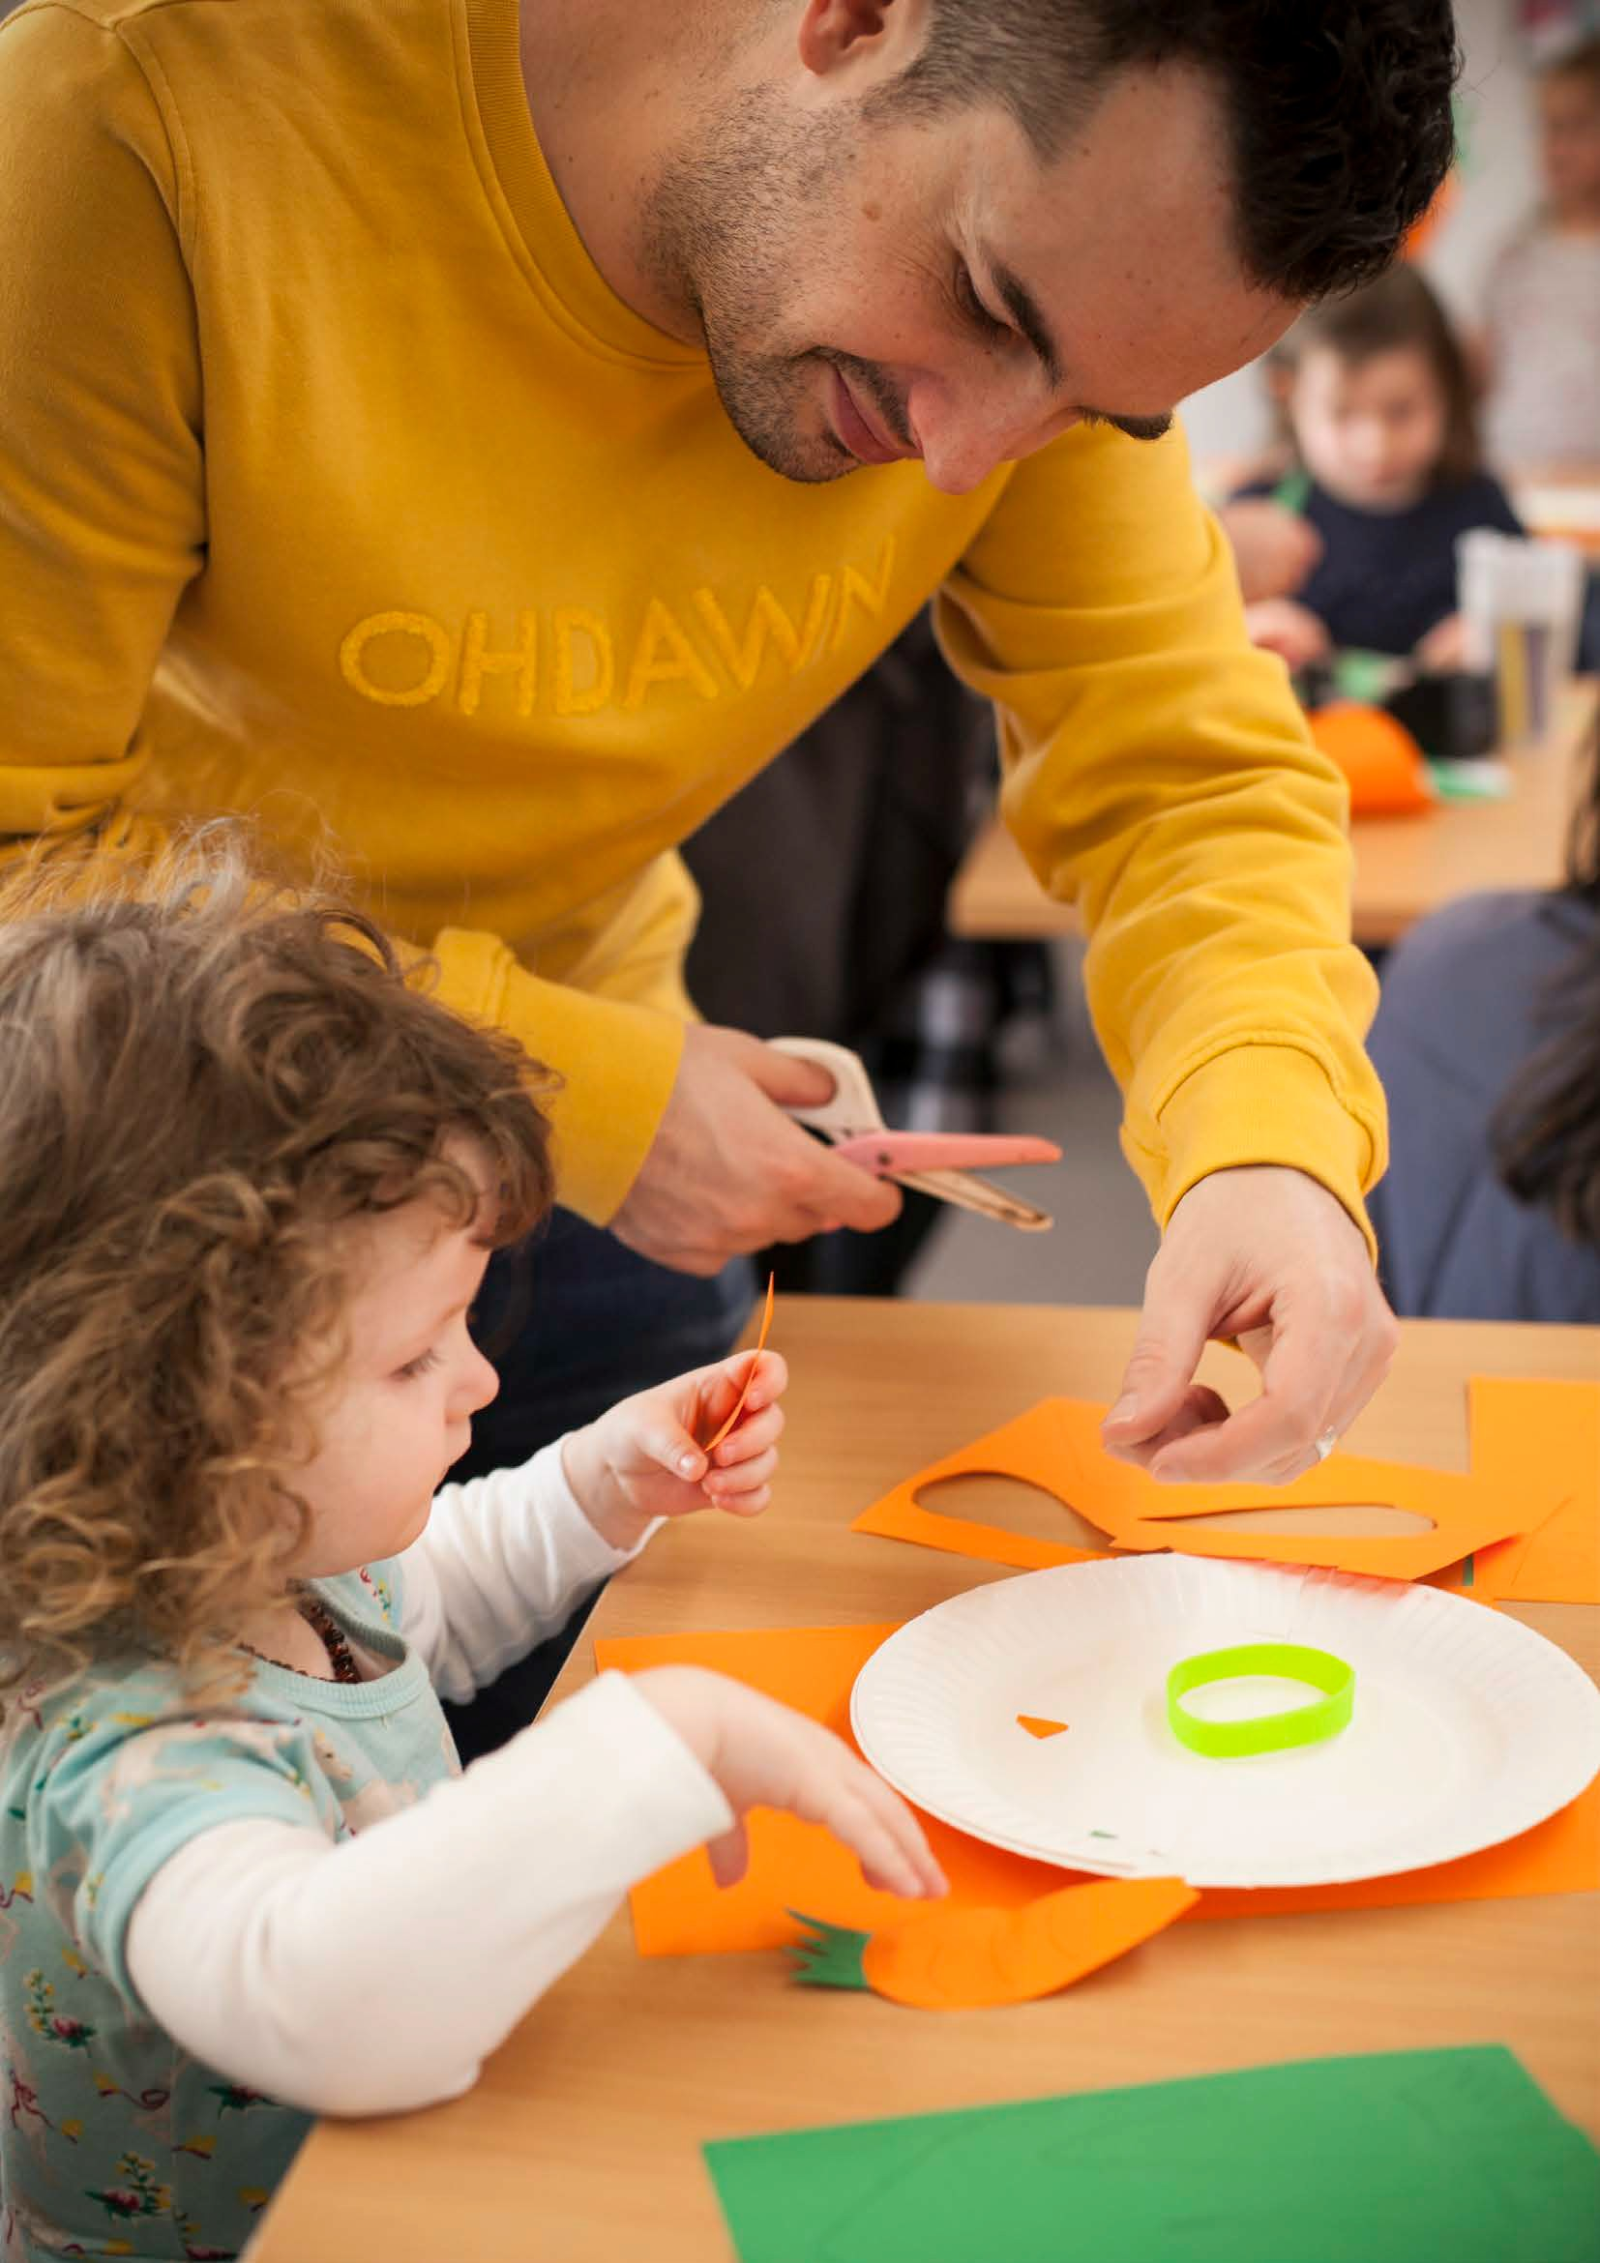
137

P6

Tackling causes - a prevention approach
Evidence shows that key predictors of violence against women relate to how individuals, communities and society as a whole view the roles of men and women. Some of the strongest predictors for holding attitudes that support violence at the individual level, are low levels of support for gender equality and following traditional gender stereotypes.
International evidence suggests benefits for fathers’ relationships and life satisfaction, and for child development from greater father engagement in the early years. Boosting parental leave and making it
more gender-equal would be good for fathers, mothers, children, and the economy (Grattan Institute 2021).
When women are not equal to men and when our attitudes and behaviours assert male dominance over women, it enables some men to abuse and it prevents women from seeking help. Recognising this, the National Plan to reduce violence against women and their children 2010-2022, has a long-term plan to address the gender inequalities that set up the conditions for violence. (43)

136 | Yarra Ranges Health and Wellbeing Plan 2021–2025

How reducing family violence help our communities
Good mental, physical, and sexual and reproductive health, is supported by:
  - gender equality and respect
  - safety and freedom from discrimination, violence and stigma.

Beyond health benefits, creating a society free from family violence will lead to: (5)
  - improved socioeconomic outcomes for women and young children
  - increased gender equity
  - participation in social and economic life for all genders
  - increased feelings of safety; reduced drug and alcohol misuse
  - reduced demand for family violence services and a range of other services.

Social determinants of family violence
The social and economic determinants of intimate partner violence are at multiple levels:
at the family level
across power differentials between partners
across status inconsistencies between partners
at the community level
peer and community influence and norms of acceptability of intimate partner violence and male intimate violence perpetration
community levels of violence
at the societal or ecological level
community or societal violence and attitudes towards violence
social, gender and economic inequity.

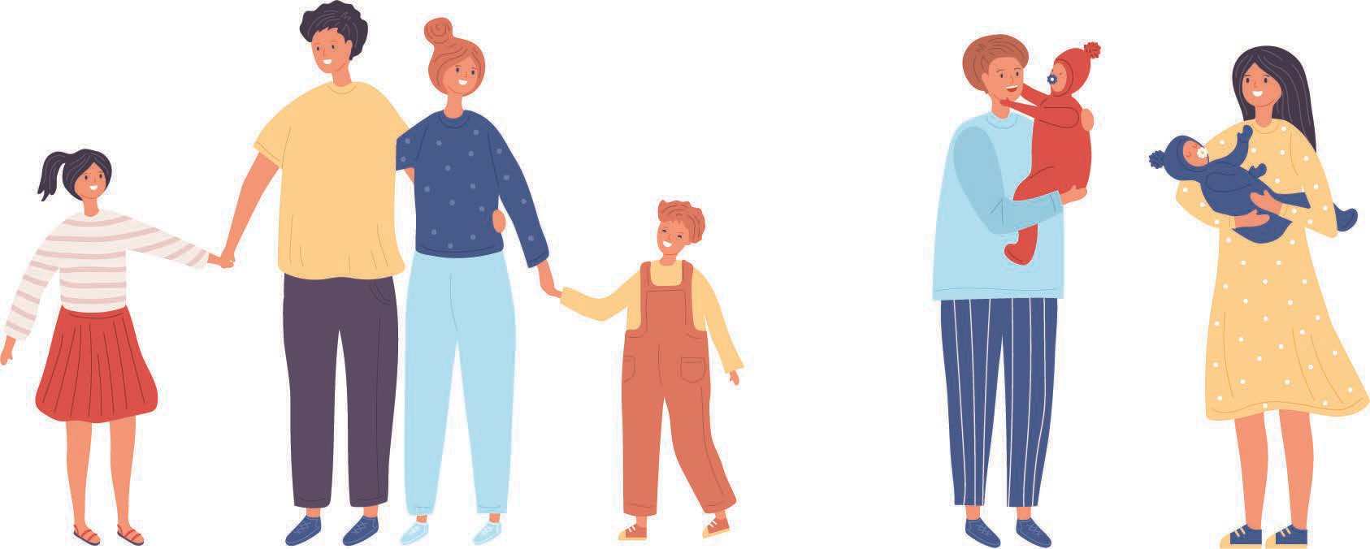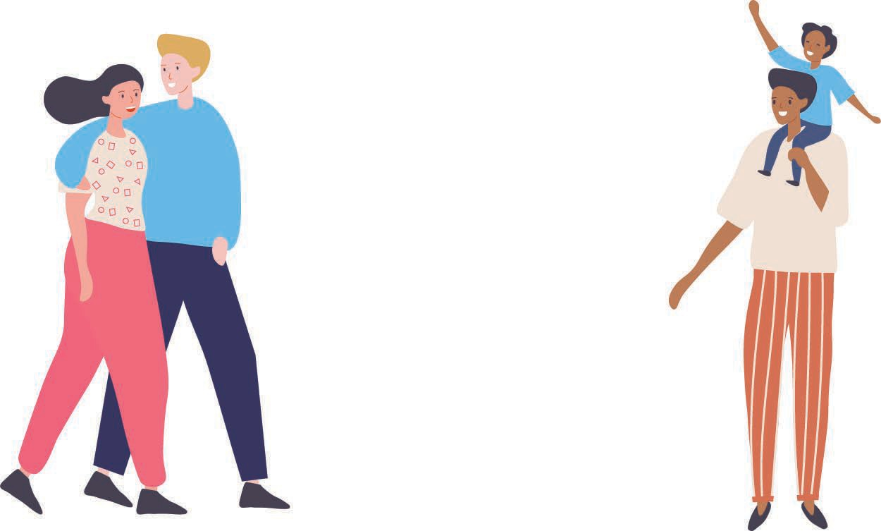

138 | Yarra Ranges Health and Wellbeing Plan 2021–2025 Yarra Ranges Health and Wellbeing Plan 2021–2025 | 139

Family violence during the Covid 19 pandemic
In Victoria in 2017, 4.2% of men and 6.6% of women and 5.4% of adults experienced family violence in the two years preceding the Victorian Population Health Survey. (44)
In Yarra Ranges, the number of reported family violence incidents increased by 4.7% in 2020 compared to 2019. (45) Females accounted for 76% of those affected by family violence. Family violence against people aged 55 years and older in Yarra Ranges increased by 22% between 2019 and 2020.
In 2020, Yarra Ranges had a rate of reported incidents of 1,094 per 100,000 residents. Reported family violence appears more prevalent in the outer east than in the inner east. Yarra Ranges, Knox and Maroondah all have rates of more than 1,000 per 100,000 residents, compared to rates ranging from 565 to 807 per 100,000 in the inner eastern areas.
Many people seeking assistance for family violence during Covid 19 were doing so for the first time and the majority of those seeking
support were women. During Stage 3 and 4 restrictions in Melbourne, the level of first-time victims engaging with the Eastern Domestic Violence Service (EDVOS) doubled to 60%. Cases showed increased frequency and severity of ongoing violence, particularly physical and sexual abuse, and coercive control.
Referrals from generalist services rose by 20% between March and June 2020; these services include community health, early childhood and counselling services. Many of these services had never contacted EDVOS previously and were highly concerned for the safety of women and children. (46)

Gender equity and intersectionality impacts
While anyone can experience family violence, some groups tend to be at increased risk. These include women who are Indigenous; identify as having a disability; live in rural, regional or remote areas; are older; identify as LGBTIQ+; or are affected by socio-economic disadvantage.
(44) The experiences of migrant and refugee women are emerging areas for Council that needs to be better understood.

Elder Abuse
Elder abuse is any act which causes harm to an older person and is carried out by someone they know and trust, such as a family member or friend. The abuse may be physical, social, financial, psychological or sexual and can include mistreatment and neglect. Older women and gender diverse people can be at increased risk of this kind of abuse and violence.

140 | Yarra Ranges Health and Wellbeing Plan 2021–2025 Yarra Ranges Health and Wellbeing Plan 2021–2025 | 141

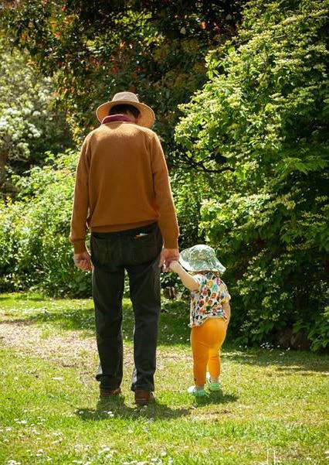
143

P6

Our approach
To prevent family violence, the Victorian Government wants:
  - women, men, girls and boys to be treated equally with respect and dignity
  - all parts of the community engaged in practical and creative ways to learn about respectful, safe and equitable relationships
  - women and children resourced, supported and empowered to make decisions regarding their safety and wellbeing
  - all Victorians feel safe and empowered to take a stand against family violence. (5)
At its core, family violence and violence against women is rooted in the inequality between women and men. (5) This priority continues work from the previous Health and Wellbeing Plan and maintains Council’s focus on a prevention approach and to promoting gender equality in our workplace and community.
Council is working towards an inclusive and diverse Yarra Ranges, where women, men and gender diverse people have equitable access to resources, power and opportunities.
Examples of Council’s work include:
  - upgrading sports and recreational facilities to provide equal access to all genders
  - supporting women into leadership at all levels of society
  - partnerships to develop resources for early years services that break down rigid gender stereotypes
  - lighting to improve safety in popular walking areas
  - services actively supporting women who may be experiencing violence in their relationships, such as Maternal and Child Health and Youth Development
  - referrals to specialist services
  - advocacy for changes to the causes of violence against women
  - support for male carers and projects that challenge stereotypical gender roles
  - organisational change to ensure Council is equitable for all employees and in how it provides services for residents.

142 | Yarra Ranges Health and Wellbeing Plan 2021–2025

P6

Community Survey
Priority actions areas
To attain our goal in preventing violence and abuse against women and children, we aim to achieve:
- increased gender equality through the work of Council, community and partner organisations
- rigid gender stereotypes are dismantled, and our community is not limited by these stereotypes and roles
- greater recognition and attainment of leadership roles by women
- respectful relationships between men, women and children
- a reduction in family violence in all its forms
- support for women with intersecting factors that increase their risk of harm
- the inclusion of women from diverse backgrounds and life experiences.

100% of people aged 18-25 rated this priority extremely or very important
86% rated this priority second highest overall
89% women and 80% men rated this extremely or very important

Second highest priority for people living in the Valley and Hills areas

Keep calling out disrespectful behaviour and sexism.
“
“

Advocate for men to have flexible work environments so there is more time for men to be involved in family responsibilities. Supports for new Dads in the maternal child health services - engaging men in parental roles early in the child’s life.
Based on the principles and approaches of the Plan, Actions to progress these achievements lists the:
- priority action areas for Council in partnership with others
- sections of Council that are responsible and our partners
- measures of success and related Council plans.
There were some comments in the survey about respect for men and boys and feeling this priority was discriminatory towards them. An example is...
“
Mutually reinforcing work across Goals
Actions to prevent violence and abuse against women and children may reflect work and co-benefits in other Priorities of the Plan, particularly:
Priority 1 | respond to health impacts of emergencies
Priority 2 | tackle climate change and its impacts on health
Priority 5 | improve mental wellbeing and social connections
Priority 7 | reduce harmful alcohol and drug use

Please try to remember that gender equality means that men are also a gender... not all young men are potentially bad.

Council’s position is that gender equality encompasses all genders and gender diverse community members. Boys and men also experience limitations as a result of rigid gender roles. Support for boys and men and working with them to promote a fair go for everyone, is important. They are also powerful champions for change.

144 | Yarra Ranges Health and Wellbeing Plan 2021–2025 Yarra Ranges Health and Wellbeing Plan 2021–2025 | 145

Priority 7

Reduce harmful alcohol and drug use

Our goal to reduce harmful alcohol and drug use:
People in Yarra Ranges are safe from the harmful effects of alcohol and other drugs - particularly from alcohol and tobacco, through preventing uptake and support for safe alcohol use.

This section outlines: why this is a health and wellbeing priority, the data for Yarra Ranges, what a gender and intersectionality lens tell us, our approach to improve health and wellbeing, and our priority actions. Appendix 1 includes detailed actions.

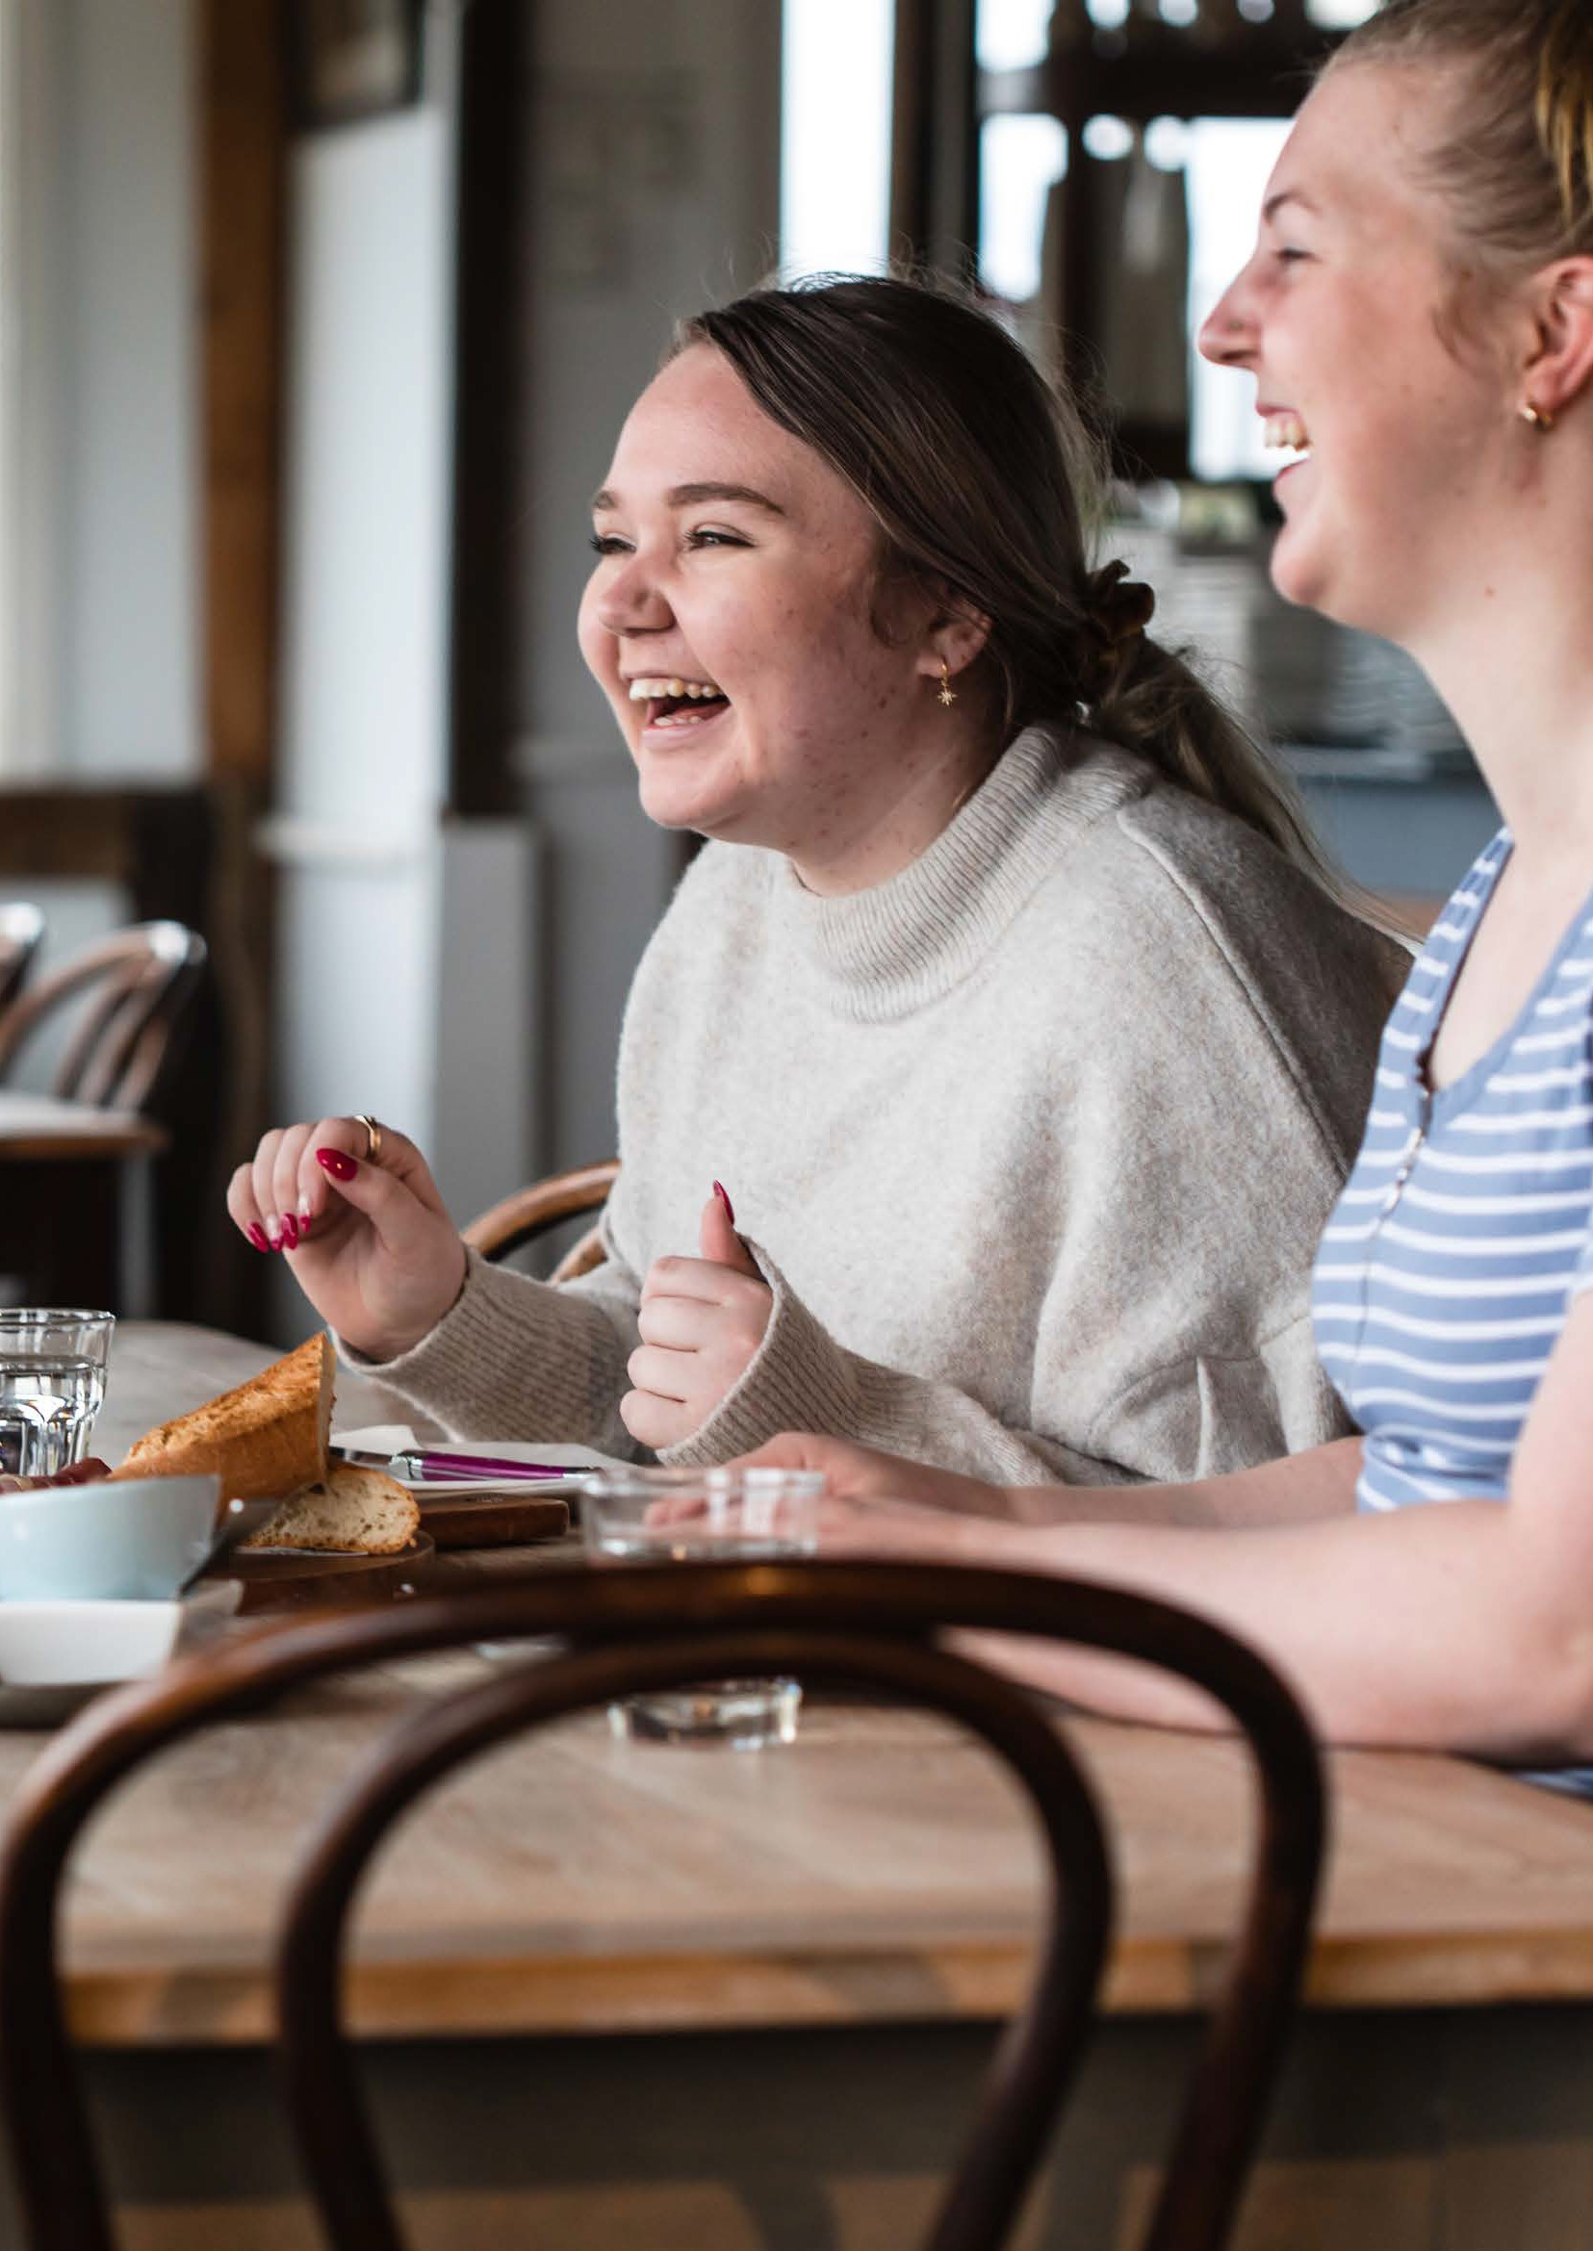146
Image: Cathy Ronalds
Yarra Ranges Health and Wellbeing Plan 2021–2025 | 147

Why reducing harms from alcohol is a priority

‘Alcohol is the most widely used drug in Australia. People drink alcohol for a range of reasons and in different social and cultural contexts, but alcohol can cause harm to the person who drinks and sometimes to others around them.’
- National Health and Medical Research Council, 2020 (47)

Harmful alcohol use was a priority in the last Council Health and Wellbeing Plan. It’s also one of ten priority areas in the Victorian Public Health and Wellbeing Plan 2019-2023. The Victorian Public Health and Wellbeing Outcomes Framework includes the outcome Victorians act to protect and promote health, indicated by reduced smoking and reduced harmful alcohol and drug use. (14)
Every year in Victoria, alcohol causes over 1,200 deaths and nearly 40,000 hospitalisations. (48) Alcohol is a known risk factor for 13 different forms of cancer. (49) In addition, heavy alcohol use can also cause short and long-term health problems such as cirrhosis of the liver, alcohol dependence, strokes, suicide, injury and car accidents. Harmful community impacts of alcohol include drink driving, contributing to family violence and violence in the public realm.
Residents and visitors to Yarra Ranges enjoy the fine wines and spirits produced in the area. These economic, culinary and tourism benefits can be at odds with health concerns and other negative impacts of alcohol such as traffic accidents and links to family violence. (50)

How much alcohol?
For adults who do drink alcohol, the National Health and Medical Research Council recommends: (47)

no more than 10 drinks per week
more drinks place a person at increased lifetime risk of alcohol-related harm

no more than four drinks on any one occasion
more drinks place a person at increased risk of injury from a single occasion of drinking.

It is also recommended that:

children and people under 18 years of age should not drink alcohol
women who are pregnant or planning a pregnancy should not drink alcohol
not drinking alcohol is safest for the baby of women who are breastfeeding.

148 | Yarra Ranges Health and Wellbeing Plan 2021–2025 Yarra Ranges Health and Wellbeing Plan 2021–2025 | 149

Social determinants of harmful alcohol
The World Health Organisation recognises that: (51)

‘Breaking the vicious circle of the social determinants and consequences of the harmful use of alcohol requires a combination of effective measures addressing social inequalities, alcohol availability and the context and patterns of alcohol use, as well as the availability of effective treatment for alcohol use disorders.’

Alcohol culture influences how often and how much alcohol people drink. Culture includes the way people drink, including the formal rules, social norms, attitudes and beliefs around what is and what is not socially acceptable.

‘It is the shared practices of a social group, rather than individuals, that have the greatest scope to bring about cultural change.’
VicHealth Alcohol Strategy 2019-2023 (48)

Alcohol consumption in Yarra Ranges and during the Covid 19 pandemic
Most adults in Yarra Ranges drink alcohol responsibly, however a significant proportion of the population still drink in a way that puts them at risk of injury from a single occasion of drinking, or at risk of chronic disease over the longer term.
The proportion of adults in Yarra Ranges who consume harmful amounts of alcohol is higher than for Victoria. In 2017, 67% of adults in Yarra Ranges were at increased lifetime risk of alcohol related harm, greater than the 59% for all of Victoria. (4) Half (50%) of adults were at increased risk of injury from a single occasion of drinking, also larger than for all of Victoria (43%).
During 2020, surveys tracked the impacts of Covid 19 and lockdowns on alcohol consumption. Nationally, 11% of women and 18% of
men increased their consumption of alcohol during the pandemic. (11) Commonwealth Bank of Australia card spend data showed decreased spending in pubs and clubs, relative to the same period in 2019. (52) This was offset by increased spending in bottle shops up until mid- November 2020.

150 | Yarra Ranges Health and Wellbeing Plan 2021–2025 Yarra Ranges Health and Wellbeing Plan 2021–2025 | 151

Gender equity and intersectionality impacts
Short-term harms from alcohol misuse, such as injury, are experienced more often by men than women. Longer-term harms including cancers, cardiovascular diseases and digestive diseases are
more likely to be experienced by people with low socio-economic backgrounds. (48)
In 2017, men in Yarra Ranges were 27% more likely to be at increased lifetime risk of alcohol related harm than women, similar to the Victorian average. (4) Similarly, men in Yarra Ranges were 39% more likely to be at increased risk of injury from a single occasion of drinking than women - where the prevalence for women in Yarra Ranges was 26% higher than the state average.
There is no information on harmful alcohol consumption for people in Yarra Ranges of other socio-demographic groups. For adults in Victoria in 2018 the prevalence of lifetime risk of alcohol related harm and risk of injury from a single occasion of drinking varied between population groups. (29) Further details are provided in Appendix 3.
Engagement with the Youth Ambassadors rated this as their third highest priority, and they saw mental wellbeing strongly linked to this priority …

“people are drinking because they are anxious, as a social lubricant…”
They expressed concern about heavy drinking, access to alcohol, and a culture of shame towards those not drinking. They highlighted a past campaign, Drink-Wise, as helpful for young people. Smoking tobacco was seen as a social prop and very easy to get. Drugs and alcohol were noted as a “massive problem” and a rite of passage that was perceived as helping with social acceptance and loneliness.
Importantly they noted a lack of alternate social and cultural activities for young people and supported Council programs and grant opportunities for young people to design and deliver their own events. A further insight was offered, that peer support is more impactful than role modelling by adults for changing these behaviours.

152 | Yarra Ranges Health and Wellbeing Plan 2021–2025 Yarra Ranges Health and Wellbeing Plan 2021–2025 | 153

Why reducing tobacco use is a priority
Tobacco smoking remains the leading contributor to the death and disease burden in Australia, despite a substantial reduction in the smoking rate over the past two to three decades. Smoking causes 22% of the cancer burden of disease, and 41% of the respiratory burden of disease. (5)
Smoking increases the risk of many illnesses including lung cancer, cardiovascular disease and chronic obstructive pulmonary disease. Evidence suggests that smoking kills almost two in three regular users. The health burden of tobacco use affects not only smokers but also their families, particularly children who are more likely to suffer from bronchiolitis and other respiratory conditions. Smoking also causes significant economic impacts through costs of health care and loss of life. (5)

Smoking in Yarra Ranges
In Yarra Ranges in 2017, 11% of adults smoked daily, similar to the 12% for all of Victoria. Including occasional smokers, 17% of both Yarra Ranges and Victorian adults smoke tobacco. (4)

Gender equity and intersectionality impacts
Smoking is a significant contributor to health inequalities. Daily smoking rates were similar for men and women in Yarra Ranges in 2017. (4) There is no information on tobacco use for people in Yarra Ranges of other socio-demographic groups.
A number of population groups in Australia have higher smoking rates than the general population. (53) This includes people who are socio- economically disadvantaged, unemployed, are sole parents, have a mental health issue, have a substance use problem, are in prison, are experiencing homelessness and Aboriginal and Torres Strait Islanders. For adults in Victoria in 2018 the prevalence of daily smoking varied between population groups. Further details are provided in Appendix 3.
The negative health effects of tobacco are experienced at greater levels by Indigenous peoples. The extent of this impact was revealed in new research early in 2021. In Australia, smoking caused around half of all deaths among Aboriginal and Torres Strait Islanders adults aged 45 years and older, exceeding 10,000 deaths in the past decade. (54)

154 | Yarra Ranges Health and Wellbeing Plan 2021–2025 Yarra Ranges Health and Wellbeing Plan 2021–2025 | 155

Why reducing drug use is a priority
Illicit drug use includes use of illegal drugs (such as methamphetamines), the use of pharmaceutical drugs for non-medical purposes (such as tranquillisers) and the misuse of other substances (such as paint, glue or petrol as inhalants). In 2015, 2.7% of the disease burden in Australia was due to illicit drug use, with about a third of the burden due to opioid use. (55) By comparison, tobacco use caused 9.3% of the burden of disease and alcohol use caused 4.5%. Typically, illicit drug use is initiated in late teenage years and peaks in young adulthood, although a small minority continue the practice into middle age. (56)
The social impact of drug use is high - crime associated costs were about 20 times the health system costs. The long-term impact is evident in chronic liver diseases and cancer.

Illicit drug use in Yarra Ranges
Information on drug use (illicit drugs and use of prescription drugs for non-medical purposes) is not available for Yarra Ranges. In 2019 in Victoria 17% of people had used an illicit drug in the past 12 months, with 5% using cocaine, 4% using ecstasy. (56) Prescription drug abuse is a rising problem in Australia and pharmaceutical drugs have been the most frequent contributors to overdose deaths in Victoria in recent years. (57)

156 | Yarra Ranges Health and Wellbeing Plan 2021–2025
157

P7

Our approach to reduce harmful alcohol and drug use

Alcohol and drug use
To reduce the health impacts of harmful alcohol and drug use, the Victorian Government wants to achieve: (5)
  - change in risky drinking cultures and environments that support low risk drinking
  - increased capability in all service systems including mental health, housing, child protection and family violence to assist people with alcohol and other drug-related issues
  - better outcomes for those who access treatment, reducing harm and improving social outcomes
  - improved capability of primary care providers to assist people to manage alcohol and other drug-related issues before treatment is required or complexity develops.

The 2019-2023 VicHealth Alcohol Strategy has a 10-year goal that 200,000 more Victorians drink less alcohol. (48). The priorities include:
  - changing risky drinking cultures
  - enabling environments to support low-risk drinking.
A culture that would support reducing harms from alcohol looks like:

‘People socially supporting one another to engage in low-risk drinking practices rather than high-risk drinking, resulting in reduced harm for the individual, their family, bystanders and the broader community.’
(VicHealth) (48)
While a life course approach is taken to address all the priorities of the Plan, it is of critical importance in reducing alcohol harm.
Of importance is the role of friends and family alcohol use and the impact it has on young people’s sociocultural norms, aspirations and wellbeing.
Recognising the importance of family and friends in reducing alcohol harms in the current and future lives of children and young people, Council supports early life through maternal and child health, early years programs and inclusive playgroups. In addition, Council’s Youth Development team takes a strengths-based approach to supporting young people and will continue to be a vital way to nurture the leaders of the future.
There are many contributors in this area of health promotion to reduce harmful alcohol use: (48)
  - prevention, early intervention, treatment and harm minimisation are primarily the responsibility of the Department of Health
  - alcohol and other drug education in schools is the responsibility of the Department of Education and Training
  - local Councils have a minor role in licensing and can object to new licences if they assess it will result in local harms
  - Councils can:
− work with partners and communities to promote safer alcohol consumption
− contribute to the reduction of alcohol related harm through advocacy
− exercise its role in planning decisions
− promote safer drinking cultures
− build local partnerships with sporting clubs, business groups, industry networks and Victoria Police
− better understand the needs of marginalised communities in relation to alcohol.

158 | Yarra Ranges Health and Wellbeing Plan 2021–2025 Yarra Ranges Health and Wellbeing Plan 2021–2025 | 159

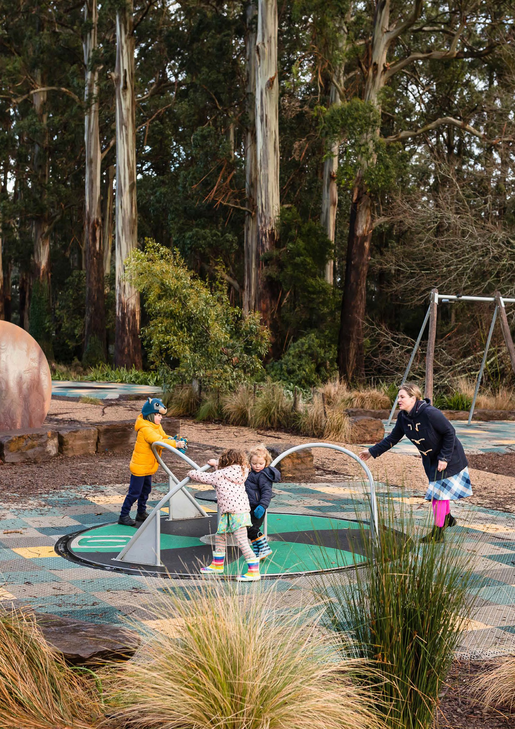
Image: Cathy Ronalds
161

P7

The Alcohol and Drug Foundation report that:

‘Prevention is an important part of a comprehensive harm reduction approach to reduce alcohol and other drug harms, particularly amongst young people. This is because young people are going through significant
social, physiological and developmental changes. In this phase of their life, prevention strategies have the potential to positively influence behaviour that will last through their adult years.’ (58)
An important goal of prevention is to change the balance between risk and protective factors so that protective factors outweigh risk factors.
Protective factors interact with alcohol and drug use in complex ways.
(58) They may moderate the influence of risk factors to reduce the likelihood of alcohol and drug use in young people, delay the uptake of alcohol and drug use in young people, and reduce harm should young people engage in their use.
Examples of protective factors are:
  - parental supervision and communication
  - participation in supervised leisure activities
  - social and emotional competence
  - sense of belonging/connectedness to community, school and family
  - participation in positive activities with adult engagement.
Risk factors can influence drug abuse in several ways. (59) The more risks a child is exposed to, the more likely the child will abuse drugs. Some risk factors may be more powerful than others at certain stages in development, such as peer pressure during the teenage years; just as some protective factors, such as a strong parent-child bond, can have a greater impact on reducing risks during the early years.

160 | Yarra Ranges Health and Wellbeing Plan 2021–2025

P7

Tobacco use
To reduce the health impacts of smoking tobacco, the Victorian Government wants to achieve: (5)
  - decreased access and affordability of tobacco products
  - decreased number of environments in which to smoke
  - decreased exposure to second- and third-hand smoke
  - decreased social acceptability of smoking
  - increased capacity to stop smoking and use of nicotine
  - increased uptake of stop-smoking supports.
Local councils have the power to enforce the Tobacco Act 1987, the legislation governing where Victorians can smoke, as well as the sales and promotion of tobacco products and certain non-tobacco products. Council monitors sale of tobacco to people under 18,
working with businesses to prevent young people taking up smoking.
Evidence-based actions that a local government can take to reduce tobacco-related harm and become a healthier place include: (5)
  - educating businesses and the community on obligations in the Tobacco Act 1987
  - monitoring compliance and taking enforcement action where necessary
  - responding to complaints in relation to the Tobacco Act 1987
  - participating in the Cigarette Sales to Minors Program and conduct test purchases with young people to ensure compliance with the Tobacco Act 1987
  - extending smoke-free areas and contribute to de-normalisation of smoking.
Currently, the Federal Government is funding the Tackling Indigenous Smoking (TIS) program. (60) The overall goal of the program is to improve Indigenous health “through local population specific efforts”. Much of these efforts rely upon place-based approaches and building relationships to support capacity-building and behaviour changes.
Reducing the impact of tobacco in Indigenous communities is through preventing uptake of smoking and smoking cessation programs.
Council recognises that:
  - Aboriginal community-controlled health services (ACCHO) are best placed to deliver culturally safe programs and support for a range of health issues
  - bespoke tobacco cessation and health promotion campaigns for Indigenous people will be more likely to succeed than mainstream programs
  - ACCHOs offer services that can provide holistic support to people wanting to Quit and across health needs e.g. smoking in pregnancy, smoking and diabetes.
Council is committed to working with Oonah Health and Community Services Aboriginal Corporation (Oonah) to achieve a purpose-built Aboriginal community controlled Aboriginal Health Service (Belonging Place). The partnership with Oonah is the most effective way for Council to support improved Aboriginal health and wellbeing through shared advocacy, design expertise and a commitment to self- determination.

162 | Yarra Ranges Health and Wellbeing Plan 2021–2025 Yarra Ranges Health and Wellbeing Plan 2021–2025 | 163

P7

Community Survey

74% of people rated ‘reducing harmful alcohol and drug use’ as extremely or very important

People are trying a range of ways to reduce drinking including low or no alcohol options, events without alcohol and Feb Fast

“

Awareness of health benefits of reducing alcohol
consumption was high overall
Priority actions areas
To attain our goal in reducing harmful alcohol and drug use, we aim to achieve:
- community attitudes that support safer alcohol culture
- partnerships that strengthen responsible consumption of alcohol
- effective use of Council’s regulatory roles to protect community amenity
- Council modelling responsible serving of alcohol
- reduced disease and death from tobacco use
- resilient young people and children who are protected from alcohol and drug harms.

Around a third of respondents did not drink alcohol and very few used illicit drugs

...consider the number of outlets that sell alcohol.
I live in and there are 4 bottle shops within walking distance and multiple wine and spirit outlets.
Based on the principles and approaches of the Plan, actions to progress these achievements lists:
- the priority action areas
- the sections of Council that are responsible
- our partners
- measures of success
- related Council plans.
“

the limited information there is around re: what help looks like and information to parents about what supports they may get. I think the hardest thing is the guilt and shame that goes with asking for help ...
Mutually reinforcing work across Goals
Actions to reduce harmful impacts of alcohol and other drugs may reflect work and co-benefits in other Priorities of the Plan, particularly:
Priority 5 | improve mental wellbeing and social connections
Priority 6 | prevent violence against women and children

Comments about freedom of choice and dignity were also made, as were questions about Council’s role in this area. Some comments also indicate a need to increase knowledge and tackle stereotypes about who drinks and why, for example risk from alcohol increases with higher income, unlike for other health priorities where higher income predicts better health.

164 | Yarra Ranges Health and Wellbeing Plan 2021–2025 Yarra Ranges Health and Wellbeing Plan 2021–2025 | 165

References
1. United Nations. Sustainable Development Goals. [Online] 2015. Sustainable Development Goals.
2. Yarra Ranges Council. https://profile.id.com.au/yarra-ranges.
[Online]
3. Yarra Ranges Council. https://forecast.id.com.au/yarra-ranges/ residential-development?WebID=190. [Online]
4. Department of Health and Human Services. Victorian Population Health Survey 2017. https://www2.health.vic.gov.au/public-health/ population-health-systems/health-status-of-victorians/survey-data- and-reports/victorian-population-health-survey/victorian-population- health-survey-2017. [Online]
5. —. Victorian Public Health and Wellbeing Plan 2019-2023. https:// www2.health.vic.gov.au/about/health-strategies/public-health- wellbeing-plan. [Online]
6. Yarra Ranges Council. Health and Wellbeing in the Yarra Ranges 2017-2021. file:///C:/Users/Catherine%20Harper/Downloads/Health_ and_Wellbeing_Strategy_2017-2021%20(1).pdf. [Online] 2017.
7. Department of Health and Human Services. Public health and wellbeing planning: Taking action. https://www2.health.vic.gov.au/ about/health-strategies/public-health-wellbeing-plan/taking-action. [Online] 2019.
8. Women’s Health Victoria. Submission to the Parlimentary Inquiry into Homelessness in Victoria - March 2020. 2020.
9. Snapshot: LGBTIQ+ homelessness in Victoria. State of Victoria.
10. Australian Bureau of Statistics. Household Impacts of COVID-19 Survey. [Online] 2020. https://www.abs.gov.au/statistics/people/ people-and-communities/household-impacts-covid-19-survey/29-apr- 4-may-2020#lifestyle-changes.
11. VicHealth. VicHealth Coronavirus Victorian Wellbeing Impact Study. Melbourne : Victorian Health PRomotion Foundation, 2020. https:// doi.org/10.37309/2020.PO909.
12. World Health Organization. WHO Director-General: Climate Change is the Defining Issue for Public Health in the 21st Century. https://www.ccacoalition.org/en/news/who-director-general-climate- change-defining-issue-public-health-21st-century. [Online]
13. Department of Health and Human Services. Victorian public health and wellbeing outcomes framework. Melbourne : State of Victoria, 2016.
14. United Nations Climate Change. Planetary Health An Essential Part of Human Health . [Online] 2017. https://unfccc.int/news/ planetary-health-an-essential-part-of-human-health.
15. Health and climate change: policy responses to protect public health. Watts, N, et al. 2015, Lancet, Vol. 386, pp. 1861-914.
16. NHS is unprepared for risks posed by climate change, warn leading UK health bodies. lacobucci, G. s.l. : BMJ, 2016, Vol. 352.
17. Department of Health and Human Services. Tackling climate change and its impacts on health through municipal public health and wellbeing planning - Guidance for local government, 2020. s.l. : State of Victoria, 2020.
18. NHMRC. Australian Dietary Guidelines. Canberra : Department of Health and Ageing, 2013.
19. Australian Bureau of Statistics. National Health Survey 2017-18. 2019.

166 | Yarra Ranges Health and Wellbeing Plan 2021–2025 Yarra Ranges Health and Wellbeing Plan 2021–2025 | 167

20. EAT-Lancet Commission. Healthy Diets From Sustainable Food Systems. Food Planet Health. 2019.
21. Tylak, T L. Positive psycholohy perspectives on body image. [book auth.] T F Cash and L Smolak. Body image: A handbook of science, practice, and prevention.s.l. : The Guilford Press, 2011, pp. 56-64.
22. Health Knowledge. Social, behavioural and other determinants of the choice of diet. [Online] https://www.healthknowledge.org.uk/
public-health-textbook/disease-causation-diagnostic/2e-health-social- behaviour/social-behavioural-determinants.
23. Australian Institute of Health and Welfare . Overweight and obesity amoung Australian children and adolescents. Canberra : AIHW, 2020. PHE 274.
24. Victorian Agency for Health Information . Challenges to healthy eating - Food insecurity in Victoria. Findings from the Victorian Population Health Survey 2014. Melbourne : State of Victoria, 2017.
25. Victorian Agency for Health Information. Victorian Population Health Survey 2018. Melbourne : State of VIctoria, 2020.
26. Yarra Ranges Council. Be Kind Survey 2020. unpublished.
27. Smart food policies for obesity prevention. Hawkes, C, et al. 19 February 2015, Lancet.
28. Our WATCh. End violence against Woemn And Their Children. How sport can help change the story. Preventing violence against women through sport.
29. RMIT. Australian Urban Observatory. What we measure. [Online] https://auo.org.au/measure/.
30. European Commission. Gender Equality in Sport. Proposal for Strategic Actions 2014-2020. [Online] 2015. https://ec.europa. eu/assets/eac/sport/events/2013/documents/20131203-gender/
final-proposal-1802_en.pdf#:~:text=Gender%20equality%20in%20 sport%20is%20primarily%20the%20responsibility,courses%2C%20 changing%20stereotypes%20and%20safety%20and%20security%20 arr.
31. HealthDirect. Good mental health. [Online] Australian Government. https://www.healthdirect.gov.au/good-mental-health.
32. Australian Institute of Health and Welfare. Australia’s health. Physical health of people with mental illness. [Online] 2020. https:// www.aihw.gov.au/reports/australias-health/physical-health-of-people- with-mental-illness.
33. Department of Health. BetterHealth Chanel. Strong relationships. strong health. [Online] 2020. https://www.betterhealth.vic.gov.au/ health/healthyliving/Strong-relationships-strong-health.
34. World Health Organization. Social determinants of mental health.
Geneva : World Health Organization, 2020.
35. Victorian Agency for Health Information. Customised data request for Yarra Ranges Council. s.l. : State of Victoria, 2020.
36. Australian Bureau of Statistics. National survey of mental health and wellbeing 2007: summary of results. Canberra : Australian Bureau of Statistics, 2008.
37. Women;s mental health in the context of COVID 19. GenVic.
38. Australian Bureau of Statistics. Household and Family Projections, Australia. [Online] 2019. https://www.abs.gov.au/statistics/ people/population/household-and-family-projections-australia/latest- release.
39. Women’s Mental Health Alliance. Policy brief: Women’s mental health in the context of COVID 19 and recommendations for action.

168 | Yarra Ranges Health and Wellbeing Plan 2021–2025 Yarra Ranges Health and Wellbeing Plan 2021–2025 | 169

40. National Health Service. 5 steps to mental wellbeing. [Online] https://www.nhs.uk/mental-health/self-help/guides-tools-and-activities/ five-steps-to-mental-wellbeing/.
41. United Nations. Declaration on the elimination of violence against women. s.l. : United Nations , 1993.
42. KPMG. The cost of family violence in Victoria. 2017 : Departmentof Premier and Cabinet.
43. Council of Australian Governments. National plan to reduce violence against women and their children 2010-2022. 2010.
44. Victorian Agency for Health Information. Family violence in Victoria: findings from the Victorian Population Health Survey 2017. Melbourne : State of Victoria, 2020.
45. Crime Statistics Agency. Latest crime data by area. [Online] 2020. https://www.crimestatistics.vic.gov.au/crime-statistics/latest-crime- data-by-area.
46. Eastern Domestic Violence Service (EDVOS). Family violence data and trends between March and August 2020 (unpublished). 2020.
47. National Health and Medical Research Council. Australian Guidelines to Reduce Health Risks from Drinking Alcohol. Canberra : Commonwealth of Australia, 2020.
48. VicHealth. Alcohol Strategy 2019-2023. Melbourne : Victorian Health Promotion Foundation, 2019.
49. Cancer Council Victoria. Limit alcohol. How drinking alcohol increases your risk of developing cancer. [Online] https://www.cancer. org.au/cancer-information/causes-and-prevention/diet-and-exercise/ limit-alcohol.
50. Laslett, A M, et al. The hidden harm: Alcohol’s impact on children and families. Canberra : Foundation for Alcohol Research and Education, 2015.
51. World Health Organization. Bulletin. 2005, Vol. 11.
52. CommBank. CommBank card spending data shows a pause in recovery. [Online] https://www.commbank.com.au/guidance/business/ commbank-card-spending-data-shows-pause-in-recovery-202006. html.
53. Australian National Prevention Agency. Smoking and Disadvantage Evidence Brief . Canberra : Australian National Prevention Agency, 2013.
54. Tobacco smoking and mortality amoung Aboriginal and Torres Strait Islander Adults in Australia. Thuber, K A, et al. s.l. : Int. J. Epi., 2021, pp. 1-13. doi: 10.1093/ije/dyaa274.
55. Australian Institute of Health and Welfare. Australian Burden of Disease Study 2015: Interactive data on risk factor burden. [Online] 2020. https://www.aihw.gov.au/reports/burden-of-disease/interactive- data-risk-factor-burden/contents/overview.
56. —. National Drug Strategy Household Survey 2019. Canberra : AIHW, 2020. PHE 270.
57. Prescription drug use - A timely update. Monheit, B, Pietrzak, D and Hocking, S. 2016, The Royal College of General Practitioners, pp. 862-866.
58. Alcohol and Drug Foundation. Prevention strategies. [Online] https://adf.org.au/reducing-risk/community-approaches/prevention- strategies/.
59. Office of Science Policy and Communications (OSPC). [Online] https://www.drugabuse.gov/about-nida/organization/offices/office- science-policy-communications-ospc.
60. Department of Health Australian Government. Tackling Indigenous Smoking. [Online] https://www.health.gov.au/initiatives- and-programs/tackling-indigenous-smoking.

170 | Yarra Ranges Health and Wellbeing Plan 2021–2025 Yarra Ranges Health and Wellbeing Plan 2021–2025 | 171

61. Wilkinson, R and Marmot, M. Social Determinants of Health: The Solid Facts. 2nd edition. s.l. : World Health Organization, 2003.
62. Department of Health and Human Services. Victorian public health and wellbeing outcomes framework. Melbourne : Victorian Government, 2017.
63. Victorian Equal Opportunity & Human Rights Commission. The public sector and human rights. [Online] https://www.humanrights. vic.gov.au/for-public-sector/human-rights/.
64. World Health Organization. Ottawa Charter for Health Promotion.
Geneva : World Health Organization, 1986.
65. Nuture development. Asset Based Community Development (ABCD). [Online] https://www.nurturedevelopment.org/asset-based- community-development/.
66. Jeder Institute. Asset Based Community Development (ABCD). [Online] https://www.jeder.com.au/asset-based-community- development-abcd/.
67. World Health Organization. The implications of training of embracing a life course approach to health. Geneva : World Health Organization, 2000.

Action Plan
See external document: Health and Wellbeing Plan Action Plan

172 | Yarra Ranges Health and Wellbeing Plan 2021–2025 Yarra Ranges Health and Wellbeing Plan 2021–2025 | 173

Appendices

Appendix 1: Abbreviations
ABCD | Asset Based Community Development
CALD | Culturally and linguistically diverse
CRC | Community Recovery Committees
DFFH | Department of Families, Fairness and Housing (formerly DHHS)
DH | Department of Health (formerly DHHS)
DHHS | Department of Health and Human Services
EDVOS | Eastern Domestic Violence Service
EHCH | Eastern Health Community Health
EMPHN | Eastern Melbourne Primary Health Network
EMR | Eastern Metropolitan Region
ERL | Eastern Regional Libraries
LDAT | Local Drug Action Team
LGBTIQ+ | Lesbian, gay, bisexual, transgender, intersex, queer or questioning, plus
MOU | Memorandum of understanding
NH | Neighbourhood Houses
OEPCP | Outer East Primary Care Partnership
RMIT | Royal Melbourne Institute of Technology
WHE | Women’s Health East
WHO | World Health Organisation

Appendix 2: Gender and intersectionality - health factors

Prevalence of factors associated with each priority varied between adults of different genders and other population groups in Victoria in 2018. (25) The prevalence of each risk or protective factors was
assessed for the following sociodemographic groups and is reported below where there are significant differences:
  - men and women
  - country of birth - born in Australia and overseas
  - language spoken at home - English and other
  - Aboriginal and Torres Strait Islander status and all other adults
  - Experienced discrimination and did not experience discrimination
  - Employed, unemployed and not in the labour force
  - Total annual income - less than $40,000, $40,000 to less than
$100,000 and $100,000 or more.

174 | Yarra Ranges Health and Wellbeing Plan 2021–2025 Yarra Ranges Health and Wellbeing Plan 2021–2025 | 175

Priority 3 – Increase healthy eating
- Fruit and vegetable consumption: Prevalence of meeting the fruit and vegetable consumptions guidelines was similar across socio-demographic groups.
- Take away food: More men than women had meals or snacks from take-away places more than once a week.
- Savory or salty snacks: Adults born in Australia and those who spoke English at home were more likely to consume savory or salty snacks three or more times per week, than comparable groups.
- Food insecurity: Aboriginal and Torres Strait Islanders had higher prevalence of food insecurity than all other adults, as did
unemployed adults, adults with low incomes and those who had experienced discrimination in the last year.

Priority 5 – Improve mental wellbeing and social connection
- Did not speak to anyone on previous day: Adults who spoke a language other than English at home, those not in the labour force and those on an annual income less than $40,000 were more likely to not speak to anybody on the previous day, than comparable groups.
- Social and emotional support: Adults who spoke a language other than English at home, those who had experienced discrimination in the last year, the unemployed and those on an annual income less than $40,000 were more likely to rarely or never get the social and emotional support they need, than comparable groups.
- Feel valued by society: adults who had experienced discrimination in the last year, who were unemployed or not in the labour force, or earnt less than $40,000 annually were more likely to never or not often feel valued by society, than comparable groups.
- Life satisfaction: Adults born in Australia, those who had experienced discrimination in the last year, those who were unemployed or not in the labour force, and those with annual income less than $40,000 were more likely to report low or medium life satisfaction, than comparable groups.
- Psychological distress: Aboriginal and Torres Strait Islanders, adults who had experienced discrimination, unemployed adults and those not in the labour force, and those with annual income less than $40,000 were more likely to report high or very high psychological distress, than comparable groups.

Priority 4 – Increase active living
- Sufficient physical activity: Adults who spoke English at home, those who were employed and adults with annual income more than $100,000 were more likely to meet the physical activity guidelines, than comparable groups.

176 | Yarra Ranges Health and Wellbeing Plan 2021–2025 Yarra Ranges Health and Wellbeing Plan 2021–2025 | 177



Priority 7 – Reduce harmful alcohol and drug use
Alcohol
- Lifetime risk: Adults born in Australia, those that spoke English at home, and those with annual income of at least $100,000 were more likely to drink alcohol weekly at a level that increased their risk of alcohol-related harm, than for comparable groups.
- Single occasion risk: Adults born in Australia, those that spoke English at home, employed adults, and those with annual income of at least $100,000 were more likely to drink alcohol weekly at
a level that increased their risk of injury from a single occasion of drinking alcohol, than for comparable groups.
Tobacco
- Daily smokers: Aboriginal and Torres Strait Islanders, adults who have experienced discrimination in the last year, and those with annual income of less than $40,000 and people who were homeless, were more likely to smoke daily, than comparable groups.

178 | Yarra Ranges Health and Wellbeing Plan 2021–2025

