YARRA RANGES

CREATIVE COMMUNITIES

STRATEGY



November 2018

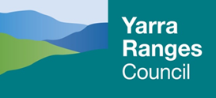

CONTENTS

A VISION FOR A CREATIVE COMMUNITY 3

MAYORS FOREWORD 4

THE YARRA RANGES’ CULTURAL STORY 5

SUMMARY 6

CULTURAL OUTCOMES 7

DEVELOPING THE STRATEGY 8

KEY COUNCIL STRATEGIES 8

KEY STRATEGIC AREAS 9

Production and Industry 10

People and Experience 12

Place and Environment 14

# A VISION FOR A CREATIVE COMMUNITY

Yarra Ranges is a place that values creativity and culture.  The Yarra Ranges community understands the profound and powerful influence our history, art and creativity have in shaping our lives. We want to extend and build on this understanding.

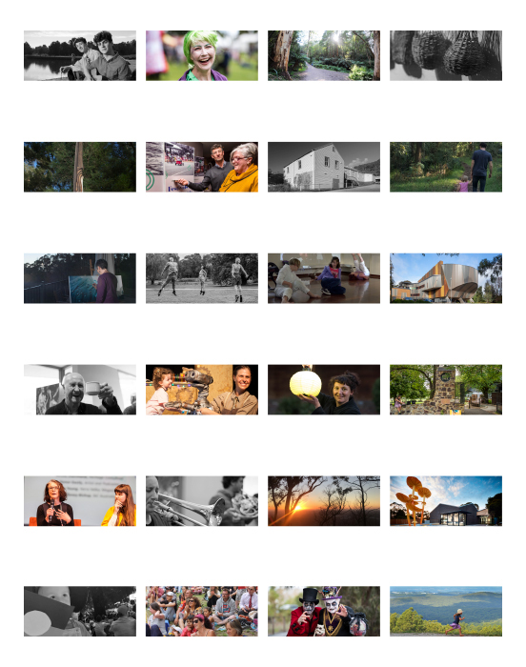

*Our vision is to shape Yarra Ranges as a creatively vibrant place where participation in the cultural life of our communities is sustained as a seamless and deeply meaningful experience encountered in the street, our open spaces, our businesses and industry, our civic places, our schools and in our homes.*

# MAYORS FOREWORD

Yarra Ranges has been a place of significant culture before and after colonisation.   
We are fortunate to have the strong presence of the oldest continuous culture on earth. We acknowledge the Wurundjeri people and their custodianship of the land and for the cultural influence of their elders past and present. We look forward to the cultural influence of future Wurundjeri leaders.

Our community has an expressed desire to see culture at the heart of our places. In the past decade Council has invested significantly in our culture, including the refWe value our vibrant culture and our opportunities for creative expression. We value being able to paint, draw, dance and sing; and we value being able to share and celebrate our creativity with each other through festivals, markets, performances and other events.”
  – Yarra Ranges Community Values Statement, 2016/17

urbishment of cultural facilities such as Burrinja Cultural Centre, Memorial Hall Healesville, Montrose Town Centre and the Yarra Ranges Regional Museum. Council has invested in the assets that provide a platform for the expression and development of our culture.

Yarra Ranges has facilitated the activation of these spaces through community participation and the success of the entire Culture Tracks program in facilities. Culture Tracks is supported by community festivals and events, heritage, dance and singing initiatives, as well as multiple public art works. Our partnerships with Burrinja and other key local cultural organisations and networks amplify the diversity of cultural offerings for the region.

Yarra Ranges Council has a vision for a thriving creative community to enable resilience, expression, innovation and economic sustainability leading to a deep sense of belonging and community connection for our residents.

As Yarra Ranges looks to the future, we want to develop deeply engaged communities who understand the past, are creatively expressive, innovative and ready for rapid changes in their spaces and the world around.

# THE YARRA RANGES’ CULTURAL STORY

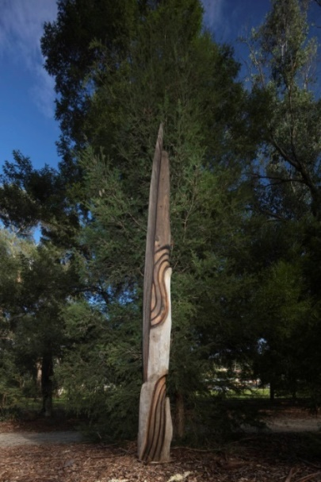For more than 40,000 years the unique Yarra Ranges landscape has been a source of spiritual and physical power and inhabited continuously by Aboriginal people for all of that time.

Colonial encounters had a devastating impact on the local Wurundjeri people. Local land wars included the ‘Battle of Yering’, whilst in Healesville, the nationally significant Coranderrk Mission was established by local Aboriginal people, led by Wurundjeri man Simon Wonga and later his successor, the inspirational William Barak.

European settlers dramatically altered the landscape through logging, pastoral runs and a gold rush precipitating the installation of transport infrastructure including timber tramways throughout the Upper Yarra Valley. Grape vines were first planted in 1838 at the Yering pastoral property of the Ryrie brothers

Lilydale became central to the Gold Rush boom of the 1850s with the extraction of lime for cement from a well-like hole at Cave Hill Estate. Historical sources suggest Aboriginal people called the cave ‘Bukker-tillible’ or cave ‘with no end’ and that Bunjil the creator spirit created the cave when angered.

From the 1860s the Yarra Ranges attracted visitors from Melbourne who enjoyed the panoramic views, ash forests, fern gullies, picturesque villages and the cultural experiences of Yarra Ranges.

The region’s international fame was established early in 1900s with one of the Yarra Ranges’ most famous daughters, operatic soprano Nellie Melba. Yarra Ranges has been a place to create for many significant artists, including William Barak, C.J Dennis, Eugene von Guérard, Arthur Streeton, Tom Roberts, Fred Williams, Norah Gurdon and Lin Onus. In Mooroolbark, the internationally celebrated and pioneering landscape designer Edna Walling created and lived at a private village of English cottages and gardens known as Bickleigh Vale.

The region’s 55 townships are home to both active and activist communities engaged uniquely in their place. This diversity of culture has built resilient communities many of whom have experienced devastating bushfires, the most recent being 2009 Black Saturday bushfires.

Today this dynamic culture takes different forms. The Yarra Ranges is still home to many artists, poets, painters, sculptors, writers and musicians. Inspired by the place, they remain the backbone of our cultural expression. They are joined by groups such as Historical Societies and museums who continue to collect, document and celebrate our stories and cultural heritage .

Where does the story go next?Our community and future communities will decide, but perhaps it looks back with acknowledgement and a respectful, deeper engagement with a strong culture that is thousands of years old. A culture inextricably connected to the landscape (or ‘Country’) and a culture we have access to and can learn from about how to put cultural expression at the centre of our lives.

# SUMMARY

We are now confronted with the prospect of rapid change. The change we are experiencing in our communities is never more evident than when viewed through the prism of culture.

Technology brings new materials, processes, systems and tools. It allows us to connect, transact and transport in a kaleidoscope of new ways. How we harness that technology, our response to it, how we connect with each other as humans and how we express that, is the domain of culture.

This Strategy looks at a future where our creativity, identity, authenticity and innovation are instrumental in shaping the places we live in and the lives we lead.

While there are many common challenges across state, national and international arenas, Yarra Ranges has distinct advantages to draw upon; a stunning natural environment, resilient and creative communities and a rich cultural heritage.

There are four key areas that will provide greatest impact and ensure meaningful change:

* **Creative industries** are among the most rapidly growing sectors worldwide and key to our economic growth and prosperity. Importantly creative industries have an amplifying effect on the economy, culture and society.
* **Indigenous people** and cultures in Yarra Ranges are central to our identity and shared heritage. To reinforce our commitment to reconciliation, we will develop and broaden knowledge and appreciation of our significant Indigenous cultural heritage in Yarra Ranges amongst the wider community.
* **Community involvement** in decision making was a central theme of our community engagement. It reflects the wider trend towards deliberative and participatory models.
* **Creative Places.** The built and the natural environments of the Yarra Ranges are a key draw-card for residents and visitors alike and a source of inspiration to creative people.

With an identified desire for increasing involvement of community, the key role of creativity and culture in shaping place and the importance of economy in our lives, we have identified three strategic areas that align with State and Federal initiatives and will guide our actions over the next 10 years. These are:

1. **People and Experience** - a community active in shaping extraordinary cultural experiences
2. **Production and Industry** - thriving creative industries attracting creative people
3. **Place and Environment** - putting culture and creativity at the heart of our places.

The proposed approach seeks to involve our community more in their facilities, spaces, programs, projects and townships through the lens of creativity, heritage and culture. We are proposing to develop our creative economy for dual economic and cultural outcomes.

We want to create an ecosystem that is accessible, allows for expression, encourages participation, connects people and facilitates creative places that drive an ideas economy.

# CULTURAL OUTCOMES

In order to effectively implement the Strategy, annual business plans will be developed and Council will report on progress and outcomes on an annual basis through an Activity Report.

In addition to qualitative and quantitative measures, we will measure and evaluate our performance and progress using specific culture measures.

The ‘five measurable outcomes of engagement in cultural development activities’ was developed by and is attributed to the Cultural Development Network Ltd in partnership with the National Local Government Cultural Forum in Australia.

The cultural measures are:

1. ***Creative expression stimulated***

The degree to which the activity stimulates creative expression among participants and enables them to create work on their own

1. ***Aesthetic enrichment experienced***

The degree to which the activity offers participants an aesthetic experience that results in a feeling of having participated in something special and beyond the everyday

1. ***New knowledge, ideas and insights gained***

The degree to which the activity is a catalyst for the generation and sharing   
of different perspectives, new knowledge, ideas and insights

1. ***Cultural diversity appreciated***

The degree to which the activity increases appreciation of different forms   
of cultural expression

1. ***Connection to shared heritage experienced***

The degree to which the activity creates a sense of connection or belonging   
to a shared past, present and future

# DEVELOPING THE STRATEGY

In 2017 Council undertook comprehensive community engagement initiatives in preparation for the strategy.

They included:

* A Creative Communities Forum and Workshop with 180 attendees, 12 speakers and 7 interactive workshops
* Culture Bucks mobile program with 1,000 participants from 18 locations
* Yarra Ranges Creative Communities Online Survey received 217 responses
* In depth focus groups which included 100 council partners and advisory committee members
* Festivals and events, music and song were foremost in community feedback results
* Presentation of a draft strategy and community feedback.

# KEY COUNCIL STRATEGIES

This strategy to develop and shape a creative community is aligned to Council’s vision   
for its community and makes a significant contribution to achieving Council’s plan for the future.

*Health and Wellbeing Strategy-* Council’s Health and Wellbeing Strategy states “Yarra Ranges has vibrant arts and heritage experiences that connect communities” as a goal.

*Environment Strategy-* The strategy acknowledges Indigenous Heritage in Yarra Ranges and the deep connection to Country at both a spiritual and physical level.

*Reconciliation Framework for Action 2013-23-* Public art and culture provide important visible cues and engender a spirit of belonging and dialogue.

*Recreation and Open Spaces Strategy-*Council encourages people to participate in sport, socialise, develop skills, play and relax in our parks.

*Economic Development Strategy-*The rich cultural tapestry of Yarra Ranges can be further developed and promoted as a product that would increase cultural tourism.

# KEY STRATEGIC AREAS

Our plan is based on the values of our community and directed towards specific Council goals. It focuses on outcomes that will make Yarra Ranges a location where creativity, art, history and heritage are an essential and a visible part of our daily lives. Yarra Ranges will be recognised internationally as a place for liveability, significant history, natural environment, living cultures, art, contemporary practice, talented people and creative industry opportunities.

To do this we have identified three strategic areas and developed priority actions for   
the next 10 years. The plan identifies how our resources can be directed to support our vision, including strategic initiatives; policy making and programs, grants and sponsorship programs; cultural spaces and infrastructure; advocacy, direct services   
and regulatory functions.

There are three connected strategic areas that underpin change that will drive us   
towards our vision in the next 10 years.

## Production & Industry

We seek to develop authentic Yarra Ranges creative industries that thrive economically, attract creative people and embed creativity within the cultural life of the region. Our priority is to establish Yarra Ranges as the most desirable environment in Victoria in which to be creative.

## People & Experience

Our community is actively involved in shaping extraordinary cultural experiences that echo our creativity and dynamic history. Our cultural spaces and facilities are activated and people centred. Our programs are of the highest quality, accessible to all and shaped in partnership with increasing community ownership.

## Place & Environment

Yarra Ranges will put culture, history and creativity at the heart of our places. Our connection to the landscape and its natural beauty is entwined with our deep sense of culture. Our priority is to develop vibrant and active public places within our townships that express and celebrate our creativity and heritage.

|  |  |  |
| --- | --- | --- |
| **People**  **& Experience** | | **Strategic Area**  Our community is actively involved in shaping extraordinary cultural experiences that echo our shared creativity and history. Our cultural spaces and facilities are activated and people centred. Our programs are of the highest quality, accessible to all and shaped in partnership with increasing community ownership.  **Strategic Goal**  Greater and more meaningful participation from communities. |
|  | **Why?**  We know that a strong sense of local identity binds communities together, making them connected and resilient. This resilience and connection is enhanced when experienced through a cultural filter. | |

**Strategic Actions – We will:**

##### Facilitate programming that puts audience experience and their participation at the centre

##### Reflect a deep understanding of local people, history and culture

##### Engage more broadly with diverse local Indigenous communities and develop broad knowledge of Indigenous history, continuity and culture in Yarra Ranges

1. Actively engage and develop community leaders to help shape our diverse cultures, infusing creativity, heritage and culture in our key institutions.

**Achieving our People and Experience goal**

Our people, their creativity and their stories are at the heart of the cultural experience in Yarra Ranges. Whether it is festivals and events, public art, collections, professional and community programming for our facilities or cultural development projects, we will put our community at the centre of our service delivery. We will support community participation in activity, organisation and decision making. We will work in partnership with groups and networks in our communities to both deliver services, but also to express our unique culture. Council will make our cultural spaces more accessible and use face to face and digital technology to engage deeply with the cultural actors in our community to ensure cultural outcomes are achieved.

|  |  |
| --- | --- |
| **Outcomes** – **What we want to achieve** Creativity Stimulated- Cultural OutcomeNew knowledge, ideas and insights gained - Cultural OutcomeConnection to shared heritage experienced - Cultural OutcomeGood physical and mental health stimulated - Social OutcomeBonding, bridging and linking social capital increased - Social OutcomeActive citizenship, leadership stimulated- Social Outcome | **Impact- What we expect to see** Extraordinary cultural experience strengthening community connectionBroad awareness and participation in cultural events that reflect our shared identity/historyThe Indigenous history and culture of Yarra Ranges is protected and celebratedCommunities actively shaping and developing the cultural landscape |

**Our strategic actions are directly aligned to the following:**

|  |  |
| --- | --- |
| Council Plan Strategic Objective: Connected  and Healthy communitiesHealth and Wellbeing StrategyEnvironment StrategyEquity Access and Inclusion Strategy **Strategic Area**  We seek to develop authentic Yarra Ranges’ creative industries that thrive economically, attract creative people and embed creativity within the cultural life of the region. Our priority is to establish Yarra Ranges as the most desirable environment in Victoria in which to be creative with increasing community ownership. | The Yarra Ranges Reconciliation Framework for Action 2013-2023 – Themes for Action: Healthy, Healing and Spirit, Participation: Increase Indigenous voices in contemporary society and community life, Service Access and Strengthening Cultural HeritageTownship structure plans, Community Master plans  and Community Safety Strategy |

|  |  |  |
| --- | --- | --- |
|  | | **Production**  **& Industry**  **Strategic Goal**  Increase the economic size of the creative industries and expand its impact on both the local economy and vibrancy of our communities.  **Why?**  Active and entrepreneurial creative practitioners help improve the livability of communities. Yarra Ranges Creative Industries already has a strong foundation and its natural beauty and geographic proximity to Melbourne provides a unique advantage in developing Creative Industries further. |
|  | **Strategic Actions – We will:** Back Yarra Ranges creative talent with specific opportunities and recognise local achievementRaise the profile, reach and impact of Yarra Ranges Indigenous artists and creative professionalsDevelop the sector by enhancing education pathways, professional development and employment opportunitiesCreate an environment that fosters thriving creative industriesDevelop and maintain strategic partnerships with peak organisations that enhance and extend the experience of arts and heritage in Yarra Ranges | | |

**Achieving our Production and Industry goal**

To attract Creative practitioners and industry to Yarra ranges we will build on the natural advantages of Yarra Ranges and develop   
a creative industry approach. We will assess the space and infrastructure, including digital infrastructure required to support industry development. We will monitor the outcomes of Creative Industry development to identify ways it can provide the dual outcome of economic and cultural development in our places. We will partner with local tourism, support and facilitate outcomes that specifically target the cultural offer from local people.

|  |  |
| --- | --- |
| **Outcomes** – **What we want to achieve** Aesthetic enrichment experienced - Cultural OutcomeCultural diversity appreciated - Cultural OutcomeConnection to shared heritage experienced - Cultural OutcomeDirect employment provided - Economic OutcomeLocal economy supported - Economic Outcome | **Impact- What we expect to see** Opportunities abound for authentic Yarra Ranges creative industries to thriveCross Sector Partnerships Embed Creativity in Yarra RangesCultural Tourism supports local creative industryYarra Ranges is the place for Arts and Culture professionals to live and work |

**Our strategic actions are directly aligned to the following:**

|  |  |
| --- | --- |
| Council Plan Strategic Objective: Vibrant economy, agriculture and tourismCouncil Plan Strategic Objective: Protected and Natural EnvironmentEconomic Development StrategyEquity Access and Inclusion Strategy | Reconciliation Framework for Action 2013 - 2023Deliver on Recreation and Open Spaces - in particular recreation, play spaces, streetscapes and other council infrastructureEnvironment Strategy |

**Strategic Area**

Yarra Ranges will put culture, heritage and creativity at the heart of our places. Our connection to the landscape and its natural beauty is entwined with our deep sense of culture.

|  |  |  |
| --- | --- | --- |
| **Place**  **&**  **Environment** | | **Strategic Goal**  Develop vibrant and active public places particularly within our townships that express and celebrate our creativity and history.  **Why?**  Deepening the understanding of our significant heritage and expressing it openly and creatively engages us and connects us as humans and communities. It creates a strong sense of belonging. |
| **Strategic Actions – We will:** Ensure public visibility of contemporary and historical Indigenous cultureMake visible the cultural, historical and artistic diversity of the region within townshipsEnsure major community and cultural facilities, recreation, play spaces and other council infrastructure is delivered with Yarra Ranges’ creativity and culture at the centre.Encourage and broaden the base of artists and community cultural leaders to activate and engage townshipsDevelop and maintain key policy and plans to support a balanced approach to protecting and celebrating our cultural heritage |  | |

**Achieving our Place and Environment goal**

Renewal of our townships provides critical opportunities for intergenerational engagement with communities. We will look at all projects and places with a creative and cultural filter. We will work with our many heritage and history groups, artists and creative workers to devise new ways to visibly express our culture and heritage within our places. We will apply a creative and cultural   
lens to improve resilience and livability for all Yarra ranges residents.

|  |  |
| --- | --- |
| **Outcomes** – **What we want to achieve**   * Aesthetic enrichment experienced - Cultural Outcome * Sense of belonging to shared heritage experienced  - Cultural Outcome * Contribution to neighbourhood character, including regeneration, made - Environmental Outcome  Positive sense of place in the local built and natural environment engendered - Environmental Outcome | **Impact- What we expect to see**   * Public projects and infrastructure are designed with creativity and heritage values at the core * Communities actively shape and develop the cultural landscape * Destination established * Significant built heritage is recognised and conserved |

**Our strategic actions are directly aligned to the following:**

|  |  |
| --- | --- |
| Council Plan Strategic Objective: Vibrant economy, agriculture and tourismCouncil Plan Strategic Objective: Protected and Natural EnvironmentEnvironment Strategy Goal 1Local Area Planning, Master Plans, and Community Safety Strategy | Reconciliation Framework for Action 2013 - 2023Deliver on Recreation and Open Spaces, in particular recreation, play spaces, streetscapes and other council infrastructurePriorities to improve place based and investment outcomes in Yarra RangesEquity Access and Inclusion Strategy |
|  |  |