Stormwater Management Plan 2024 - 2034

Contents
1 Executive Summary 3
2 Glossary 3
3 Introduction 4
4 Indigenous Water Knowledge 5
5 Background 5
5.1 Responsibilities 5
5.2 Setting 6
5.3 Stormwater Policy 7
6 Challenges and Opportunities 9
6.1 Municipal Size, Geography and High Value Waterways 9
6.2 Water in the Landscape 9
6.3 Ageing Infrastructure 10
6.4 Constrained Funding 10
6.5 Growth and Development 10
6.6 Flooding, Climate Change and Resilience 10
6.7 Landslips and the Environmental Management Overlay 11
7 Stormwater Management Plan 2024-2034 11
7.1 Mission 11
7.2 Objectives, Targets and Measures 11
7.3 Managing Drainage and Flood Requests 17
7.4 Updates to Development Engineering Guidelines and Planning Permit Processes 17
7.5 Investigation of Stormwater Offsets 18
7.6 Establishing Strategic Partnerships 18
7.7 Exploring Funding Mechanisms 19
7.8 Waterway Prioritisation Framework: Where to Focus WSUD and IWM Initiatives 19
7.9 Flood Mapping Program 24
7.10 Flood Catchment Prioritisation 25
7.11 Implementation Plan and Timeline 29
8 References 43

Executive Summary
The Yarra Ranges region is the largest local government area in land size in Melbourne. The Council's drainage network is almost 800km long. The drainage network intersects with waterways managed by Melbourne Water. There are many challenges related to the management of stormwater including:
- increased development
- more pollution and runoff from stormwater
- ageing infrastructure
- funding constraints
- existing flood risk
- impacts of climate change.
The Yarra Ranges Stormwater Management Plan (SWMP) analyses the challenges and opportunities and details key actions to address them. It reflects federal, state and local policies, guidelines and legislation. It also reflects Council plans and strategies.
The Yarra Ranges SWMP supports the Council's stormwater policy. The six objectives that support the policy are:
- utilising stormwater as a resource
- existing and future flood risks are managed to maximise outcomes for the community
- healthy and valued waterways
- healthy and valued urban and rural landscapes
- community values are reflected in stormwater planning
- strategic partnerships.
The Stormwater Drainage Management Plan will be implemented by Council in partnership with stakeholders and the local community. Reporting on the Plan will be undertaken through biennial reviews presented to Council.
The Plan will be monitored to determine if Council is on track to meet its vision and intent and a monitoring plan will be established to track progress.

Glossary
Directly Connected Imperviousness (DCI) | This is an umbrella measure that combines all aspects of waterway condition that are known to be impacted by development and urbanisation, into a factor that can determine if significant stormwater changes may occur to a specific area. Aspects include changes in stormwater flows, volumes, quality, gross litter.
Drainage network | The network of pits, pipes, swales and channels that collects stormwater runoff and moves it away from the built environment.
Erosion Management Overlay (EMO) | Identifies areas that are at risk of landslip.
Fluvial or riverine flooding | A type of flooding when a river, creek or other waterway overtops its banks and floods the land around it.
Hotspot | A known flood problem area which has a history of repeat flooding of a road, crossing or property, often known through anecdotal information and complaints.
Pluvial, overland or flash flooding | A type of flooding in large rainfall events, when the drainage network is overwhelmed and some of the stormwater flows over the ground.
Runoff | The amount of rainfall that enters the stormwater drainage system.
Stormwater | Flows produced when rain falls and runs off from all surfaces within a catchment, including roads, roofs, driveways, footpaths and vegetated areas.
Water Sensitive Urban Design (WSUD) | An approach to minimise harmful effects to the environment when designing drainage systems.

Introduction
Stormwater is produced when rain falls onto and runs off from surfaces. These include roads, roofs, driveways, footpaths and vegetated areas. Stormwater needs to be managed to protect local waterways and improve flood resilience. Council’s drainage network includes pits, pipes, swales and channels. It collects stormwater runoff. It then moves it away from the built environment to the waterways. Currently, stormwater management focuses on flood risk and the impact on waterways. Council’s stormwater services include:
- planning and controlling land use and development
- understanding flood risk
- preparing for and recovering from flood events
- protecting waterways and the environment from harmful impacts from stormwater
- improving climate resilience
- design, construction and maintenance of drainage assets and stormwater quality treatment systems
- increasing fit for purpose stormwater reuse
- improving landscape resilience, urban greening and cooling stormwater irrigation and passive irrigation
- partnering with other water authorities to improve management of stormwater
- capacity and flexibility in the drainage for climate change impacts and population growth.
The Yarra Ranges municipal area covers an area of 2450 square km. Council own 2%, private ownership is 30% and 68% is Crown land. The land is a mix of farming, residential, commercial, industrial, and townships. It also has state forest and drinking water catchments.
The Yarra Ranges contains pristine waterways, including the headwaters of the Yarra River. The community value these and they have high ecological importance. Rain that falls in the catchments makes its way to these waterways. When development happens, areas that were once forest, farm or more natural surfaces end up becoming covered with concrete and other ‘hard’ surfaces. Increased hard surfaces cause more rainwater to flow over the landscape rather than naturally soaking into the soil. This causes higher than natural flows of water to enter streams and creeks. The outcome is potential erosion and damage to fish and platypus habitat.
The stormwater runoff can also pick up debris, chemicals, sediment, and other pollutants, which can make its way to our waterways. Our waterways need to be protected by keeping some of the stormwater within the catchment. This needs to be balanced with maintaining flood protection.
Water and flooding are part of our natural environment and landscape. We aim to control and improve conditions in some rainfall events. But there is not always an engineering solution for every stormwater issue. The municipality faces several local flood management and drainage challenges. There are over 4,900 properties known to be at risk of flooding from waterways or underground drains (Flood Management Plan – Yarra Ranges Council and Melbourne Water, 2016). More developments and an increase in extreme rainfall events because of climate change are also pressures to the existing drainage system.
Council has produced the Stormwater Management Plan 2024-2034 to strategically manage both the flood risk and to protect and maintain the natural water cycle and the health of waterways from the impacts of urban development.

Indigenous Water Knowledge
Waterways and floodplain areas have always been important places for Aboriginal people to gather as families and communities for cultural, social, and recreational activities. Access to floodplain areas is crucial for these activities to continue and for future generations of Aboriginal people to learn about their culture. Traditional Owners speak of waterways moving back and forth across floodplains over time, which scatters artefacts and influences cultural practices.
The Yarra Ranges Indigenous Advisory Committee (IAC) played a crucial role in creating the Stormwater Management Plan 2024-2034. The IAC ensures the Aboriginal voice is part of Council decisions, offering advice on weaving Indigenous knowledge into Council strategies and projects. This effort builds resilience in communities and landscapes, improving health and wellbeing.
Insights from the IAC highlight the importance of water movement for the health of the Country. The impact of colonisation changed natural water paths, leading to flooding and waterway degradation. The IAC stressed the need to identify natural flow paths to prevent future flooding. Emphasis was placed on working with the natural elements to ensure sustainable outcomes and the ongoing health of the Country, especially with climate change. Effective land management, such as traditional cultural fire practices, revitalises grasslands and biodiversity.
Stormwater Management Plan 2024-2034 acknowledges the Traditional Owner’s connection to the land and waterways and has identified initiatives to:
- Reduce dangerous flooding now and in the future, considering development and climate change.
- Improve asset management, making it more efficient and cost-effective for the council.
- Enhance responses to climate and climate change-related events through resilience planning.
- Minimise stormwater increases due to development and protect the landscape’s environmental values and physical characteristics from stormwater degradation.
- Promote integrated water management and flood mitigation strategies.

Background

Responsibilities
Council has legislative responsibilities related to drainage within the community. These responsibilities are below.
Yarra Ranges Council is classified as one of the local drainage authorities under the Water Act 1989. This means we are responsible for managing some of the drainage within the municipal area. This includes the planning, construction, and maintenance of drainage infrastructure. This helps prevent flooding, manage stormwater runoff, and maintain water quality standards.
Note: between two private properties, the landowners, developers, and body corporates are responsible for the drainage up to the 'Legal Point of Discharge'. This is except if the drainage structure is within a drainage easement. The image below helps to show this.
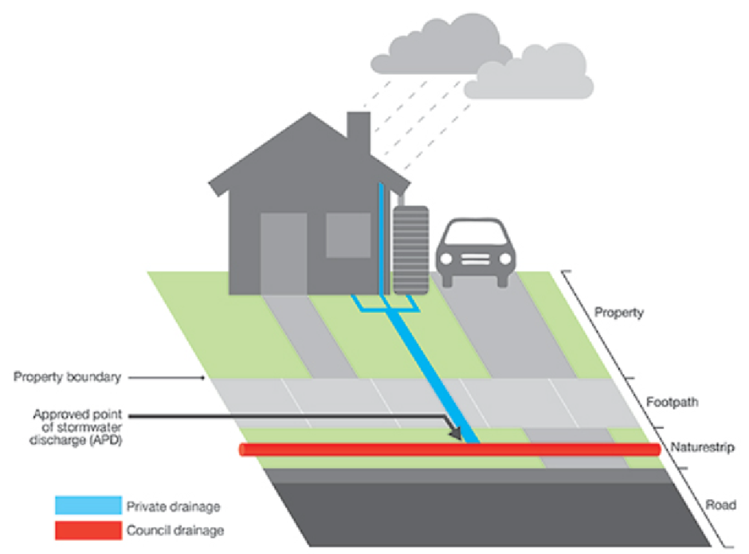
Figure 5-1 Private property showing private drainage (landowner’s responsibility) versus Council drainage (Council’s responsibility)
Council is also responsible for:
- Nominating stormwater discharge points under the Building Regulations 2018. This ensures stormwater moves in a way that reduces the risk of flooding and harm to the environment.
- Ensuring stormwater quality targets are met for different types of development. This promotes sustainable development practices and protects the local environment.
- Reducing the risk of activities that might harm the environment.

Setting
A review of state and local policies, legislation, strategies, plans and frameworks was undertaken. These documents are summarised in Appendix A and informed the objectives, measures, targets and actions of the Yarra Ranges SWMP.
Table 5-1 Summary of key relevant policies, legislation, strategies, plans and frameworks
Category | State / Regional | Local
Land Use & Planning | Victorian Planning Provisions (VPP) | Yarra Ranges Planning Scheme  Community Vision for 2036  Housing Strategy 2024
Climate Adaptation | Victoria’s Climate Change Strategy  Built Environment Climate Change Adaptation Action Plan 2022–2026 | Council Plan 2021-2025  Community Vision for 2036  Environment Strategy 2015-2025  Health and Well-being Plan
Stormwater Specifications & Management | Victorian Planning Provisions (VPP)  Water for Victoria and IWM Framework for Victoria  Stormwater Best Practice Environmental Management Guidelines (CSIRO, 1999)  Urban Stormwater Management Guidance (EPA, 2021) | Yarra Catchment IWM Plan and Dandenong Catchment IWM Plan  Yarra Ranges IWM Plan  Environment Strategy 2015-2025  Recreation and Open Space Strategy – Policy, Implementation and Strategic Framework  Tree Canopy Strategy
Flood Management & Mitigation | DELWP Guidelines for Development in Flood Affected Areas  Plan Melbourne– 2017-2050 Strategy  Flood Management Strategy for Port Phillip and Western Port (2021-2031) | Flood Management Plan  Recreation and Open Space Strategy – Policy, Implementation and Strategic Framework
Riverine & Waterway Management | The Healthy Waterways Strategy (HWS)  HWS Stormwater Targets: Practitioner’s Note  Greater Melbourne Urban Water & System Strategy: Water for Life | Yarra River Action Plan  Yarra Strategic Plan  Environment Strategy 2015-2025
General Environment | General Environmental Duty  Environmental Protection Act | Environment Strategy 2015-2025  Tree Canopy Strategy  Health and Well-being Plan
Collaboration & Partnerships |  | Council Plan 2021-2025  Community Vision for 2036

Stormwater Policy
The Stormwater Policy outlines how stormwater will be managed in the Shire of Yarra Ranges. The Policy outlines implementation of:
- Council’s legislative requirements
- Existing Council policies, strategies and plans
- State-led strategies, plans and guidelines
The purpose of the Stormwater Policy is to:
- Summarise Council’s current position and priorities of stormwater management within the municipality.
- Define Council’s responsibility and scope of control in relation to stormwater management.
- Outline Council’s objectives for stormwater management in relation to sustainable development.
- Provide an internal framework and action plan for how policy objectives will be achieved.
- Guide Council’s use and implementation of internal documents such as the Stormwater Management Plan 2024 -2034, the Engineering Development Guidelines, Flood Mapping Program, the IWM Plan and the Stormwater Asset Management Plan.
The objectives of the Stormwater Policy are shown below, along with their links to the Yarra Ranges SWMP objectives (discussed further in section 6.2).
Policy Objective | Links to SWMP Objectives
Encourage all eligible new stormwater assets and developments within Yarra Ranges Council to be water sensitive, allowing them to be attractive, thrive and perform well now and into the future. | - Utilising Stormwater as a resource.  - Healthy and valued waterways.  - Healthy and valued urban and rural landscapes.  - Strategic Partnerships.
Continue Council and Melbourne Water’s efforts to rehabilitate, protect and enhance all waterways within the municipality. | - Healthy and valued waterways.  - Strategic Partnerships.
Ensure all new eligible developments achieve full compliance with relevant best practice standards in BPEMG and encourage developments to follow the Urban Stormwater Management Guidance. | - Healthy and valued waterways.
Ensure that all new eligible development on public and private land does not adversely impact on the performance of the existing local stormwater drainage network. | - Existing and future flood risks are managed to maximise outcomes for the community.
Ensure that all new eligible development on public and private land does not cause detrimental increases in flows to neighbouring properties. | - Existing and future flood risks are managed to maximise outcomes for the community.
Ensure that all new capital stormwater works are fit for purpose. | - Existing and future flood risks are managed to maximise outcomes for the community.  - Community values are reflected in stormwater planning.  - Healthy and valued waterways.  - Healthy and valued urban and rural landscapes.
Increase Council’s knowledge of the current stormwater asset base and the existing and future flood risk across the municipality. | - Existing and future flood risks are managed to maximise outcomes for the community.
Enhance communications with residents, landowners and developers who live and work within the municipality to clearly articulate issues, solutions, and responsibilities related to stormwater management and flooding. | - Community values are reflected in stormwater planning.  - Utilising Stormwater as a resource.  - Healthy and valued waterways.  - Healthy and valued urban and rural landscapes.  - Strategic Partnerships.

Challenges and Opportunities
There are many challenges and opportunities in stormwater management in the Yarra Ranges:
- size of the municipality
- abundance of high value waterways
- constrained funding
- growth and development plans
- ageing infrastructure
- existing flood risk
- climate change and resilience.

Municipal Size, Geography and High Value Waterways
The Yarra Ranges municipality is the largest in area of all local government areas in Melbourne. It covers an area of 2450 square kilometres. The majority of the upper catchment is protected forest. Development occurs across the municipality through forest, farmland and urbanised areas. The Council managed drainage network is almost 800km, contains over 29,000 pit structures and over 20 km of minor culverts. There are over 1,962 km of waterways, 64 km of open channels and 42 km of underground drainage managed by Melbourne Water. The majority interfaces with Council’s stormwater drainage network.
The geographic spread and topography of the area presents unique challenges. Also, the large geographic size of Yarra Ranges means it is more costly to deliver services. There are also greater distances for residents to access services. The roads, footpaths, bridges and drainage need to be maintained and renewed into the future.
The Yarra Ranges contains pristine and highly valued waterways including the headwaters of the Yarra River. Most of the Yarra Ranges has been identified as a Stormwater Priority Area within the Healthy Waterways Strategy 2018-2028. These are areas with high ecological values, making it critical to ensure protection from the impacts of urban development. This protection is essential to maintain the natural water cycle and safeguard the health of the waterways.

Water in the Landscape
Water and flooding are part of our natural environment and landscape. However, there is not an engineering solution for every stormwater issue. We aim to integrate traditional knowledge and innovative approaches in managing stormwater. Through continuous monitoring, research, and adaptation, we aim to build a resilient future. This will help ensure sustainable stormwater resource management within the Yarra Ranges.

Ageing Infrastructure
Many older areas contain drainage infrastructure of previous standards. This met requirements then, but not necessarily now. A lot of the original drainage infrastructure was designed for a lower-density developments with significant with significant areas that allow water to soak into the ground compared to today’s standards. With new Drainage assets, once constructed, are not guaranteed to maintain their designed capacity indefinitely due to potential future development, increased rainfall intensity from climate change, and the natural ageing of infrastructure.

Constrained Funding
The maintenance and construction of the stormwater infrastructure across such a large area requires considerable budget. The Council Plan identifies that there are reduced options to raise revenue due the introduction of rate capping by the State Government while at the same time needing to ensure essential community services are accessible. The Council Plan further identifies that there is a need for significant investment in our ageing infrastructure to meet the expectations of the community.

Growth and Development
Yarra Ranges has a population of approximately 159,000. Predicted to grow to 180,000 residents by 2041, which is an average annual growth rate of 0.7%. This future growth will not be equal across the Yarra Ranges. Majority of the growth expected is forecasted to be concentrated in urbanised part of Yarra Ranges. These are the suburbs of Lilydale, Chirnside Park, Mooroolbark and Kilsyth. The Council Plan identifies the need to manage future growth and consider impacts of development across the municipality.
Urban development also presents specific threats to our water resources. Hard surfaces cause rainwater to flow over the landscape, rather than naturally soaking into the soil. This causes high flows of water to enter streams and creeks, causing erosion and damage to fish and platypus habitat. The stormwater runoff also carries pollution to the waterways.
Sustainable stormwater management measures need to consider the protection of waterways. Protecting waterways can be partly met by keeping more stormwater within the catchment. This needs to be balanced with flood protection. Strategic initiatives in new developments can also be used such as the storage of water within open spaces, buildings, and roadways for reuse. This can create opportunities for more sustainable water usage and provide more drought resilient Council assets.

Flooding, Climate Change and Resilience
Many properties in the Yarra Ranges are potentially flood prone (The Flood Management Plan, 2016). Major contributors to this are:
- increased housing density
- developments within floodplains and overland flow paths
- no formal overland flow paths
Council’s Flood Management Plan (2016) identifies known flood hotspots throughout the municipality. Council attend to many floods and drainage requests each year across the municipality.
The Council Plan notes frequency and severity of extreme weather events will increase. This includes floods and storms.
Development and climate change increases stormwater runoff entering creeks and rivers.
By 2100, Yarra Ranges may see an 18.5% increase in rainfall intensity and a temperature rise of 3.48°C. Increased urbanisation and hard surfaces will likely increase flood risk and pressure on the drainage network. The Development Engineering Guidelines will require all new developments to account for an 18.5% increase in rainfall intensity in designs for the 2100 planning horizon.
Council will consider impacts of more rainfall in their stormwater management and planning. In planning, Council will:
- use industry standard approaches, State and local strategies, plans and frameworks
- update Council’s Development Engineering Guidelines to require all new developments to account for an 18.5% increase in rainfall intensity in designs
- investigate opportunities of IWM and water sensitive urban design
- investigate and build fit for purpose water supply where possible, for example, harvesting stormwater and reusing it to irrigate open spaces
- support WSUD initiatives to incorporate passively irrigated street trees with stormwater runoff. This supports increasing tree canopy on public land as per Council’s Tree Canopy Strategy
- require that all new developments incorporate an 18.5% increase in rainfall intensity in all designs for the planning horizon of 2100.

Landslips and the Environmental Management Overlay
Council’s Erosion Management Overlay (EMO) identifies areas that are at risk of landslip. The likelihood of slip is a factor of slope, soil type, what structures are on the ground, and rainfall. Long periods of consistent rainfall can cause saturation of the soil which may lead to landslips. Similarly, large volumes of water introduced to a landslip area can lead to landslips.

Stormwater Management Plan 2024-2034
Key actions relating to the entire Stormwater Management Plan include SWMP20, SWMP22, SWMP23, SWMP26, and SWMP27.

Mission
At Yarra Ranges Council, our mission is to proactively manage stormwater to safeguard our community, preserve natural ecosystems, and promote sustainable development practices.
We strive to minimise flood risk while protecting our waterways and the health of our communities amidst the increasing frequency and severity of severe weather events.
Through innovative strategies, continuous monitoring, and collaborative partnerships, we aim to adapt to evolving environmental challenges and build a future where stormwater management serves as a foundation for thriving, resilient communities within the Yarra Ranges municipality.

Objectives, Targets and Measures
Note: These will be delivered via the actions in the Yarra Ranges SWMP (refer section 7.11)
Key objectives and indicators of the Yarra Ranges Stormwater Management Plan are outlined below.
- Utilising Stormwater as a resource
- Increase fit-for-purpose use of stormwater and rainwater
2. Existing and future flood risks are managed to maximise outcomes for the community
- Reduce the impacts of dangerous flooding now and into the future with development and climate change
- Increase cross-consideration of flood mitigation and integrated water management
- Improve community education around the flood management function of roadways
- Healthy and valued waterways
- Reduce the total urban stormwater runoff volume discharged to receiving waters
- Decrease pollutants discharged to receiving waters
- Protect high value waterways
- Healthy and valued urban and rural landscapes
- To minimise increases in stormwater due to development and protect the environmental values and physical characteristics of the landscape from degradation by stormwater
- To ensure integrated stormwater management that maximises ecosystem services, such as cooling and local habitat improvement, and provides attractive and enjoyable spaces
- Community values are reflected in stormwater planning
- Increase organisational capacity to partner with Traditional Owners to be able to respectfully acknowledge the connection of Traditional Owners to the land and waterways and include indigenous knowledge in stormwater management
- Engage with the community during flood mapping and stormwater management projects and studies to support and enhance community connection with and understanding of the water cycle
- To enable better asset management with improved efficiencies and overall cost reductions for Council via strategic planning
- Respond to climate and climate change related events through resilience planning
6. Strategic Partnerships
- Increased collaboration with other organisations to support strategic stormwater management
The objectives come from the Yarra and Dandenong Catchment Integrated Water Management (IWM) Plans and connect strongly to the Council's IWM Plan. The targets in the table below help meet these plans' goals to reduce Annual Average Damage (AAD), consider IWM and flood mitigation for all projects, and reduce annual mean run-off. Links to the Monitoring, Evaluation, Reporting, and Improvement Plan (MERI) indicators of the Yarra and Dandenong Catchment IWM Plans are included for future reporting.

Objective | Indicator | Measure | Target
Utilising Stormwater as a resource | Increase fit-for-purpose use of stormwater and rainwater | Percentage of new buildings and new development areas with opportunities for water reuse that have storage and reuse installed (%). Note: Council’s IWMP will also focus on storage and reuse options for open spaces, parks and Council buildings  Links to MERI indicator 1.2. | 90-100% of new buildings and new development areas with opportunities for water reuse that require a planning permit to have storage and reuse installed by 2025. All other buildings and areas encouraged.
Existing and future flood risks are managed to maximise outcomes for the community. | Reduce the impacts of dangerous flooding now and into the future with development and climate change. | Area of the municipality which has been flood mapped and has in place a catchment-wide stormwater strategy including identification of mitigation projects. | 50% of the municipal catchments considered in the prioritisation framework to have their mapping completed by 2029.
 |  | Reduction in community exposure to hazardous flooding delivered by flood management initiatives. | Investment decisions use an appropriate cost/benefit assessment. Capital works programs are informed by asset management plans and are included in the long-term financial plan.
 |  | Annual Average Damage (AAD) reduction delivered by flood management initiatives ($ millions addition to baseline).  Links to MERI indicator 3.1  N.B. Council’s IWMP will contain targets relating to TN , TP and TSS reductions | Reduction in Annual Average Damage (AAD) delivered by flood management initiatives. Capital works programs are informed by asset management plans and are included in the long-term financial plan.
 | Increase cross-consideration of flood mitigation and integrated water management | Number of projects that include IWM opportunities.  Links to MERI indicator 3.3. | Increase the number of projects cross-consider IWM and flood mitigation opportunities as part of their design by 2030 and maintained by 2050 in line with the Yarra and Dandenong Catchment IWM Plans. This includes consideration of opportunities to achieve stormwater, open space and/or amenity outcomes on all existing and future flood infrastructure projects.
 | Improve community education around the flood management function of roadways. | Community survey. | Improvement in knowledge base.
Healthy and valued waterways | Reduce the total urban stormwater runoff volume discharged to receiving waters. | Mean annual urban runoff volume reduction:  - Urban runoff volume reduction achieved by WSUD assets (infiltrated in ML/y)  - Rainwater use for residential, commercial and industrial development (ML/y)  - Stormwater use for public open space and infiltration (ML/year)  Links to MERI indicator 4.1. | - Decrease urban runoff volume via WSUD.  - Increase rainwater use for residential, commercial and industrial development via increase in new buildings with rainwater tanks.  - Increase stormwater use for public open space and irrigation.
 | Decrease pollutants discharged to receiving waters. | Percentage of new developments that require a planning permit that meet best practice water quality guidance within the same catchment (i.e. via on-lot WSUD, street-scale WSUD or downstream IWM/WSUD) (%). | Increase in percentage of new developments that meet best practice water quality guidance within that catchment.
 |  | Percentage of new developments that require a planning permit that pay a stormwater offset to Melbourne Water. | Year on year reduction in percentage of new developments that require a planning permit that contribute a stormwater offset contribution to Melbourne Water.
 | Protect high value waterways | % Directly Connected Imperviousness (DCI) in priority catchments.  Links to HWS target. | Achieve minimal net increase in DCI in priority catchments.
Healthy and valued urban and rural landscapes. | To minimise increases in stormwater due to development and protect the environmental values and physical characteristics of the landscape from degradation by stormwater. | Target established for road sealing program. | Baseline and target for stormwater management associated with road sealing programs determined.
 | To ensure integrated stormwater management that maximises ecosystem services, such as cooling and local habitat improvement, and provides attractive and enjoyable spaces.  N.B. this indicator, measure and target can also sit in the below objective. | Area (m²) of blue-green infrastructure created or enhanced by WSUD or IWM.  Links to MERI indicator 6.2. | Year on year increase in area of blue-green infrastructure created or enhanced by WSUD or IWM.
Community values are reflected in stormwater planning. | Increase organisational capacity to partner with Traditional Owners to be able to respectfully acknowledge the connection of Traditional Owners to the land and waterways and include indigenous knowledge in stormwater management. | Partner with the Traditional Owners and engage other community groups during flood mapping and catchment management projects so that natural flow paths are understood and protected. | Identify natural flow paths through flood mapping programs and engagement in flood mapping programs for 100% of all high-priority catchments identified in the catchment prioritisation framework.
 | Engage with the community during flood mapping and stormwater management projects and studies to support and enhance community connection with and understanding of the water cycle. | Extent of engagement with community on the delivery of stormwater services and participation with a community reference panel. | All flood mapping and mitigation studies include community engagement and participation with community reference panel.
 | To enable better asset management with improved efficiencies and overall cost reductions for Council via strategic planning. | Area of the municipality which has been flood mapped with pipe/pit/channel blockage scenarios included. | 50% of the municipal catchments considered in the prioritisation framework to have their mapping completed by 2029, including pipe/pit/channel blockage modelling where those assets exist.
 | Respond to climate and climate change related events through resilience planning. | Number of public and private drainage and stormwater designs which include climate change factors. | 100% of public and private drainage and stormwater designs which include climate change factors.
Strategic Partnerships | Increased collaboration with other organisations to support strategic stormwater management | Number of partnerships for flood or stormwater projects undertaken.  Links to MERI indicator E3. | Partnerships pursued for all flood mapping/mitigation or stormwater infrastructure projects.

Managing Drainage and Flood Requests
Stormwater drainage network issues will be reviewed using flood modelling, asset surveys and local knowledge collected via drainage complaints and post flood event data. This will provide 'pulse checks' of the stormwater drainage network.
Drainage and flood issues reported by residents will be categorised by severity. Issues will be ranked against all municipal stormwater management issues. Council will let the community know the priority ranking of issues. This approach will ensure that capital and operational expenditure is prioritised appropriately to address the most severe problems first.
Council will use the collated drainage and flood requests to:
- add new projects to Council’s Project pipeline
- reprioritise projects that are already within Council’s Project pipeline
- respond to residents about the prioritisation program, linked to Council budgets
- manage capital expenditure on drainage assets in an efficient and equitable manner.
The following will be shared with community:
- A public fact sheet that describes how flood mapping and drainage issues are prioritised.
- The process for prioritisation of reported flood and drainage issues and complaints. This involves a new classification system for all flooding issues reported by residents. This will help more efficiently and effectively manage issues and enquiries. A public fact sheet will be developed.
- A public fact sheet that describes how Council will manage new developments in respect to flooding.
- A public fact sheet that outlines authority and private responsibilities. This includes responsibilities for private-to-private property flooding with no infrastructure and property access.

Relevant actions within the implementation plan – SWMP4, SWMP6, SWMP7, SWMP15, SWMP16, SWMP17, SWMP18 and SWMP19

Updates to Development Engineering Guidelines and Planning Permit Processes
The Yarra Ranges Council Engineering Development Design Guidelines 2024 (the Engineering Guidelines) will be updated to include:
- A requirement for all applicable development classes to comply with the Best Practice Environmental Management Guidelines (BPEMG) performance requirements.
- Yarra Ranges Planning Scheme provisions and requirements that support sustainable stormwater management.
- Design specifications and requirements for the design of stormwater management systems.
- Examples of acceptable on-lot and street-scale water sensitive urban design options.
- Climate change factors in Permissible Site Discharge and Onsite Detention requirements.
- A requirement that all new developments incorporate an 18.5% increase in rainfall intensity in all designs for the planning horizon of 2100.
The updates will:
- Reflect Council’s technical requirements for stormwater and associated works.
- Allow them to be more understood by land developers and engineering consultants. This will result in more plans prepared to standard, endorsed with minimum delay and constructed to an acceptable sustainable standard.
- Reflect impacts of climate change and increased urban development. These impacts are likely to be an increased flood risk and pressures on the drainage network.
Council will use the Engineering Guidelines to:
- Communicate its position on stormwater management and linkages with policies, plans, and requirements.
- Communicate the standards and requirements for stormwater management in new developments.
- Provide up-to-date technical guidance and direction to land developers and engineering consultants.
- Clarify the differences in responsibility between private developers and Council in relation to the implementation and management of stormwater assets.
- Outline the approval process required for new developments and contact points between Council and developers. This will help facilitate efficient, equitable and appropriate designs and approvals.
Relevant actions within the implementation plan – SWMP2, SWMP3, SWMP10, SWMP11, SWMP12, SWMP13, SWMP18 and SWMP25

Investigation of Stormwater Offsets
Under the Victorian Planning Rules, developments need to treat stormwater to prevent pollution. Sometimes you can do this on-site using rainwater tanks or rain gardens. But sometimes there isn’t enough space or there are other technical reasons why they won’t work.
In these cases, a better environmental outcome may come by treating stormwater offsite. For example, by using a larger treatment asset within the same catchment, like a man-made wetland.
Instead of treating all their stormwater on-site, developments can pay a stormwater offset fee. The current Stormwater Offset Program requires developers to make a financial contribution to Melbourne Water, which then allocates funds to councils based on project priorities.
The Implementation Plan includes an Action to Investigate a Stormwater Offset Program managed by Council. Council managed Offset Program allows the municipality to receive financial contributions directly towards council projects. This program would enable Council to prioritise and fund stormwater management projects that align with local needs and strategic goals.
Relevant actions within the implementation plan – SWMP9

Establishing Strategic Partnerships
Strategic partnerships are vital for the Stormwater Management Plan. Collaborating with agencies like the Department of Energy, Environment, and Climate Action (DEECA) and Melbourne Water (MW) is crucial for joint stormwater projects.
Engaging and educating the community about stormwater management is also important to the plan's success. Council will develop and distribute educational materials, such as fact sheets, to inform residents about flood risks, Water Sensitive Urban Design (WSUD), Integrated Water Management (IWM) practices, and individual responsibilities in managing stormwater.
Involving community groups and stakeholders in planning and decision-making fosters a sense of ownership and collaboration. A significant initiative is the establishment of a Community Reference Panel. This panel will include representatives from diverse community groups and stakeholders who will provide input and feedback on stormwater management projects and strategies. The Community Reference Panel will serve as a bridge between the municipality and its residents, ensuring community concerns and suggestions are considered in the decision-making process. This approach ensures the community is well-informed and actively contributing to stormwater management efforts, enhancing the plan's effectiveness and acceptance.
Relevant actions within the implementation plan – SWMP26, SWMP28 and SWMP30

Exploring Funding Mechanisms
There are multiple funding mechanisms available for drainage and stormwater management. Examples include:
- Stormwater offsets (Victorian urban and collected by Melbourne Water)
- Drainage scheme contributions
- Melbourne Water quality and quantity infrastructure – sometimes handed over to council (not as a rule though)
- Developer Contribution Plans
- Special rates and charges
- General rates
- Grants
- Leveraging other plans such as road upgrades and infrastructure
- Melbourne Water partnership on flood modelling, mapping and planning scheme amendments
- Melbourne Water redevelopment schemes
- Partnerships with major projects
- Federal and state funding
Council will explore more options as per the Implementation Plan.
Relevant actions within the implementation plan - SWMP9, SWMP14, SWMP29, and SWMP31

Waterway Prioritisation Framework: Where to Focus WSUD and IWM Initiatives
The Yarra Ranges contains pristine waterways, including the headwaters of the Yarra River. The community value these and they have high ecological importance. Rain that falls in the catchments makes its way to these waterways. When development happens, areas that were once forest, farm or more natural surfaces end up becoming covered with concrete and other ‘hard’ surfaces. These new surfaces cause rainwater to flow over the landscape rather than naturally soaking into the soil. This causes higher than natural flows of water to enter streams and creeks. The outcome is potential erosion and damage to fish and platypus habitat. The stormwater runoff can also carry pollution to the waterways. Our waterways need to be protected by keeping some of the stormwater within the catchment. This needs to be balanced with maintaining flood protection.
The stormwater condition of a catchment is measured by 'directly connected imperviousness' (Healthy Waterways Strategy). The measure is general and includes:
- all aspects of waterway condition that are known to be impacted by development and urbanisation
- increases in flows due to more hardstand surface area (i.e. from more road pavement post-development) and reductions in water quality (i.e. Increases in gross litter and silt entering the waterways)
Most of the Yarra Ranges municipality is identified as having high priority waterways (Healthy Waterways Strategy). Consequently, there are ambitious stormwater management targets.
The updates to Council's Development Engineering Guidelines will help meet harvesting and best practice infiltration targets. Additionally, the Directly Connected Imperviousness (DCI) waterways prioritisation framework will help identify locations for IWM and WSUD initiatives and stronger stormwater management.
Prioritisation of WSUD and IWM initiatives will enable more targeted effort that is more effective in achieving desired outcomes.
Datasets used in the prioritisation process include:
- Healthy Waterways Strategy Priority Areas (Melbourne Water)
- Current waterway DCI and future waterway DCI under a Business As Usual (BAU) scenario (Melbourne Water)
Figure 7-1 highlights current waterway DCI, while Figure 7-2 shows the expected change in DCI from current to 2060 under a BAU scenario. The final waterway prioritisation is shown in Figure 7-3, which is based on the following prioritisation framework:
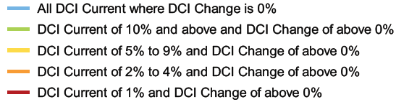
Where:
- Red catchments waterways are of a high to very high condition currently and are projected to have a DCI change in future under BAU development.
- Orange catchments waterways are of a moderate condition currently and are projected to have a DCI change in future under BAU development.
- Yellow catchments waterways are of a low condition currently and are projected to have a DCI change in future under BAU development.
- Green catchments waterways are of a very low condition currently and are projected to have a DCI change in future under BAU development.
- Blue catchments waterways do not have an increase in DCI projected in this dataset. Catchments containing blue waterways may still have rural road sealing programs being undertaken.
Research has concluded that waterway health declines significantly when DCI exceeds 2% of catchment area. The prioritisation above shows catchments requiring the most effort and attention to maintain desirable levels of DCI. This is based on given projected increase in DCI, with red being the highest priority.
The Housing Strategy’s Change Areas are shown in the maps. This indicates where focus will be required in managing any potential increases in DCI as development occurs.
Relevant actions within the implementation plan - SWMP1, SWMP10, SWMP11, SWMP12, and SWMP13.

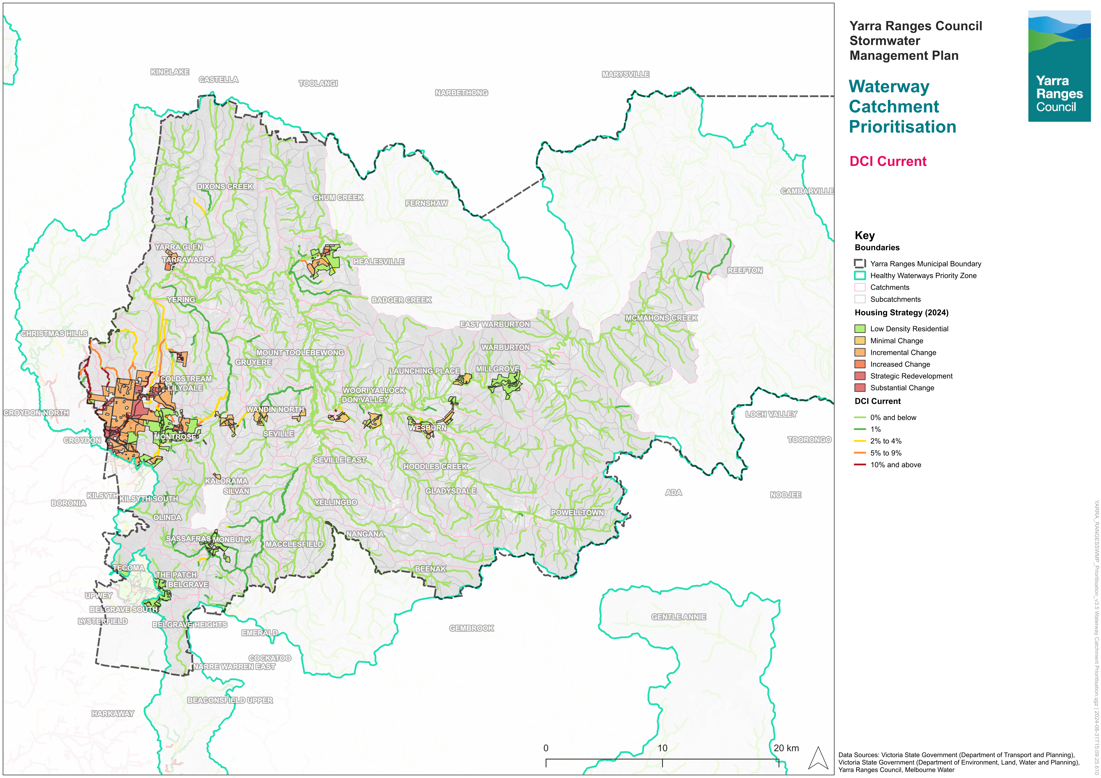
Figure 7-1 Current waterway DCI
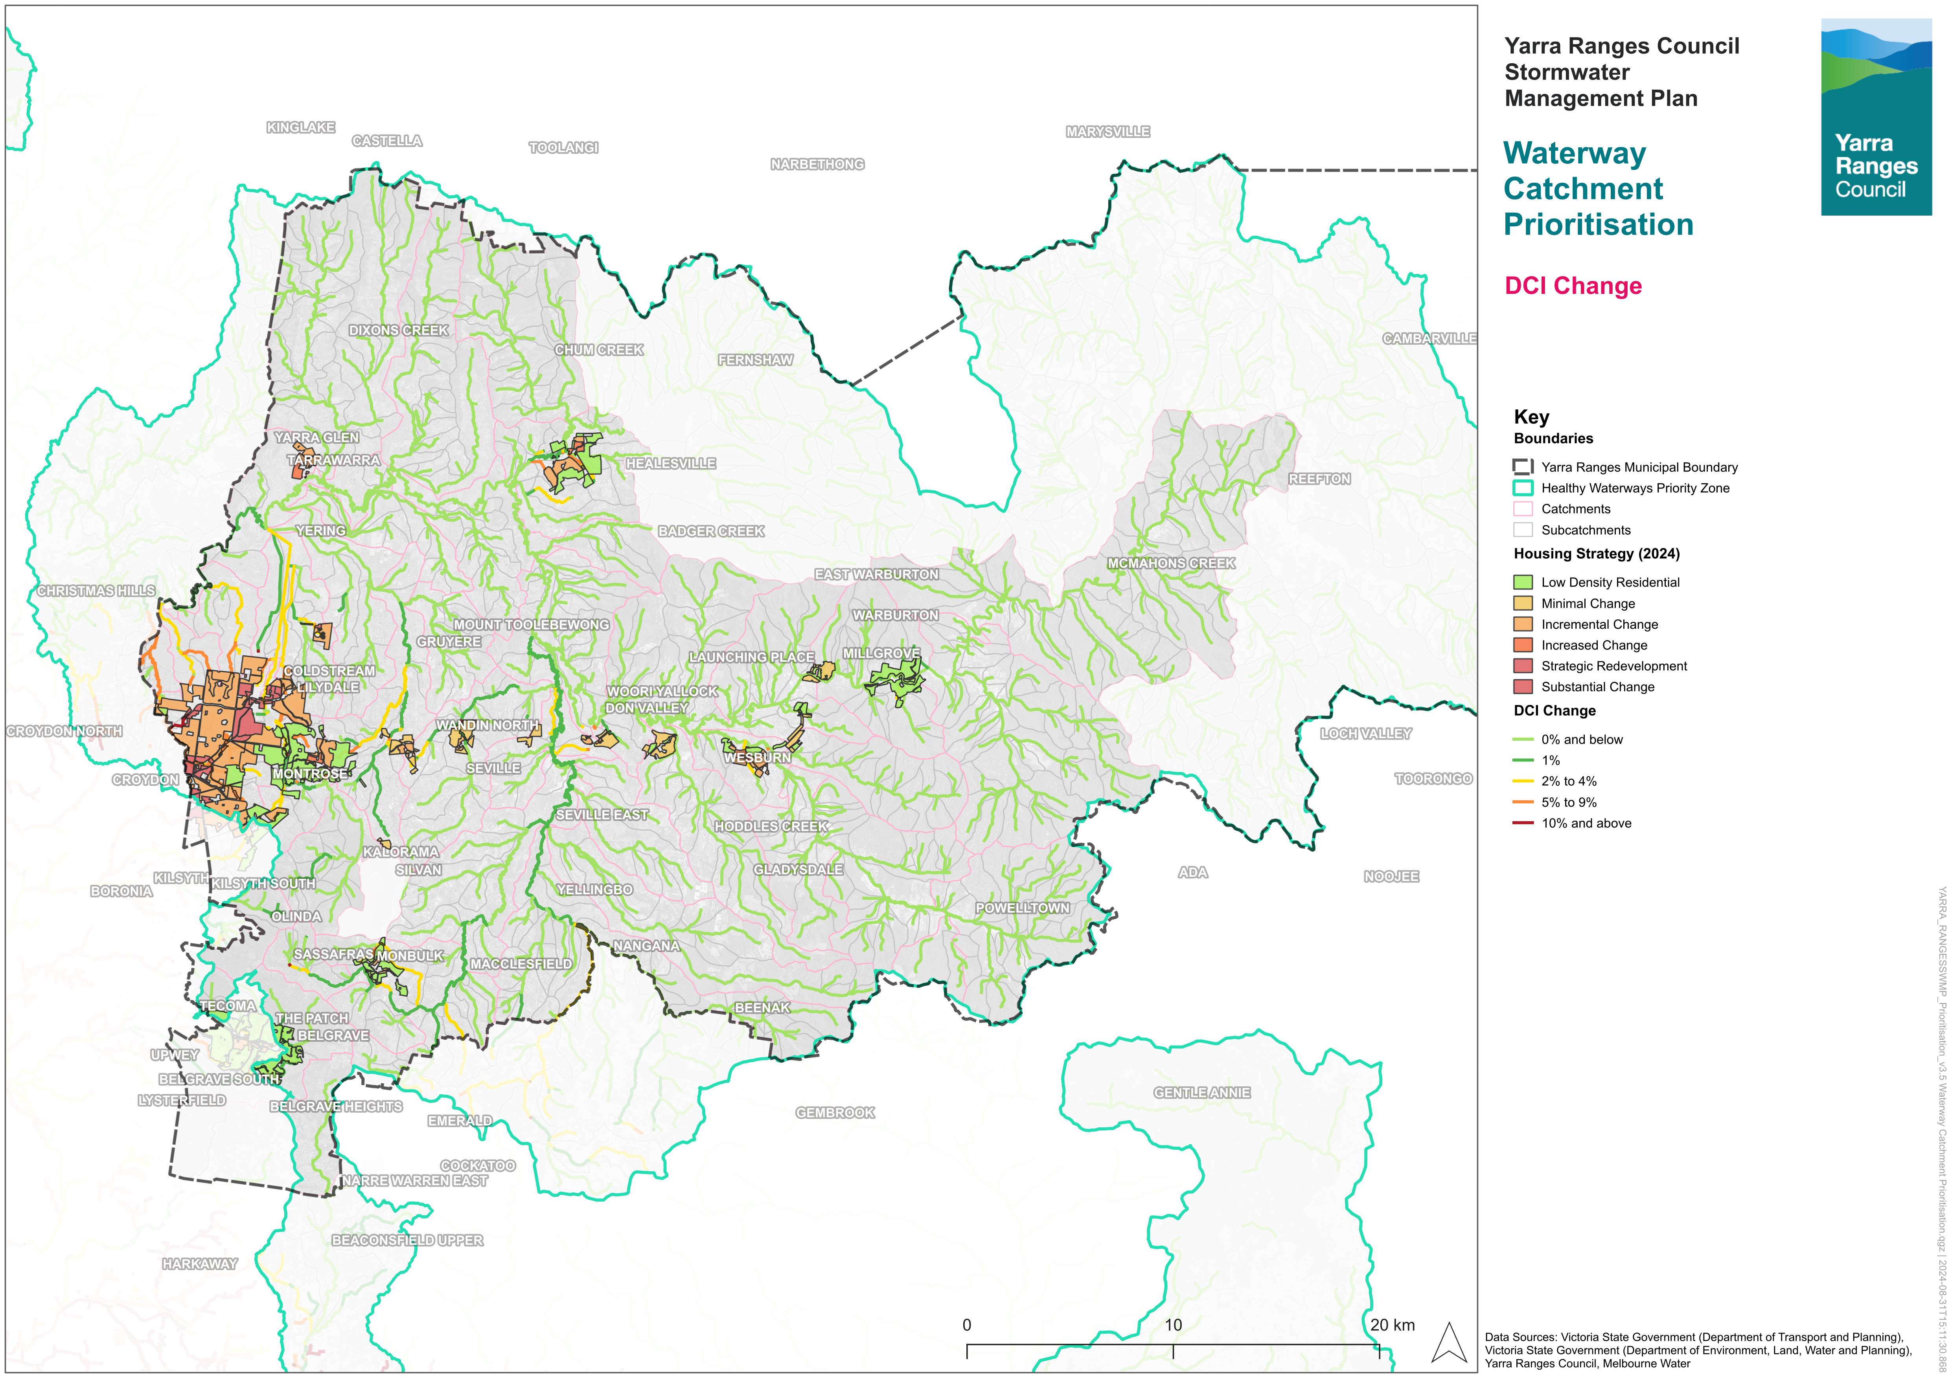
Figure 7-2 Predicted change in DCI of waterways (to 2060 under a BAU scenario)
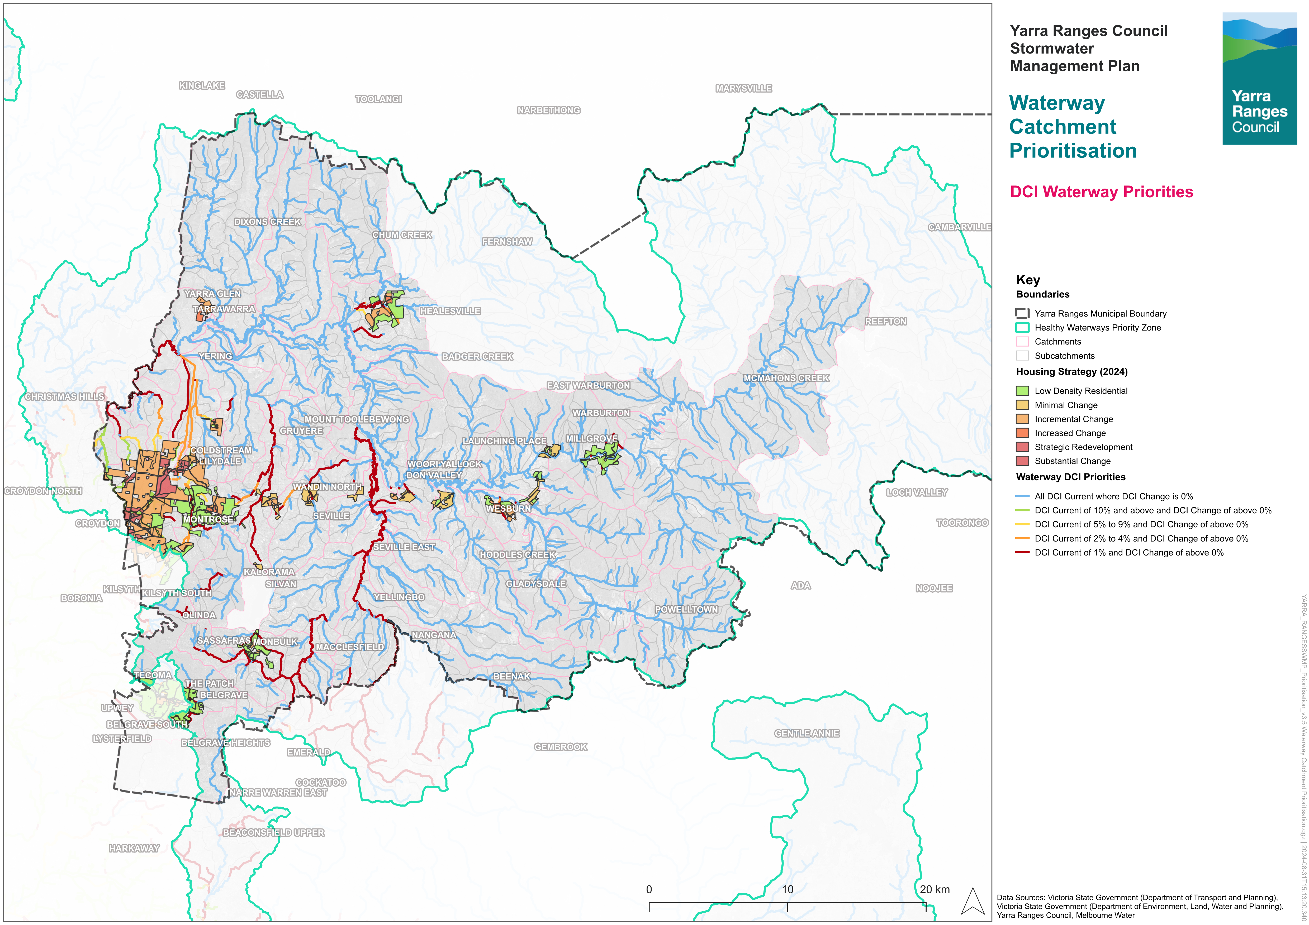
Figure 7-3 Waterway prioritisation

Flood Mapping Program
Stormwater is rainwater that runs off surfaces such as rooftops, roads, carparks, and other ‘hard surfaces’. It can also come from hard grassed surfaces such as lawns and ovals. The drainage network helps to capture and move it away from people and buildings. It eventually flows to the waterways.
There are events when there is a large amount of rain or rain in a short amount of time, the water can’t get into the drains quickly enough. The drains may not have been designed to take the amount of rain, or there may not be drainage structures present to move the stormwater away. When this happens, some of the stormwater flows over the ground instead and can cause flooding. This can happen quickly and without warning. This is known as ‘pluvial’, ‘overland’ or ‘flash’ flooding.
Another type of flooding that occurs in Yarra Ranges is ‘fluvial’ or ‘riverine’ flooding. Fluvial flooding is what happens when a river, creek or other waterway overtops its banks and floods the land around it. This flooding can also cause the drainage network to back up and surcharge (come out) in the catchment itself, worsening the flooding.
Each type of flooding is different and can affect the environment and people in different ways.
Under Regulation 148 of the Building Regulations 2018, Council is now required to prepare mapping for areas under its control that are liable to flooding.
The Flood Mapping Program is a fundamental component of the Stormwater Management Plan, aimed at identifying flood-prone areas within the municipality. The Flood Mapping Program will be delivered by Melbourne Water in collaboration with Council.
Flood mapping involves the use of historical flood information and modern mapping techniques to accurately predict where water will flow and where flooding may occur during storm events.
Current and reliable flood mapping information is essential to understand and manage flood risk. It is used to:
- Conduct drainage improvement works through Council’s Annual Capital Works Program, such as the installation of new drainage, flood retarding basins, and stormwater harvesting/reuse works.
- Maintain and renew drainage assets, including pipe and pit cleaning, street sweeping to minimise leaf debris, and repairing Council-managed stormwater drains and pits.
- Provide flood management and prevention advice to landowners.
- Support the work of the SES in preparing for emergency flood events and providing assistance during events.
- Educate and prepare our community through flood information.
- Ensure that new developments appropriately consider flood events/impact and implement any required drainage upgrades through development construction.
The flood mapping process will also be informed by the latest available data and guidance recommended under the 2019 version of Australian Rainfall and Runoff.
Following the development of the Draft Flood Map, Council will engage with community to understand the impacts on properties and make updates to the draft flood maps accordingly.
Relevant actions within the implementation plan - SWMP4, SWMP5, SWMP21, SWMP28 and will help deliver SWMP6, SWMP7, SWMP8, SWMP22, SWMP23

Flood Catchment Prioritisation
Given the scale and size of our municipality, it is important to prioritise catchments for Stormwater Planning Initiatives. Flood Catchment Prioritisation will guide initiatives like the Flood Modelling Program, Drainage Asset Surveys, and drainage upgrades (note: Catchment Prioritisation is not the only criterion for drainage upgrades – other factors such as flood velocity, depth, number of properties impacted will also form part of the project prioritisation).
The information used to prioritise the catchment areas includes:
- whether or not there were flood hotspots
- the type of development (if any) expected
- whether there are any facilities that are considered ‘vulnerable’
- how much ‘hard surface’ drains directly to waterways now, and how much this is expected to change in the future.
There are 49 identified catchment areas that have been prioritised. Further details about the prioritisation process are in Appendix B. The results of the prioritisation process are shown in Figure 7-4.
Council is collaborating with Melbourne Water to undertake flood modelling across all 49 catchments between 2024 and 2026.
A map has been created for each catchment area. Each map is accompanied by a table of important information and potential opportunities. Figure 7-5 provides an example of one of the maps for an area. Lilydale, Mt Evelyn, and Montrose are included. Table 7-1 provides an example of one of the catchment area information tables. The remaining maps are in Appendix D and the remaining tables are in Appendix E.
Key information shown on the maps includes:
- Development density expected based on the 2024 Housing Strategy
- High, medium, and low priority flood hotspots (per Flood Management Plan for Yarra Ranges and Melbourne Water)
- Current DCI of waterways in the catchment area
- Approximate locations of stormwater harvesting and stormwater infiltration opportunities identified by Council
- Locations of vulnerable facilities
- Land Subject to Inundation Overlay extents
- Known flood extents (from either Melbourne Water or Council flood mapping)
- Locations of Melbourne Water stormwater channels and pipes
- Locations of Council stormwater pipe
It is important to note that the catchment prioritisation approach will need to be revisited and updated based on the results of the comprehensive flood modelling. An action (SWMP32) has been included in the plan, committing to an update of the catchment prioritisation in consultation with the Community Reference Panel, which will be established under SWMP26, following the completion of the municipality-wide flood modelling.
Relevant actions within the implementation plan -SWMP26 and SWMP32

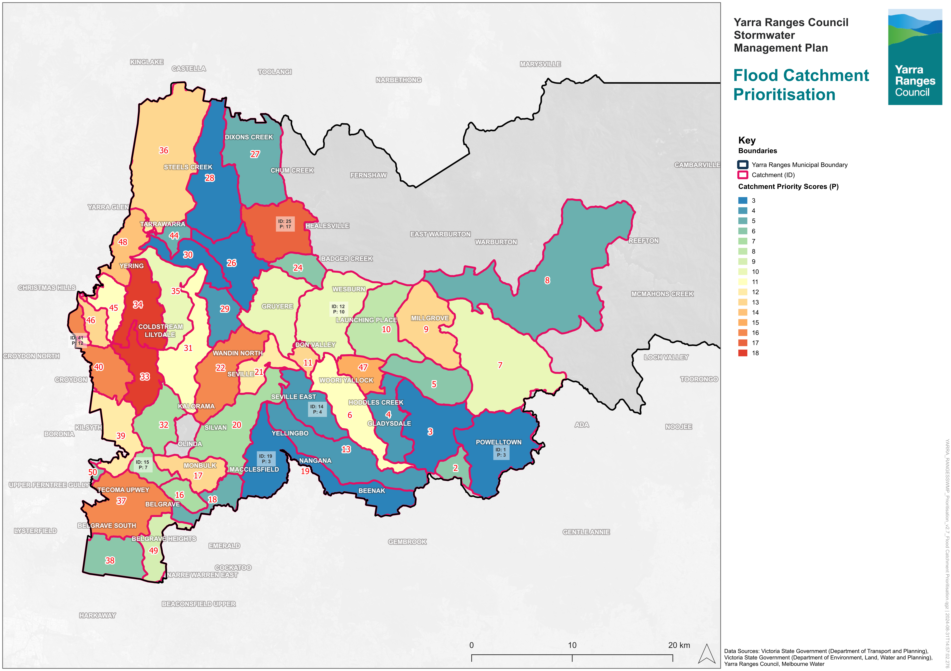
Figure 7-4: Flood mapping catchment area prioritisation (where ID is the catchment ID and P is the priority score, with a higher P number being higher priority)
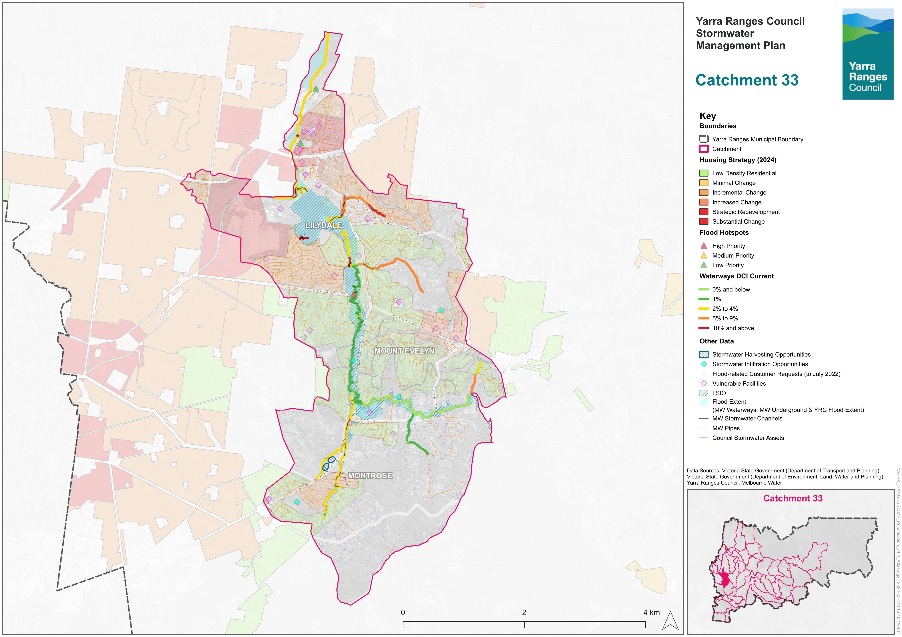
Figure 7-5: Example catchment area map
Table 7-1 Example catchment area information table
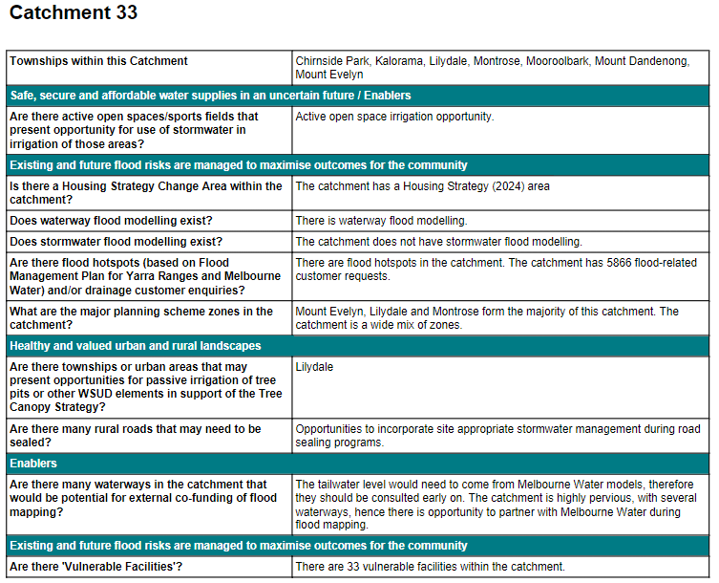

Implementation Plan and Timeline
The Yarra Ranges SWMP will be implemented over a 10-year timeframe, concluding in 2034. The below table outlines each action and its associated details.
Action ID | Description | Timeline (target completion date) | Key External Stakeholders | Estimated Cost | Funding Source | Key SWMP Indicator Link
Utilising Stormwater as a resource
SWMP1 | Finalise the Integrated Water Management plan which will help inform the catchment stormwater management strategies. | 2026 | MW, DEECA | No Cost | Existing | - Increase fit-for-purpose use of stormwater and rainwater.  - Protect high value waterways.  - Reduce the total urban stormwater runoff volume discharged to receiving waters.  - Decrease pollutants discharged to receiving waters.  - To minimise increases in stormwater due to development and protect the environmental values and physical characteristics of the landscape from degradation by stormwater.  - Respond to climate and climate change related events through resilience planning.  - Increased collaboration with other organisations to support strategic stormwater management.
Existing and future flood risks are managed to maximise outcomes for the community
SWMP2 | Update the Development Engineering Guidelines to better support the Stormwater Policy and this SWMP. | 2025 | MW, DEECA, Developers | No Cost | Existing | - Reduce the total urban stormwater runoff volume discharged to receiving waters.  - Decrease pollutants discharged to receiving waters.  - Reduce the impacts of dangerous flooding now and into the future with development and climate change.  - Respond to climate and climate change related events through resilience planning.
SWMP3 | Review and improve the development application and approvals process to better support the Stormwater Policy and the SWMP. | 2025 | MW, DEECA, Developers | No Cost | Budget process/ Grants | - Reduce the total urban stormwater runoff volume discharged to receiving waters.  - Decrease pollutants discharged to receiving waters.  - Reduce the impacts of dangerous flooding now and into the future with development and climate change.  - Respond to climate and climate change related events through resilience planning.
SWMP4 | Undertake Flood Mapping within the whole municipality in partnership with Melbourne Water. | 2026 | MW, Wider local community within Yarra Ranges Council | $1,000,000 | Existing/ Grants | - Reduce the impacts of dangerous flooding now and into the future with development and climate change.  - To enable better asset management with improved efficiencies and overall cost reductions for council via strategic planning.  - Respond to climate and climate change related events through resilience planning.  - To minimise increases in stormwater due to development and protect the environmental values and physical characteristics of the landscape from degradation by stormwater.  - Increase cross-consideration of flood mitigation and integrated water management.  - Increase organisational capacity to partner with Traditional Owners to be able to respectfully acknowledge the connection of Traditional Owners to the land and waterways and include indigenous knowledge in stormwater management.
SWMP5 | Complete development of flood mapping and Stormwater Management Strategies for all catchments. Provide implementation status update and prepare next version of the Stormwater Policy and SWMP. | 2034 | MW | Cost under review | Budget process/ Grants | - Reduce the impacts of dangerous flooding now and into the future with development and climate change.  - To enable better asset management with improved efficiencies and overall cost reductions for council via strategic planning.  - Respond to climate and climate change related events through resilience planning.  - To minimise increases in stormwater due to development and protect the environmental values and physical characteristics of the landscape from degradation by stormwater.  - Increase cross-consideration of flood mitigation and integrated water management.  - Increase organisational capacity to partner with Traditional Owners to be able to respectfully acknowledge the connection of Traditional Owners to the land and waterways and include indigenous knowledge in stormwater management.
SWMP6 | Develop and prioritise a program of works (for design & delivery) for our most critical outfall drains as part of the rolling completion of action SWMP4. These outfall drains coincide with where the downstream drainage network meets the natural waterways. | Ongoing | Nil | $30,000 | Existing | - Reduce the impacts of dangerous flooding now and into the future with development and climate change.
SWMP7 | Develop and prioritise a program of drainage upgrade works focused on reducing risk to properties. Critical areas will be determined via a combination of flood modelling (SWMP4) and hazard categorisation assessment (flood depth, flood velocity, and overlays such as EMOs). | Ongoing | Nil | $60,000 | Existing | - Reduce the impacts of dangerous flooding now and into the future with development and climate change.
SWMP8 | Consider drainage infrastructure for new unsealed road upgrade programs. | Ongoing | Nil | $30,000 | Existing | - To minimise increases in stormwater due to development and protect the environmental values and physical characteristics of the landscape from degradation by stormwater.  - Reduce the impacts of dangerous flooding now and into the future with development and climate change.  - Convey to the community that roadways are intended to perform a flood management function in large rainfall events, allowing the stormwater runoff to make its way to the waterways.
Healthy and valued waterways
SWMP9 | Investigate Victorian urban stormwater offsets which can be managed by Council. | 2026 | MW, DEECA | $120,000 | Budget process/ Grants | - To minimise increases in stormwater due to development and protect the environmental values and physical characteristics of the landscape from degradation by stormwater.  - Protect high value waterways.
SWMP10 | Improve workable options for on lot WSUD via research and pilot testing and develop WSUD Guidelines with preferred solutions. | 2025 | MW, DEECA | No Cost | Existing | - Protect high value waterways.  - Reduce the total urban stormwater runoff volume discharged to receiving waters.  - Decrease pollutants discharged to receiving waters.
SWMP11 | Establish WSUD criteria for public and private realms – either in standalone guidelines or as part of updates to existing guidelines. | 2025 | MW, DEECA | $60,000 | Existing | - Protect high value waterways.  - Reduce the total urban stormwater runoff volume discharged to receiving waters.  - Decrease pollutants discharged to receiving waters.  - To ensure integrated stormwater management that maximises ecosystem services, such as cooling and local habitat improvement, and provides attractive and enjoyable spaces.  - Increase fit-for-purpose use of stormwater and rainwater.
SWMP12 | Review outcomes of the Little Stringy Bark Creek stormwater management. | 2025 | MW, DEECA | No Cost | Existing | - Increased collaboration with other organisations to support strategic stormwater management.  - Protect high value waterways.
Healthy and valued urban and rural Landscapes
SWMP13 | Following the completion of SWMP10, assess the Tree Canopy Strategy (e.g. along key pedestrian routes and throughout activity centres) for overlaps with new or redevelopment areas, or with road upgrade plans to determine where passively irrigated street trees could best be placed. | 2025 | MW, DEECA | $20,000 | Existing | - To enable better asset management with improved efficiencies and overall cost reductions for council via strategic planning.  - Respond to climate and climate change related events through resilience planning.  - Increase fit-for-purpose use of stormwater and rainwater.  - Reduce the total urban stormwater runoff volume discharged to receiving waters.  - Decrease pollutants discharged to receiving waters.  - Protect high value waterways.  - To minimise increases in stormwater due to development and protect the environmental values and physical characteristics of the landscape from degradation by stormwater.
Community values are reflected in stormwater planning
SWMP14 | Determine where road capital works program locations overlap with drainage works and align timelines where appropriate. | 2024 | DOT, MW | No Cost | Existing | - To enable better asset management with improved efficiencies and overall cost reductions for Council via strategic planning.
SWMP15 | Develop framework for data collection to inform assessment against SWMP objectives. | 2024 | Nil | $25,000 | Existing | - To enable better asset management with improved efficiencies and overall cost reductions for council via strategic planning.
SWMP16 | Develop a Fact Sheet to clearly outline Council’s approach to prioritising catchments and waterways, and the roles that infrastructure, including roadways, play in flood management. | 2025 | Wider local community within Yarra Ranges Council | No cost | Existing | - Engage with the community during flood mapping and stormwater management projects and studies to support and enhance community connection with and understanding of the water cycle.  - Convey to the community that roadways are intended to perform a flood management function in large rainfall events, allowing the stormwater runoff to make its way to the waterways.
SWMP17 | Determine a clear prioritisation for and approach to addressing flood and drainage complaints and an associated Fact Sheet. | 2025 | Wider local community within Yarra Ranges Council | $10,000 | Existing | - Engage with the community during flood mapping and stormwater management projects and studies to support and enhance community connection with and understanding of the water cycle.
SWMP18 | Develop a Fact Sheet to clearly detail how Council manages new developments with respect to flooding, per the Stormwater Policy. | 2025 | Wider local community within Yarra Ranges Council | $5,500 | Existing | - Engage with the community during flood mapping and stormwater management projects and studies to support and enhance community connection with and understanding of the water cycle.
SWMP19 | Develop a Fact Sheet to clearly outline authority and private responsibilities including responsibilities for private to private property flooding with no infrastructure and property access (e.g. water running down driveway). | 2025 | Wider local community within Yarra Ranges Council | $5,500 | Existing | - Engage with the community during flood mapping and stormwater management projects and studies to support and enhance community connection with and understanding of the water cycle.
SWMP20 | Provide SWMP implementation status update to Council. | 2026, 2028, 2030, 2032, 2034 | Nil | No cost | Existing | All
SWMP21 | Following completion of flood mapping, undertake community consultation and investigate Planning scheme amendment. | 2029 | MW | $200,000 | Budget process/ Grants | - Reduce the impacts of dangerous flooding now and into the future with development and climate change.  - To enable better asset management with improved efficiencies and overall cost reductions for council via strategic planning.  - Respond to climate and climate change related events through resilience planning.  - To minimise increases in stormwater due to development and protect the environmental values and physical characteristics of the landscape from degradation by stormwater.  - Increase cross-consideration of flood mitigation and integrated water management.  - Increase organisational capacity to partner with Traditional Owners to be able to respectfully acknowledge the connection of Traditional Owners to the land and waterways and include indigenous knowledge in stormwater management.
SWMP22 | Update asset management plans (including 10-year capital plan) using information from completed stormwater management strategies. | Ongoing | Nil | $25,000 | Existing | - To enable better asset management with improved efficiencies and overall cost reductions for council via strategic planning.
SWMP23 | Incorporate key findings from the flood mapping projects into the Municipal Flood Management Plan and include critical infrastructure identified through the blockage analysis in the Proactive Maintenance Program. | Ongoing | Wider local community within Yarra Ranges Council | $20,000 | Existing | - Engage with the community during flood mapping and stormwater management projects and studies to support and enhance community connection with and understanding of the water cycle.
SWMP24 | Investigate ways of further improving community flood resilience, such as retrofits and overlays. | 2024 | Wider local community within Yarra Ranges Council, MW | No cost | Existing | - Reduce the impacts of dangerous flooding now and into the future with development and climate change.  - Respond to climate and climate change related events through resilience planning.
SWMP25 | Undertake a process review and gap analysis of the permit application process from start to statement of compliance. Involve planners, developers, engineering, consultants in the review. This will help with overall process improvement. | 2024 | Developers | No cost | Existing | - Increase fit-for-purpose use of stormwater and rainwater.  - Protect high value waterways.  - Reduce the total urban stormwater runoff volume discharged to receiving waters.  - Decrease pollutants discharged to receiving waters.  - To minimise increases in stormwater due to development and protect the environmental values and physical characteristics of the landscape from degradation by stormwater.  - Respond to climate and climate change related events through resilience planning.  - Increased collaboration with other organisations to support strategic stormwater management.
SWMP26 | Establish a Community Reference Panel (CRP) to provide community input on stormwater projects and studies under the Stormwater Management Plan | Ongoing | Wider local community within Yarra Ranges Council | $30,000 | Existing | - Engage with the community during flood mapping and stormwater management projects and studies to support and enhance community connection with and understanding of the water cycle.
SWMP27 | Review the Stormwater Management Plan, incorporating updates based on completed actions and updates to relevant policies, legislation, strategies, plans, and frameworks. | 2029 | All | No cost | Existing | All
Strategic Partnerships
SWMP28 | Establish a partnership between the Yarra Ranges water managers, including Yarra Valley Water, South East Water and Melbourne Water to enable a governance structure that supports the commissioning and development of the flood mapping and stormwater management strategies, and that supports the implementation of actions identified in the strategies. | 2024 | MW, DEECA | No cost | Existing | - Increased collaboration with other organisations to support strategic stormwater management.
SWMP29 | Investigate alternative funding opportunities. | 2026 | MW | No cost | Existing | - To enable better asset management with improved efficiencies and overall cost reductions for council via strategic planning.  - Increased collaboration with other organisations to support strategic stormwater management.
SWMP30 | Commence advocacy for any special or flagship projects pertaining to waterway protection, stormwater and flood management as identified in stormwater management strategies. | 2026 | MW, DEECA | No cost | Existing | - Increased collaboration with other organisations to support strategic stormwater management.  - Reduce the total urban stormwater runoff volume discharged to receiving waters.  - Protect high value waterways.  - Reduce the impacts of dangerous flooding now and into the future with development and climate change.
SWMP31 | Test alternative funding opportunities. | 2027 | MW, DEECA, State Government | No cost | Existing | - To enable better asset management with improved efficiencies and overall cost reductions for council via strategic planning.
SWMP32 | Update catchment prioritisation following completion of municipal wide flood modelling through active participation with the Community Reference Panel (CRP) | 2026 | CRP | No Cost | Existing | - Engage with the community during flood mapping and stormwater management projects and studies to support and enhance community connection with and understanding of the water cycle.

References
Yarra Ranges Planning Scheme. Planning scheme last updated by VC231 on 06/04/2023.
Urban Stormwater Best Practice Environmental Management Guidelines. CSIRO, 1999.
Urban stormwater offsets: Guidance for councils developing urban stormwater offsets in Victoria. DELWP, date unknown.
Plan Melbourne 2017-2050. DELWP, 2017a.
Yarra River Action Plan. DELWP, 2017b.
Victoria’s Climate Change Strategy. DELWP, 2021.
Dandenong Catchment IWM Plan Summary. DELWP, 2022a.
Yarra Catchment IWM Plan Summary. DELWP, 2022b.
Built Environment Climate Change Adaptation Action Plan. (DELWP, 2022c)
Urban Stormwater Management Guidance. EPA Victoria, 2021.
Flood Management Strategy for Port Phillip and Westernport. Melbourne Water, 2021.
Greater Melbourne Urban Water & System Strategy: Water for Life. Melbourne Water, 2022.
Yarra Ranges Housing Strategy. Yarra Ranges Council, 2024.
Healthy Waterways Strategy. Victorian State Government, 2018.
Burndap Birrarung Burndap Umarkoo: Yarra Strategic Plan. A 10-year plan for the Yarra River corridor 2022-2032. Victorian State Government, 2022a.
Yarra Strategic Plan Implementation Plan. Victorian State Government, 2022b.
Development Engineering Guidelines v1.2. YRC, date unknown.
Recreation and Open Space Plan Strategic Framework 2013-2023. YRC, 2013.
Environment Strategy 2015-2025. YRC, 2016.
IWM Plan 2017. YRC, 2017.
Council Plan 2021-2025. YRC, 2021.
Health and Wellbeing Plan 2021-2025. YRC, 2021a.
Tree Canopy Strategy 2022-2042. YRC, 2022a.
Yarra Ranges Council Asset Plan 2022-2032. YRC, 2022b.
Flood Management Plan. YRC & MW, 2016.

