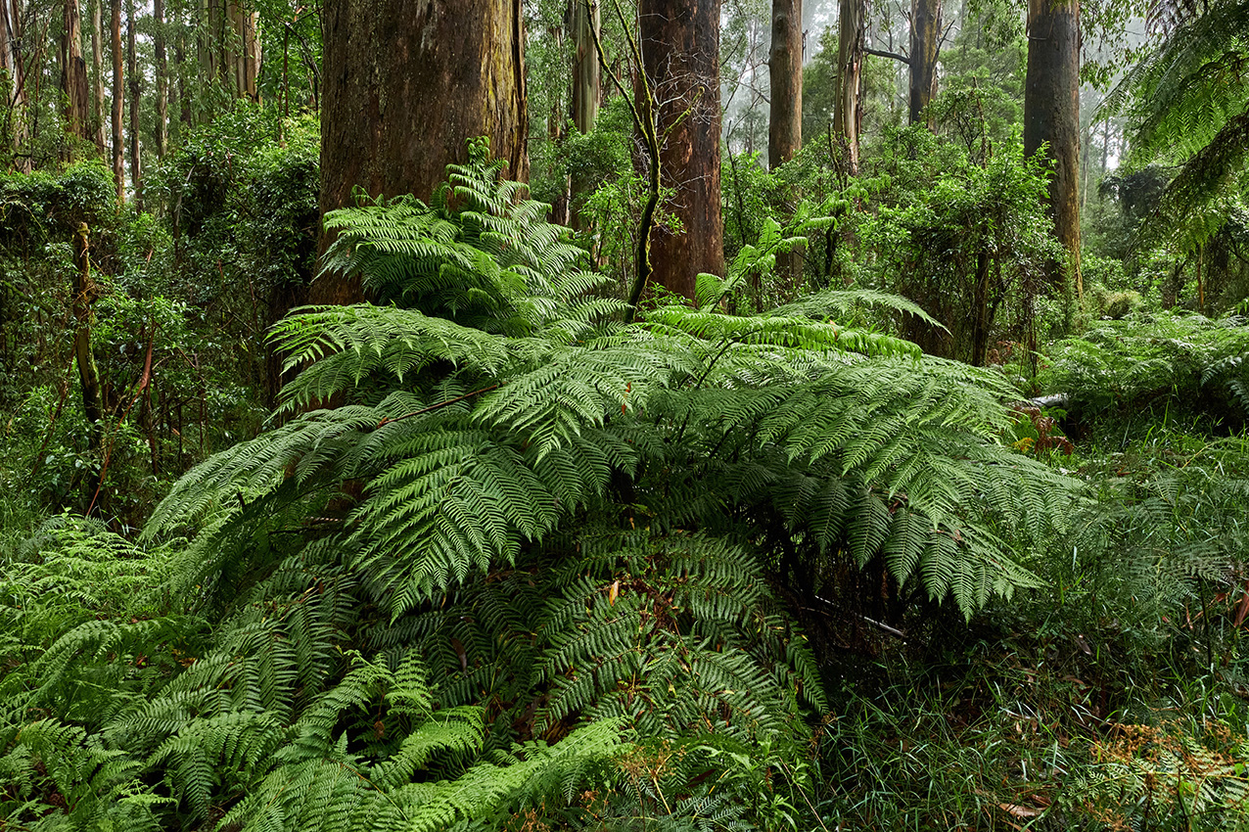

# Comprehensive Action Plan

2024 — 2034

# Nature Plan

The following is a comprehensive action plan, which complements Yarra Ranges Council’s Nature Plan 2024 — 2034. While it includes all the foundation actions in the plan, it also includes additional operational actions required along with more detail.

The actions are categorised by the following themes:

Landscapes and ecosystems  
Land use and changing climate  
Pest plants and animals  
People and nature

Foundation actions (marked with *) are the strategic activities required to meet Council’s targets under the Nature Plan.

Yarra Ranges Council  
15 Anderson Street, Lilydale Vic 3140  
1300 368 333  
yarraranges.vic.gov.au

## Landscapes & Ecosystems

|  |  |  |
| --- | --- | --- |
| No. | Action Description | Duration |
| 1.1* | Develop a Biolinks Plan to identify and restore important corridors for biodiversity protection and enhancement across the municipality in partnership with community and agencies. | Short 1—3 years |
| 1.2* | Develop a prioritisation matrix to identify biodiversity hotspots and focal areas across the municipality. | Short 1—3 years |
| 1.3* | Undertake vegetation surveys to measure change in native vegetation cover across Yarra Ranges to report on our target. | Medium 4—6 years |
| 1.4* | Establish an opt-in monitoring program of biodiversity assets on private land within Yarra Ranges, to better understand the ecological values and inform decision making for statutory and strategic planning. | Long 7—10 years |
| 1.5* | Develop a research partnership program with educational institutions to focus on natural resource management and applied ecology to continuously improve evidence base for decision making. | Long 7—10 years |
| 1.6* | Support restoration of waterway corridors, billabongs and floodplain habitat within the municipality through cross-promotion and facilitated engagement with landowners and action on Council-managed reserves. | Long 7—10 years |
| 1.7* | Advocate, as part of the Upper Yarra Local Development Strategy of the Victorian Forestry Plan, consideration of nature-based tourism opportunities and biodiversity protection. | Short 1—3 years |
| 1.8* | Adaptively manage Council reserves through analysing conservation value data and using this to inform techniques, approaches and investment. | Long 7—10 years |
| 1.9* | Complete Flora and Fauna Guarantee (FFG) Act listed species impact statement and review of the goals of the State Government’s Biodiversity 2037 Strategy to address the new Public Authority Duty required by recent amendment to the FFG Act. | Short 1—3 years |
| 1.10 | Undertake strategic review of Council’s Biodiversity Offset Program (BOP) to determine future direction in line with strategic objectives. | Short 1—3 years |
| 1.11 | Develop an ecological slashing program to improve regeneration of indigenous grass species on Council land and reduce chemical application over time. | Med to long 4—10 years |
| 1.12 | Contribute to the catchment-wide objective to increase environmental water reserve by 10 GL per year for the Yarra River by 2028. | Long 7—10 years |
| 1.13 | Work with State Government to develop guidelines for biodiversity-sensitive response and recovery practices following natural disasters. | Medium 4—6 years |

* Foundation actions

## Land Use & Changing Climate

|  |  |  |
| --- | --- | --- |
| No. | Action Description | Duration |
| 2.1* | Increase support to community through the Ribbons of Green program to deliver a revitalised incentive program and implement the Biolinks Plan. The program will include existing habitat protection, revegetation, pest plant and animal control and regenerative land management practices. | Long 7—10 years |
| 2.2* | Work with traditional owners, local growers, peak bodies, and land managers to promote and support implementation of resilient land management and regenerative agriculture practices, including traditional cultural practices and carbon drawdown. | Long 7—10 years |
| 2.3* | Implement sustainable bushfire reduction works which achieve net biodiversity benefit in collaboration with relevant agencies. Incorporate cultural burning practices to support biodiversity improvements. | Long 7—10 years |
| 2.4A* | Increase restoration and revegetation activities across the existing bushland reserve network with a focus on improving conservation values, enhancing habitat corridors and supporting threatened species and their habitats through the municipality. | Long 7—10 years |
| 2.4B* | Implement a 15% increase in plant numbers and increased maintenance and pest exclusion to ensure long term climate success. | Long 7—10 years |
| 2.4C* | Control of foxes and rabbits on council land. Foxes and rabbits are not currently managed on council land and there are obligations as land managers under the Catchment and Land Protection (CaLP) Act. | Long 7—10 years |
| 2.5* | Foster strong collaboration with other land managers, conservation organisations, Landcare, and community environment groups through representation on multi-agency collaborative committees. | Long 7—10 years |
| 2.6* | Support private landowners with environmental regulation and complementary land management practices. | Long 7—10 years |
| 2.7 | Broaden the application of the Code of Environmental Practice (COEP) to ensure all works undertaken by council, or on behalf of Council, are adhering to high environmental standards.  Implement council developed Environmental Green Card training to council staff and contractors. Embed COEP in council tender documentation and explore ways to enforce compliance. | Short 1—3 years |
| 2.8 | Support delivery of Council major projects, Recreation and Active Living trails and open space development and township strategic planning being subject to comprehensive environmental assessment processes. | Long 7—10 years |
| 2.9 | Utilise data from various sources inclusive of council’s own monitoring programs, to build the foundation of proposed alterations to local environmental planning scheme overlays. | Long 7—10 years |
| 2.10 | Support permanent protection of private land with conservation covenanting in key locations across the municipality.  Investigate expansion of program, for identified properties of high ecological value, or deemed inappropriate for development. | Long 7—10 years |
| 2.11 | Develop an urban greening program, through delivery of Council’s Tree Strategy to increase canopy cover. | Long 7—10 years |
| 2.12 | Review of the Restructure Overlay Plans to determine value proposition from view of future additions to Council’s bushland reserve network. | Short 1—3 years |
| 2.13 | In partnership with community and agency, prepare and implement Township “Emergency Preparedness” Plans for at least 3 more localities within Yarra Ranges, considering the value and retention of important biodiversity within those plans. | Long 7—10 years |
| 2.14 | Utilise map areas from the Biolinks project of permit exemptions across the municipality based on existing dwellings to model potential impact on biodiversity. | Short 1—3 years |
| 2.15 | Support community to undertake annual bushfire preparedness in a biodiversity sensitive manner through delivery of educational material and resources. | Long 7—10 years |
| 2.16 | Develop an operational program for cultural firestick burns on public land. | Short 1—3 years |
| 2.17 | Investigate application of nature-based accounting for Yarra Ranges, through accredited program to encourage regenerative farming practices in the region. | Short to med 1—6 years |
| 2.18 | Undertake a process review of “First Party Offsets” that utilise a Planning Section 173 Agreement. Process improvements are required to ensure efficiency, best environmental outcomes and compliance with legal obligations by all parties. | Short 1—3 years |

* Foundation actions

## Pest Plants & Animals

|  |  |  |
| --- | --- | --- |
| No. | Action Description | Duration |
| 3.1A* | Implement targeted cross-tenure weed management programs at a minimum of 3 locations informed by the State Government’s Biodiversity 2037 Strategy and Council’s Biolinks Plan. This will build on the success of programs delivered previously including Peri-urban Weed Management Initiative. | Long 7—10 years |
| 3.1B* | Implement targeted cross-tenure pest animal programs at a minimum of 3 locations informed by the Eastern Region Pest Animal Strategy, Peri-urban Melbourne Region Deer Control Plan and Council’s Biolinks Plan. | Long 7—10 years |
| 3.2A* | Implement a targeted program to address the impacts of deer on council managed land. Undertake targeted deer control activities in accordance with legislative obligations. | Long 7—10 years |
| 3.2B* | Collaborate with land managers to address the prevalence of feral deer across Yarra Ranges, through partnerships, funding programs and education of residents to achieve an overall reduction in the impact of deer on the environment. | Long 7—10 years |
| 3.3* | Utilise prioritisation matrix, Biolinks Plan and updated levels of service to develop Bushland Reserve Management Plans for high priority reserves, with emphasis on invasive species that drive ecological change. | Short 1—3 years |
| 3.4* | Promote Yarra Ranges cat curfew and deliver supporting community education regarding impact of cats on wildlife. Investigate mechanisms for enforcement of existing local laws. | Long 7—10 years |
| 3.5* | Facilitate strategic development of municipal pest action plans as part of legislative requirements, support community pest animal programs and collaborate with the Eastern Region Pest Animal Network. | Long 7—10 years |
| 3.6 | Advocate to State Government for listing of feral deer as pests under the CALP Act and provision of adequate funding to support monitoring, control and research within the region. | Long 7—10 years |
| 3.7 | Investigate support of local deer meat industry, to support control efforts, local economy and sustainability practices. | Short 1—3 years |
| 3.8 | Support community action in pest plant removal on private land through delivery of expanded Weed Wipeout program. | Long 7—10 years |
| 3.9 | Review existing local laws which target environmental weeds and pest animal control on private property to determine efficacy and suitability. | Medium 4—6 years |
| 3.10 | Create a mature woody weed program to target significant landscape impacts of established woody weeds in bushland reserves. | Medium 4—6 years |

* Foundation actions

## People and Nature

|  |  |  |
| --- | --- | --- |
| No. | Action Description | Duration |
| 4.1* | Support the development of areas suitable for the application of contemporary concepts of Indigenous Ways of Knowing, Being and Doing such as cultural burning. Enhance opportunities for Council and community connection through delivery of cultural awareness program. | Long 7—10 years |
| 4.2* | Enhance opportunities for cultural awareness and integration of indigenous land management practices into bushland management through employment of Indigenous Ranger. | Long 7—10 years |
| 4.3* | Enhance biodiversity in urban townships through increase in street tree cover and habitat planting, along with expanding community support through Gardens 4 Wildlife. | Long 7—10 years |
| 4.4* | Support Council network of environmental volunteers, including Friends of groups, Landcare network and others to undertake direct action and community led knowledge sharing of environmental values. | Long 7—10 years |
| 4.5* | Provide a suite of environmental education programs, events, and opportunities to engage the community in environmental topics. A renewed focus on providing opportunities for equitable access and diversity of offerings to reach more of our community. | Long 7—10 years |
| 4.6 | Investigate opportunities to enhance biodiversity in urban townships through habitat improvements to council managed parks and reserves. | Short 1—3 years |
| 4.7 | Promote and foster greater uptake in citizen science opportunities that align with Council’s objectives of obtaining greater understanding of biodiversity values across the Shire. | Long 7—10 years |
| 4.8 | Enhance environmental interpretation and education opportunities along key tourist destinations, trails and reserves. | Long 7—10 years |
| 4.9 | Increase support for implementation of environmental grants through Council, and for seeking external funds to support priority programs and projects within Biodiversity, Bushland and Sustainability teams. | Long 7—10 years |
| 4.10 | Partner with Early Years and Sustainability Teams to develop increased nature based education opportunities in early learning programs. | Long 7—10 years |

* Foundation actions

Yarra Ranges Council  
PO Box 105  
Lilydale Vic 3140

1300 368 333  
[mail@yarraranges.vic.gov.au](mailto:mail@yarraranges.vic.gov.au)  
yarraranges.vic.gov.au