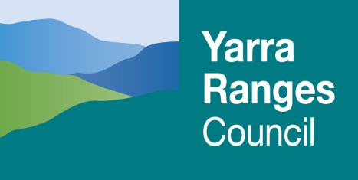
Recreation and Sport Capital Development Grants Program
Project Management Framework
2024/25

What is a Project Management Framework?

A Project Management Framework is a tool that will help you plan/monitor the progress of your project. It is a statement of all the required tasks that need to be undertaken, as well as a timeline for each task, and who is responsible for its implementation.

Why do we need a Project Management Framework?

As well as being a required component of the funded project’s Funding Agreement, the Project Management Framework is used to assist in evaluating the progress of the project. It is important for both the Project Manager and for Council to know what stage the project is at, at any given time. The Project Management Framework can also identify potential delays in the project prior to them occurring. This is a useful tool to assist in keeping the project on track and assist in determining how long it will take to achieve the project and whether it is ready for submission to Council for consideration.

How do we create a Project Management Framework?

Step 1 Determine what steps you need to take to complete your project.

Step 2 Use the form provided; and add more steps if necessary.

Step 3 Allocate budget and responsibility for each task.

Step 4 Submit a copy with Funding Agreement to Council, prior to commencement of project.

A copy of this document is required to be sent to Council for endorsement at the time the Funding Agreement is returned, or when requested.

If due to any circumstances, the Project Management Framework needs adjustment, either in relation to the timing or the components of the project, please forward an updated copy to Council for endorsement.
2024/25 Project Management Framework

Project Title ……………………………………………………………………….………………………………………….…

Organisation …………………………………………………………………………………………………………………..…

Project Manager ………………………………………………………………. Phone …………………………..….

Council Contact: Recreation Development and Liaison Officer Phone 1300 368 333
TASK | Start Date | Completion Date | Cost | Responsibility

2024/25 Project Management Framework (Example)

Project Title ……………………………………………………………………….………………………………………….…
Organisation …………………………………………………………………………………………………………………..…
Project Manager ………………………………………………………………. Phone …………………………..….
Council Contact: Recreation Development and Liaison Officer Phone 1300 368 333
  TASK | Start Date | Completion Date | Cost | Responsibility
- Sign and return of funding agreement |  |  |  | Club
- Return Project Management Framework |  |  |  | Club
- Discussion about the project between Club/Council |  |  |  | Club to arrange meeting
- Sign off concept plans prior to commencing works |  |  |  | Council
- Develop detailed design |  |  |  | Club
- Obtain quotes for works |  |  |  | Club
- Develop detailed plans and sign off by Council |  |  |  | Club
- Obtain Planning approval and Building permits (if applicable) |  |  |  | Club
- Tender/sign contracts |  |  |  | Club
- Commence project (acknowledge Council on signage) |  |  |  | Club
- Site works/preparation |  |  |  | Club
- Submission of project reports/liaison with Council |  |  |  | Club
- Payment to contractors |  |  |  | Club
- Submission of claims (provide evidence of expenditure) |  |  |  | Club
- Forward 80% funding payment within 30 days |  |  |  | Council
- Seek approvals for variations to project (if required) |  |  |  | Council
- Arrange final inspection by Council |  |  |  | Club
- Preparation of final claim (provide evidence of expenditure & in kind works) |  |  |  | Club
- Forward final 20% funding payment within 30 days |  |  |  | Council
- Final report – Activity & Financial Reports |  |  |  | Club

