

eTENDERING PORTAL Respondent User Manual

7-0-2

Open Windows Software Pty Ltd

ABN 22 605 191 375

635 Glenferrie Road, Hawthorn VIC 3122, Australia

Phone: +61 3 9819 5088

Email: etendering[support@openwindows.com.au](mailto:support@openwindows.com.au)

Web: www.openwindows.com.au

Prepared by:

Melisa Perkins

Senior Consultant

Client/Prospect Name

Subject/Engagement description

# Document Control

## Document Version

The full version history of this document can be found in the appendix.

## Terms and Definitions

Glossary containing the meaning of all names, acronyms, and abbreviations used within this document.

|  |  |
| --- | --- |
| Term/Acronym | Definition |
| Access Code | The unique code issued to an invited Respondent that will grant them access to the Rfx within the eTENDERING PORTAL. Access Codes are only provided when the tender is an ‘Invited Only’ tender. |
| Buyer | An internal CONTRACTS officer representing the entity that manages the eTENDERING PORTAL for the purpose of establishing contracts with suppliers. |
| Closing Date | The date and time at which an RFx will be closed and Submissions can no longer be uploaded via the online eTENDERING Portal. |
| Contract | ‘Contract’ is the term used to represent an agreement between your organisation and another contracting Supplier or Suppliers (see below). A contract can refer to the actual agreement or to the contract record within the database, with associated data and documents attached. |
| Dashboard | The Dashboard is the first screen the user will be directed to once they log into Open Windows CONTRACTS. It is made up of widgets, modules and a message bar. The dashboard can always be accessed by clicking on the Open Windows logo. |
| eTENDERING Portal | The online portal in which RFx’s are advertised and where Submissions are lodged electronically. The eTENDERING Portal supports the tendering process on the web. |
| Opening Date | The date and time in which an RFx is open and accessible via the eTENDERING Portal. |
| Pre-contract | A pre-contract is a record used to capture budgetary, sourcing, and/or procurement information prior to letting a contract. |
| Respondent | This is the term used to refer to an organisation that has registered on the eTENDERING PORTAL. When a submission is imported into CONTRACTS, the respondent is added as a supplier. |
| Revised Clarification Date | The effective and revised closing date of the clarification period as it may be amended from time to time. After this date no further clarifications can be submitted. |
| Revised Closing Date | The effective and revised Closing Date as it may be amended from time to time. |
| RFx | A generic term used to represent a stage in your tender process such as Request for Information (RFI), Request for Proposal (RFP), Request for Quote (RFQ), or Request for Bid (RFB). |
| SOURCING | An optional module for CONTRACTS which supports the tender lifecycle and allows you to record tender details and collate tender documentation each time you go out to market via ‘Stages’. |
| Submission | A written offer submitted by the Respondent to an RFx via the eTENDERING Portal. |
| Supplier | A ‘Supplier’ is the term given to an ‘other’ contracting organisation. In most cases, a supplier will be associated to a Contract, Preliminary or a Project within the application. |
| Tenderer | Another term that is used for a respondent. |
| Unlocker | Internal Staff member responsible for unlocking the RFX on the eTENDERING Portal and importing RFx Submissions into Contracts. |

## Document References

All documents referenced and / or used to assist the creation of this document.

|  |  |  |
| --- | --- | --- |
| Document | Author(s) | Version |
| CONTRACTS User Manual for 7-0-2 | Various | 7-0-2 |
| SOURCING User Manual for 7-0-2 | Various | 7-0-2 |
| eTENDERING PORTAL User Manual for 7-0-2 | Various | 7-0-2 |

Contents

1 Document Control 2

1.1 Document Version 2

1.2 Terms and Definitions 2

1.3 Document References 3

2 Introduction 5

3 Registering on the eTENDERING PORTAL 6

4 Logging into the eTENDERING PORTAL 9

5 The eTENDERING PORTAL Desktop 10

5.1 How to locate an RFx 10

5.2 Locating an Invited Only RFx 13

5.3 Viewing an Invited Only RFx 13

6 Navigating within an RFx 15

6.1 The Details Tab 16

6.2 The Documents Tab 17

6.2.1 Registering as a Respondent / Downloading RFx Documents 17

6.2.2 Unregistering as a Respondent 18

6.3 The Contacts Tab 19

6.4 The Communications Tab 19

6.4.1 Sending a Communication 20

7 Responding to an RFx 22

7.1 Lodging a Submission 22

7.2 Modifying your Submission 25

7.3 Viewing your Submission History 29

8 Resetting your Password 33

9 Changing your Password 34

10 Appendix: Document Revision History 35

# Introduction

This Instruction Book will assist you in using the eTENDERING Portal to view and lodge electronic Submissions to RFx’s. This document covers the following functions:

* Registering and logging on as a Respondent
* Viewing RFx details
* Register/deregister your interest in an RFx
* Download RFx Documentation
* Lodge and modify a Submission to an RFx
* View RFx communications and submit queries via the eTENDERING Portal
* Contacting a Contact during the RFx period.
* Viewing RFx updates during the RFx Period.
* Managing your account details (including resetting your password)

# Registering on the eTENDERING PORTAL

You are required to register on the eTENDERING Portal to lodge submissions and access invited tenders. Use the following instructions to register, you will only need to do this if you have not previously registered and/or do not have an eTENDERING Portal account.

1. From the **My Account** widget select **Create Account** link.

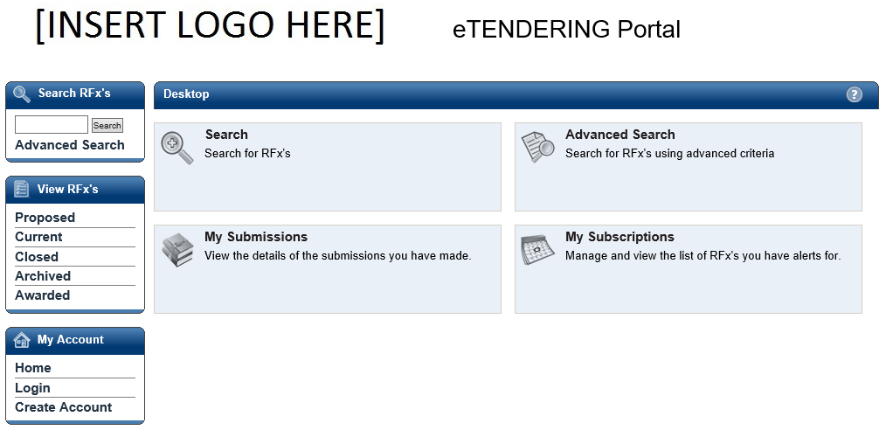

1. Complete your details on the **Respondent Registration** page. Note all fields marked with * are mandatory.

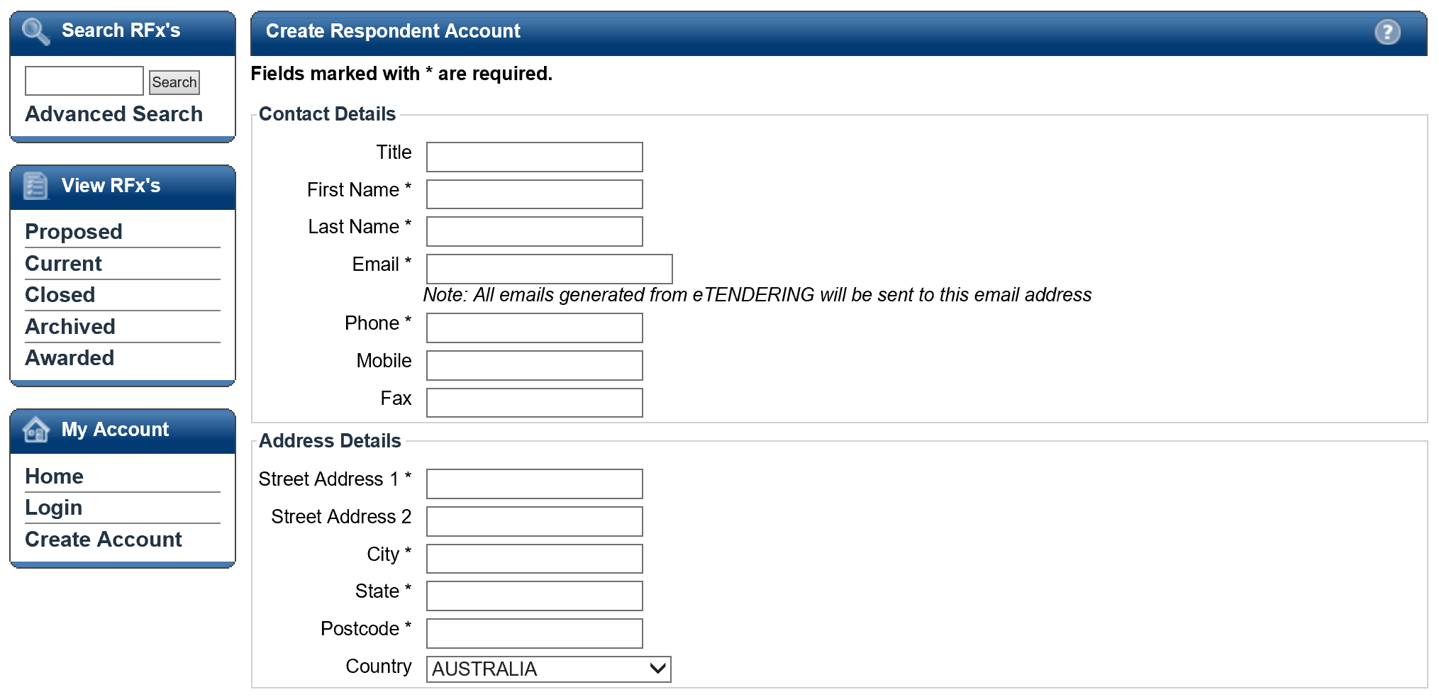

1. Review the **Conditions of Use** and select the checkbox. Select **Submit** to complete the registration.

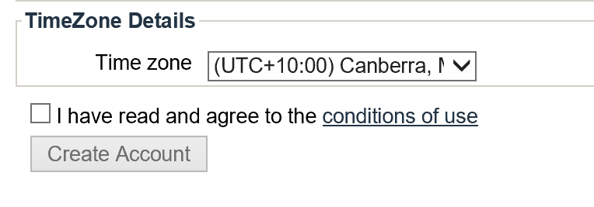

1. Amessage will appear indicating you have successfully registered and notify you that an email has been sent to you with instructions on how to complete the registration process.

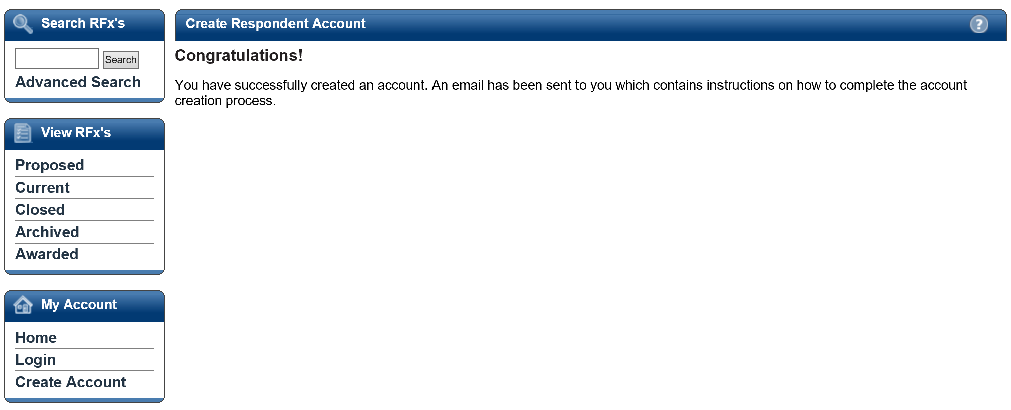

1. Log into your email account, you will see an email similar to the following from the eTENDERING Portal. Click the verification hyperlink to complete the registration.

Note: Your email security settings may prevent this hyperlink from being active. If this is the case copy and paste the link into the address bar of your internet browser.

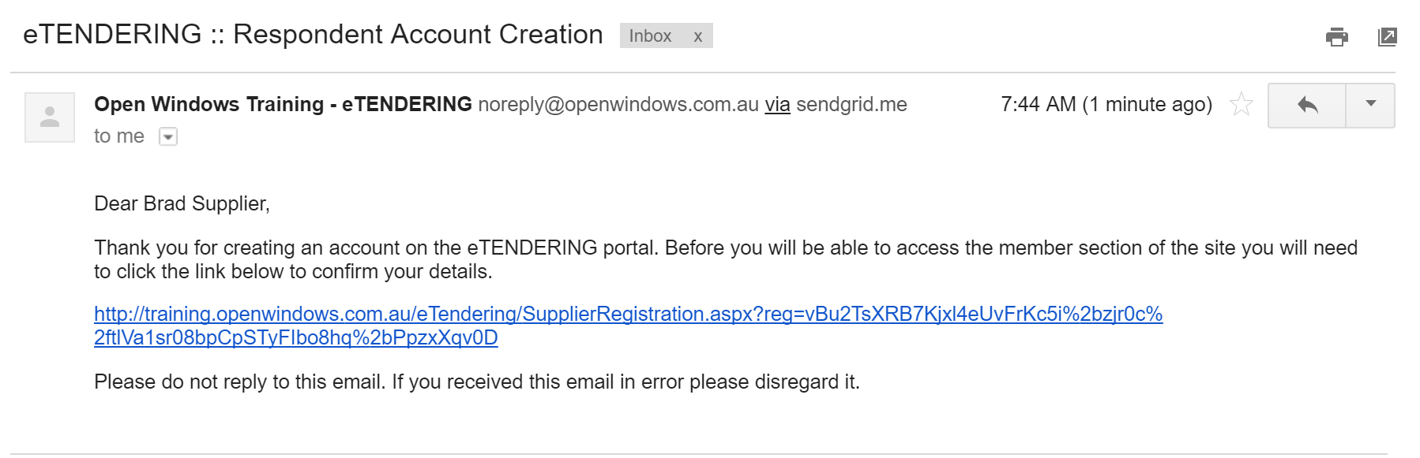

1. The link will open the eTENDERING Portal to the **Respondent Account Registration** page. Enter your password to log into your account.

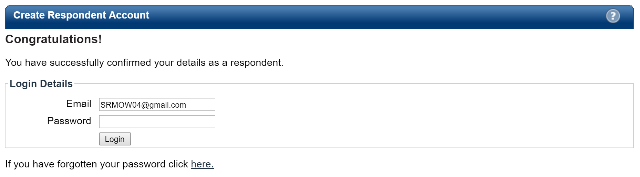

1. Once logged in you will be directed to the **eTENDERING Portal Desktop.**

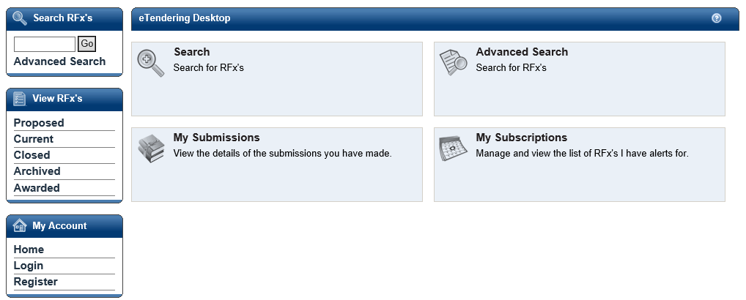

# Logging into the eTENDERING PORTAL

Once you have registered an account on the eTENDERING PORTAL you may use the “login” link to access your account. It is important you remember the email account you used to register on the portal, to ensure probity you are the only one who can modify your account.

To log onto the eTENDERING Portal select the **Login** link.

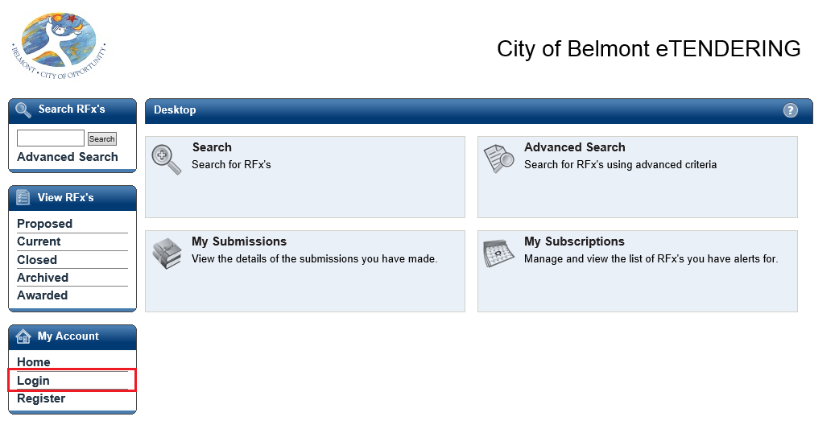

Enter your registered email address and password on the Login screen. If you have forgotten your password, click on the here hyperlink. See the section “Resetting your password” for more information on resetting your password.

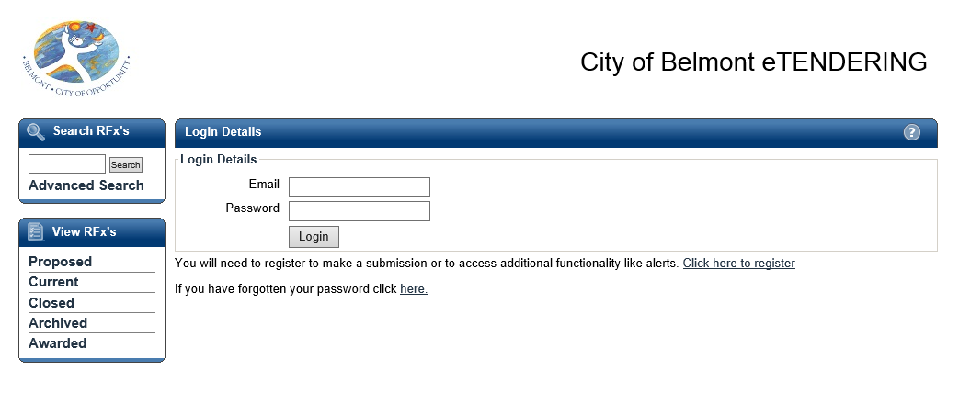

Once you are successfully logged in to the eTENDERING Portal, you will be presented with your desktop where you can now search for your RFx, view all your current and closed RFxs, and view your Submissions history.

# The eTENDERING PORTAL Desktop

The eTENDERING Portal supports procurement and sourcing processes by providing a secure, web based solution in which respondents can view upcoming and current RFx’s and lodge responses electronically.

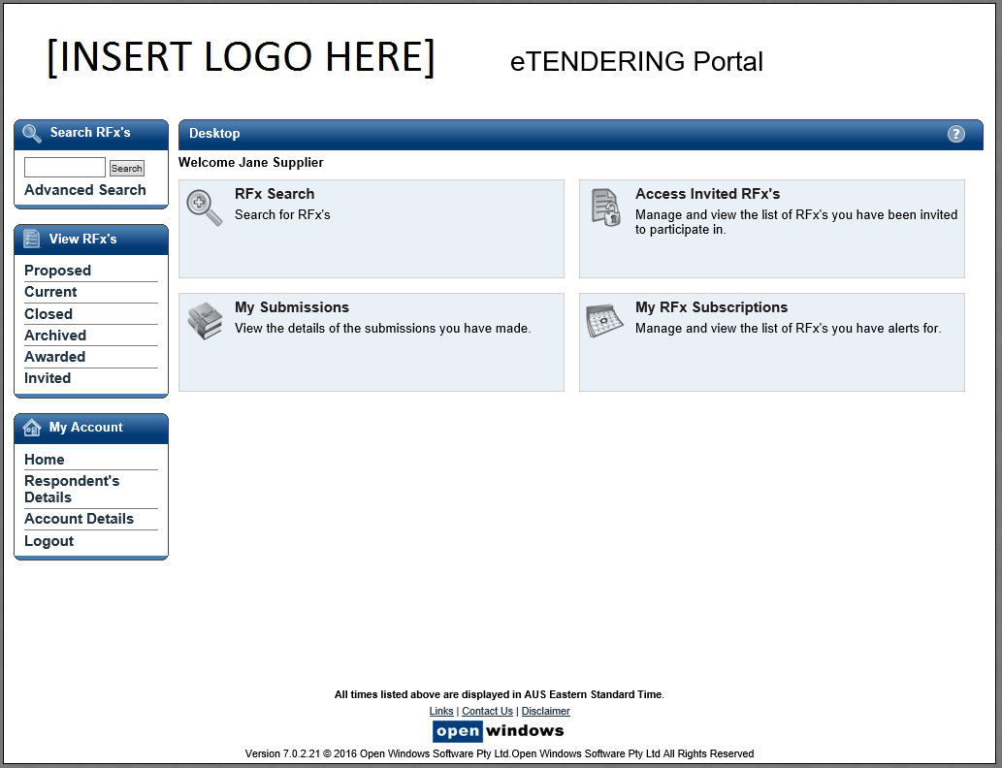

Access Invited Only RFx’s using the code provided

Setup and manage alerts for RFx Categories

View Online Help

View and update your account details

View additional links, Contact Information and the Disclaimer

Use these links to quickly access tender records

View lodged submissions

Search for an RFx

## How to locate an RFx

There are 4 methods you can use to locate an RFx within the eTENDERING Portal.

1. **RFX Search**:

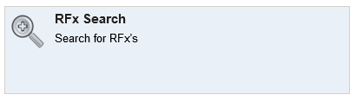

Click on the **Search** widget to search across all current and expired RFX’s within the system (both public and those you have been invited to tender on). Use the following fields to perform your search:

* 1. **Number:** Search using part or all of the RFx number.
  2. **Title:** Search using part or all of the RFx title.
  3. **Category:** Search by selecting the category of the RFx.
  4. **Preliminary Stage:** Search by using the stage the RFx is likely to be published under.

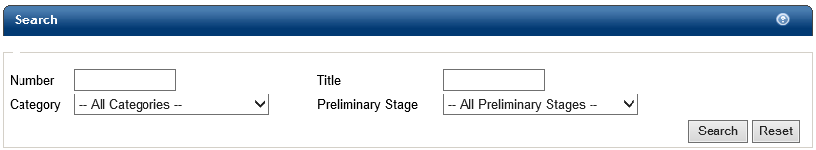

1. **Advanced Search:**

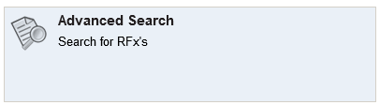

Click on the **Advanced Search** to view and access a set of more detailed search criteria. Use the following fields to perform a stricter search;

1. **Number:** Search using part or all of the RFx number.
2. **Title:** Search using part or all of the RFx title.
3. **Description:** Search using key words contained in the RFx description.
4. **Preliminary Stage:** Search by using the stage the RFx is likely to be published under.
5. **Category:** Search by selecting the category of the RFx.
6. **Location:** Seach by selecting the location of the RFx.
7. **Closing Date Range:** Search by entering the date range you belive the RFx is due to close between.
8. **View RFx’s:**

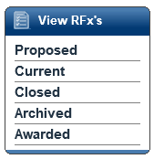

Located on the left hand menu is a widget called View RFx’s. Here you will find links that will allow you to locate the following RFx’s;

* 1. **Proposed:** Displays an organisations proposed RFx’s, .
  2. **Current:** All current public RFxs. These RFx’s are currently accepting Submissions.
  3. **Closed:** All closed public RFxs and all RFxs to which you were previously invited and have passed their Closing Date. These RFx’s are no longer receiving Submissions. All RFx’s will stay in a ‘closed’ state for Ninety (90) days before moving to the archived folder.
  4. **Archived:** RFX’s will be visible within this folder for Thirty (30) days after which the records will be removed from the eTENDERING Portal.
  5. **Awarded:** Displays information about the awarded RFx. Please note the decision to publish this information is at the discretion of the organisation.

1. **Search RFX’s:**

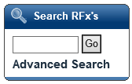

This widget provides a shortcut to performing the following searches;

* 1. **RFx Search:** Enter the RFx number and select **Go.**

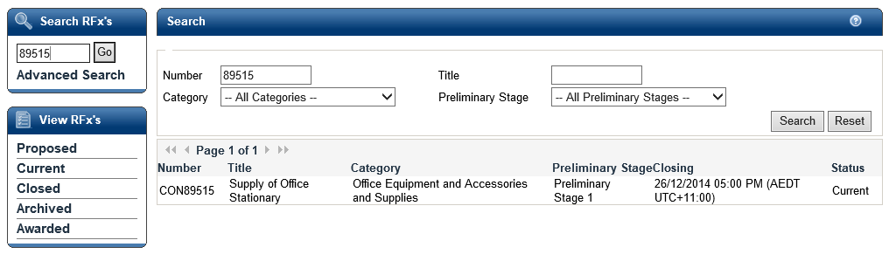

* 1. **Advanced Search:** Click the **Advanced Search** to be directed to the criteria screen shown at point 2 (Advanced Search).

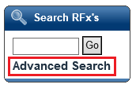

## Locating an Invited Only RFx

An invited only RFx is not visible to the public and only be responded to by those suppliers who have been invited to respond. If you are invited to respond to an RFx you will receive an email with an **Access Code** similar to the example below. Note: You must log into the eTENDERING PORTAL with the email address that was sent the access code. Only this account can access the Invited Tender.

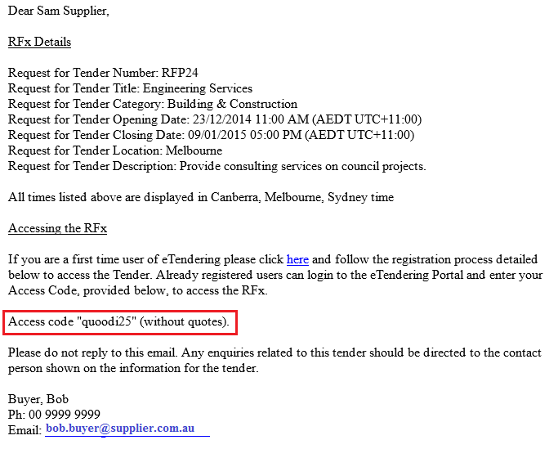

## Viewing an Invited Only RFx

To view the RFx use the following instructions

1. Log into the eTENDERING Portal.

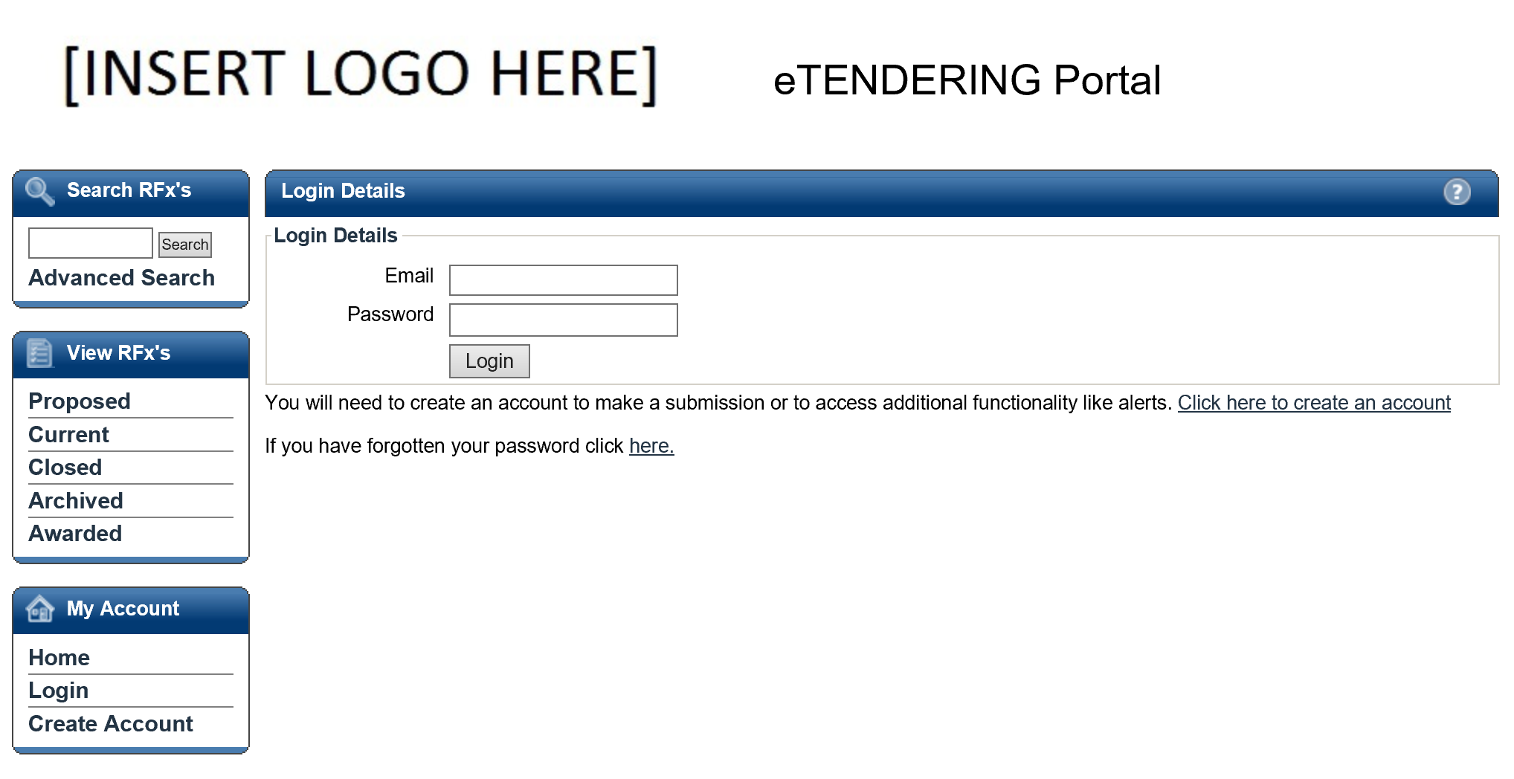

1. Select the **Invited** View. Enter the **Access Code** in the **RFx Invited Code** field. Select **Get RFx.**

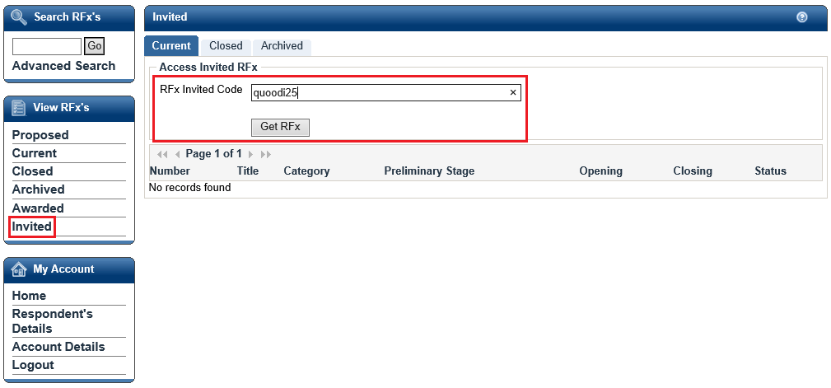

1. The **RFx** will now display in the list.

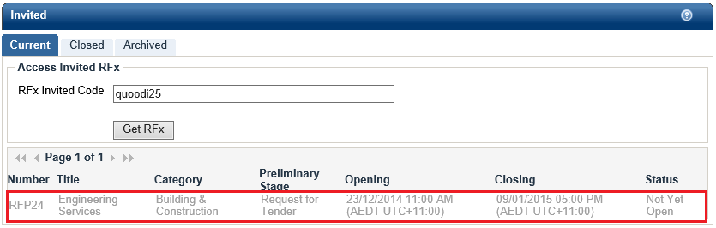

This RFx is greyed out as the Opening Date has not yet passed

# Navigating within an RFx

Once you have located an RFx you are interested in, select the RFx to view more details.

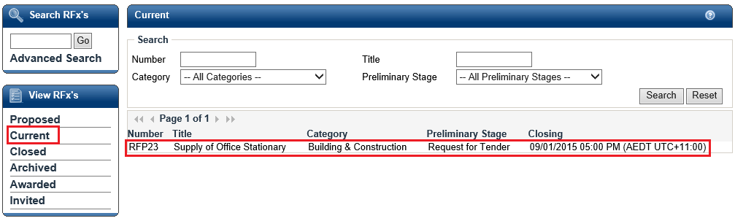

Click anywhere on the RFx record to be directed to the RFx Details screen, where you can navigate through the different tabs of information relating to the RFx. These tabs are further explained in the next sections.

**Communications Tab:** View and send communications to the RFx contact.

**Contacts Tab:** View Contact details for the RFx.

**Document Tab:** Download RFx documents here. Note: You must register first.

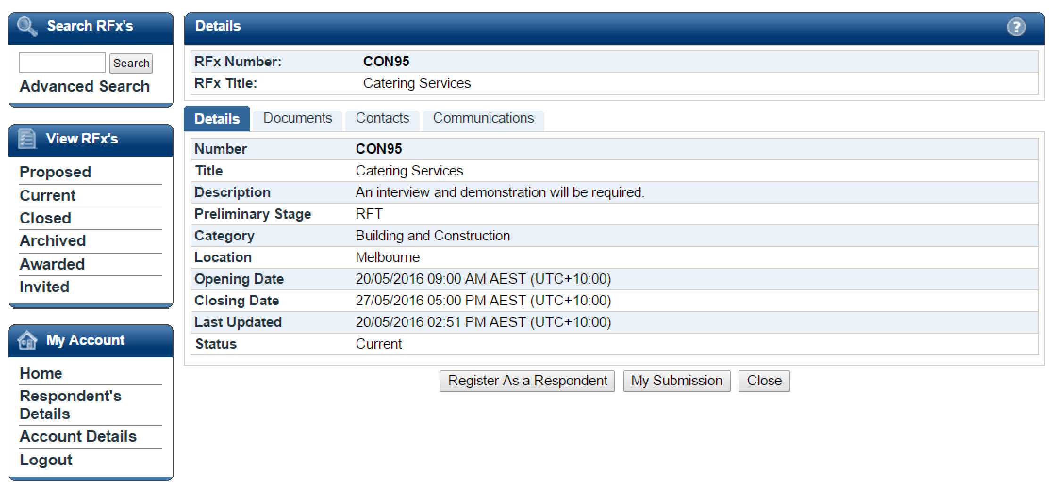

**Details Tab:** Provides a summary of the RFx details.

## The Details Tab

The **Details** tab shows all the key details about the RFx.

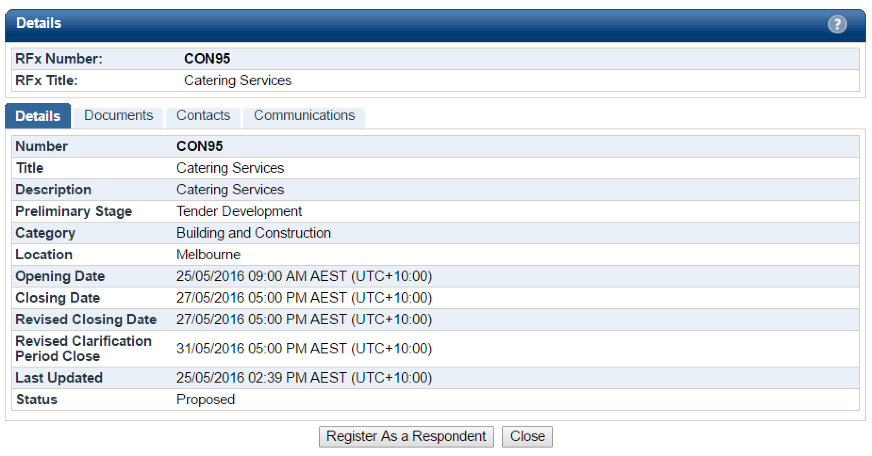

**What do the fields mean?**

1. **Number:** RFx reference number.
2. **Title:** Title of the RFx.
3. **Description:** A summary description of the RFx.
4. **Preliminary Stage:** The market approach used for your RFx, e.g. Expression of Interest, Request for Proposal, Request for Services etc.
5. **Category:** The category or classification for the project/good/service.
6. **Location:** The RFx Location or Site for which the project works/good/service is required.
7. **Opening Date:** The date and time at which an RFx is open, accessible and available for Submissions.
8. **Closing Date:** The date and time at which an RFx will be closed and electronic lodgement of Submissions thereafter is strictly unavailable.
9. **Revised Closing Date:** If the Closing Date of the RFx is amended at any time during the RFx Period, the Revised Closing Date field will appear under the Closing Date field in this Details tab. The new Closing Date will be communicated to all Respondents via email Notice.
10. **Revised Clarification Period Close Date:** If the Clarification Date of the RFx is amended at any time during the RFx Period, the Revised Clarification Date field will appear on Details tab. The new Clarification Period Close Date will be communicated to all Respondents via email Notice.
11. **Last Updated:** The last time a change was made to the RFx.
12. **Status:** The current status of the RFx: Current or Closed.

## The Documents Tab

The Documents tab lists all RFx Documents issued with the RFx. In order to access the **Download all documents** button you will first need to **Register as a Respondent.**

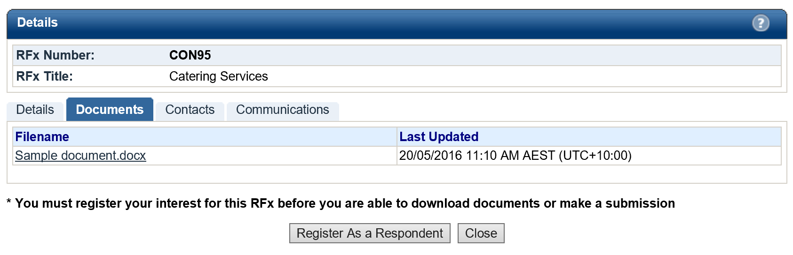

### Registering as a Respondent / Downloading RFx Documents

In order to view RFx documents you will be required to login using your eTENDERING account and register for the RFx, if you do not have an eTENDERING Portal account please see section 3. Registering on the eTENDERING Portal. To register for an RFx and download the RFx documents;

1. Ensure that you are on the **Documents** tab of the RFx.
2. Click on the **Register as a Respondent** button.

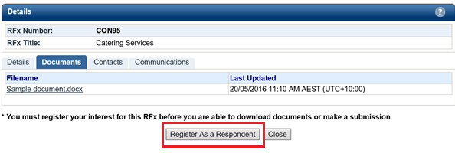

1. If you are not logged into the eTENDERING Portal you will be required to enter your account details at this point.
2. Select the **Click here to download all documents** button, this will only be available once you have registered as a respondent to the RFx.

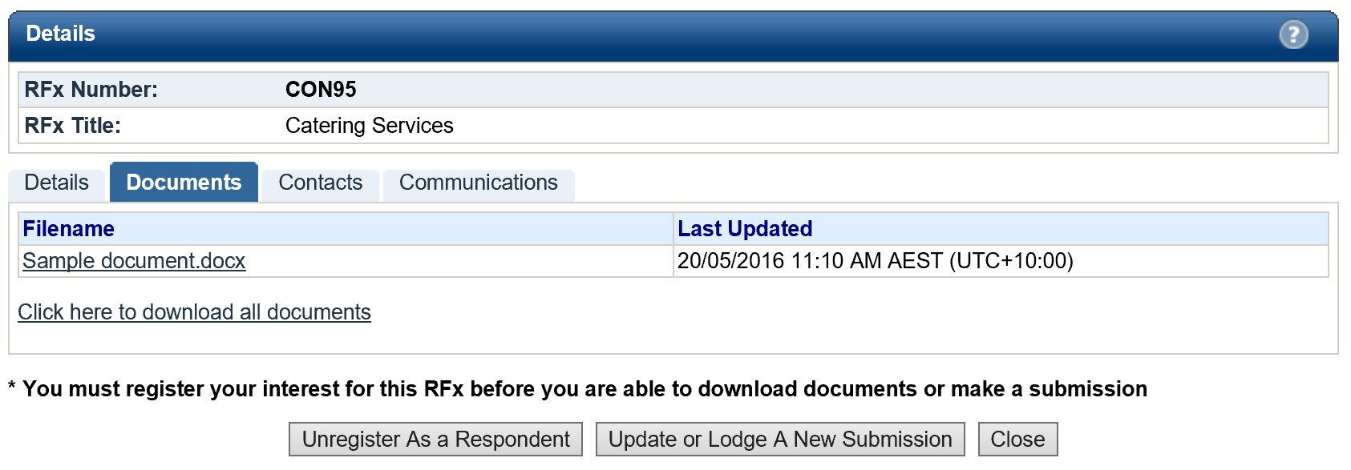

### Unregistering as a Respondent

At any time during the RFx Period you are able to unregister your intent to participate in the RFx.

1. Navigate to the Documents tab of the RFx and click on the **Unregister as a Respondent button.**



1. Click **Confirm** to acknowledge that you no longer wish to receive communications regarding the RFx.

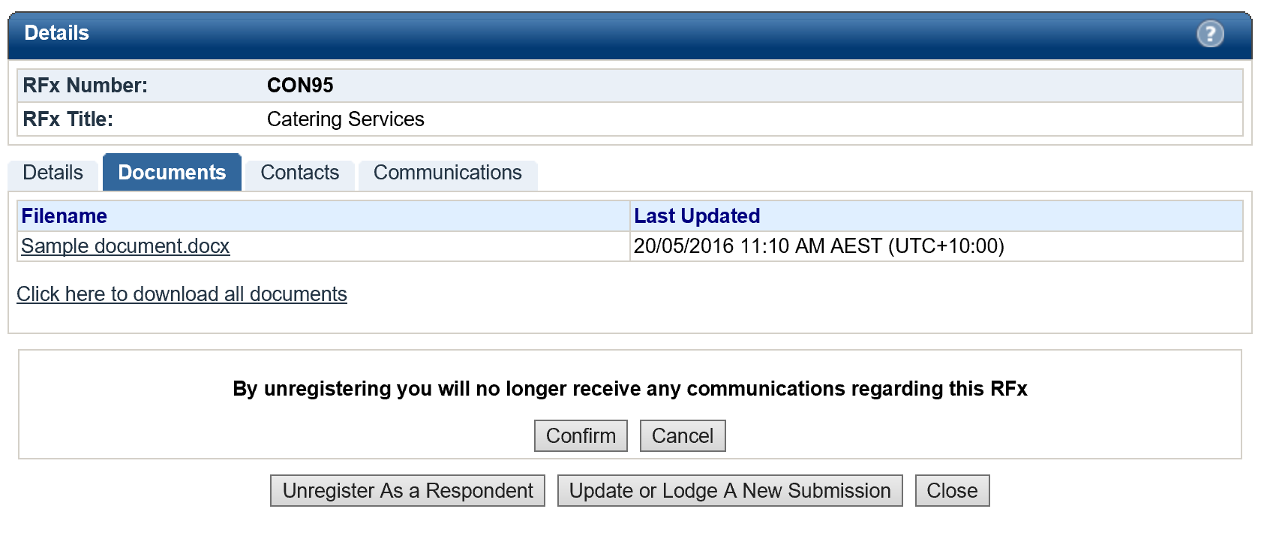

1. Once you have unregistered you will notice that your access to the RFx has reverted back to Read Only as it was prior to your registration. This means you are no longer able to download RFx Documents (including any addendums), send communications or lodge a Submission.

## The Contacts Tab

The Contacts tab details the contact information of the Organisation’s Contacts that have been nominated for the RFx. Please note that the Contacts may differ for each RFx.

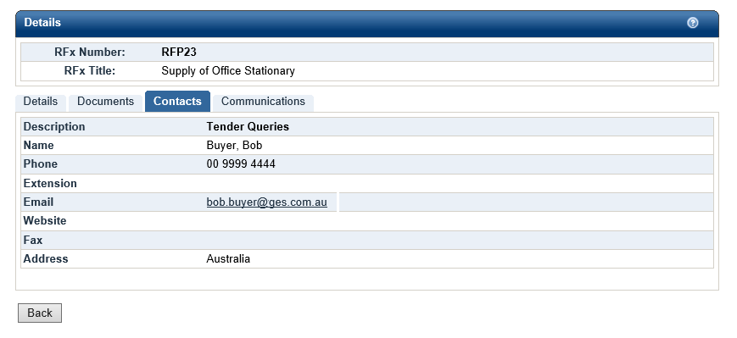

## The Communications Tab

The Communications tab acts as a repository for all RFx communications and queries that have been submitted to the RFx Contact since the RFx Opening Date.

Note: Your use of the Communications tab will be restricted until you have registered as a respondent for the RFx. Communications may close at a different date to the actual RFx, please note the Clarification Closing Date listed on the RFx details tab.

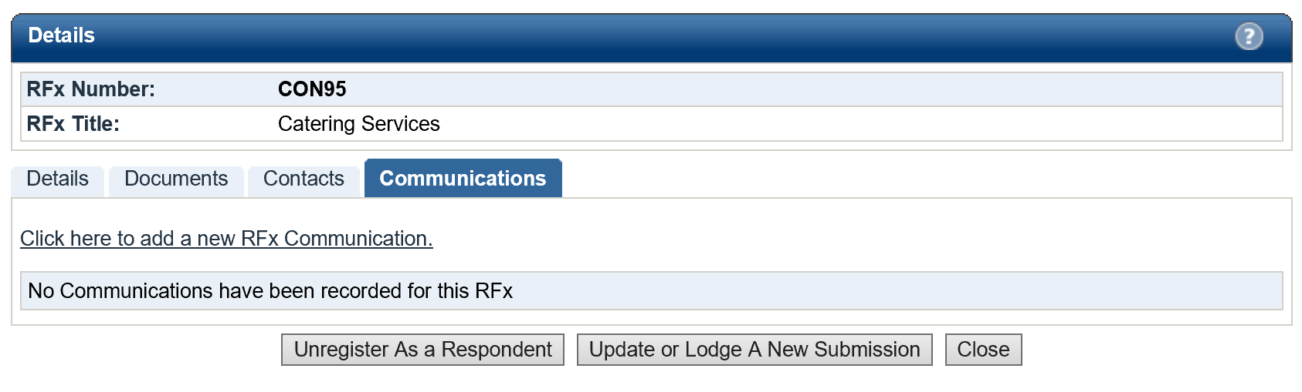

### Sending a Communication

You may submit a query or clarification for RFx’s at any time while the RFx is open and also once it has been closed. The RFx contact will receive an alert to notify them of the query once it has been submitted. Follow the steps below to send a query to the RFx Contact:

1. Click the link **Click here to add a new RFx Communication.**



1. Enter a **Subject** for the communication and populate the detail of your query in the text box.

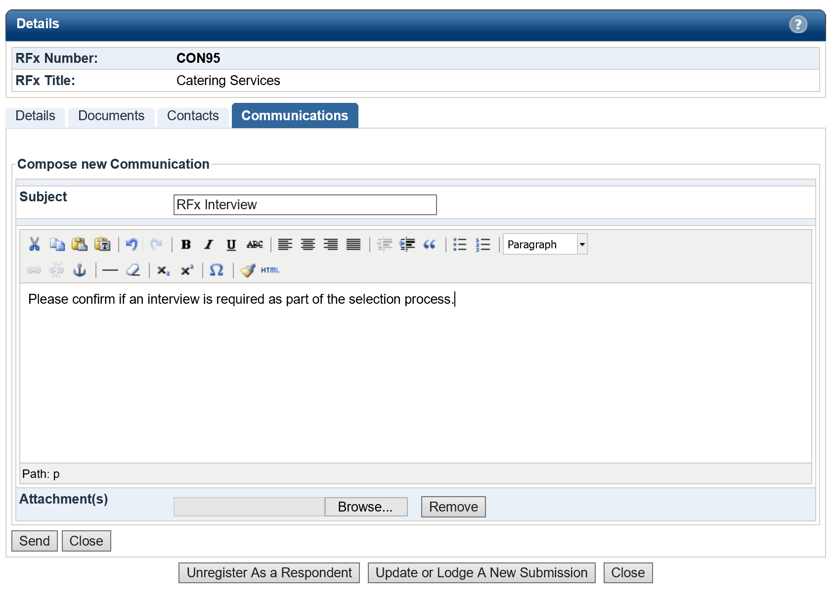

1. Attach any relevant documentation using the **Browse** button to locate the document.

Note: If you would like to attach more than 1 document, these can be uploaded as a Zip FIle.

To remove an attachment simply click on the **Remove** button.

1. Click **Send** to lodge the communication.

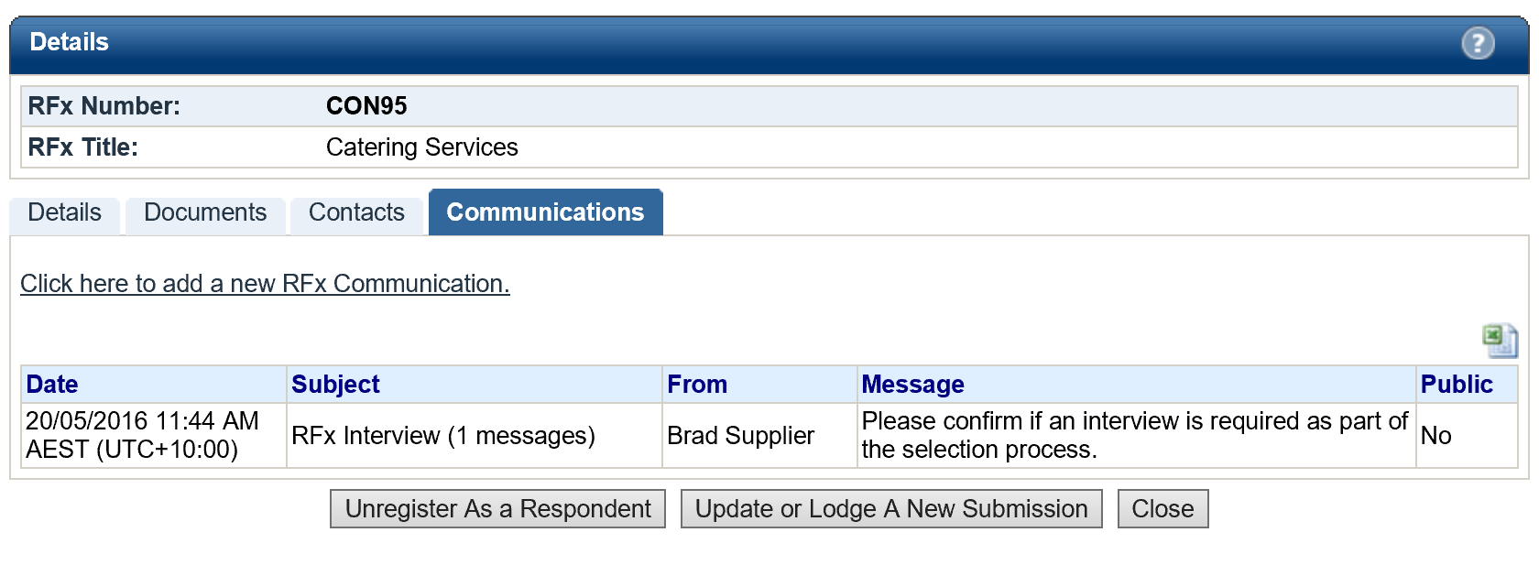

Click on the icon to download an Excel spreadsheet of all communications

1. The Communications screen lists all public communications for the RFx including any you have submitted. Upon successfully submitting a communication your communication item will appear in this log.
2. Once the RFx contact has responded to your communication you will receive an email with the details of their response. You will also be able to view the details of the response within the Communications tab.

# Responding to an RFx

In order to respond to an RFx and lodge a submission you must first ensure that you;

1. Register as a Respondent to the RFx
2. Download all RFx documentation

The following instructions assume you have already completed these steps.

## Lodging a Submission

The following steps will guide you through lodging a Submission.

NOTE: There are limits on the acceptable file types, file size and number of documents per Submission, as explained below.

1. Locate the RFx you wish to respond to using one of the methods indicated earlier.
2. Click on the RFx to open the RFx details.

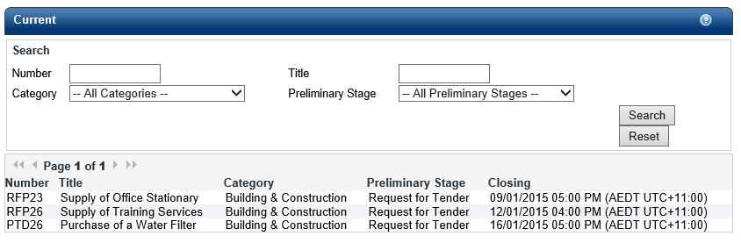

1. Firstly, you will need to Register as a Respondent by clicking the button (if you have already done this move on the next step).
2. Click on the **Update or Lodge a New Submission** button.

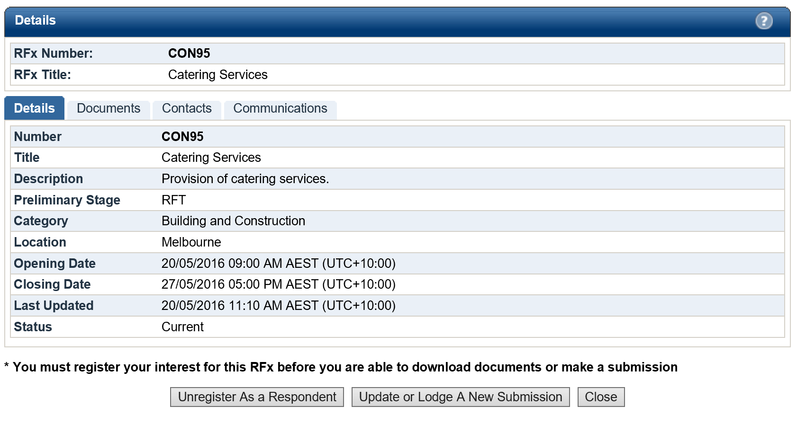

1. You will be directed to the **Update or Lodge a New Submission conditions page**. Click on the **Continue** button to agree with the terms and conditions of the RFx process

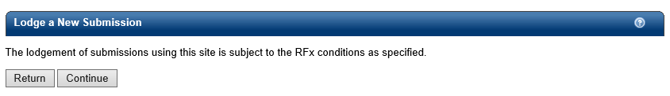

1. You will be navigated to the screen where you are able to upload your Submission. Before you start uploading documents and lodging your Submission, please locate the RFx name and check that you are lodging your Submission against the correct RFx.

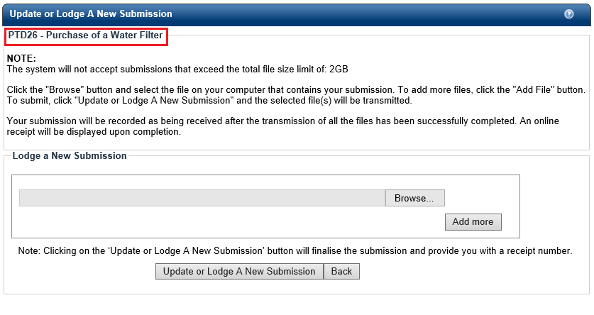

1. To upload a Submission document, click on the **Browse** button to locate your document.
2. To upload additional documents, click on the **Add More** button. Repeat this process for all remaining documents, remembering there is a limit of 5 documents per Submission. You can make multiple submission against the RFx if you have more than 5 documents to upload.

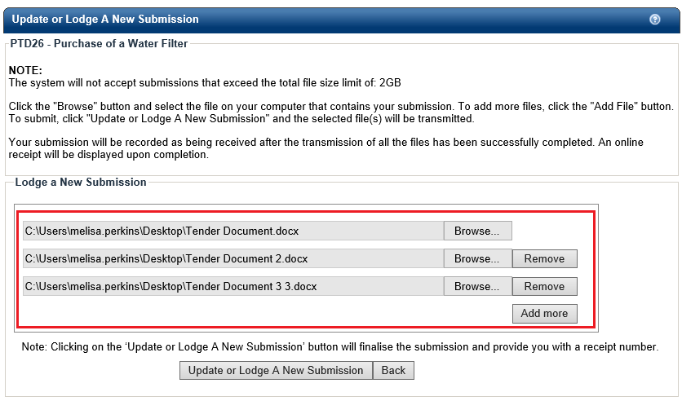

1. If you make a mistake and need to remove a document from your Submission, click on the **Remove** button next to the file you wish to remove.
2. Click on the **Update or Lodge a New Submission button to lodge your Submission**. You may see an **Upload in progress** screen which indicates the Submission is being uploaded.
3. Once your Submission has been successfully lodged, you will be navigated to the Submission Receipt screen. On this screen please:
   1. Locate and note your Submission receipt number for future reference; and
   2. Check that all your Submission documents have been successfully lodged.
   3. You will receive a reference number for each lodged Submission

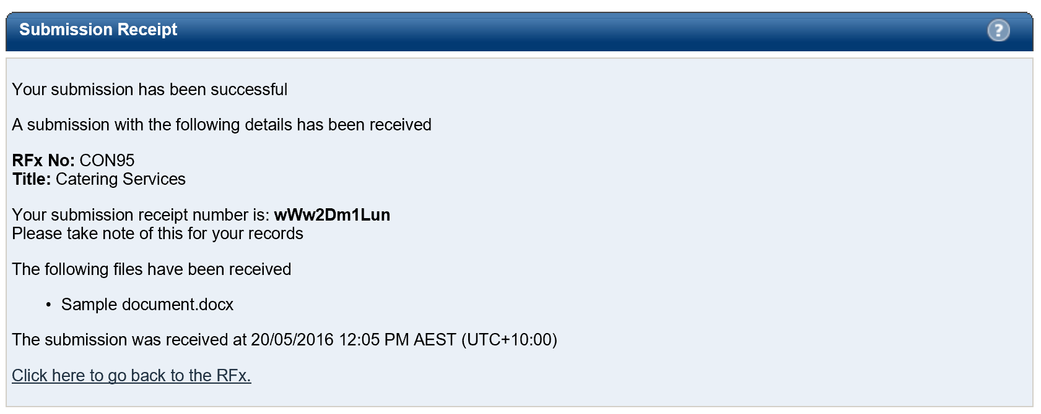

You will also receive an **eTENDERING: RFx Submission Lodged Notification** email which is a copy of your Submission Receipt.

To retrieve your Submission history against an RFx, return to the **Details** screen of the RFx and click on the **My Submission** button.

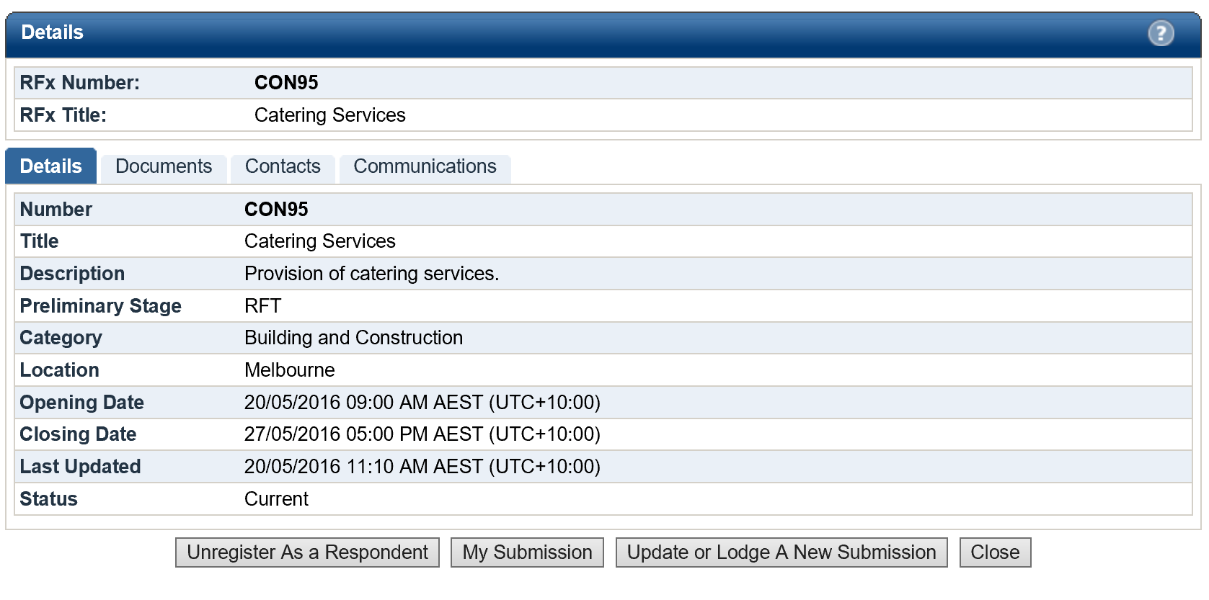

## Modifying your Submission

At any time before the Closing Time, you are able to modify your previously lodged Submission(s).

1. Log in to the eTENDERING Portal and navigate to the RFx.
2. On the **Details** screen of the RFx, click on the **Update or Lodge A New Submission** button.

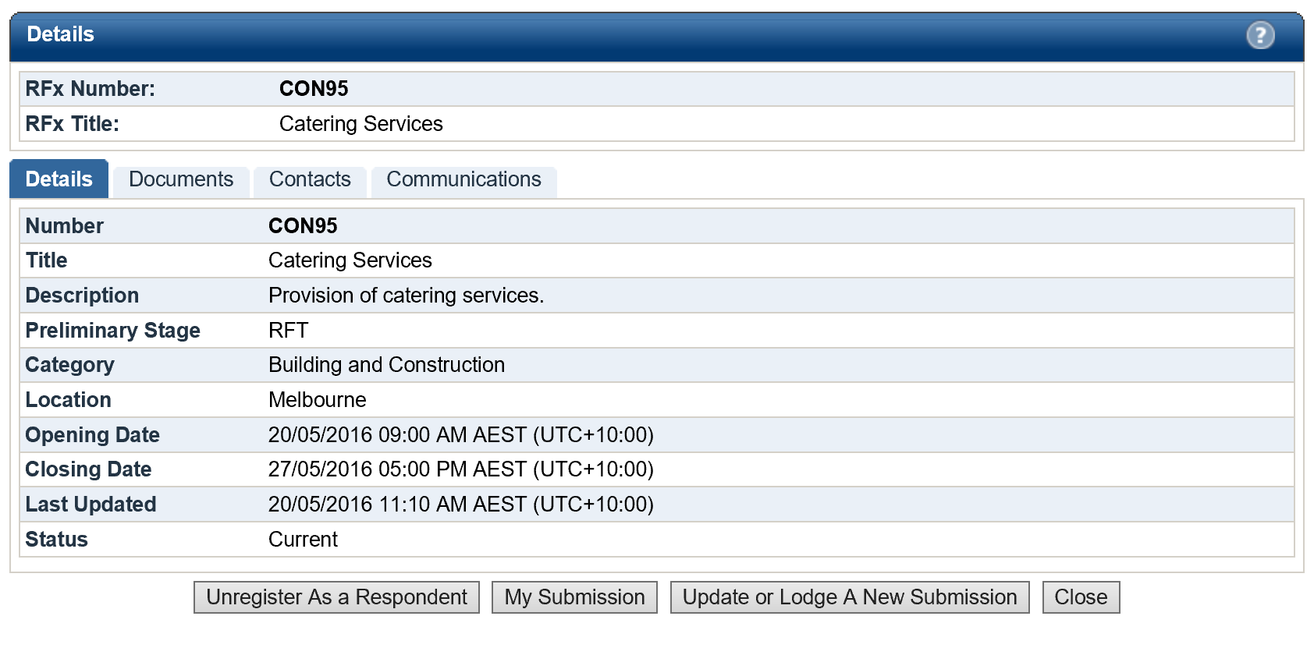

1. Click on the **Continue** button to accept the terms and conditions of the RFx process.
2. You will be navigated to the **Update or Lodge a New Submission** screen. Since you have previously lodged a Submission, the screen will now display **Lodged Documents** and an area to **Lodge a New Submission** as shown below:

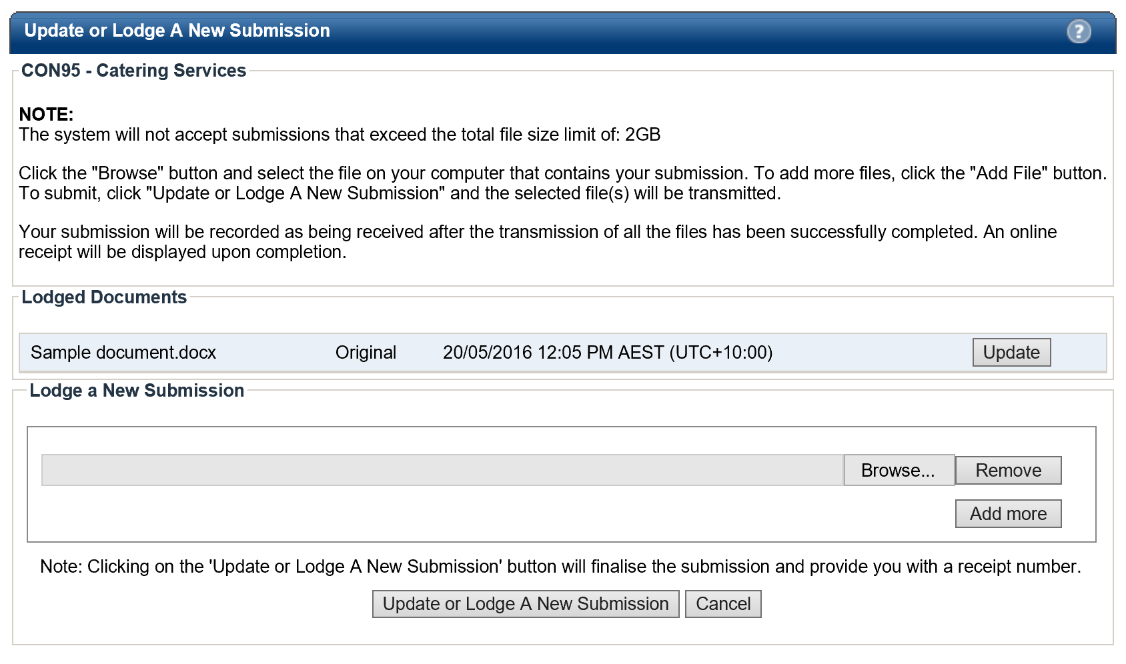

Option 2

Option 1

1. You are now ready to make amendments to your Submission(s). There are two (2) options for updating your previously lodged Submission:

**Option 1** – **Update a previously lodged Submission document**

This option allows you to update specific documents that you have lodged as part of a previously lodged Submission.

1. Locate the **Lodged Documents** area on the top half of the **Update or Lodge a New Submission** screen; all your submitted documents will be listed in this area.
2. Click on the **Update** button next to the document that you wish to update.



1. A browse documents pop up will appear under the document record that you are modifying.

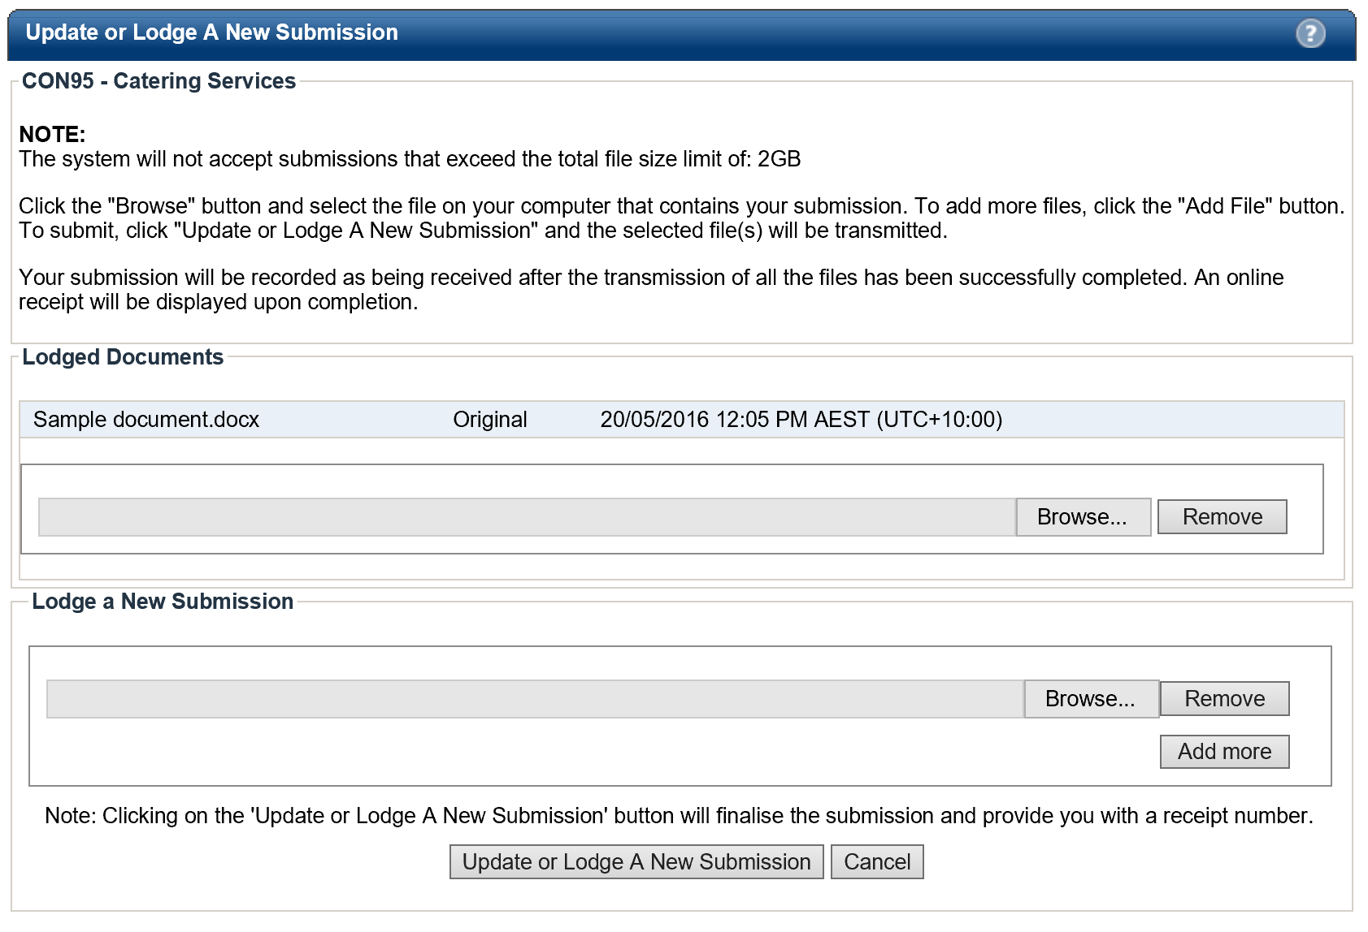

1. Click on the **Browse** button and locate your revised/modified document. If you have selected the incorrect document, click on the Remove button and repeat this step. Click on the **Update or Lodge a New Submission** button at the bottom of the screen to finalise your modification.

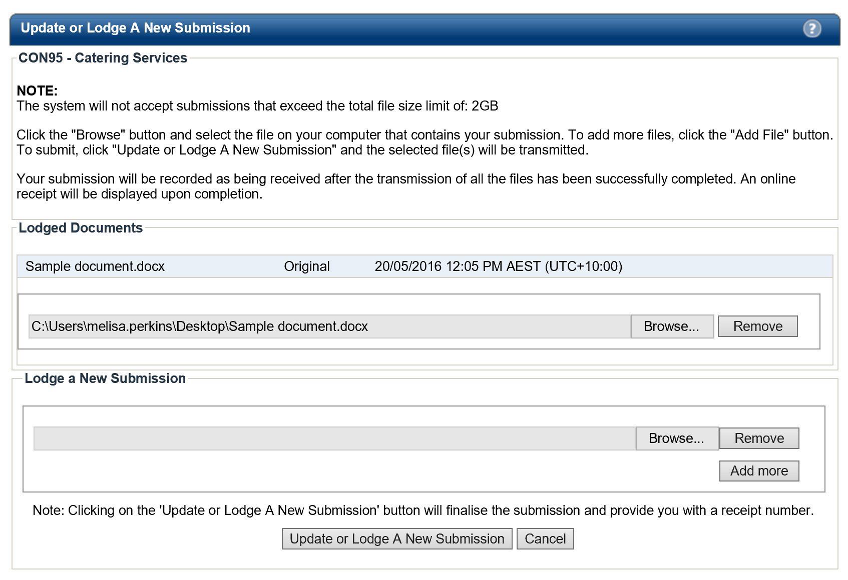

1. You will receive another **Submission Receipt**. Please note your Submission receipt number for future reference and check your modified document(s) has been successfully uploaded. Your Submission Receipt will also be emailed to you.

**Option 2 – Submit additional Submission documents:**

This option allows you add more documents to your Submission.

1. Locate the **Lodge a New Submission** area at the bottom half of the Update or Lodge a New Submission screen.
2. Click on the **Browse** button and locate the document you wish to lodge. If you have selected the incorrect document, click on the Remove button and repeat this step. Click on the **Update or Lodge a New Submission** button at the bottom of the screen to finalise your submission.



1. You will receive another Submission Receipt. Please note your Submission receipt number for future reference and check your modified document(s) has been successfully uploaded. Your Submission Receipt will also be emailed to you.

## Viewing your Submission History

There are 2 methods of viewing your Submission history depending on whether the RFx is still open or has closed.

**Submission History - RFx Open**

When the RFx is still open, your Submission history will appear on your **Update or Lodge a New Submission** screen.

1. Log in to the eTENDERING Portal and navigate to the RFx.
2. On the **Details** screen of the RFx click on the **My Submission** button to view a summary of the submission details.

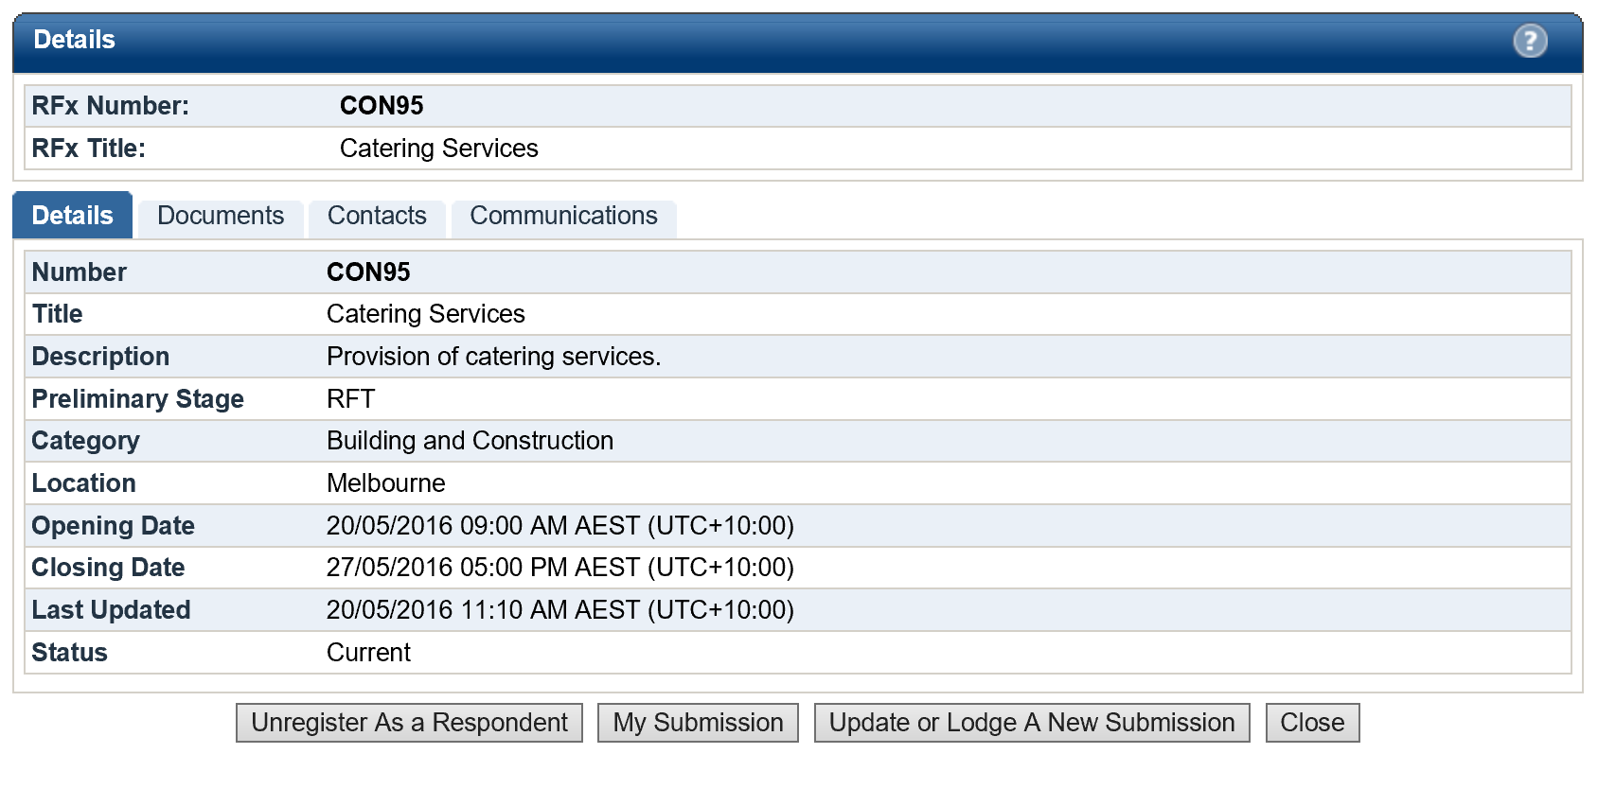

1. A history of your submissions will display. Click the **View Submission Files** to see a list of the documents you submitted. (Note this is only a list – you will not be able to open or view the content of the files)

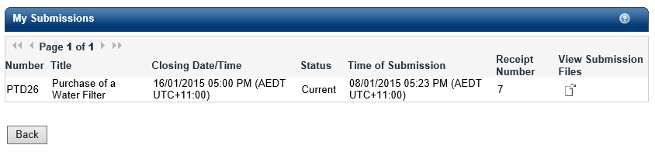

**Submission History - RFx Closed**

When the RFx has closed, follow the below steps to view your Submission history.

1. Log in to the eTENDERING Portal using your account details.
2. On the eTENDERING Desktop locate and click on the My Submissions widget.

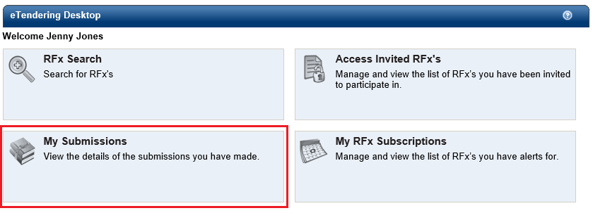

1. You will be navigated to the **My Submissions** screen which displays your entire submission history.

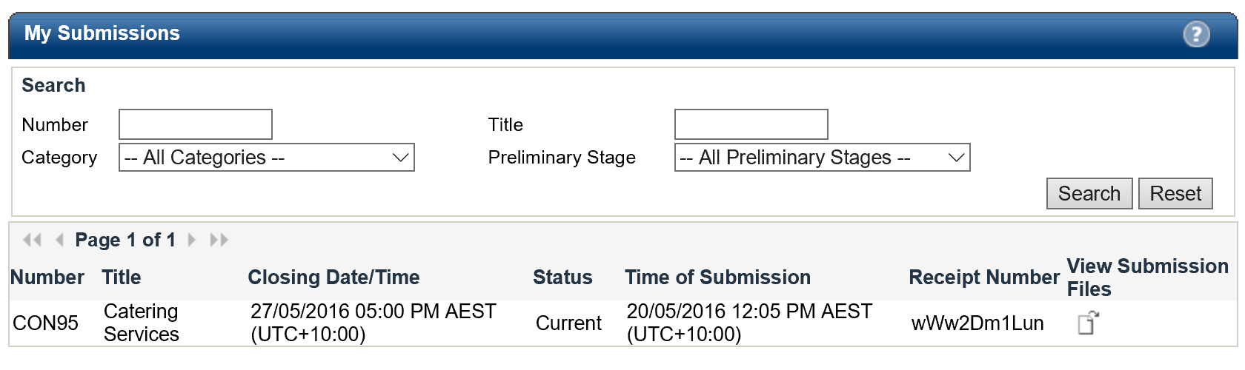

Note: There will be a Submission record for each Submission receipt. Therefore, if you have lodged more than one Submission for a particular RFx or you have modified a Submission, you will have a Submission record for each Submission Receipt.

1. Click on the **View Submission Files** icon next to the RFx record for which you wish to view the Submission document log.

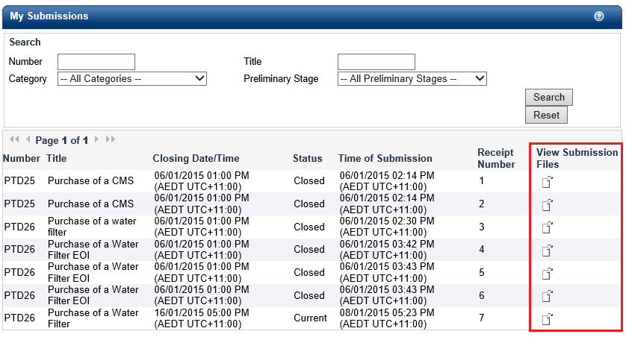

1. The **Submission Document** log will be presented below the Submission History List as highlighted in the following screenshot.



## 

# Resetting your Password

The organisation does not have access to your account on the eTENDERING Portal, thus we cannot change or reset your password on your behalf. If you have forgotten, or wish to change, your password please refer to the guidelines below.

If you have forgotten your password to the eTENDERING Portal, you are able to obtain a new password using the Forgot Password function.

1. Locate and select **Login** under the **My Account** left hand menu.

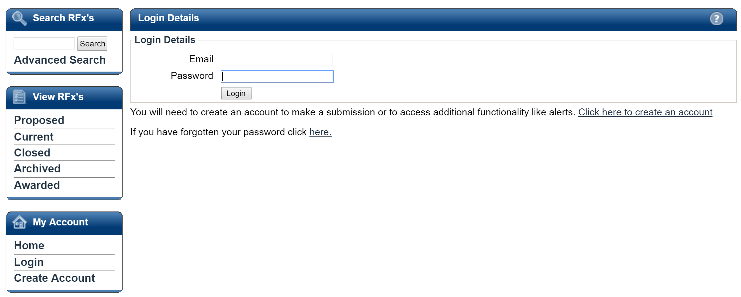

1. Locate the ‘If you have forgotten your password click here’ information below the **Login Details** area. Click on the here hyperlink.
2. You will be navigated to the **Forgot your password** screen where you are required to enter your name and email address for confirmation purposes. Click **Send password information**.

Note: Your name and email address must be the same as you used to initially register on the eTENDERING Portal.

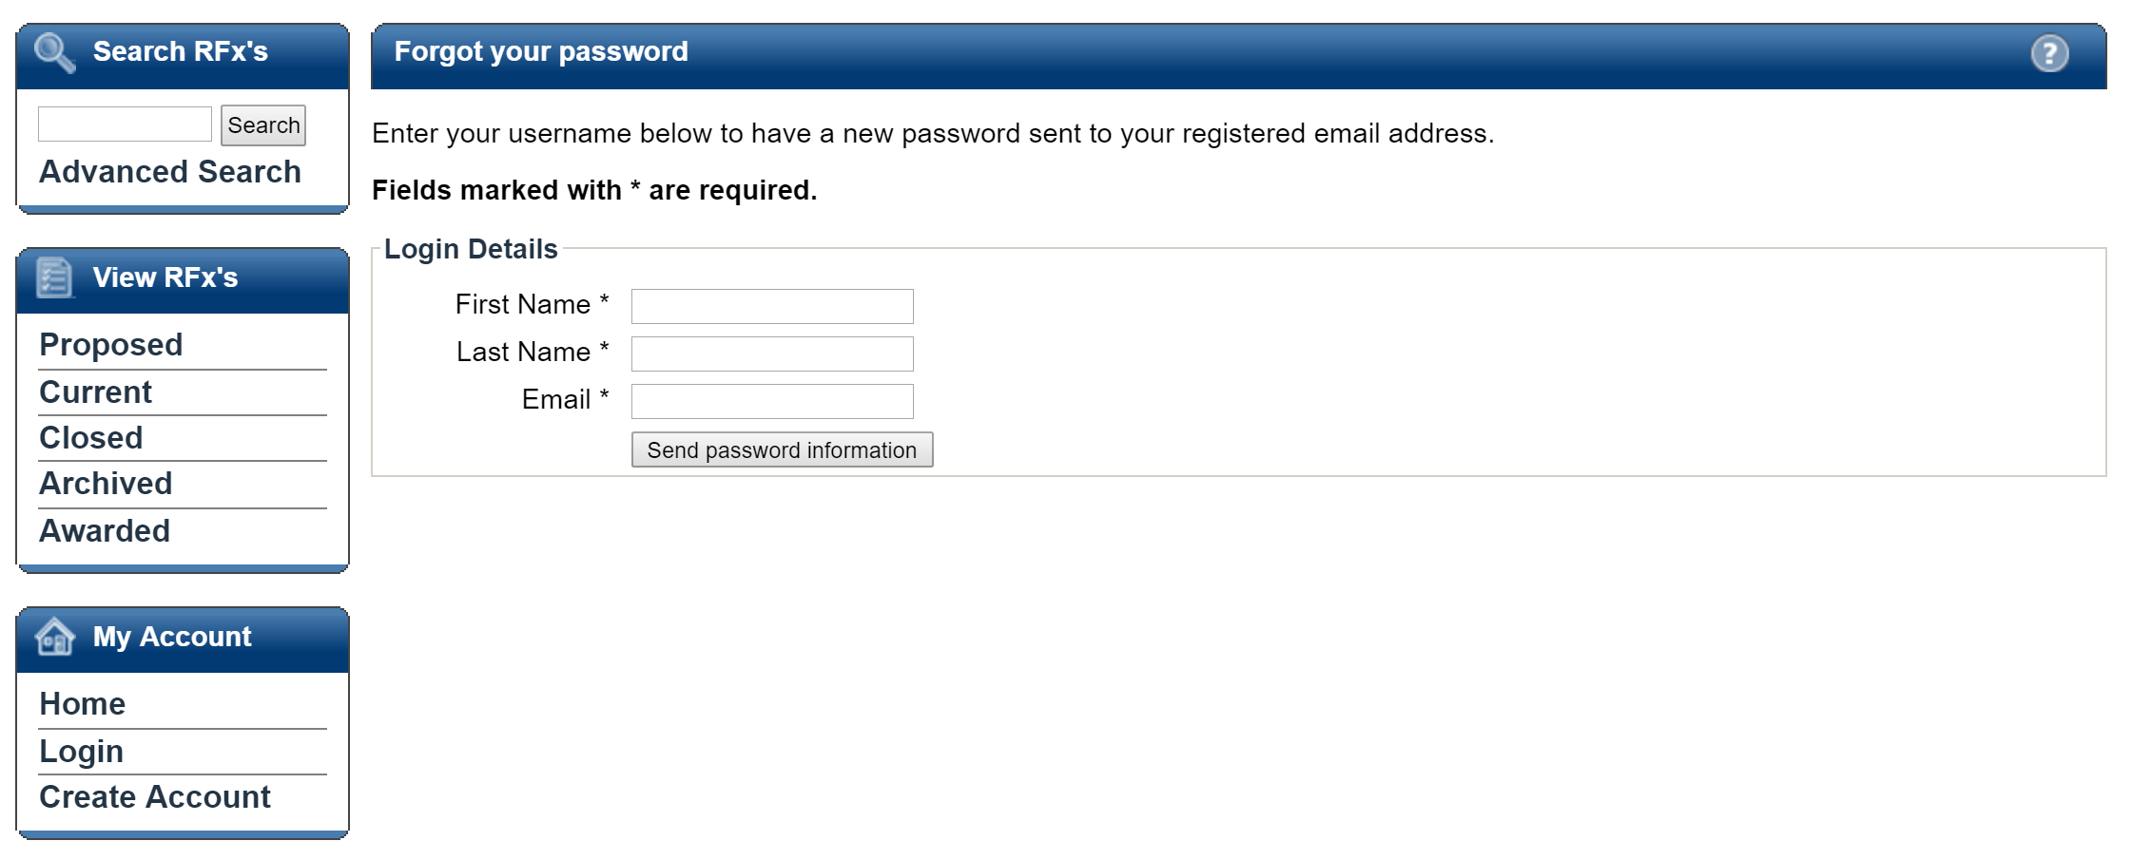

1. You will receive an on-screen notification, notifying you that your new password request has been successful. Your new password will be contained in an **eTENDERING: New Password Notification email**.

# Changing your Password

You may change your password at any time by following the steps outlined below.

1. Log into the eTENDERING Portal. If you do not remember your password, please refer to Section 8 ‘Resetting your Password’ to receive a temporary password.
2. Navigate to **the My Account** left hand menu and click on **Account Details**.

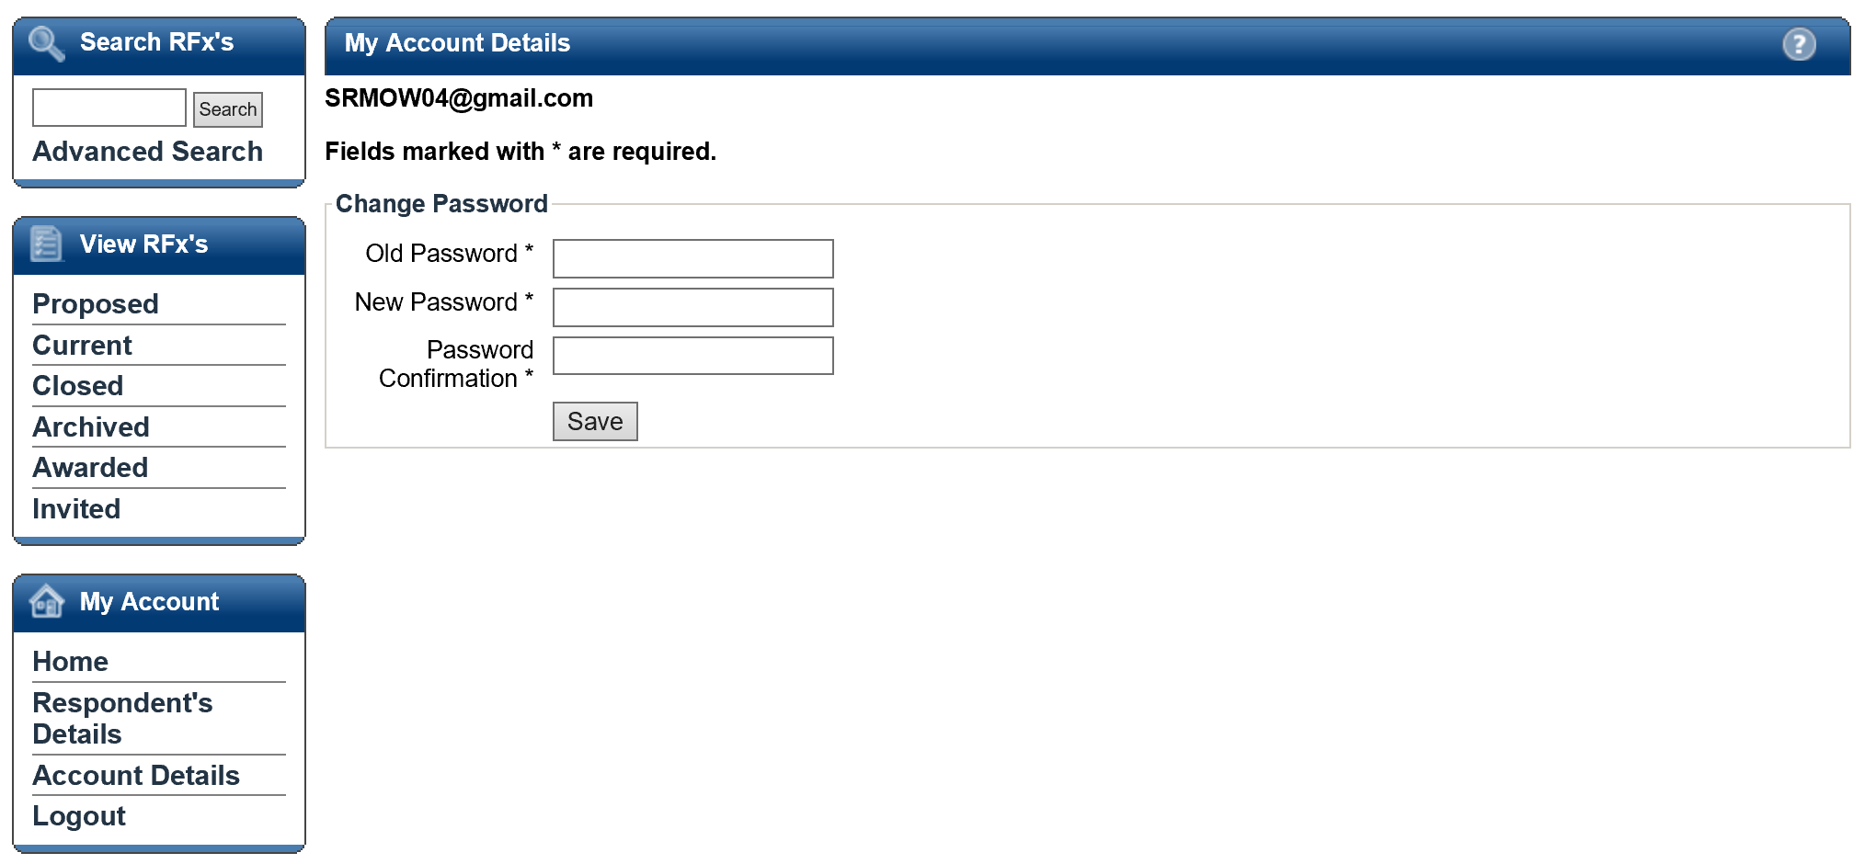

1. On this screen you will be required to enter in your old password into the Old Password* field.
2. Enter a new password and confirm this password in the New Password* and Password Confirmation* fields. Your new password must be at least seven (7) characters long and contain letters and numbers. The password is not case sensitive nor do you require a space between letters and numbers.
3. Click the **Submit** button to reset your password. Your password has been reset when you receive a successful on-screen message.

# Appendix: Document Revision History

The purpose of this section is to capture all changes made to the content of document.

|  |  |  |  |
| --- | --- | --- | --- |
| Version | Date | Updates / Changes | Author / Reviewer |
| 0.1 | 20/05/2016 | Draft for 7-0-2 | Melisa Perkins |
| 0.2 | 23/05/2016 | Peer Review | Jane Adams |
| 0.3 | 25/05/2016 | Addressed Peer Review Feedback | Melisa Perkins |
| 1.0 |  | Final QA |  |