

Yarra Ranges Council
Exhibitions and Creative Pathway Program

Information Pack

2025
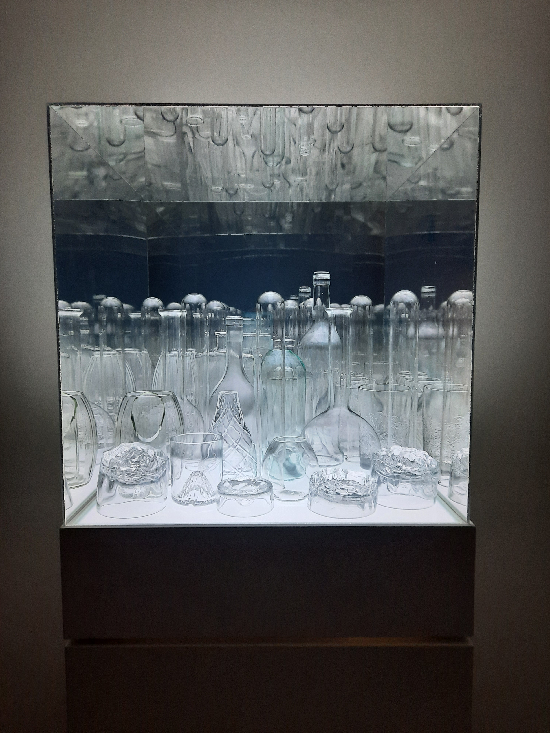

Image: NOT, Selladoor, CHARD, 2023, The Memo Healesville

Exhibitions and Creative Pathways Program Information Pack
Introduction
This document will provide potential exhibitors with information about exhibiting as part of the Exhibitions and Creative Pathways Program (ECPP) with Yarra Ranges Council (Council). Consisting of two galleries, these vibrant spaces adhere to the curatorial aims below:

New for 2025, we are presenting ECPP, formerly the Regional Exhibitions Program. It supports and develops extraordinary creative output in the region which in turn fosters a strong sense of local identity and encourages meaningful participation from community members.
The ECPP plays an integral role in the delivery of the Creative Communities Strategy at Yarra Ranges Council. Through it we promote the Yarra Ranges as a vibrant arts hub that thrives economically, attracts creative people and embeds creativity within the cultural life of the region. This opportunity has been developed in alignment with the 2023 Regional Exhibitions Program Review process which identified priorities from the Yarra Ranges community.

Please read the following document carefully as it is the main source for information needed to participate in the ECPP. It details what Council provides to the artist / creative regarding installation, marketing, and opening launch. This document also describes what the artist / creative needs to provide to Council to be considered for the program.

The preferred method for applying to the ECPP for 2025 is via our online form available from www.culturetracks.info.

If you require assistance or an alternative method of application, please contact the Regional Exhibitions Officer at exhibitions@yarraranges.vic.gov.au.

What is the Exhibitions and Creative Pathways Program?

This program will offer opportunity for emerging and mid-career Yarra Ranges artists / creatives seeking to progress their career and further develop their creative practice through mentoring and development of new work to deliver exceptional exhibition outcomes.
You are invited to submit proposals that can include but not limited to:
- Experimentation and testing new ideas
- Community engagement and interactive artworks
- Exhibition outcomes
- Activations and installations
- Residencies within gallery spaces in our cultural venues
- Workshops and public programming
- Collaborations with other creatives
We are interested in proposals which offer a novel way of activating the gallery spaces in our cultural venues or have the potential to connect with other events and community priorities.
There will be a small number of exhibition / activation opportunities available for 2025 with the following possible offerings for the successful artists / creatives:
- 8-10 week exhibition time
- Mentoring and/or project development support from Regional Exhibitions Officer (REO)
- Option to use some of the exhibition time for a self-funded residency in the space
- Possibility to run self-funded workshops and additional programming with in-kind venue hire
- REO support to facilitate links with other events and networking outside of the shire and connection to relevant council teams for potential partnerships.
Please note that at times exhibition / activation space availability will vary in duration. The galleries are closed on public holidays and at times the galleries might be closed at the Council’s discretion. This may impact the number of days an exhibition / activation is open to the public. See our website for opening hours.

Fees

Please note the following regarding payments and charges:
- Successful artists / creatives will be offered the gallery space free of charge for the duration allocated.
- We are not able to offer an artist fee.
- We are not able to fund additional programming.
- We do not take commission on sale of artworks (sales must be managed by the artist / creative, see Art Sales section for more information)
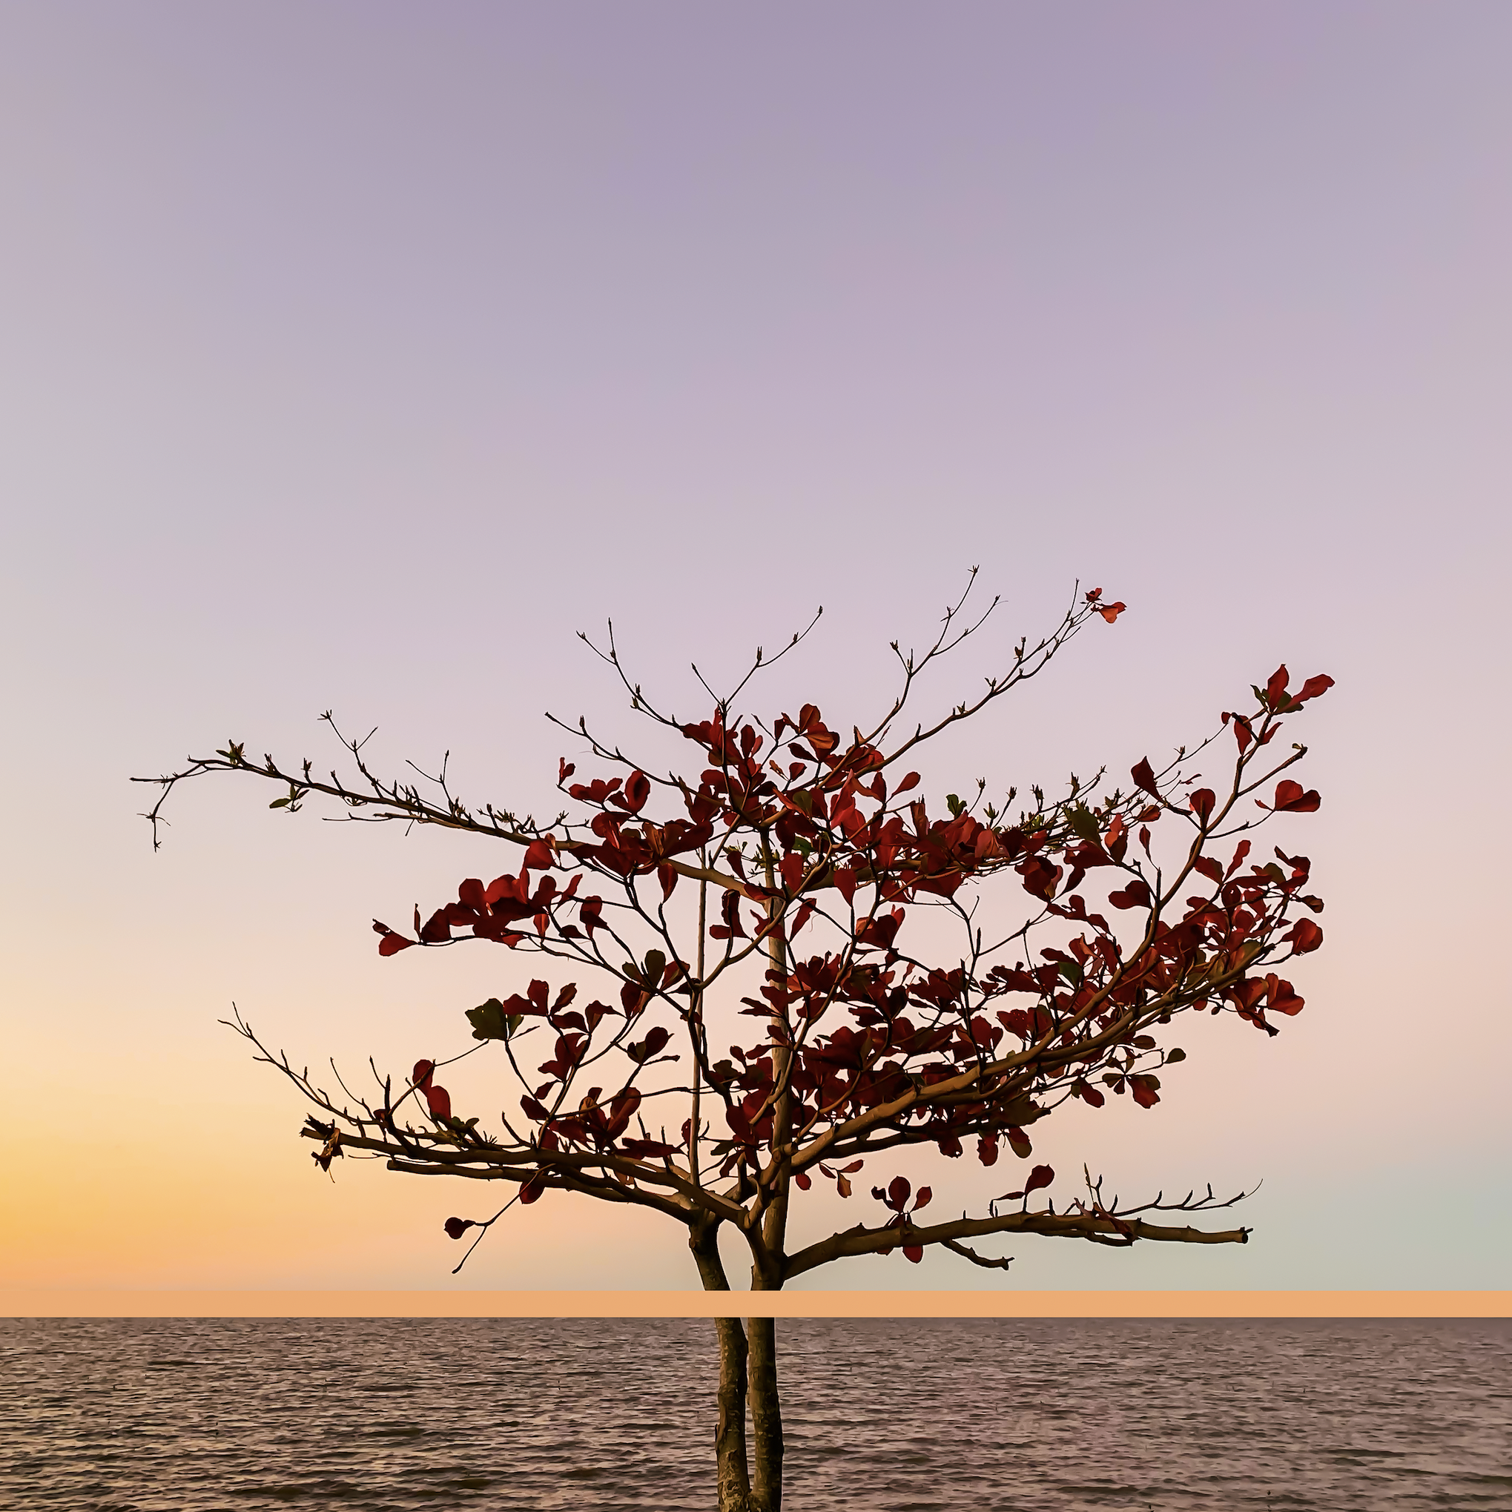
Exhibition Spaces

The exhibition spaces available as part of this program include:

- The Gallery, The Memo Healesville
- The Studio, Arts Centre Warburton

Image: Brin Cloud, I Tell Lies, 2023, Art Centre Warburton

Selection Criteria
Anyone who lives, works or plays in the Yarra Ranges can apply to participate in this initiative, but priority will be given to exhibitions / activations that:
- Present a coherent body of work of high visual and conceptual quality that articulate a theme, idea, premise, narrative, historical or contemporary issue.
- Give representation to:
  - Aboriginal and Torres Strait Islander artists and communities
  - LGBTIQA+ artists
  - Creatives who identify as neurodivergent, or have a lived experience of mental or physical illness or disability
- Contribute to a program which achieves overall balance of gender equity, cultural and linguistic diversity and engages a broad age range.
- Demonstrate strong audience engagement, community focus and public program opportunities.
- May be experimental, innovative and have not been shown before.
- Are funded through the YRC Community Arts and Heritage Grants Fund.
- Clearly demonstrate how the artist / creative would use this opportunity to progress or develop their art practice.

Proposals will be assessed by a professional selection panel. Please be aware that we receive a high number of applications each year, however we are only able to support a very limited number of exhibitions.

Successful artists / creatives will be notified by mid November 2024, with the program commencing in February 2025.

Exhibition / Activation Support

The REO provides a range of supports and advice to the artists / creatives as follows:

- Advice and assistance with exhibition development and design
- Installation of the artworks by professional art technicians
- Advice and mentoring for:
  - Exhibition / activation planning and development
  - Artist professional development
  - Networking and connections
  - Planning and development of public programming / activations
  - Grants and funding opportunities
- Design and installation of exhibition signage including wall texts, labels or room sheet
- Use of the following equipment:
  - Audio-visual equipment including projection
  - Sound system for the opening event or during the exhibition
  - Access to a variety of plinths, movable walls and suspension capabilities

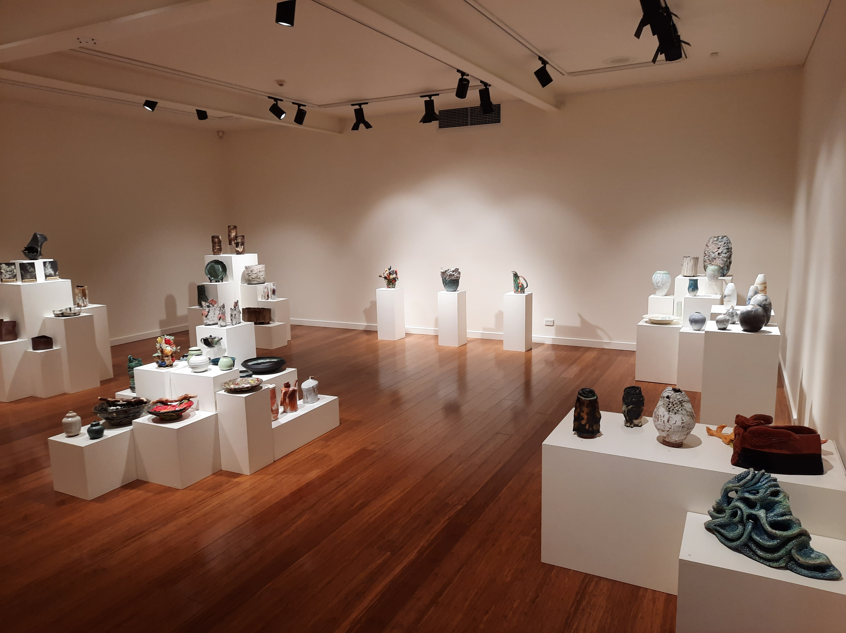

Image: Shaping Earth by Valley Potters, 2024, installation view, The Memo Healesville
Exhibition Information

Installation

- In-house staff, professional installation and technical staff will install the exhibition.
- There are a variety of plinths available for display purposes – there are no lockable display cabinets available.
- Our hanging system consists of tracks, wires and hooks. A visit to the space is recommended. A sample can be provided to ensure the exhibitor’s work is prepared in a suitable manner to be hung from this system. No pins, screws or nails, including stick-on hooks are allowed to be used on the walls. Template artwork labels/catalogue will be provided and we will use this to make professional labels/catalogue using YRC style and branding. Any alternative designs must be created by the exhibitor and approved by the REO.
- We can provide access to gallery tools and audio-visual equipment including: DVD players, media players, sound system, digital projectors and televisions subject to availability. The exhibitor may bring their equipment however it must be tested and tagged prior to installation at the exhibitor’s expense.

The artists / creatives are required to:
- Pack and transport exhibition artwork to and from the gallery and adhere to agreed delivery and installation dates and times. All transport costs to be met by the artists / exhibitor.
- Prepare artworks for installation using the existing gallery hanging system at each venue. For example, 2D works will require D-hooks and/or hanging wire 1/3 from top of frame) and weighing up to 20 kilograms each maximum. They must meet professional presentation standards. If unsure, please bring an example to the production meeting for confirmation. The REO has the right to veto any work deemed unsafe to hang.
- The installer and/or other Council staff are not able to alter the artwork in any way.
- No nails, pins or permanent fixtures can be used in the gallery spaces under any circumstances.
- The gallery must be left tidy and restored to original condition. Costs related to repairing damage will be charged to the artists / creative.
- Artworks must be removed by the artists / creative at the end of the exhibition within specified times as agreed.
- All venues will supply a staff member to install the exhibition. If items for display are not delivered ready to be installed and arranged in the gallery by the artists / creative within specified times there is no guarantee it will be displayed.
- The REO has the right to veto any artworks that require maintenance or contain live animals or plants; these must be discussed in the production meeting.

Pack Down / Deinstall

The artists / creative is required to pack down their exhibition within opening hours. If needed, the REO may assist the exhibitor. Please discuss deinstall in the production meeting. If ladders and special equipment is needed, a Council staff member must assist.

Staffing

Council will staff the main venue during opening hours. Artists /creatives are not permitted to staff an exhibition outside of these hours. The opening event will take place within usual opening hours and will also be staffed by Council staff. Please note the gallery may be open outside of usual opening hours if another event is on in one of the venues.

Artwork Sales

Artwork sales are the responsibility of the artists /creative and Council will not act as artist agent or undertake responsibility for the sale of art works from the exhibition. We also take no commission on sales.

Enquiries regarding the purchase of works will be referred to the artist / creative or their agent. Please advise the REO on the preferred method of contact for all sales enquiries.

Artworks must not be removed from an exhibition prior to its closing date.

The distribution of all sold works is the responsibility of the artist / creative.

As works are sold, artists /creatives must contact the REO to have a red ‘sold’ dot sticker placed on the label for the respective artwork.

Insurance

Council can provide insurance for the artist / creative’s work while it is being exhibited in their galleries. This cover is subject to:
- the artworks being declared on Council’s insurance policy (Fine Arts)
- the terms and conditions of Council’s insurance policy wording (Fine Arts).
Please discuss further with REO if cover is required. Alternatively, the artist / creative can insure their artworks at their own discretion. Minimum claim for an artwork to be insured is $2,500.

Artists / creatives to provide:
- The dollar value and total number or artworks for insurance purposes – not doing this will mean that the exhibition is not insured. Please ensure this detail is provided at least four weeks prior to exhibition installation.

Security

- Council venues have after-hours alarm protection and security.
- Please note that exhibition spaces are NOT invigilated inside the gallery during opening hours, however venue staff invigilate exhibitions as part of their front of house and customer service duties.

Production Meeting
The artist / creative is asked to attend a production meeting with members of Council’s Creative Communities team to discuss marketing, artwork labels, opening details, installation, deinstallation, insurance and more. Although it is best to conduct these meetings in the exhibiting venue, they may also be conducted in the artist’s studio, over the phone or on Microsoft Teams. This will be held approximately three to four months before the opening date of the exhibition. If desired, the meeting can occur earlier than this timeframe. A time will be mutually agreed and confirmed.

Marketing and Promotion

- Artists / creatives are encouraged to promote their exhibition / activation as widely as possible.
- Promotional material or advertisements must include the Council logo, Culture Tracks logo and be approved by Council prior to distribution.
- Council reserves the right to take and publish photographs of works/events for promotional/marketing purposes.
- Artists / creatives will be offered our marketing guidelines to assist.

All artists / creatives will be requested to provide:
- High resolution image either emailed beforehand or on a USB
- A short and a long blurb for marketing use
- Broad overview of concept behind exhibition
- Title of exhibition confirmed
- Confirmation of opening event time
- A complete list of artworks that will be included in the exhibition
- All exhibitors including full names, addresses, email and phone numbers.

The marketing material will be created from the information provided by the artist / creative. Information must be completed and proofread as requested by the REO, in the format requested. If the artist / creative does not supply this information at this time, Council cannot guarantee that marketing support will be received in time for the exhibition / activation. Once the artist /creative is sent the marketing material, their approval will be required so the material can be sent to print. Changes made after this approval can incur extra costs and will be at the discretion of Council staff.

The REO can supply further information regarding marketing opportunities.
Artwork Labels

A template document will be emailed for the artist / creative to complete and return within the date requested. This information will become the final label/catalogue, and therefore all information provided should be final.

Opening Event
Council will endeavour to support the artist / creative to hold an opening event at a time suitable for them. Please note that openings must be within existing venue opening hours and the specific details of the opening will be discussed during the production meeting.

- Artists / creatives can opt to hold a two-hour exhibition opening. Changes can be subject to availability.
- The REO assists in the coordination of exhibition openings. An opening could include light refreshments, including alcohol, supplied by the exhibitor, which can be served as complimentary and not sold, one or more speeches and possibly some entertainment.
- The artist / creative is required to supply their own food and drinks at the opening; the Council can supply tea, coffee and water for opening events upon request.
- The gallery is staffed during the opening event including setting up and packing down catering and drinks.
- Use of wine glasses and water glasses, cutlery and crockery are available for opening event.
- Use of a PA system is available for opening event.
- The Arts Centre, Warburton is a multi-purpose space. Other functions may be held in these spaces during the course of the exhibition at the sole discretion of the Yarra Ranges Council.
- Arts Centre, Warburton and The Memo, Healesville can sell wine and beer at bar prices at the opening.
- All details will be finalised at the exhibition production meeting.

For further details on the exhibition venues, please visit the venue pages for up-to-date opening hours (subject to change):
- The Memo, Healesville - https://www.yarraranges.vic.gov.au/Experience/The-Arts/Cultural-venues/The-Memo-Healesville
- The Arts Centre Warburton - https://www.yarraranges.vic.gov.au/Experience/The-Arts/Cultural-venues/Arts-Centre-Warburton

General Terms and Conditions

- All artists / creatives will be sent a letter (via email) outlining whether their application was successful or otherwise.
- All works in the exhibition / activation must be original and created by the artist / creative.
- All artworks must be ready to install when they arrive at the gallery otherwise Council Staff may not be able to exhibit them.
- The exhibition / activation presented must relate to the original proposal submitted and approved. Council reserves the right to refuse installation if the exhibition deviates from the original proposal.
- Council will not permit the exhibition of works which are unfinished, deemed offensive/inappropriate for the space in which it is situated, or an OH&S risk to staff and/or public.
- Council reserves the right for final curatorial decisions on all exhibitions / activations.
- Artists / creatives should be aware that other events and programs can be on at the same time as the exhibition; multiple events will lead to higher exposure of the artwork and exhibition.

Questions and Assistance

If you have any questions relating to the Exhibitions and Creative Pathways Program, please contact the REO at exhibitions@yarraranges.vic.gov.au.
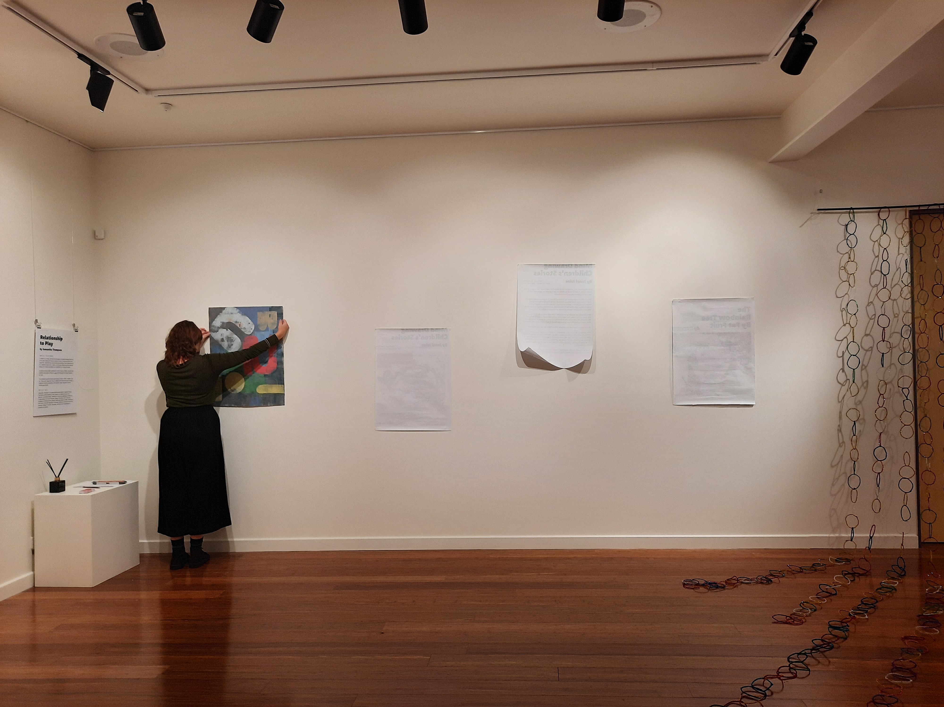
Image: Installing Relationship to Play, Samantha Thompson,2023, The Memo Healesville

The Gallery, The Memo Healesville
235 Maroondah Highway, Healesville

The Memo Gallery opened in 2011 and is owned and operated by the Yarra Ranges Council. The gallery is located in an exclusive exhibition space within The Memo, Healesville. It is centrally located in Healesville, has ample parking and is an accessible venue.

The space is a large white painted box, with floorboards. It is a professional looking gallery space suitable for contemporary artworks, as well as more traditional 2 and 3D artworks. It is an accommodating space that could be used for activations, residencies, installations, projections and other ideas. It is frequented by the local community, movie and theatre goers, as well as tourists. A foyer is also available for hanging artwork, and may be used in conjunction with the Gallery, or as a smaller, secondary community hanging space.

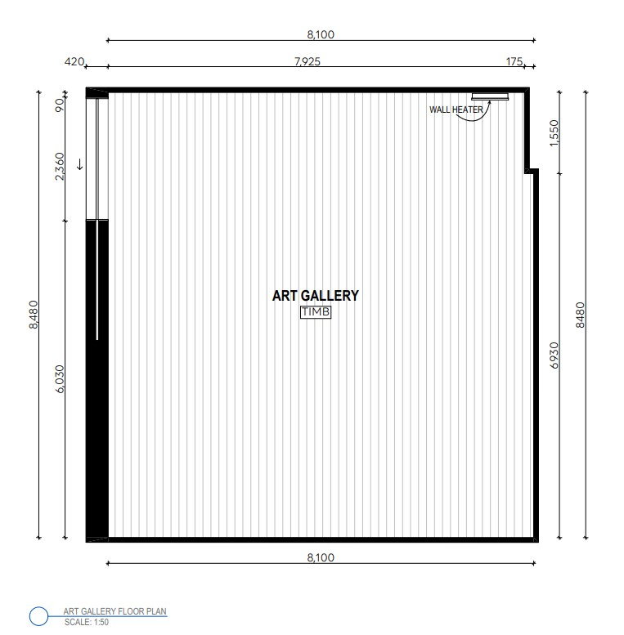

The Gallery, The Memo Healesville has:
- 30m of wall space with a height of 3m
- Walls are fitted with a professional gallery hanging system
- Walls are white plasterboard
- Lighting will be completed by technical team and REO to best display artwork
- Data projector/s/TV available to screen directly onto wall or screen
- Audio options available – please discuss your requirements with gallery staff
- Various plinths, display cases and mannequins are available, please discuss with the REO

Access
- Is a public space frequented by adults and children who may be in the centre for other purposes
- Town Centre, main street location
- There are no admission charges
- Accessible venue
- Public parking located adjacent to the Centre
- Public transport includes access to buses

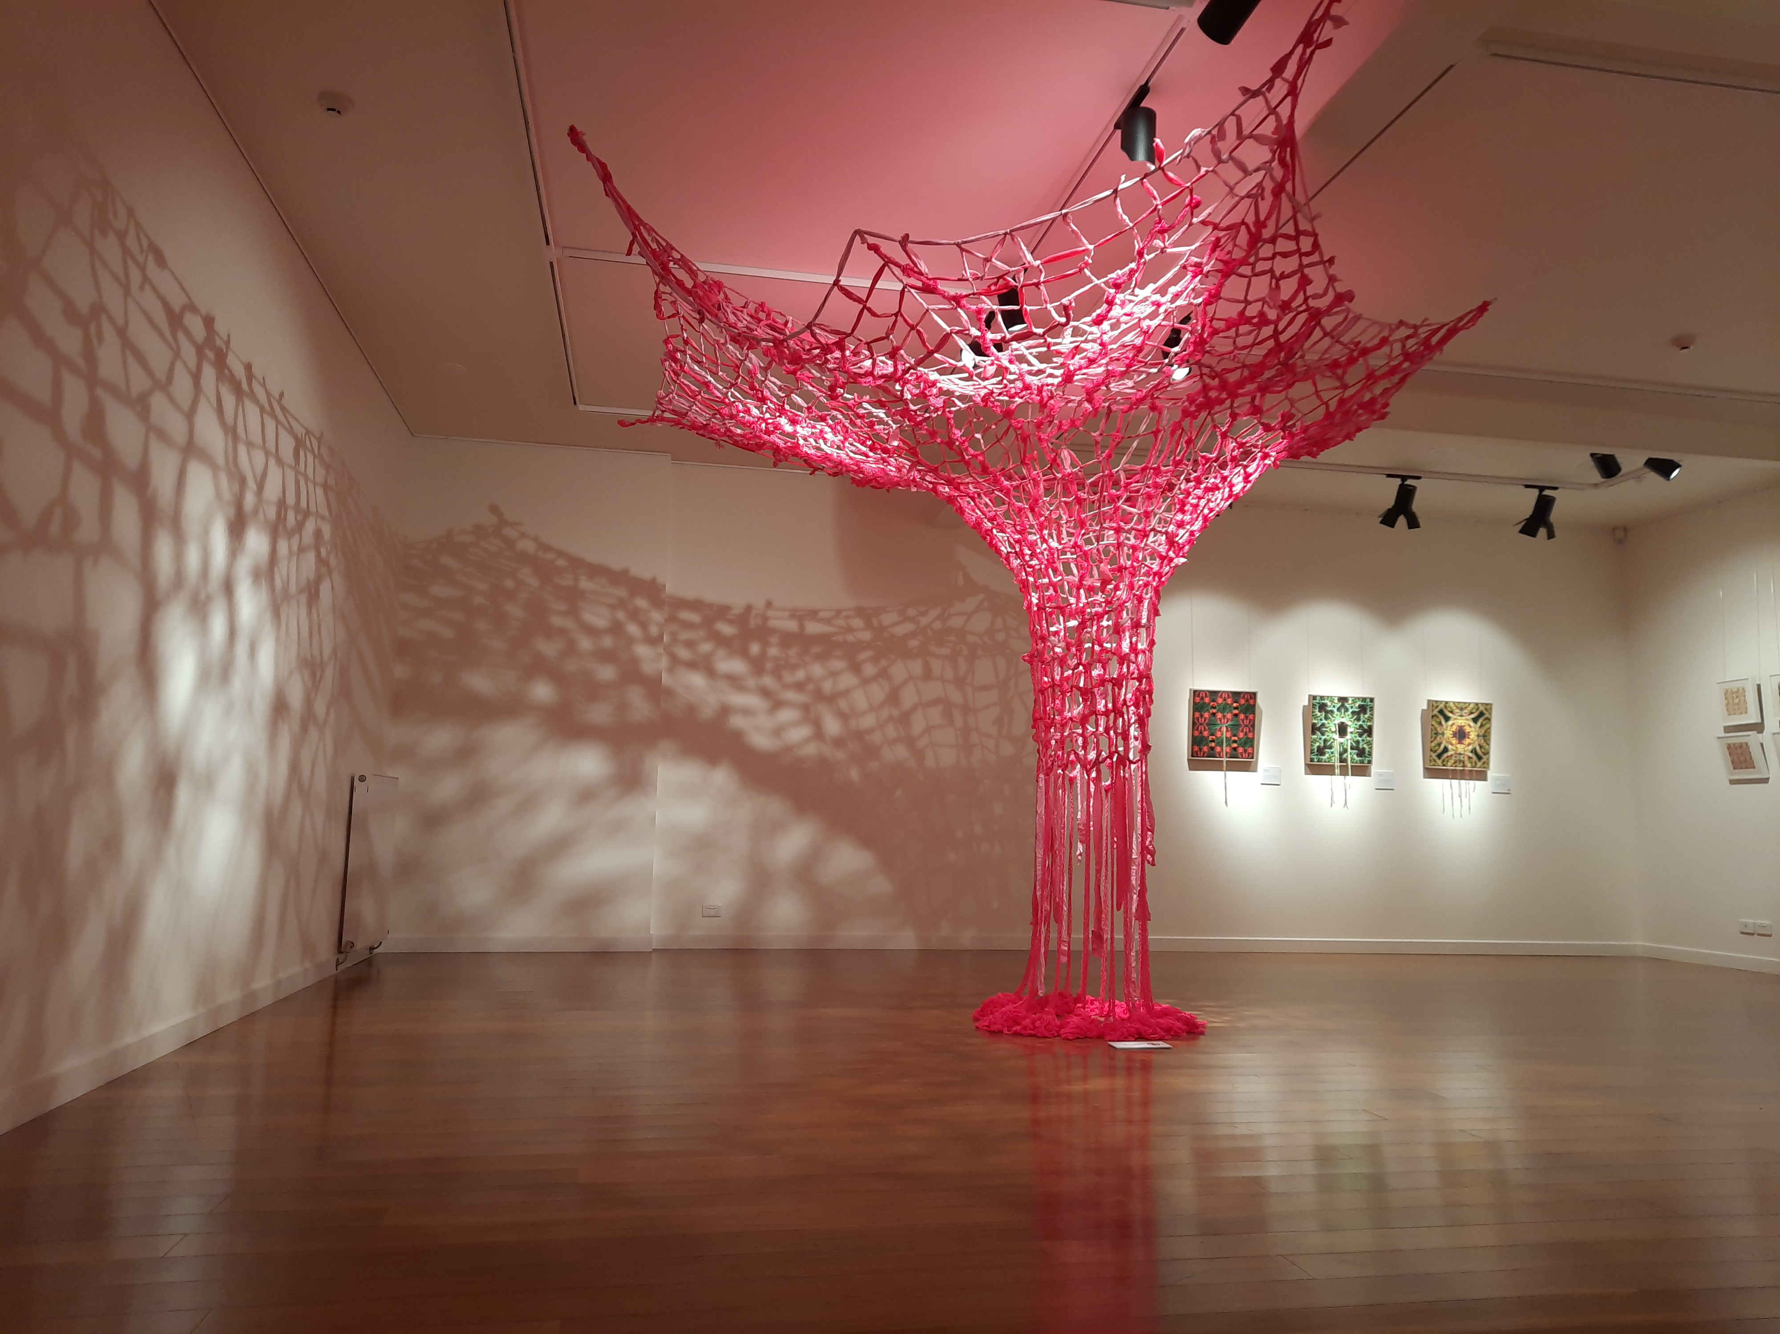
Image: Canopy by Makers Merge, 2023, Installation view, The Memo Healesville

The Studio, Arts Centre Warburton
3409 Warburton Highway, Warburton

The Studio opened in 2005 and is owned and operated by Council. The space is located in a multi-purpose exhibition space within the Arts Centre Warburton. It is centrally located in Warburton, has ample parking, and is an accessible venue.

The space is a large white painted box, with floor to ceiling windows at one end, letting light flood in from the ‘river’ end of the street. Frequented by a very creative local community, ‘The Studio’ is a space for exhibitions, events, residencies, installations and activations. A foyer is also available for hanging a small amount of artwork, and may be used in conjunction with The Studio, or as a smaller, secondary community hanging space.

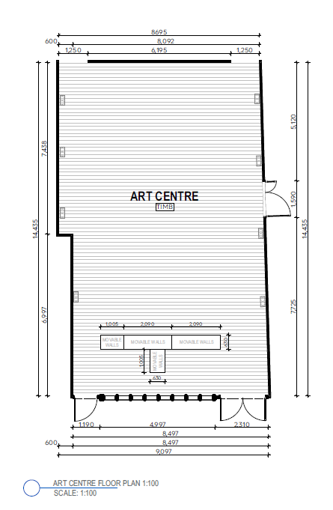

The Studio, Arts Centre Warburton has:
- 40m of wall space with heights between up to 3m.
- Walls are fitted with a professional gallery hanging system
- Walls are white brick
- Lights will be focussed by gallery staff to best display artwork
- Data projector available to screen directly onto wall or screen
- Audio options available – please discuss requirements with staff
- Various plinths, display cases and mannequins are available, please discuss with the REO
- Ceiling rigging for suspension of works
- Temporary walls are stored in the space and are usually utilised for exhibitions.

Access
- It is a public space frequented by adults and children who may be in the centre for other purposes
- Town centre, main street location
- There are no admission charges
- Accessible venue
- Public parking located to the centre
- Public transport includes access to buses

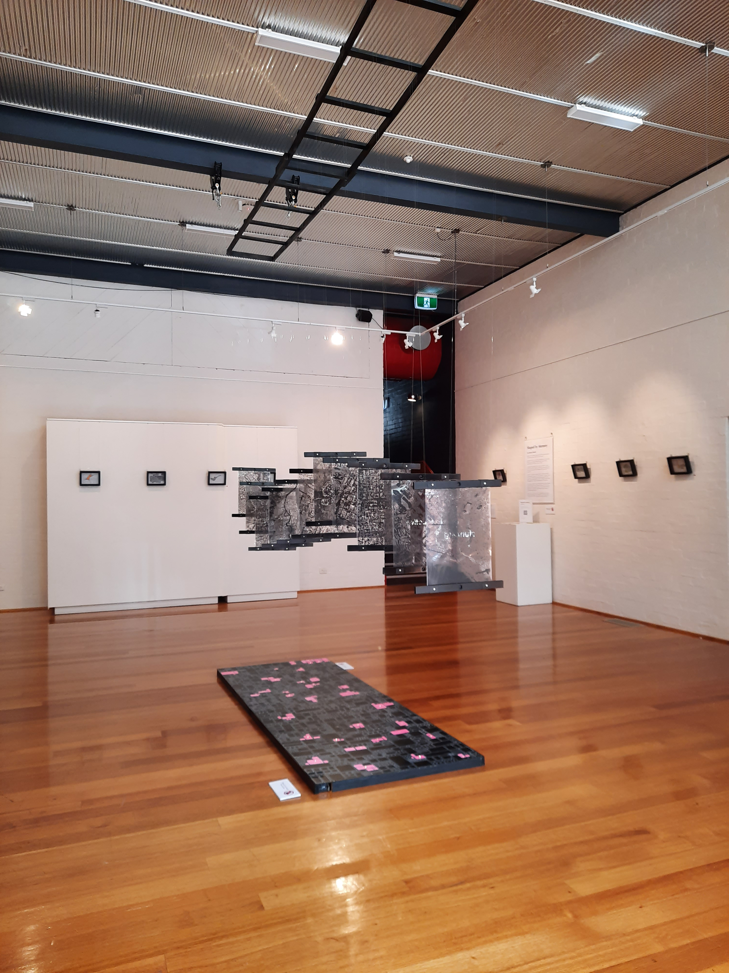
Image: Shaped by Memory by Jessica Harris, 2023, installation view, Art Centre Warburton

